dbEdit Program
Test plan
Version 3.0
04/24/2020
Document Control
Approval
The Guidance Team and the customer shall approve this document.
Document Change Control
Initial Release: | 1.0
Current Release: | 3.0
Indicator of Last Page in Document: | @@
Date of Last Review: | 4/24/2020
Date of Next Review: | TBA
Target Date for Next Update: | TBA
Distribution List
This following list of people shall receive a copy of this document every time a new version of this document becomes available:
Guidance Team Members: Dr. Steven Roach

Customer: Dr. Steven Roach

Software Team Members: Javier Soon (Producer)
Ricardo Pena (Reviewer)
Bianca C. De La Cruz (Reviewer)
Change Summary
The following table details changes made between versions of this document

Version | Date | Modifier | Description
1.0 | 04/07/2020 | Javier Soon | Initial Release, Filling out the document
2.0 | 4/18/2020 | Javier Soon | Added more information, addressed comments
2.1 | 4/19/2020 | Javier Soon | Continued to address comments
3.0 | 4/24/2020 | Javier Soon | Addressed issues about leaving comments in place which causes confusion(will no longer cause confusion, hopefully), addressed issue of consistency with reviewer position (for consistency), template footer fixed (unneeded information was left behind before no longer the case), addressed issues on change summary being vague (clearly states what was changed and why), updated table (table is now up-to-date with pages and new sections), github was added to references, fixed grammar issues, corrected the introduction, purpose, scope, system overview, suspension and exit criteria. Fixed a misunderstanding author had about User Interface Testing and Appendix, Fixed Appendix, Fixed Test Cases, Fixed Footers

Note: The template presented in this document was taken from:
Donaldson, S., and S. Siegel, Successful Software Development. Upper Saddle River, NJ: Prentice Hall, 2001, pp. 321-323.

Note: The template presented in this document was taken from: Donaldson, S., and S. Siegel, Successful Software Development. Upper Saddle River, NJ: Prentice Hall, 2001, pp. 321-323 and modified by Humberto Mendoza and Steve Roach.

Supplementary information is from:
Pfleeger, S. Software Engineering, Theory and Practice. Upper Saddle River, NJ: Prentice Hall, 1998, p. 365.

Table of Contents
Document Control ii
Approval ii
Document Change Control ii
Distribution List ii
Change Summary ii
1. Introduction 5
1.1. Purpose 5
1.2. Scope 5
1.3. System Overview 5
1.4. Suspension and Exit Criteria 5
1.5. Document Overview 5
1.6. References 5
2. Test Items and Features 6
3. Testing Approach 7
4. Test Duplicate and Compare 8
4.1. Test 1 8
4.2. Test 2 9
4.3. Test 3 10
4.4. Test 4 11
4.5. Test 5 12
5. User Interface Testing 13
6. Test Schedule 14
7. Other Sections 15
8. Appendix 16

Introduction
This test plan document is created in order to validate and verify a database editor that the stakeholder Dr. Steven Roach has provided. The tests for the databases focus on files also provided by Dr. Steven Roach, they are .XML files, and the author of the tests has the option to create additional .XML files for the purpose of testing.

Purpose
The focus of the test plans is on the most critical items that the author believes are of high priority. The testing to be done is comparing previous versions of data tables and checking for duplicates in a row for ta table in question.

Scope
The software used is dbEdit.jar, it will be focused on the compare functionality of the system provided by the client and using the .XML files that the client provided.

System Overview
The overview of the system is on the comparison of .XML files and to check for duplicate rows in the .XML files using the “dbEdit” program, where it will read the .XML files that are to be tested.

Suspension and Exit Criteria
The criteria for suspension is as follows: even though open is not a testing requirement it depend that the “Open” feature works as intended, in order to open the .XML files, the “Compare table to another version”, if this fails all test that deal with comparison (tests 3-5) will fail automatically, “Check For Duplicate Rows” feature if this feature fails all test that deal with duplicate row checking (test 1 and 2). If “Save” fails “Test 2” fails. If any tests result in a failure the test sets for the corresponding sets will be suspended. The exit criteria is either the completion of the test plan, or the suspension of the test sets.

Document Overview
Section 2. Test Items and Features will describe the testing items that are to be tested and features.
Section 3 Testing Approach describes the approach to be used to the test the system. This description includes
specifying the types of tests to be performed
Section 4 Test 5 will be where the tests that are to be conducted will be documented
Section 5 User Interface Testing will describe the process on how to go about doing certain aspects for the
tester, it may include hotkeys that the tester can use
Section 6 Testing Schedule is the schedule for when and what tests will be conducted
Section 7 Other Sections is where any sections not listed in this Document Overview subsection would be
located in.
section 8 Appendix is for additional information that is referenced and not included in previous sections of this
document.

References
TestPlanAssign040120.pptx
4387/5387 Test Plan Assignment
Spec.docx
https://github.com/CS5387/testplangroup4-team-9-1

Test Items and Features
Test Items and Features is focused on testing for duplicates and the compare features of the “dbEdit” software program, where it compares .XML files to previous versions of the same file, and duplicates rows. It will not focus on other aspects that are assumed to be working such as “insert, copy paste, opening and closing files, and save”.

Operation | Functionality
Check Duplicates | Checks for duplicate rows in the same .XML file
Compare | Compare the different versions of the same.XML file

Testing Approach

Test 1, 3, and 5 will be tested independently from each other and do not matter if some test pass while others do not, as long as the tests do not end up getting suspended. Test 4 depends on test 2 and is suggested that Test 2 be completed before Test 4. The tester will follow the instructions and compare the results to what the test plan returns.
All tests are to be rated from a 1 to 5 scale where 1 is the lowest and 5 is the highest priority. This test plan document will focus on the most critical parts that, the author believes to be of critical, of each feature so they will be all 5.

Table 1: Test Plan
TEST SUITE: Duplicate & Compare
Description of Test Suite | Test suite will focus on the duplication of rows, and the comparison of .XML files to previous versions
Test Case Identifier | Objective | Criticality
1 | Check for duplicate rows in the same .XML file (no duplicates exist) | 5
2 | Check for duplicate rows in the same .XML file (duplicate exists) | 5
3 | Compare the .XML file to itself | 5
4 | Compare the .XML file to a previous version of itself | 5
5 | Compare the .XML file to a completely different .XML file | 5

Test Duplicate and Compare
The setup for the test plan goes as follows: Tester will need access to the git repo and open the dbEdit.jar file in order to have access to the .XML files. This can be done by using gitbash,: git clone https://github.com/CS5387/testplangroup4-team-9-1 , java -jar dbEdit.jar to open the jar file. Any additional instructions will be given in the corresponding test, and any images needed for reference will be added in Section 8 Appendix.
There is no actual need to proceed with the test in the order they are in, but the tester is recommended to proceed with the test in how they are presented.
Any notes or comments that the tester discovers or has is free to write them in the comment section of the test plan to the corresponding step.

Test 1

Objective: Check for duplicate rows in the same .XML file
Notes: Tester will need access to the git repo and open the dbEdit.jar file in order to have access to the .XML files. This can be done by using gitbash,: git clone https://github.com/CS5387/testplangroup4-team-9-1 , java -jar dbEdit.jar to open the jar file.

Test No.: 1 |  |  |  | Current Status: Pending
Test title: Check Duplicate Rows (no duplicates present)

Testing approach: Open the jar file, open a .XML file, and run a duplicate row feature, results should pop up.
STEP  1 | OPERATOR ACTION  Click File - Open (see Section 8 Appendix: Image 1) | PURPOSE  To be able to see available files to open. |  |  | EXEPCTED RESULTS  A window is opened that shows available files (see Section 8 Appendix: Image 2) | COMMENTS
2 | Click an .XML file  (for this test use TEST _DB_BIG_TABLE.XML)  And select Open  (see Section 8 Appendix Image 3) | Open a table for testing. |  |  | Table opens as a pop up named: TTC XML Editor 09/01/17: BIG_TABLE.XML (1 of 1 row)
3 | Click File - Check for duplicate rows (see Section 8 Appendix Image 4) | Shows if there are any duplicate rows in the .XML file |  |  | It should open a pop up named: Duplicate Check, that shows that there are no duplicates. (see Section 8 Appendix Image 5)
Concluding Remarks:
Testing Team:  TBA |  |  | Date Completed:  TBA

Test 2

Objective: Check for duplicate rows in the same .XML file where duplicates exist
Notes: Tester will need access to the git repo and open the dbEdit.jar file in order to have access to the .XML files. This can be done by using gitbash,: git clone https://github.com/CS5387/testplangroup4-team-9-1 , java -jar dbEdit.jar to open the jar file.

Test No.: 2 |  |  |  | Current Status: Pending
Test title: Check For Confirmed Duplicate Rows

Testing approach: Open the jar file, open a .XML file, copy a row and paste it, run duplicate row feature, result should pop up.
STEP  1 | OPERATOR ACTION  Click File - Open (see Section 8 Appendix: Image 1) | PURPOSE  To be able to see available files to open. |  |  | EXEPCTED RESULTS  A window is opened that shows available files (see Section 8 Appendix: Image 2) | COMMENTS
2 | Click an .XML file  (for this test use TEST _DB_BIG_TABLE.XML)  And select Open  (see Section 8 Appendix Image 3) | Open a table for testing. |  |  | Table opens as a pop up named: TTC XML Editor 09/01/17: BIG_TABLE.XML (1 of 1 row)
3 | Select a filter row, and copy it, Click Edit – Copy Row  (see Section 8 Appendix Image 6 | Copies the row |  |  | Copies the row
4 | Click Edit – Paste Row  (see Section 8 Appendix Image 7) | Pastes the exact copy of the row in order to have something to use check duplicate with |  |  | Pastes an exact copy of the row that was copied  (see Section 8 Appendix Images 8 and 9)
5 | Click File - Check for duplicate rows (see Section 8 Appendix Image 4) | Shows if there are any duplicate rows in the .XML file |  |  | A pop up will open named: Duplicate Check, stating how many duplicates there are. A Duplicate key opens up named: and ERROR: Duplicate Rows, showing where the duplication is at  (see Section 8 Appendix Images 10 and 11)
6 | Click File – Save As, name the file as xxxx _v2.xxx | Saves the changes done |  |  | Saves the file
Concluding Remarks:
Testing Team:  TBA |  |  | Date Completed:  TBA

Test 3

Objective: Compare the same .XML files, no changes should be found
Notes: Tester will need access to the git repo and open the dbEdit.jar file in order to have access to the .XML files. This can be done by using gitbash,: git clone https://github.com/CS5387/testplangroup4-team-9-1 , java -jar dbEdit.jar to open the jar file.

Test No.: 3 |  |  |  | Current Status: Pending
Test title: Compare Same .XML file

Testing approach: Open the jar file, open a .XML file, and compare the file to itself
STEP  1 | OPERATOR ACTION  Click File - Open (see Section 8 Appendix: Image 1) | PURPOSE  To be able to see available files to open. |  |  | EXEPCTED RESULTS  A window is opened that shows available files (see Section 8 Appendix: Image 2) | COMMENTS
2 | Click an .XML file  (for this test use TEST _DB_BIG_TABLE.XML)  And select Open  (see Section 8 Appendix Image 3) | Open a table for testing. |  |  | Table opens as a pop up named: TTC XML Editor 09/01/17: BIG_TABLE.XML (1 of 1 row)
3 | Click File - Compare table to another table (see Section 8 Appendix Image 12) | To choose a table to compare |  |  | A window is opened that shows available files (see Section 8 Appendix: Image 2)
4 | Click the same .XML file  (for this test use TEST _DB_BIG_TABLE.XML)  And select Open  (see Section 8 Appendix Image 13) | To compare the base |  |  | Opens two pop ups named: Compare Result and TTC XML Table Compare Display Compare Tables.  (see Section 8 Appendix 14 and 15)
Concluding Remarks:
Testing Team:  TBA |  |  | Date Completed:  TBA

Test 4

Objective: Compare 2 .XML files that are different versions, some discrepancies should be detected and shown what they are, i.e. updates
Notes: Tester will need access to the git repo and open the dbEdit.jar file in order to have access to the .XML files. This can be done by using gitbash,: git clone https://github.com/CS5387/testplangroup4-team-9-1 , java -jar dbEdit.jar to open the jar file.

Test No.: 4 |  |  |  | Current Status: Pending
Test title: Compare .XML file to a previous version of it

Testing approach: Open the jar file, open a newer version of an .XML file, compare it to a previous version of itself
STEP  1 | OPERATOR ACTION  Click File - Open (see Section 8 Appendix: Image 1) | PURPOSE  To be able to see available files to open. |  |  | EXEPCTED RESULTS  A window is opened that shows available files (see Section 8 Appendix: Image 2) | COMMENTS
2 | Click an .XML file  (for this test use TEST _DB_BIG_TABLE_v2.XML)  And select Open  (see Section 8 Appendix Image 16) | Open a table for testing. |  |  | Table opens as a popup named: TTC XML Editor 09/01/17: BIG_TABLE.XML (1 of 1 row)
3 | Click File - Compare table to another table (choose same table but a previous version of itself for this example the TEST_DB_BIG_TABLE.XML, see Section 8 Appendix Image 3) and click open | Comparison of table |  |  | It should open the following pop ups: Compare Result, that shows there is one mismatch, TTC XML Table Compare Display Compare Tables, showing that a table has 1 mismatch, and it opens the table that was being compared, TTC XML Editor 09/01/17: BIG_TABLE.XML (1of 1 row) (see Section 8 Appendix Images 17 to 19)
Concluding Remarks:
Testing Team:  TBA |  |  | Date Completed:  TBA

Test 5

Objective: Compare 2 different types of .XML files, should catch that they are a lot of discrepancies
Notes: Tester will need access to the git repo and open the dbEdit.jar file in order to have access to the .XML files. This can be done by using gitbash,: git clone https://github.com/CS5387/testplangroup4-team-9-1 , java -jar dbEdit.jar to open the jar file.

Test No.: 5 |  |  |  | Current Status: Pending
Test title: Comparison of Two Different .XML files

Testing approach: Open the jar file, open a .XML file, compare it to a different .XML file not a previous version of the now opened .XML file
STEP  1 | OPERATOR ACTION  Click File - Open (see Section 8 Appendix: Image 1) | PURPOSE  To be able to see available files to open. |  |  | EXEPCTED RESULTS  A window is opened that shows available files (see Section 8 Appendix: Image 2) | COMMENTS
2 | Click an .XML file  (for this test use TEST _DB_BIG_TABLE.XML)  And select Open  (see Section 8 Appendix Image 3) | Open a table for testing. |  |  | Table opens as a pop up named: TTC XML Editor 09/01/17: BIG_TABLE.XML (1 of 1 row)
3 | Click File -Compare table to another table (Test_DB_TYPE_TABLE.XML, see Section 8 Appendix Image 20) and click open | Comparison of the tables |  |  | It opens the following pop ups for comparison: Table Columns do not Match, meaning that the tables are not the same, Compare Result, with 0 mismatches, TTC CML Table Compare Display Compare Tables, shows that the compare was a failure since the second .XML file was not the same, TTC XML Editor 09/01/17: TYPE_TABLE.XML (92 of 92 rows) (see Section 8 Appendix Images 21 to 23, and Image 14)
Concluding Remarks:
Testing Team:  TBA |  |  | Date Completed:  TBA

User Interface Testing
Not Applicable for this Test Plan Document.

Test Schedule

Task and date | People | Description
TBA | TBA | Testing

Other Sections
Not Applicable for this Test Plan Document.

Appendix
Image 1: Opening a .XML File

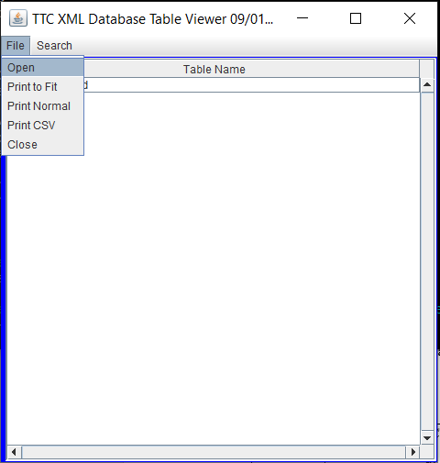

Image 2: Available Files

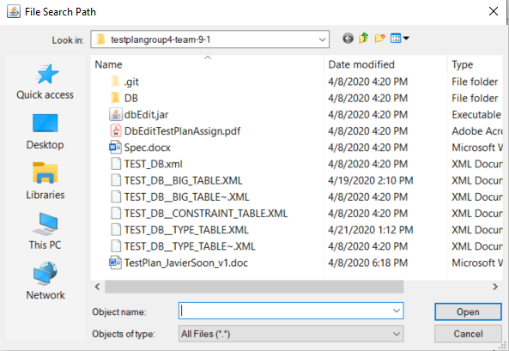

Image 3: Selecting and Opening

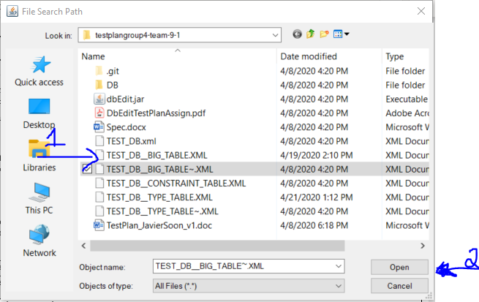

Image 4: Check for Duplicates

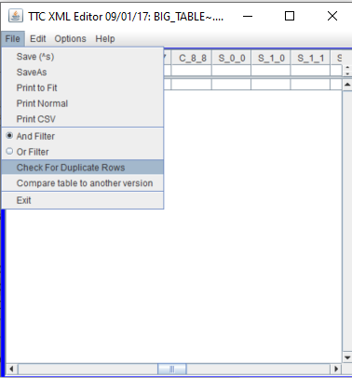

Image 5: No Duplicates

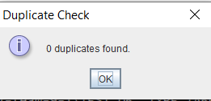

Image 6: Copy Row

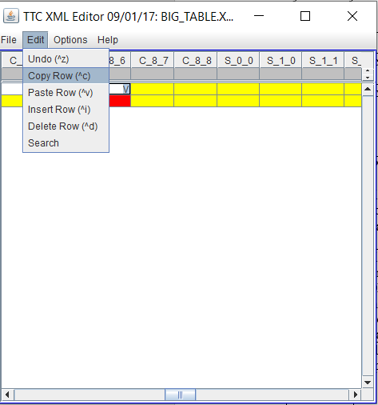

Image 7: Paste Row

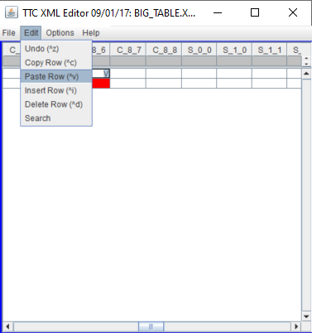

Image 8: BIG_TABLE.XML before copy paste

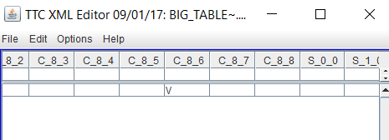

Image 9: BIG_TABLE.XML after copy paste
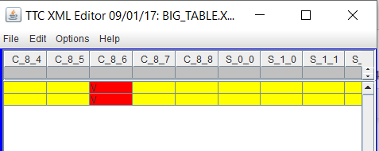

Image 10: Duplicate Found

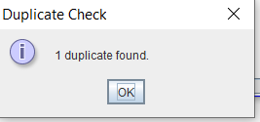

Image 11: Location of Duplicate

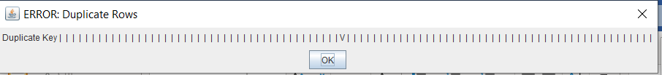

Image 12: Compare table

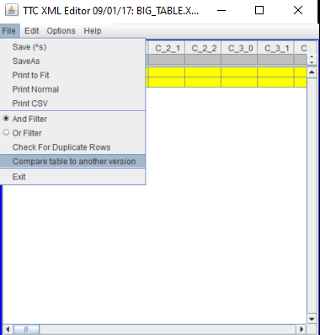

Image 13: Compare File Open Window

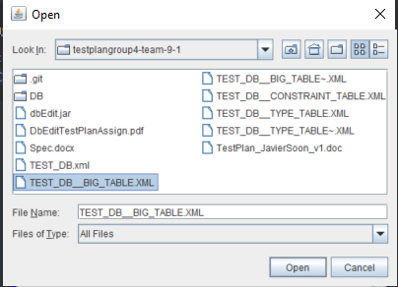

Image 14: Compare Results

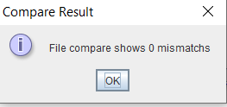

Image 15: Table Compare Display

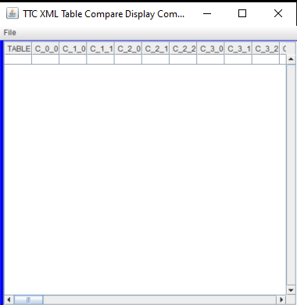

Image 16:Big Table_v2

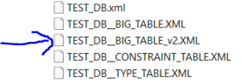

Image 17: Compare Result Mismatch

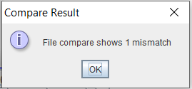

Image 18: Table Compare Display Mismatch

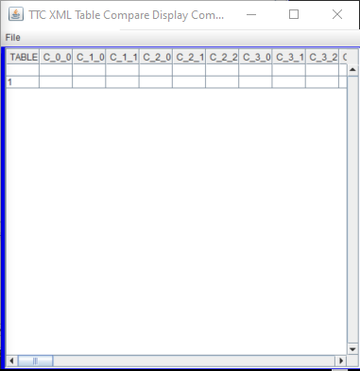

Image 19: Side by Side Big Table/Table Compare

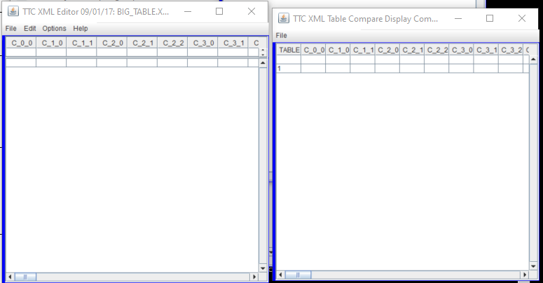
Image 20: Type Table Opening for Comparison

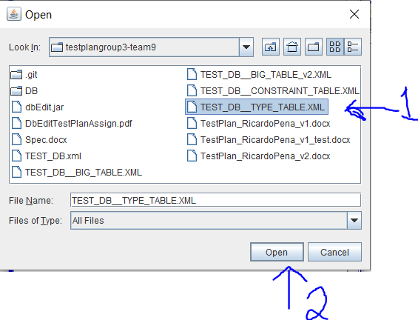
Image 21:Table Columns do not Match

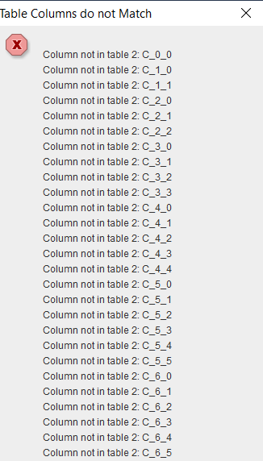

Image 22:Table Compare Display, Empty

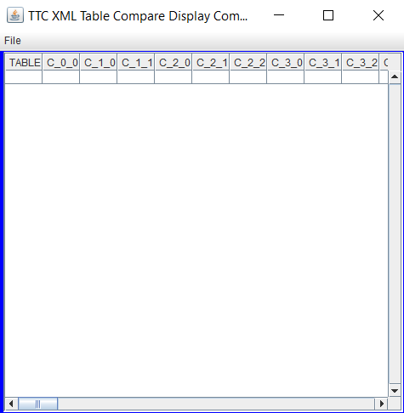

Image 23: Type Table





