dbEdit Program
Test plan
Version 2.0
04/18/2020
Document Control
Approval
The Guidance Team and the customer shall approve this document.
Document Change Control
Initial Release: | 1.0
Current Release: | 2.0
Indicator of Last Page in Document: | @@
Date of Last Review: | 4/19/2020
Date of Next Review: | TBA
Target Date for Next Update: | TBA
Distribution List
This following list of people shall receive a copy of this document every time a new version of this document becomes available:
Guidance Team Members:

Customer: Dr. Steven Roach

Software Team Members: Javier Soon (Producer)
Ricardo Pena (Reviewer)
Bianca C. De La Cruz
Change Summary
The following table details changes made between versions of this document

Version | Date | Modifier | Description
1.0 | 04/07/2020 | Javier Soon | Initial Release, Filling out the document
2.0 | 4/18/2020 | Javier Soon | Added more information, addressed comments
2.1 | 4/19/2020 | Javier Soon | Continued to address comments

Note: The template presented in this document was taken from:
Donaldson, S., and S. Siegel, Successful Software Development. Upper Saddle River, NJ: Prentice Hall, 2001, pp. 321-323.

Note: The template presented in this document was taken from: Donaldson, S., and S. Siegel, Successful Software Development. Upper Saddle River, NJ: Prentice Hall, 2001, pp. 321-323 and modified by Humberto Mendoza and Steve Roach.

Supplementary information is from:
Pfleeger, S. Software Engineering, Theory and Practice. Upper Saddle River, NJ: Prentice Hall, 1998, p. 365.

Table of Contents
Document Control ii
Approval ii
Document Change Control ii
Distribution List ii
Change Summary ii
1. Introduction 1
1.1. Purpose 1
1.2. Scope 1
1.3. System Overview 1
1.4. Suspension and Exit Criteria 1
1.5. Document Overview 1
1.6. References 1
2. Test Items and Features 2
3. Testing Approach 3
4. Test XX 4
4.1. Test <<test id>> 4
5. User Interface Testing 5
6. Test Schedule 6
7. Other Sections 7
8. Appendix 8

Introduction

Creating a test plan for a program provided by the customer Dr. Steven Roach, the program is based on a database table editor.

Purpose

The focus of this project test plan is to test the database table editor by comparing .XML files to other previous versions of said .XML files to itself by checking for duplicate rows.

Scope
The software used is dbEdit.jar, it will be focused on the compare functionality of the system provided by the client and using the .XML files that the client provided.

System Overview
<<Describe the system to be exercised by the testing approach specified in the plan. This overview serves to identify aspects of the system operation that will be the focus of the plan’s testing approach. This should align with the systems overview of other documents in the project.>>

Suspension and Exit Criteria
<< “suspension criteria” describes when we suspend testing, to be resumed at a later time. For example, if 40% of the test cases fail, or if any of the critical test cases fail. If there are no suspension criteria, indicate that all tests cases will be executed. “Exit criteria” indicates when testing stops. This could be based on run rate (number of test cases run divided by number of test cases specified) or pass rate (number of test cases passed divided by number of test cases run, or test cases passed divided by number of test cases specified). Nominally, we expect to run all of the specified tests. We want the pass rate to be high. We might specify that all critical tests must pass, and 90% of the non-critical must pass. In general, we want this to be high. >>

Document Overview
Section 2. Test Items and Features will describe the testing items that are to be tested and features.
Section 3 Testing Approach describes the approach to be used to the test the system. This description includes
specifying the types of tests to be performed
Section 4 Test 5 will be where the tests that are to be conducted will be documented
Section 5 User Interface Testing will describe the process on how to go about doing certain aspects for the
tester, it may include hotkeys that the tester can use
Section 6 Testing Schedule is the schedule for when and what tests will be conducted
Section 7 Other Sections is where any sections not listed in this Document Overview subsection would be
located in.
section 8 Appendix is for additional information that is referenced and not included in previous sections of this
document.

References
TestPlanAssign040120.pptx
4387/5387 Test Plan Assignment
Spec.docx

Test Items and Features
Test Items and Features is focused on testing for DUPLICATES and the COMPARE features of the dbEdit software program, where it compares .XML files to previous versions of the same file, and duplicates rows. It will not focus on other aspects that are assumed to be working such as INSERT, COPY PASTE, OPENING AND CLOSING FILES, and SAVE.

Operation | Functionality
Check Duplicates | Checks for duplicate rows in the same .XML file
Compare | Compare the same versions of a .XML file

Testing Approach

<<Describe the approach to be used to the test the system. This description includes specifying the types of tests to be performed, e.g., tests designed to exercise system functions one by one; tests designed to exercise sequences of functions that approximate operational use of the system; tests designed to stress the system to its design and requirements limits. The description lists the specific tests to be performed, but does not give the test steps. For each of these tests, give it a name and specify its objective. Label the criticality of the test cases. >>

Table 1: Test Plan
TEST SUITE: Duplicate & Compare
Description of Test Suite | Test suite will focus on the duplication of rows, and the comparison of .XML files to previous versions
Test Case Identifier | Objective | Criticality
1 | Check for duplicate rows in the same .XML file | 5
2 | Check for duplicate rows in the same .XML file (duplicate exists) | 5
3 | Compare the .XML file to itself | 5
4 | Compare the .XML file to a previous version of itself | 5
5 | Compare the .XML file to a completely different .XML file | 5

Test 5
<<The purpose of this section is to:
- document test input, specific test procedures, and outcomes.
- establish test methods,
- explain the nature and extent of each test >>
<< for each test case, complete the following: >>

Test 1

Objective: Check for duplicate rows in the same .XML file
Notes: Tester will need access to the git repo and open the dbEdit.jar file in order to have access to the .XML files. This can be done by using gitbash,: git clone https://github.com/CS5387/testplangroup4-team-9-1 , java -jar dbEdit.jar to open the jar file.

Test No.: 1 |  |  |  | Current Status: Pending
Test title: Check Duplicate Rows

Testing approach: Open the jar file, open a .XML file, and run a duplicate row feature, results should pop up
STEP  1 | OPERATOR ACTION  Open a .XML file (for this test use BIG_TABLE.XML) | PURPOSE  To have a table to test |  |  | EXEPCTED RESULTS  Table opens | COMMENTS
2 | File – Check for duplicate rows | Shows if there are any duplicate rows in the .XML file |  |  | It should open a pop up that shows that there are no duplicates
Concluding Remarks:
Testing Team:  TBA |  |  | Date Completed:  TBA

Test 2

Objective: Check for duplicate rows in the same .XML file where duplicates exisit
Notes: Tester will need access to the git repo and open the dbEdit.jar file in order to have access to the .XML files. This can be done by using gitbash,: git clone https://github.com/CS5387/testplangroup4-team-9-1 , java -jar dbEdit.jar to open the jar file.

Test No.: 2 |  |  |  | Current Status: Pending
Test title: Check For Confirmed Duplicate Rows

Testing approach: Open the jar file, open a .XML file, copy a row and paste it, run duplicate row feature, result should pop up.
STEP  1 | OPERATOR ACTION  Open a .XML file (for this test use BIG_TABLE.XML) | PURPOSE  To have a table to test |  |  | EXEPCTED RESULTS  Table opens | COMMENTS
2 | Select a non-grayed out row, and copy it from the edit menu toolbar | Copies the row |  |  | Copies the row
3 | Select paste from the edit menu toolbar | Pastes the exact copy of the row in order to have something to use check duplicate with |  |  | Pastes an exact copy of the row that was copied
4 | File -Check For Duplicate Rows | To see if a row was duplicated |  |  | It will highlight the rows that are duplicated and a pop up will open stating how many duplicates there are. A Duplicate key opens up showing where the duplication is at
Concluding Remarks:
Testing Team:  TBA |  |  | Date Completed:  TBA

Test 3

Objective: Compare the same .XML files, no changes should be found
Notes: Tester will need access to the git repo and open the dbEdit.jar file in order to have access to the .XML files. This can be done by using gitbash,: git clone https://github.com/CS5387/testplangroup4-team-9-1 , java -jar dbEdit.jar to open the jar file.

Test No.: 3 |  |  |  | Current Status: Pending
Test title: Compare Same .XML file

Testing approach: Open the jar file, open a .XML file, and compare the file to itself
STEP  1 | OPERATOR ACTION  Open a .XML file (for this test use BIG_TABLE.XML) | PURPOSE  To have a table to test |  |  | EXEPCTED RESULTS  Table opens | COMMENTS
2 | File -Compare table to another table(choose same table) | Comparison of table |  |  | It should open a pop up stating there is no differences
Concluding Remarks:
Testing Team:  TBA |  |  | Date Completed:  TBA

Test 4

Objective: Compare 2 .XML files that are different versions, some discrepancies should be detected and shown what they are, i.e. updates
Notes: Tester will need access to the git repo and open the dbEdit.jar file in order to have access to the .XML files. This can be done by using gitbash,: git clone https://github.com/CS5387/testplangroup4-team-9-1 , java -jar dbEdit.jar to open the jar file.

Test No.: 4 |  |  |  | Current Status: Pending
Test title: Compare .XML file to a previous version of it

Testing approach: Open the jar file, open a newer version of an .XML file, compare it to a previous version of itself
STEP  1 | OPERATOR ACTION  Open a .XML file (for this test use BIG_TABLE.XML) | PURPOSE  To have a table to test |  |  | EXEPCTED RESULTS  Table opens | COMMENTS
2 | File -Compare table to another table(choose same table but a previous version of itself) | Comparison of table |  |  | It should open a pop up that shows the number of mismatches there are, and another table for comparison
Concluding Remarks:
Testing Team:  TBA |  |  | Date Completed:  TBA

Test 5

Objective: Compare 2 different types of .XML files, should catch that they are a lot of discrepancies
Notes: Tester will need access to the git repo and open the dbEdit.jar file in order to have access to the .XML files. This can be done by using gitbash,: git clone https://github.com/CS5387/testplangroup4-team-9-1 , java -jar dbEdit.jar to open the jar file.

Test No.: 5 |  |  |  | Current Status: Pending
Test title: Comparison of Two Different .XML files

Testing approach: Open the jar file, open a .XML file, compare it to a different .XML file not a previous version of the now opened .XML file
STEP  1 | OPERATOR ACTION  Open a .XML file (for this test use BIG_TABLE.XML) | PURPOSE  To have a table to test |  |  | EXEPCTED RESULTS  Table opens | COMMENTS
2 | File -Compare table to another table(Test_DB_TYPE_TABLE.XML) | Comparison of the tables |  |  | It should open a pop up stating where the columns are not in the original file.
Concluding Remarks:
Testing Team:  TBA |  |  | Date Completed:  TBA

User Interface Testing

Notes
Opening jar in gitbash 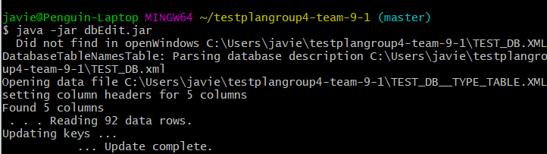

Section 4.1
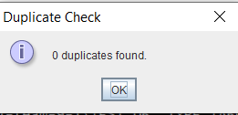

Section 4.2

BIG_TABLE.XML before copy paste
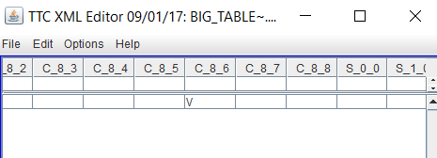
BIG_TABLE.XML after copy paste
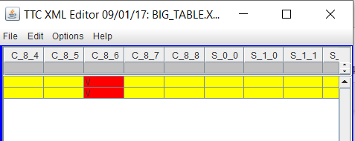
Duplicate check

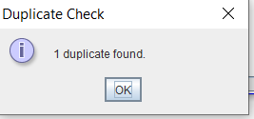
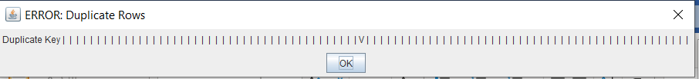

Section 4.3
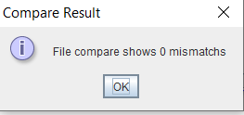

Section 4.4
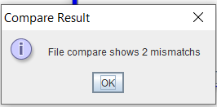
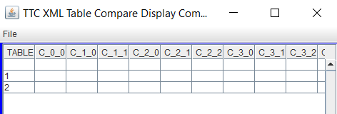

Section 4.5
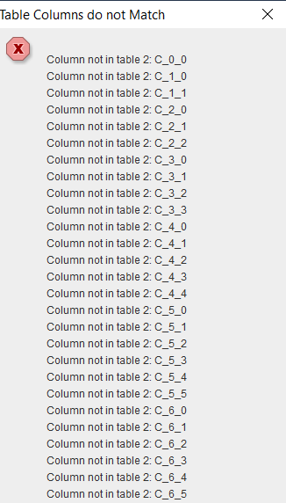
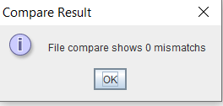

Test Schedule

Task and date | People | Description
TBA | TBA | Testing
TBA | TBA | Testing
TBA | TBA | Testing
TBA | TBA | Testing
TBA | TBA | Testing
TBA | TBA | Testing
TBA | TBA | Testing
TBA | TBA | Testing
TBA | TBA | Testing

Other Sections
Not Applicable for this Test Plan Document

Appendix
<< possibly more readable to put the expected output here and refer to it in the previous sections. Might also provide explicit directions for analysis of output, if it’s easier to read as an appendix or if analysis is post execution. >>

@@

