Database Table Editor
Test plan
Version 2.0
04/15/20

Document Control
Approval
The Guidance Team and the customer shall approve this document.
Document Change Control
Initial Release: | 04/03/2020
Current Release: | 04/05/2020
Indicator of Last Page in Document:
Date of Last Review:
Date of Next Review:
Target Date for Next Update: | 04/15/2020
Distribution List
This following list of people shall receive a copy of this document every time a new version of this document becomes available:
Reviewers:
- Roman A. Martinez
- Valente Arellano
Change Summary
The following table details changes made between versions of this document

Version | Date | Modifier | Description
1.0 | 04/05/20 | Kevin Rodriguez | Test plan created
2.0 | 04/15/20 | Kevin Rodriguez | Edits on Test Plan based on reviews.

Note: The template presented in this document was taken from:
Donaldson, S., and S. Siegel, Successful Software Development. Upper Saddle River, NJ: Prentice Hall, 2001, pp. 321-323.

Note: The template presented in this document was taken from: Donaldson, S., and S. Siegel, Successful Software Development. Upper Saddle River, NJ: Prentice Hall, 2001, pp. 321-323 and modified by Humberto Mendoza and Steve Roach.

Supplementary information is from:
Pfleeger, S. Software Engineering, Theory and Practice. Upper Saddle River, NJ: Prentice Hall, 1998, p. 365.

Table of Contents
Document Control ii
Approval ii
Document Change Control ii
Distribution List ii
Change Summary ii
1. Introduction 1
1.1. Purpose 1
1.2. Scope 1
1.3. System Overview 1
1.4. Suspension and Exit Criteria 1
1.5. Document Overview 1
1.6. References 1
2. Test Items and Features 2
3. Testing Approach 3
4. Test XX 4
4.1. Test <<test id>> 4
5. User Interface Testing 5
6. Test Schedule 6
7. Other Sections 7
8. Appendix 8

Introduction

The test plan will focus on testing a simple database table editor system. This test plan is meant to be reviewed by a team of Testers and provide feedback to the producer in order to improve the quality of the Test Plan.

Purpose

By conducting this Test Plan, it will focus on the functionality of the system. The approach taken to test this table edit is Black Box testing. The functionality focused on this test plan is on the ‘compare file to other version’ and ‘check for duplicate rows’.

Scope
Version 1.0

System Overview
System is a basic database table editor.

Suspension and Exit Criteria
Suspension of testing will take place if test cases are not able to be ran due to a bug on the system not allowing to do functionality being tested.

Exit Criteria would be satisfied when all test cases have been run regardless of the outcome.

Document Overview
<<Describe the remainder of the document.>>

References
https://piazza.com/class_profile/get_resource/k55rbh37ri6be/k8hjj7sn7hu7n0

https://github.com/CS5387/testplangroup4-team3

Test Items and Features
The following are the features to be tested and a description on what each feature should do.

Feature | Description
‘Compare file to other version’ | This feature focuses on comparing a table to another version of the same file. The purpose is to show the differences of both tables (What has been edited, removed, etc.).
‘Check for Duplicate Rows | This feature focuses on checking if a table holds any duplicate rows.

Testing Approach

Table 1: Test Plan
TEST SUITE 1
Description of Test Suite | Test designed to test the functionality of the following operations: compare file to other version and check for duplicate rows
Test Case Identifier | Objective | Criticality
1 | Test functionality of comparing file to another version with TYPE_TABLE.xml and CONSTRAINT_TABLE.xml
2 | Test the functionality of checking for duplicate rows on BIG_TABLE.xml
3 | Test the functionality of comparing file to another version with TYPE_TABLE.xml compared to itself.
4 | Test the functionality of comparing file to another version with TYPE_TABLE.xml while changing one value and comparing table with old version.
5 | Test the functionality of comparing file to another version with TYPE_TABLE.xml and CONSTRAINT_TABLE.xml

Test Suite 1
Tests are going to be done using the .jar application provided by the professor.

4.0 Set-up
1) Launch the .jar application. The following should show.

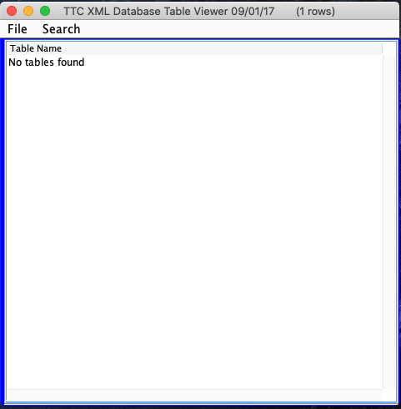
2) Click on File -> Open -> (chose) TEST_DB.xml
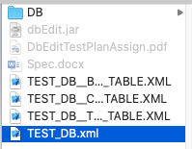

3) The following should show, with the following 3 tables (BIG_TABLE, CONSTRAINT_TABLE, TYPE_TABLE)
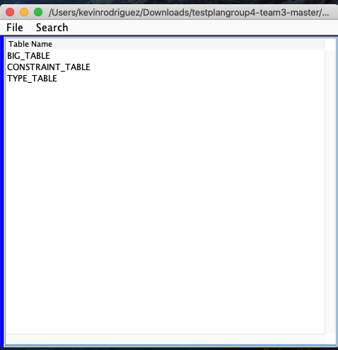
4) Double clicking on a table, will show the selected table. For example, picking CONSRAINT_TABLE will populate the following
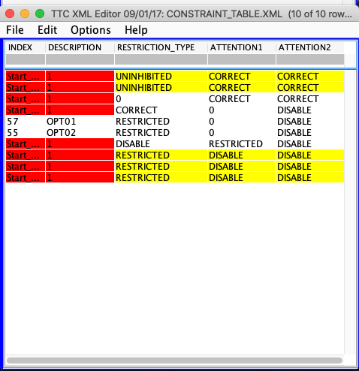

Test 1

Objective: Test functionality of comparing file to another version with TYPE_TABLE.xml and CONSTRAINT_TABLE.xml
Notes: .jar must be running
In order to execute following Test, program must have TYPE_TABLE and CONSTRAINT_TABLE imported.

Test No.: 1 |  |  |  | Current Status: Pending
Test title: Compare file to another version test

Testing approach: Black Box
STEP  1 | OPERATOR ACTION  Select TYPE_TABLE.xml in main window | PURPOSE  Opening first table | EXEPCTED RESULTS  The following table should open  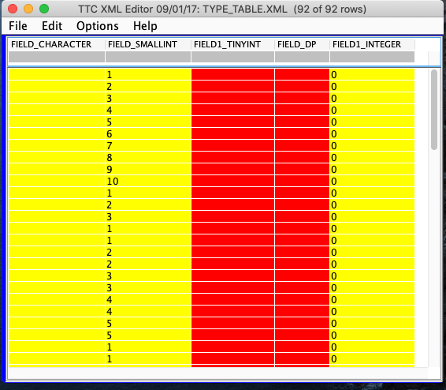 |  | COMMENTS
2 | On TYPE_TABLE.xml window click the following:  File -> Compare table to another version | Selecting table to compare table from ‘Step 1’. | N/A |  | This step is just selecting table to compare version.
3 | chose CONSTRAINT_TABLE.xml | Launching operation to compare table 1 to another version. | 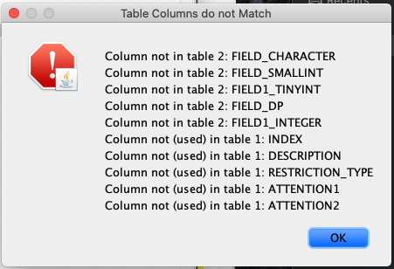  The following should appear as output. Showing differences between two tables |  | ‘table 1’ is table from Step 1.  ‘table 2’ is CONSTRAINT TABLE  If window does not appear with results shown, test has FAILED.
Concluding Remarks: N/A
Testing Team:  N/A |  |  | Date Completed:

4.2 Test 2

Objective: Test the functionality of checking for duplicate rows on BIG_TABLE.xml
Notes: .jar program must be running
In order to execute following Test, program must have BIG_TABLE.xml imported

Test No.: 2 |  |  |  | Current Status: Pending
Test title: Check for duplicate rows

Testing approach: Selecting BIG_TABLE.xml as main table
STEP  1 | OPERATOR ACTION  Select BIG_TABLE in main window. | PURPOSE  Selecting table to be tested | EXEPCTED RESULTS  The following table should show  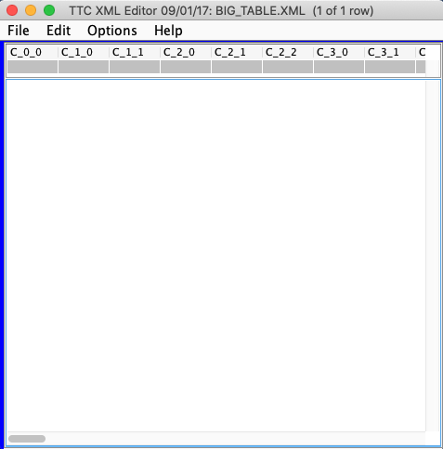 |  | COMMENTS
2 | On BIG_TABLE.xml window, click File -> Check for duplicate row | Selecting functionality to be tested | 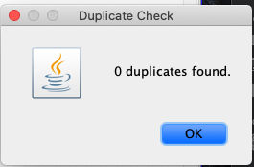  Window will show with 0 duplicate rows. |  | If window does not appear with results shown, test has FAILED.  Test has PASSED if window appears as shown
Concluding Remarks: N/A
Testing Team:  N/A |  |  | Date Completed:

4.2 Test 3

Objective: Test the functionality of comparing file to another version with TYPE_TABLE.xml compared to itself.
Notes: .jar must be running
In order to execute following Test, program must have TYPE_TABLE imported.

Test No.: 3 |  |  |  | Current Status: Pending
Test title: Compare file to same version of itself.

Testing approach: Selecting TYPE_TABLE.xml table as the first table.
STEP  1 | OPERATOR ACTION  Select TYPE_TABLE.xml in main window | PURPOSE  Opening first table | EXEPCTED RESULTS  The following table should open |  | COMMENTS
2 | On TYPE_TABLE.xml window, click File -> Compare table to another version -> chose SAME table (TEST_DB_TYPE_TABLE.xml) | Selecting functionality to test and table to compare it to. | 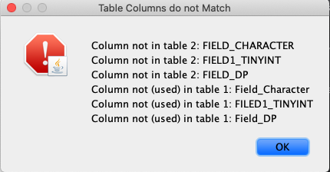  The following result should appear showing the columns that do not match  An empty Table Compare Display window should populate  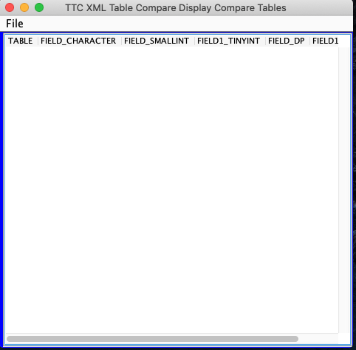 |  | If window does not appear with results shown, test has FAILED.  Test has PASSED if window appears as shown
Concluding Remarks: N/A
Testing Team:  N/A |  |  | Date Completed:

4.2 Test 4

Objective: Test the functionality of comparing file to another version with TYPE_TABLE.xml while changing one value and comparing table with old version.
Notes: .jar must be running
In order to execute following Test, program must have TYPE_TABLE must be imported

Test No.: 4 |  |  |  | Current Status: Pending
Test title: Compare file to old version after being edited test.

Testing approach: Selecting TYPE_TABLE.xml table as the first table.
STEP  1 | OPERATOR ACTION  Select TYPE_TABLE.xml in main windows | PURPOSE  Opening desired table | EXEPCTED RESULTS |  | COMMENTS
2 | Change value on first cell under FIELD_SMALLINT from ‘1’ to ‘20’ | Making a change to table | 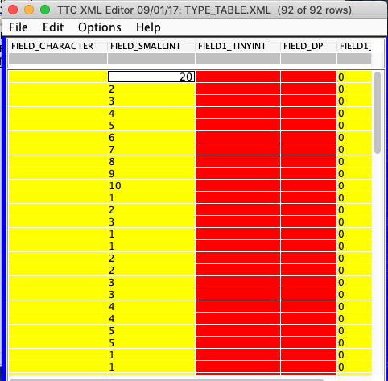
3 | On TYPE_TABLE.xml window, click File -> Compare table to another version -> chose SAME table (TEST_DB_TYPE_TABLE.xml) | Comparing original to edited table | 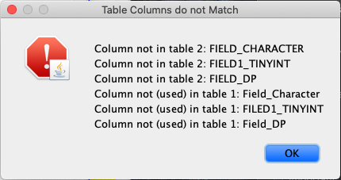  Pop-up window will show up with results.
4 | Click OK on Pop-up window shown in ‘Step 3’ | Show results for difference | 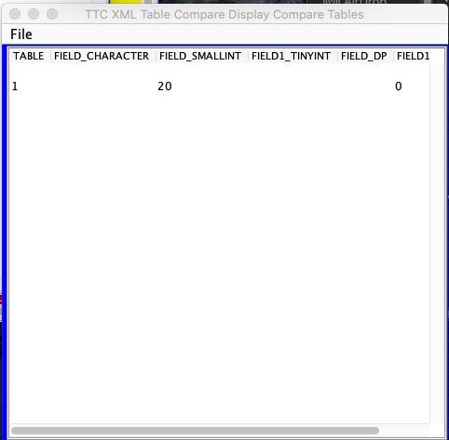  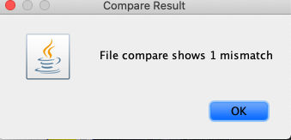 |  | This window will show the differences between the two tables and it should be the value which we changed on ‘Step 2’  If window does not appear with results shown, test has FAILED.  Test has PASSED if window appears as shown
Concluding Remarks: N/A
Testing Team:  N/A |  |  | Date Completed:

4.2 Test 5

Objective: Test the functionality of comparing file to another version with different tables.
Notes: .jar program must be running
In order to execute following Test, program must have TYPE_TABLE and CONSTRAINT_TABLE.xml imported

Test No.: 5 |  |  |  | Current Status: Pending
Test title: Compare file to another version (Different tables)

Testing approach: Selecting TYPE_TABLE.xml as main table
STEP  1 | OPERATOR ACTION  Select TYPE_TABLE in main window. | PURPOSE  Selecting table to be tested | EXEPCTED RESULTS  The following table should show |  | COMMENTS
2 | On TYPE_TABLE.xml window, click File -> Compare table to another version -> chose CONSTRAINT_TABLE.xml | Selecting functionality to be tested as well as second table. | 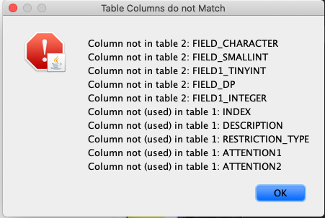  Results will show after second table selected. |  | If window does not appear with results shown, test has FAILED.  Test has PASSED if window appears as shown
Concluding Remarks: N/A
Testing Team:  N/A |  |  | Date Completed: n/a

Appendix
N/A

