Test Plan Practice
Test plan
Version 3.1
4/24/20
Document Control
Approval
The Guidance Team and the customer shall approve this document.
Document Change Control
Initial Release: | 1.0
Current Release: | 3.1
Indicator of Last Page in Document: | $
Date of Last Review: | 4/24/20
Date of Next Review: | 5/1/2020
Target Date for Next Update: | 5/1/2020
Distribution List
This following list of people shall receive a copy of this document every time a new version of this document becomes available:
Guidance Team Members: Dr. Steven Roach

Customer: Dr. Steven Roach

Software Team Members: Jonathan Roman, Stephanie Medina
Change Summary
The following table details changes made between versions of this document

Version | Date | Modifier | Description
0.1 | 4/6/2020 | Jonathan Roman | Completed section 1
0.3 | 4/9/2020 | Jonathan Roman | Completed sections 2 and 3
0.6 | 4/10/2020 | Jonathan Roman | Completed section 4, 5 and 6
1.0 | 4/11/2020 | Jonathan Roman | Proof read document for first release
2.0 | 4/15/2020 | Jonathan Roman | Added notes to test Cases, added intro sentences to sections.
2.5 | 4/18/2020 | Jonathan Roman | Proof read document.
3.0 | 4/23/2020 | Jonathan Roman | Added two test cases and proofread document.
3.1 | 4/24/2020 | Jonathan Roman | Proof read document.

Table of Contents
Document Control ii
Approval ii
Document Change Control ii
Distribution List ii
1. Introduction 1
1.1. Purpose 1
1.2. Scope 1
1.3. System Overview 1
1.4. Suspension and Exit Criteria 2
1.5. Document Overview 2
1.6. References 2
2. Test Items and Features 3
3. Testing Approach 4
4. Test XX 5
4.1. Test 1 5
4.2. Test 2 7
4.3. Test 3 9
4.4. Test 4 11
4.5. Test 5 13
4.6. Test 6 14
4.7. Test 7 15
4.8. Test 8 16
5. User Interface Testing 18
6. Test Schedule 19
7. Appendix 20

Introduction

Purpose
Included in the test plan are a series of five test cases to be executed in an attempt to properly test error prone areas of the software under test. The proper documentation of these test cases will serve in the process improvement of test plan development and documentation as expected for the spring 2020 course CS4387/CS5387 at the University of Texas at El Paso.

Scope
The software under test is version 1.0 of dbEdit.

System Overview
When started, the editor opens a database edit window. This window displays the tables in a database. Initially, no database is loaded. There is a menu with File and Search. File has the options to open, close, and print tables. A user can open either a database description file or a data file. If a data file is opened, the corresponding database description is also opened. The database description window displays all the database tables. Selecting a table from this display opens the data table display in a new window. It is possible to open more than one database at a time. Opening a database table file results in the database description also being opened. It is possible to open more than one database at a time. All the windows associated with a specific database have the same color outline. Opening an already-opened table should result in the table editor window for that table being raised to the top of the screen and being visible.

The Options/History option displays the history data section. On file save, the user is prompted to enter a new history entry.

If the file has been modified and the user attempts to close the file, a save prompt should be displayed.

Search opens a file search dialog that allows a user to search specified directories for files that contain a given text string. When using this option, files containing the text string are listed. Selecting the file from the display will open the database table.

In the data table display, data is displayed and is editable. The menu has File, Edit, Options, and Help. The Help option describes the editor features. The Edit menu option allows the user to insert, delete, copy, paste, and undo. The create and delete options are row operations: entire rows are affected. Undo is any operation that affects the data. It is also possible to modify rows from the table. It is not allowed to change the column headers. It is possible to re-order columns by dragging them to a new location. Duplicate rows are highlighted in yellow. Fields violating field constraints specified in the database description file are highlighted in red.

In data table display, the column names are displayed across the top row. Just below this is a blank row. This row is the display filter row. Entering data in this row will result in only the matching data rows to be displayed. In the File menu, there are options for OR FILTER or AND FILTER. If AND FILTER is selected, the display is restricted to rows that match all of the filters entered. If the OR FILTER is selected, the display should contain rows that match any of the filters entered. The filters allow a limited type of regular expression matching described on the Help pages.

The File/Compare option allows a user to compare two versions of a table. This compare can be restricted to selected columns by using the Options/Column Selection feature. The output is rather crude and is not intended for large change lists.

File/Check for Duplicate Rows should list rows that have identical contents. This check is restricted to the columns selected in Options/Select Columns.

Constraints
A constraint on a column is specified in the database table description inside the column description. For example:
<COLUMN name='FIELD_DP' type='DOUBLE_PRECISION' >
<CONSTRAINT name='NN_0' type='NotNull'/>
</COLUMN>

The constraint name must be unique in the table. Types of constraints are
NotNull
Unique
Check
For NotNull, the entry in the data table must have some value. For Unique, the value must not be duplicated anywhere else in the table (e.g., the table's key value). For Check, the value must match one of the OPTION fields. For example:
<CONSTRAINT name='EN_1' type='Check'>
<OPTION>OPT01</OPTION>
<OPTION>OPT02</OPTION>
</CONSTRAINT>
Constraint violations are highlighted in red in the data table display, and hovering the mouse cursor over the highlighted column should display a message describing the violation. Multiple constraints are allowed for each column.

Suspension and Exit Criteria
All test cases are to be executed, all critical tests must pass and 80% of non-critical tests must pass.

Document Overview
- Introduction: A description of the test plan and the software under test.
- Test Items and Features: Describes features being tested
- Testing Approach: Explains the approach being used in the test plan.
- Tests: Contains information and procedures to properly execute every test scenario included in the test plan.
- User interface testing: User interface is not being tested.
- Test Schedule: Provides a timeline for test execution.
- Other Sections: N/A
- Appendix: Additional information.

References
- Spec of version 1.0 of dbEdit, https://github.com/CS5387/testplangroup4-team_4/blob/master/Spec.docx

Test Items and Features
The following features will be placed under test in the test plan that follows.

- File version comparison
- This feature takes two existing files that have the same layout and compares them to find inconsistencies.

- Duplicate row identification
- This feature searches through a file and identifies duplicate rows.
- Can be enabled to check for duplicate rows after every save.

Testing Approach

These tests will be executed using a black box approach.

Table 1: Test Plan
TEST SUITE 1
Description of Test Suite | The test suite will test the functionalities of file version comparison and duplicate row identification.
Test Case Identifier | Objective | Criticality
1 | Test file version comparison difference detection with differences between files. | Critical
2 | Test file version comparison difference detection without differences between files. | Critical
3 | Test the automatic duplicate check after saving when there are no duplicates. | Non-Critical
4 | Test the automatic duplicate check after saving when there are duplicates. | Non-Critical
5 | Test the automatic duplicate check after saving when there are duplicates. | Non-Critical
6 | Test the manual duplicate check after saving when there are duplicates. | Critical
7 | Test the manual duplicate check after saving when there are duplicates. | Critical
8 | Test the manual duplicate check after saving when there are no duplicates. | Critical

Test XX
The following test cases should be executed using a black box approach. Be sure to document the status of the test, test team, date completed and any concluding remarks.

Test 1

Objective: Test file version comparison difference detection with differences between files.
Notes: This test case should be conducted at the start after opening the application

Test No.: 1 |  |  | Current Status: Pass
Test title: File Version Comparison with Single Row Difference

Testing approach: This test should be conducted using a black box approach. Execute the operator action and observe for the expected result.

STEP  1  2  3  4  5  6  7 | OPERATOR ACTION  Left click the file tab.  Left click the open option.  Select “TEST_DB_TYPE_TABLE” and click open.  Edit the first row and replace the “1” in the FIELD_SMALLINT column with a 90.  Save the current file with the new name “TEST_DB_TYPE_TABLE_2”  Click the file tab and click “compare table to another version”  Select “TEST_DB_TYPE_TABLE” and click open | PURPOSE  Attempting to open a file.  Attempting to open a file.  Attempting to open a file.  Create a single difference between files.  Create a single difference between files.  Compare files.  Compare files. |  |  | EXEPCTED RESULTS  Menu should appear  Window for file searching should appear.  File should open in a new window  File should display a “90” instead of a “1” in the cell that was edited.  New file with the name “TEST_DB_TYPE_TABLE_2”  Should be created.  New file search window should appear.  A new window should open containing the row that is different. | COMMENTS  An error message about missing columns might appear.
Concluding Remarks:
It appears that this test has passed. The tool did detect the one change that has been conducted. See appendix section for screenshot of results.
Testing Team:  Stephanie Medina |  |  |  | Date Completed:  04/17/2020

Test 2

Objective: Test file version comparison difference detection without differences between files.
Notes: This test case should be conducted at the start after opening the application.

Test No.: 2 |  |  |  | Current Status: Pass
Test title: File Version Comparison with No Difference

Testing approach: This test should be conducted using a black box approach. Execute the operator action and observe for the expected result.

STEP  1  2  3  4  5  6 | OPERATOR ACTION  Left click the file tab.  Left click the open option.  Select “TEST_DB_TYPE_TABLE” and click open.  Save the current file with the new name “TEST_DB_TYPE_TABLE_3”  Click the file tab and click “compare table to another version”  Select “TEST_DB_TYPE_TABLE” and click open | PURPOSE  Attempting to open a file.  Attempting to open a file.  Attempting to open a file.  Create a file with no difference.  Compare files.  Compare files. |  |  | EXEPCTED RESULTS  Menu should appear  Window for file searching should appear.  File should open in a new window  New file with the name “TEST_DB_TYPE_TABLE_3”  Should be created.  New file search window should appear.  A new window should open showing that the files compared have no differences. | COMMENTS  An error message about missing columns might appear.
Concluding Remarks:
It appears that this test has passed. The tool did detect that no change has been conducted. See appendix section for screenshot of results.
Testing Team:  Stephanie Medina |  |  | Date Completed:  04/17/2020

Test 3

Objective: Test the automatic duplicate check after saving when there are no duplicates.
Notes: This test case should be conducted at the start after opening the application.

Test No.: 3 |  |  |  | Current Status: Pass
Test title: Automatic Duplicate Check After Saving without Duplicates

Testing approach: This test should be conducted using a black box approach. Execute the operator action and observe for the expected result

STEP  1  2  3  4  5  6 | OPERATOR ACTION  Left click the file tab.  Left click the open option.  Select “TEST_DB_TYPE_TABLE” and click open.  Go to options and select “Check For Duplicates on File Save”  Delete every row in the document at the same time except for 1.  Save the current file with the new name “TEST_DB_TYPE_TABLE_4” | PURPOSE  Attempting to open a file.  Attempting to open a file.  Attempting to open a file.  Enable automatic duplicate check  Create a document without duplicates  Use automatic duplicate check |  |  | EXEPCTED RESULTS  Menu should appear.  Window for file searching should appear.  File should open in a new window.  “Check For Duplicates on File Save” should display a checkmark next to it.  Only one row should be visible in the file.  New file with the name “TEST_DB_TYPE_TABLE_4”  No duplicate error messages should appear. | COMMENTS  You can delete multiple rows at once by highlighting the desired rows, go to edit and select delete row. (This may or may not work depending on the environment on which the software is run on.)
Concluding Remarks:
The test appeared to pass. No error message appeared when the file was saved.
Testing Team:  Stephanie Medina |  |  | Date Completed:  04/17/2020

Test 4

Objective: Test the automatic duplicate check after saving when there are duplicates.
Notes: This test case should be conducted at the start after opening the application.

Test No.: 4 |  |  |  | Current Status: Pass
Test title: Automatic Duplicate Check After Saving with Duplicates

Testing approach: This test should be conducted using a black box approach. Execute the operator action and observe for the expected result

STEP  1  2  3  4  5  6  7 | OPERATOR ACTION  Left click the file tab.  Left click the open option.  Select “TEST_DB_TYPE_TABLE” and click open.  Delete every row in the document except for two rows.  Change the value of the second row such that the values of the first row and second row are equal.  Go to options and select “Check For Duplicates on File Save”  Save the current file with the new name “TEST_DB_TYPE_TABLE_5” | PURPOSE  Attempting to open a file.  Attempting to open a file.  Attempting to open a file.  Creating a single duplicate on the file.  Creating a single duplicate on the file.  Enable automatic duplicate check  Use automatic duplicate check |  |  | EXEPCTED RESULTS  Menu should appear.  Window for file searching should appear.  File should open in a new window.  The file should only have two rows.  The file should have only two rows and their values should be equal to each other.  “Check For Duplicates on File Save” should display a checkmark next to it.  New file with the name “TEST_DB_TYPE_TABLE_5”  Should be created and an error message for every duplicate row should appear. | COMMENTS  You can delete multiple rows at once by highlighting the desired rows, go to edit and select delete row.  (This may or may not work depending on the environment on which the software is run on.)
Concluding Remarks:
The test appears to pass, it detects all the duplicates when it is saved.
Testing Team:  Jonathan Roman |  |  | Date Completed:  04/21/2020

Test 5

Objective: Test the automatic duplicate check after saving when there are duplicates.
Notes: This test case should be conducted at the start after opening the application.

Test No.: 5 |  |  |  | Current Status: Pass
Test title: Automatic Duplicate Check After Saving with Duplicates

Testing approach: This test should be conducted using a black box approach. Execute the operator action and observe for the expected result

STEP  1  2  3  4  5 | OPERATOR ACTION  Left click the file tab.  Left click the open option.  Select “TEST_DB_TYPE_TABLE” and click open.  Go to options and select “Check For Duplicates on File Save”  Save the current file with the new name “TEST_DB_TYPE_TABLE_6” | PURPOSE  Attempting to open a file.  Attempting to open a file.  Attempting to open a file.  Enable automatic duplicate check  Use automatic duplicate check |  |  | EXEPCTED RESULTS  Menu should appear.  Window for file searching should appear.  File should open in a new window.  “Check For Duplicates on File Save” should display a checkmark next to it.  New file with the name “TEST_DB_TYPE_TABLE_6”  Should be created and an error message for every duplicate row should appear. | COMMENTS
Concluding Remarks:
The test appears to pass, it detects all the duplicates when it is saved. However, when there is a large amount of duplicate error messages, multiple error windows appear. It might be better to have only one error message box pop up and list the errors instead of opening many error windows. This however, can be tested at a later date since it is out of scope for this testing approach. See appendix for screenshot of result.
Testing Team:  Stephanie Medina |  |  | Date Completed:  04/17/2020

Test 6

Objective: Test the manual duplicate check after saving when there are duplicates.
Notes: This test case should be conducted at the start after opening the application.

Test No.: 6 |  |  |  | Current Status: Pass
Test title: Manual Duplicate Check with Duplicates

Testing approach: This test should be conducted using a black box approach. Execute the operator action and observe for the expected result

STEP  1  2  3  4  5  6 | OPERATOR ACTION  Left click the file tab.  Left click the open option.  Select “TEST_DB_TYPE_TABLE” and click open.  Delete every row in the document except for two rows.  Change the value of the second row such that the values of the first row and second row are equal.  Go to file and select “Check For Duplicate Rows” | PURPOSE  Attempting to open a file.  Attempting to open a file.  Attempting to open a file.  Creating a single duplicate on file.  Creating a single duplicate on file.  Activate duplicate row check |  |  | EXEPCTED RESULTS  Menu should appear.  Window for file searching should appear.  File should open in a new window.  The file should have only two rows.  The file should have only two rows and their values should be equal to each other.  An error message should appear stating that there is 1 duplicate and an error message should appear for every duplicate row. | COMMENTS  You can delete multiple rows at once by highlighting the desired rows, go to edit and select delete row. (This may or may not work depending on the environment on which the software is run on.)
Concluding Remarks:
The test appears to pass, it detects all the duplicates when the option is selected.
Testing Team:  Jonathan Roman |  |  | Date Completed:  04/21/2020

Test 7

Objective: Test the manual duplicate check after saving when there are duplicates.
Notes: This test case should be conducted at the start after opening the application.

Test No.: 7 |  |  |  | Current Status: Pass
Test title: Manual Duplicate Check with Duplicates

Testing approach: This test should be conducted using a black box approach. Execute the operator action and observe for the expected result

STEP  1  2  3  4 | OPERATOR ACTION  Left click the file tab.  Left click the open option.  Select “TEST_DB_TYPE_TABLE” and click open.  Go to file and select “Check For Duplicate Rows” | PURPOSE  Attempting to open a file.  Attempting to open a file.  Attempting to open a file.  Activate duplicate row check |  |  | EXEPCTED RESULTS  Menu should appear.  Window for file searching should appear.  File should open in a new window.  An error message should appear stating that there are 79 duplicates and an error message should appear for every duplicate row. | COMMENTS
Concluding Remarks:
The test appears to pass, it detects all the duplicates when the option is selected. However, when there is a large amount of duplicate error messages, multiple error windows appear. It might be better to have only one error message box pop up and list the errors instead of opening many error windows. This however, can be tested at a later date since it is out of scope for this testing approach. See appendix for screenshot of result.
Testing Team:  Stephanie Medina |  |  | Date Completed:  04/17/2020

Test 8

Objective: Test the manual duplicate check after saving when there are no duplicates.
Notes: This test case should be conducted at the start after opening the application.
Test No.: 8 |  |  |  | Current Status: Fail
Test title: Manual Duplicate Check without Duplicates

Testing approach: This test should be conducted using a black box approach. Execute the operator action and observe for the expected result

STEP  1  2  3  4  5  6 | OPERATOR ACTION  Left click the file tab.  Left click the open option.  Select “TEST_DB_TYPE_TABLE” and click open.  Delete every row in the document except for 1.  Save the current file with the new name “TEST_DB_TYPE_TABLE_6”  Go to file and select “Check For Duplicate Rows” | PURPOSE  Attempting to open a file.  Attempting to open a file.  Attempting to open a file.  Create a document without duplicates  Create a document without duplicates  Activate duplicate row check |  |  | EXEPCTED RESULTS  Menu should appear.  Window for file searching should appear.  File should open in a new window.  Only one row should be visible in the file.  New file with the name “TEST_DB_TYPE_TABLE_6”  An error message should appear stating that there are 0 duplicates. | COMMENTS  You can delete multiple rows at once by highlighting the desired rows, go to edit and select delete row. (This may or may not work depending on the environment on which the software is run on.)
Concluding Remarks:
This test appeared to fail due to the fact that it did not print an error message stating that there are 0 duplicates. It only saved and no other action was done. See appendix for screenshot of result.
Testing Team:  Stephanie Medina |  |  | Date Completed:  04/17/2020

User Interface Testing

Due to the user interface not being the target system under test for this test plan, the user interface will not be tested.

Test Schedule
The actual dates for the following test schedule are to be determined, the dates included serve only as a suggested execution date.

Task and date | People | Description
Test 1  4/23/2020 | Jonathan Roman, Stephanie Medina | Test file version comparison difference detection with differences between files.
Test 2  4/23/2020 | Jonathan Roman, Stephanie Medina | Test file version comparison difference detection without differences between files.
Test 3  4/23/2020 | Jonathan Roman, Stephanie Medina | Test the automatic duplicate check after saving when there are no duplicates.
Test 4  4/23/2020 | Jonathan Roman, Stephanie Medina | Test the automatic duplicate check after saving when there is only one duplicate.
Test 5  4/23/2020 | Jonathan Roman, Stephanie Medina | Test the automatic duplicate check after saving when there are duplicates.
Test 6  4/23/2020 | Jonathan Roman, Stephanie Medina | Test the manual duplicate check after saving when there is only one duplicate.
Test 7  4/23/2020 | Jonathan Roman, Stephanie Medina | Test the manual duplicate check after saving when there are duplicates.
Test 8  4/23/2020 | Jonathan Roman, Stephanie Medina | Test the manual duplicate check after saving when there are no duplicates.

Appendix
Additional information and the JAR file for dbEdit can be found at https://github.com/CS5387/testplangroup4-team_4/blob/master/Spec.docx.

Results for Test Case 1:

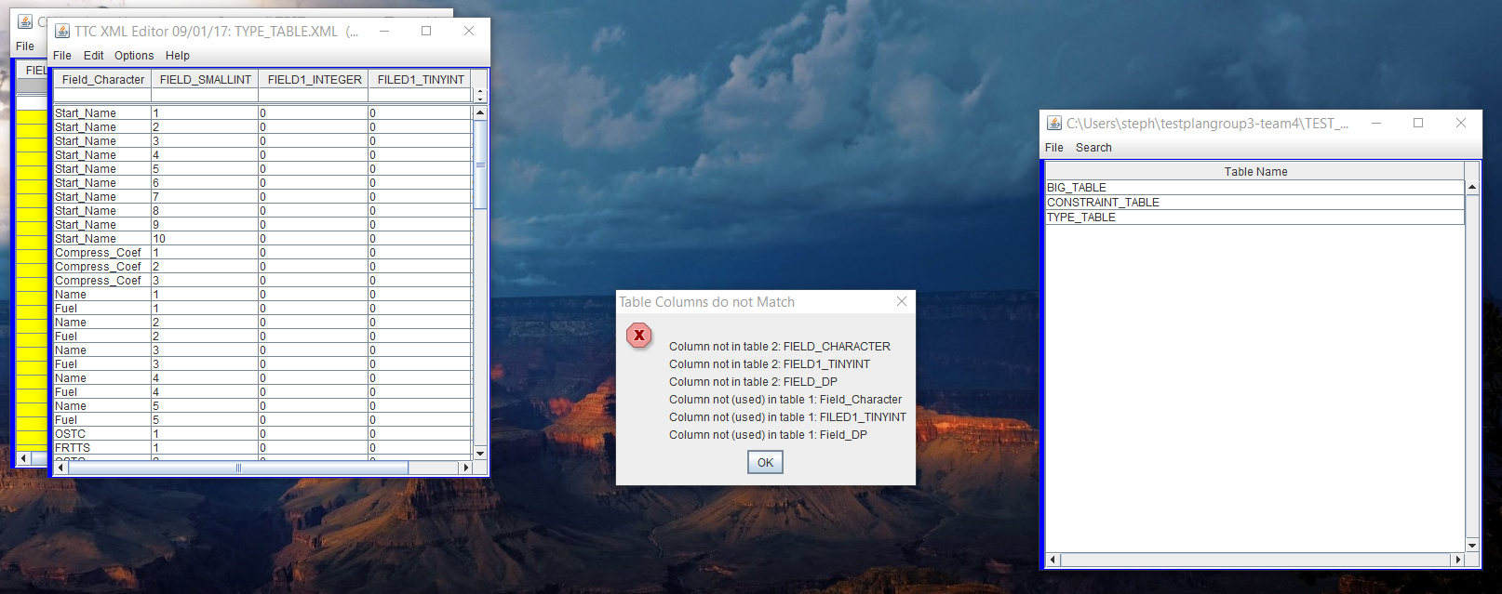
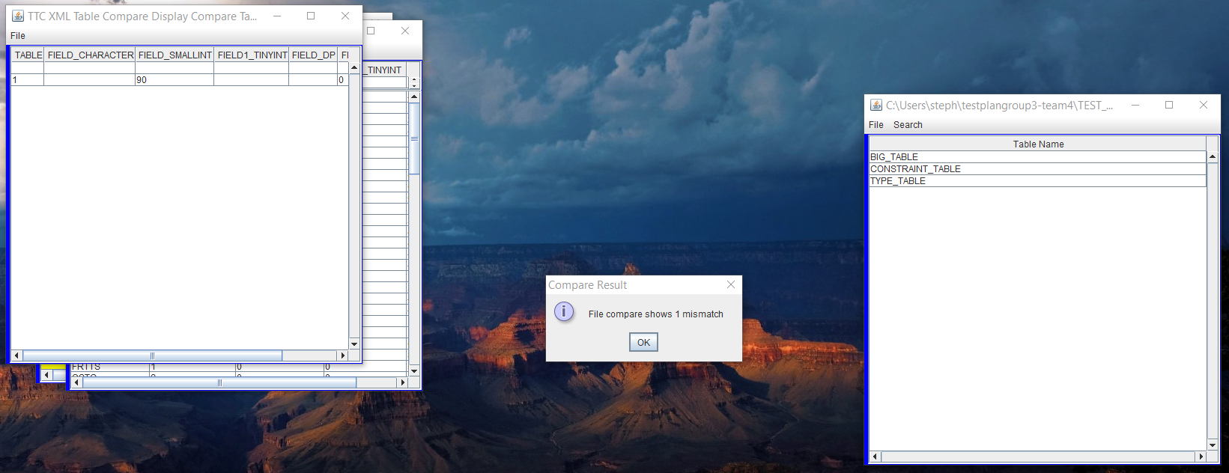

Test Case 2 Results:

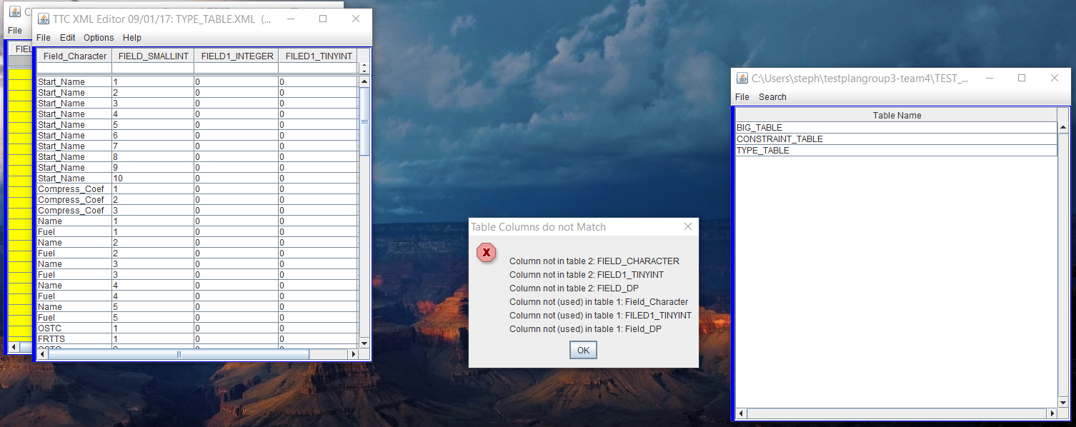
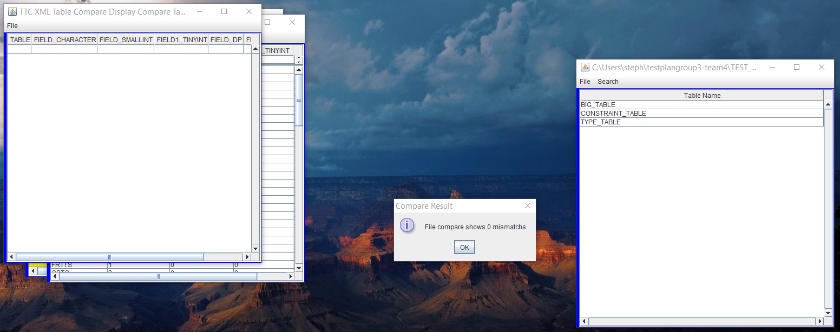

Test Case 3 Results:

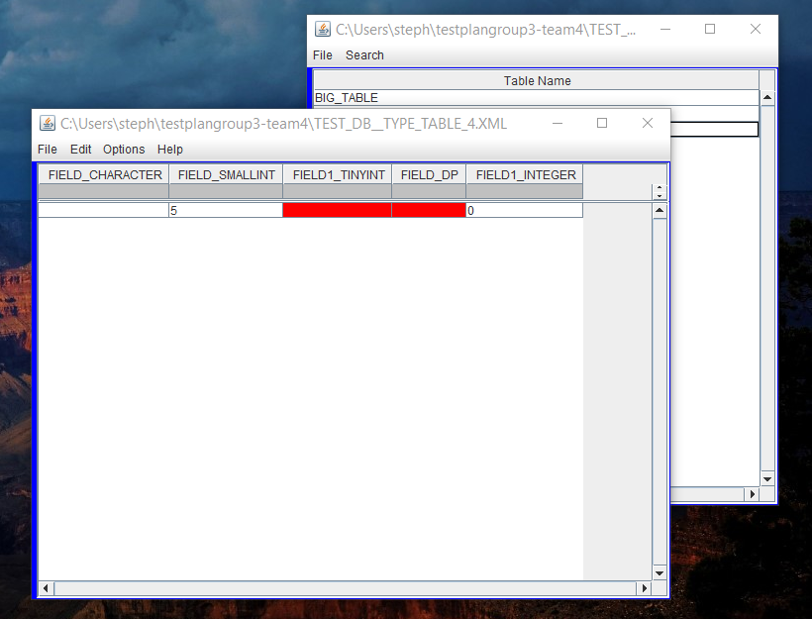

Test Case 5 Results:

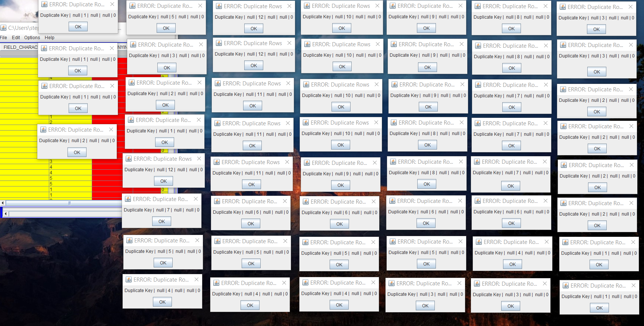

Test Case 7 Results:

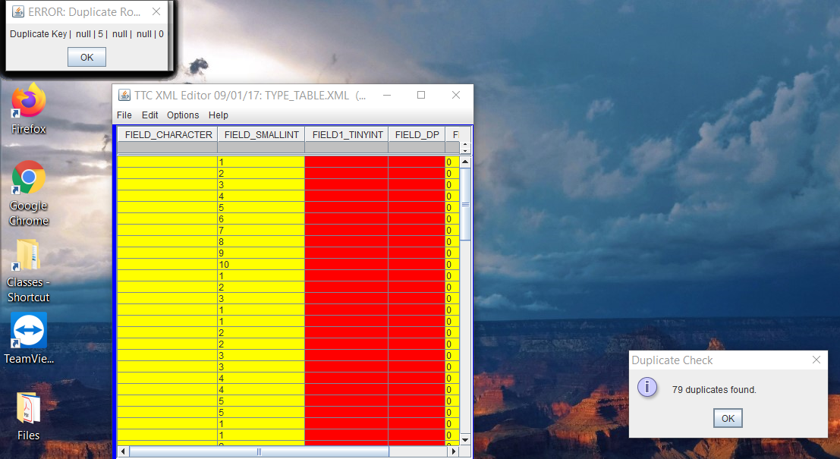

Test Case 8 Results:





