Test plan project
Test plan
Version 0.03
04/21/2020
Document Control
Approval
The Guidance Team and the customer shall approve this document.
Document Change Control
Initial Release: | 04/08/2020
Current Release: | 04/22/2020
Indicator of Last Page in Document: | $
Date of Last Review: | X
Date of Next Review: | X
Target Date for Next Update: | 04/23/2020
Distribution List
This following list of people shall receive a copy of this document every time a new version of this document becomes available:
Test plan Grader:
DR. Roach

Test plan reviewers:
Diego Rincon
Blanca Galvan

Change Summary
The following table details changes made between versions of this document

Version | Date | Modifier | Description
0.01 | 04/08/2020 | Alejandro Zamora | Initialize baseline
0.03 | 04/21/2020 | Alejandro Zamora | Section 1,2,3 updates
0.04 | 04/22/2020 | Alejandro Zamora | Added 2 test cases for section 4

Note: The template presented in this document was taken from:
Donaldson, S., and S. Siegel, Successful Software Development. Upper Saddle River, NJ: Prentice Hall, 2001, pp. 321-323.

Note: The template presented in this document was taken from: Donaldson, S., and S. Siegel, Successful Software Development. Upper Saddle River, NJ: Prentice Hall, 2001, pp. 321-323 and modified by Humberto Mendoza and Steve Roach.

Supplementary information is from:
Pfleeger, S. Software Engineering, Theory and Practice. Upper Saddle River, NJ: Prentice Hall, 1998, p. 365.

Table of Contents
Document Control ii
Approval ii
Document Change Control ii
Distribution List ii
Change Summary ii
1. Introduction 1
1.1. Purpose 1
1.2. Scope 1
1.3. System Overview 1
1.4. Suspension and Exit Criteria 1
1.5. Document Overview 1
1.6. References 1
2. Test Items and Features 2
3. Testing Approach 3
4. Test XX 4
4.1. Test <<test id>> 4
5. Test Schedule 6
6. Other Sections 7
7. Appendix 8

Introduction

<< This section gives introductory information regarding the project, the system to be tested, and the testing approach.>>
The system is unknown to the tester and will explore black box testing methods to provide a well written test plan. Aspects such as testing functionality edge cases that might have a yield in finding errors

Purpose

The purpose of this would be the ability to give more hands-on experience to the class CS4387 in writing test plans and reviewing them as well. The system we will be examining is dbEdit.jar. This system will go through black box testing to find since information on this is limited.

Scope
The software we are going to exclusively test on is the dbEdit.jar which is the latest version known of the system.

System Overview
dbEdit.jar is a system that allows modification and configuration of XML tables. The system allows the user to search for a file they wish to ingest. The system also allows the user to create, delete, add and update the XML files as well as comparing files to one another.

Suspension and Exit Criteria
<< “suspension criteria” describes when we suspend testing, to be resumed at a later time. For example, if 40% of the test cases fail, or if any of the critical test cases fail. If there are no suspension criteria, indicate that all tests cases will be executed. “Exit criteria” indicates when testing stops. This could be based on run rate (number of test cases run divided by number of test cases specified) or pass rate (number of test cases passed divided by number of test cases run, or test cases passed divided by number of test cases specified). Nominally, we expect to run all of the specified tests. We want the pass rate to be high. We might specify that all critical tests must pass, and 90% of the non-critical must pass. In general, we want this to be high. >>
Suspension Criteria:
- Hardware malfunction where data is unrecoverable
- that all tests cases will be executed
Exit Criteria:
- Critical test has 100% pass rate
- Non-critical system test has at least a 90% pass rate
- Overall system is test is 97% pass rate

Document Overview

- Section 2 – Test items and features. Shows important features that are going to be tested along with a description
- Section 3 -Testing approach. Shows additional notes for section 4.
- Section 4- Test. Shows the step by step process of a test in detail.
- Section 5- Test schedule. Shows a schedule of all activities performed.
- Section 6 - Other Section. Provides addition notes on the test document.
- Section 7 – Appendix. Provides additional information for any part of the test plan such as visuals.

References
[1]S.Roach “Spec.doc”, El Paso, TX, USA, April, 2020
[2]S.Roach “DbEditTestPlanAssign.pdf”, El Paso , TX, USA, April 2020
[3]S.Roach ”DbEdit.jar”, El Paso, TX , USA , April 2020

Test Items and Features
The test items are the most common things that the user interacts with in the system that we will be performing black box testing on

Figure1.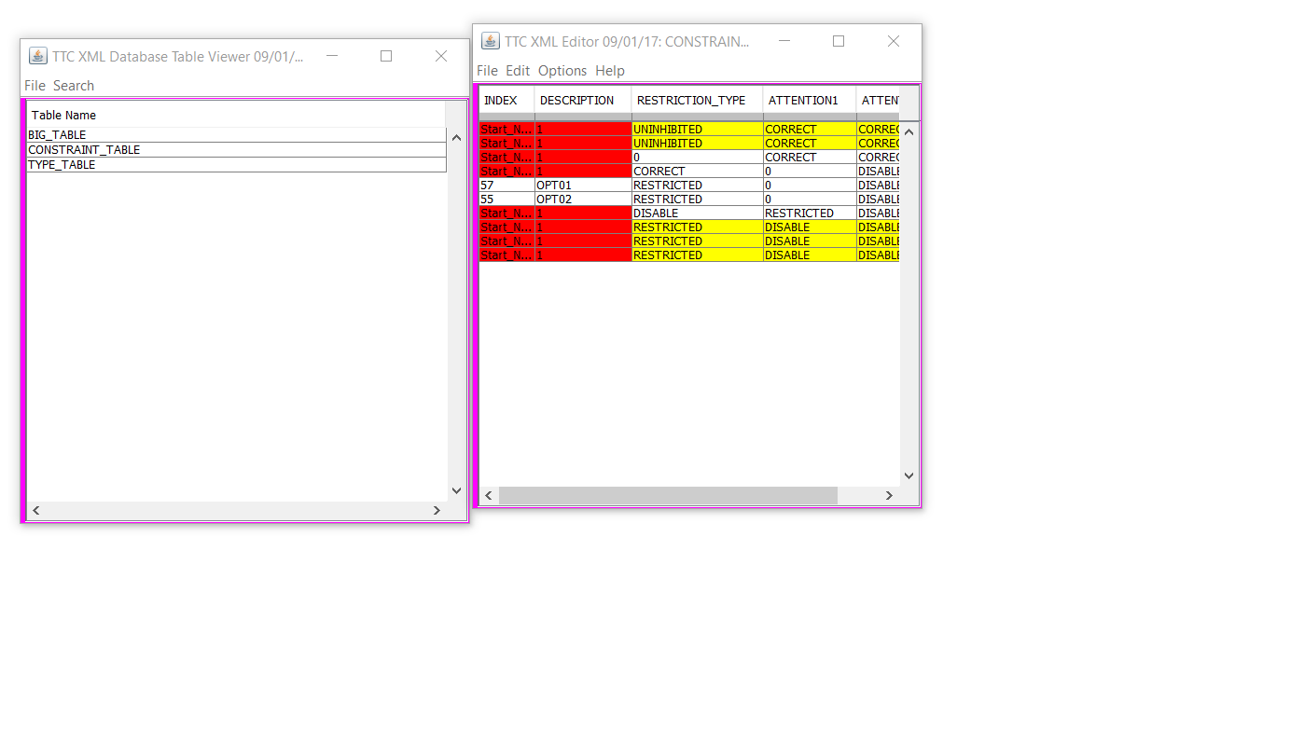
Figure 2
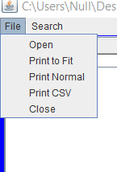

Figure 3
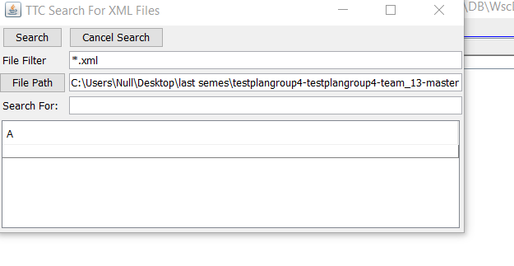

Testing Approach

The table below will be done through black box testing. The Objectives labeled below will be tested upon the functionality of the DbEdit.jar system. The tables show which objectives are viewed as highly critical or low criticality. This provides a foundation on what to expect in section 4.
Table 1: Test Plan
Menu Options TEST SUITE
Description of Test Suite
Test Case Identifier | Objective | Criticality
MO1 | Open and load a file | High
MO2 | Save a file | High
MO3 | Create a file | High
MO4 | Edit a file | High
MO5 | Search | Low
MO6 | Print a file | High

Menu Options Test Suite
The purpose of this section is to show the step by step process on how tests are performed while also listing the expected outcome.

Test MO1

Objective: Open a file and load it into the system
Notes: dbEdit.jar is running

Test No.: MO1 |  |  |  | Current Status: Pending
Test title: Open load tables

Testing approach: This test will see it can open and load files into the system. This test will explore loading compatible file types and loading incompatible file types to the system.

STEP  1 | OPERATOR ACTION  User clicks double clicks the dbEdit.jar | PURPOSE  Start the system dbEdit.jar |  |  | EXEPCTED RESULTS  The system starts | COMMENTS  Figure a1.
2 | Upper left-hand corner of application user clicks the “File” option | Shows contents in the file |  |  | The system shows the contents inside the file menu option | Figure 2
3 | User clicks the “Open” option | Opens file browser to select desired file |  |  | The system shows another window allowing for file selection
4 | In file search window user clicks a file labeled as “Test_DB_CONSTRAINT_TABLE” | Opens and loads a file into the system which is a compatible file type |  |  | The system will load the file and open 2 windows displaying its contents. | Figure 1  Compatible file type opening  (XML)
5 | The user closes the windows of the “Test_DB_CONSTRAINT_TABLE” | Resetting the system in preparation to load a bad file type |  |  | The system will close those windows and exit those files.
6 | Upper left-hand corner of application user clicks the “File” option | Opens file browser to select desired file |  |  | The system shows another window allowing for file selection
7 | User clicks the “Open” option | Opens file browser to select desired file |  |  | The system shows another window allowing for file selection
8 | In file search window user clicks a file labeled as “Spec.doc” | Opens and loads a file into the system which is an incompatible file type |  |  | The system will prompt the user with an error window | Figure 2a
9 | User clicks “ok” option on the error window | This take user back to the system |  |  | The system restores the user back to a safe state of the system
Concluding Remarks: If the system does not respond exactly that has specified to the step above the test is a failure.
Testing Team:  Testing team member |  |  | Date Completed: 04/22/2020

Test MO2

Objective: Open a file and save it
Notes: dbEdit.jar is running

Test No.: MO2 |  |  |  | Current Status: Pending
Test title: Open and save a file

Testing approach: This test will see if the system can save a current existing file. Using the save(^s) option and the save as option

STEP  1 | OPERATOR ACTION  User clicks double clicks the dbEdit.jar | PURPOSE  Start the system dbEdit.jar |  |  | EXEPCTED RESULTS  The system starts | COMMENTS  Figure 1a.
2 | Upper left-hand corner of application user clicks the “File” option | Shows contents in the file |  |  | The system shows the contents inside the file menu option | Figure 2
3 | User clicks the “Open” option | Opens file browser to select desired file |  |  | The system shows another window allowing for file selection
4 | In file search window user clicks a file labeled as “Test_DB_CONSTRAINT_TABLE” | Opens and loads a file into the system |  |  | The system will load the file and open 2 windows displaying its contents. | Figure 1
5 | In the “Test_DB_CONSTRAINT_TABLE” window click file | Show contents of the file option |  |  | The system will show options available to select from
6 | Click the option save(^s) | Allows user to save the file |  |  | The system shows another window called “XML History Input” | Figure 3a
7 | User clicks the “ok” option on the “XML History Input” window | This saves the file |  |  | The system shows another window called “File write” | Figure 4a
8 | In the “Test_DB_CONSTRAINT_TABLE” window click file | Show contents of the file option |  |  | The system will show options available to select from | Pressing ok does not affect anything you can continue with the rest of the system with this window open
9 | Click the option save as | Allows user to save the file as a different file effectively making a copy of the file |  |  | The system opens a save file directory and prompts you to name the new file
10 | Input file name as “X1” | Names the file that is going to be saved |  |  | System maintains the window as user inputs data
11 | Click save | Save the new file |  |  | System saves the new file and opens the “File write” window
12 | User opens the directory they saved X1 in | Checks to see if the system made a new file |  |  | NA
Concluding Remarks: If the system does not respond exactly that has specified to the step above the test is a failure. File write window may confuse users with it actually still being able to access the rest of the system while its open.
Testing Team:  Testing team member |  |  | Date Completed: 04/22/2020

Test Schedule
<< Specify the schedule for testing activities. A table with the order and completion dates of the tests is useful. The table below might be useful.>>

Task | Date | People | Description
MO1 | 04/22/2020 | Alejandro Zamora | Open / load good and bad file types
MO2 | 04/22/2020 | Alejandro Zamora | Save files
MO3 | 04/23/2020 | Alejandro Zamora | Create file
MO4 | 04/23/2020 | Alejandro Zamora | Edit file

Other Sections
<< Other sections that may appear in a test plan (but not required for this course) are:

- Test Management Requirements: how testing is to be managed; a delineation of responsibilities of each project organization involved with testing
- Staffing and training needs: delineate the responsibilities of those individuals who are to perform the testing, level of skill required, and training to be provided
- Environmental Requirements: describe the hardware (including communication and network equipment) needed to support testing; describe configuration of hardware components on which software and database to be tested are to operate.
- Software Requirements: describe the software needed to support testing; include the software code and databases that are object of the testing. Also include software tools such as compilers, CASE instruments and simulators that are needed to model the user’s operational environment.
- Risk and contingencies
- Cost: include an estimate of costs.
- Approvals
- Test Deliverables
>>

Appendix
<< possibly more readable to put the expected output here and refer to it in the previous sections. Might also provide explicit directions for analysis of output, if it’s easier to read as an appendix or if analysis is post execution. >

Figure 1a
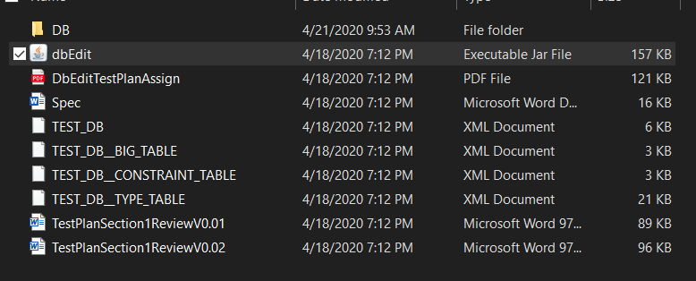>
Figure 2a

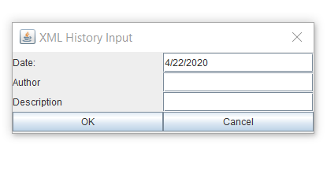Figure 3a
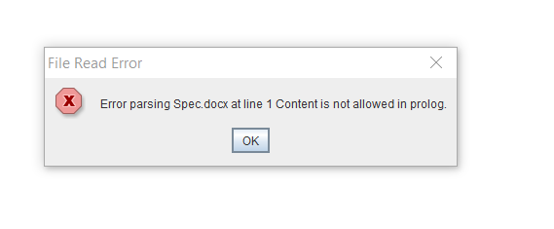
Figure 4a 