Database Proposal: Car Hub

**Team Members**

* Anshul Mistry
* Chetana Nirmal
* Atharva Kulkarni
* Tushar Batla

# **User**

The User collection will contain all the registered users. Within each document, it will contain information describing the first name, last name login id, password, phone number, age, and address of the users. The user collection also stores the registered cars of each user. Cars are the sub-collection of the users and will be updated accordingly as more cars are registered by the user.

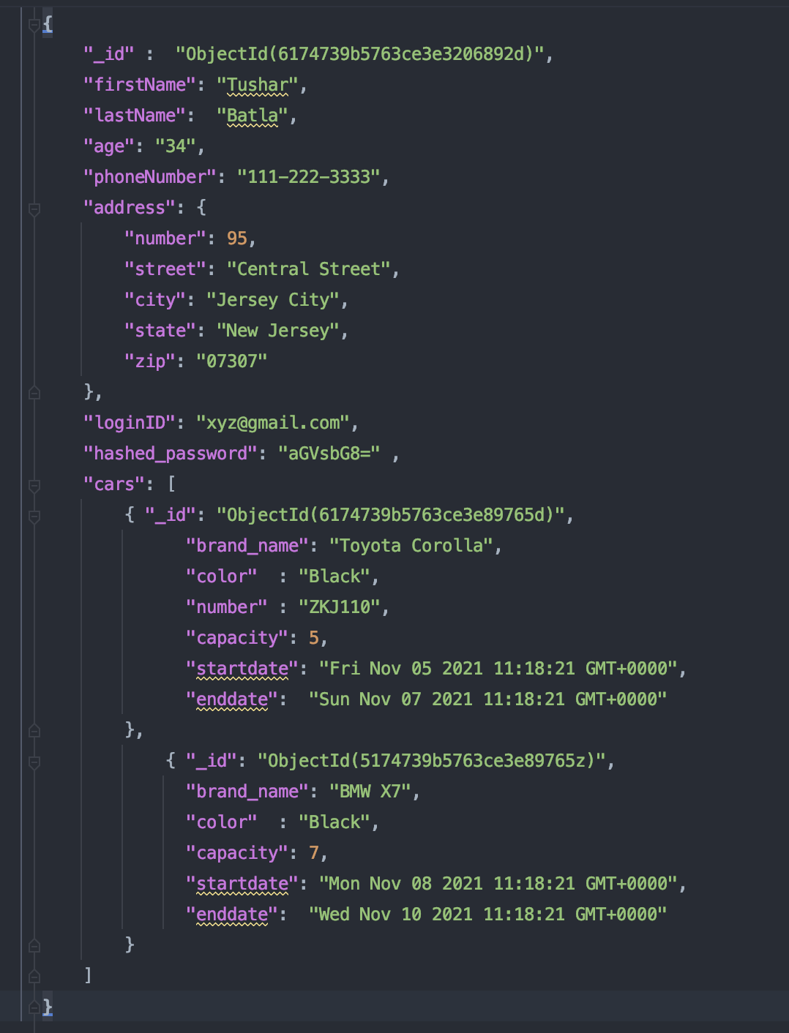

|  |  |  |
| --- | --- | --- |
| **Name** | **Type** | **Description** |
| _id | ObjectId | Globally unique identifier to represent the user |
| firstName | String | First Name of the user |
| lastName | String | Last Name of the user |
| age | Number | Age of the user |
| phoneNumber | Number | Phone Number of the user |
| address | Object | Address of the user |
| loginID | Number | Login ID or email id of the user |
| hashed_password | Number | Password of the user (Encrypted password) |
| cars | Array | List of cars that are registered for this user |

**Cars**

Cars are the sub-collection of the users and will be updated accordingly as more cars are registered by the user.

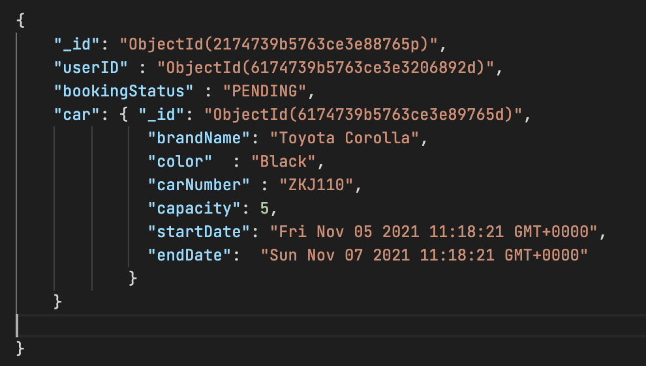

|  |  |  |
| --- | --- | --- |
| **Name** | **Type** | **Description** |
| _id | ObjectId | A global unique identifier to represent a car |
| brand_name | string | Brand name of the car |
| color | string | Color of the car |
| number | string | Number of the car |
| capacity | number | Capacity of the car |
| startdate | time | Startdate of the booking |
| enddate | time | Enddate of the booking |

**Booking**

Booking collection stores all the user bookings. A user can book the car and the data related to the booking gets stored in this collection. The booking collection stores the user id, status of the booking and car details.

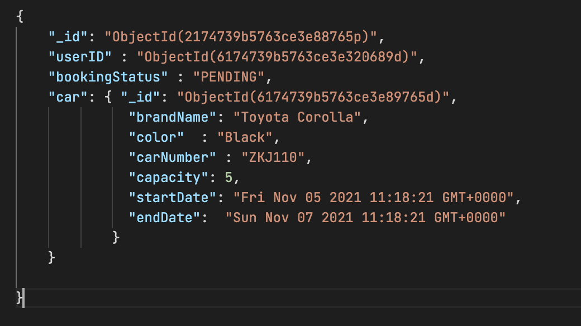

|  |  |  |
| --- | --- | --- |
| **Name** | **Type** | **Description** |
| _id | ObjectId | A globally unique identifier to represent the booking |
| userID | string | Unique identifier representing the user associated with the car booking |
| bookingStatus | string | Status of the booking (approved, pending, rejected) |
| car | Object | Car associated with booking |