Sensor based Mobile Games for Healthy Life

A sensor based mobile application which uses machine learning to detect their movements and gives appropriate recommendation to users on their calorie intake and energy burnt while using the mobile application.

Malathy Krishnan

Prakash Vakka Reddy

**Sensor Based Mobile Games for Healthy Life**

**Iteration I**

**Summary:**

For 1st Iteration, analyzed the accelerometer data completely to identify different actions and to select the features appropriately to identify the actions. Feature extraction is one of the important criteria for machine learning. Decided on four features which will identify different actions. Created the login and registration page in android to get user details.

1. **Framework Specification**
2. **Android Front end:**

Developed a front end android application which gets the user details and saves it in a file with user id, name, age, health, weight, etc. This details will be used for calculating the calories burnt while report generation and recommendation.

* **System Architecture Diagram**

Android Application

Solr

Details stored in files

**Application**

* **Data Sources**

Data collected from user through the android application.

* **Design of Mobile Client**

The application has a login and registration page. It collects the details and saves in a file.

* **Features, Styles, Technologies, GUI**

Android, Java, Intents

**Implementation**

**Current implementation:**

The front end application is developed and the file is saved locally.

**Next Increment:**

Need to connect the android application to Solr and save the files in Solr.

1. **Feature Extraction:**

**System Architecture Diagram**

Raw Data

Filter Data

Extract the features

**Domain Model**

* **Data Sources**

Data collected from the sensor. Data has the timestamp, x, y, z values.

* **Methodologies and Algorithms**

Collected the data and analyzed them to recognize patterns. Used Weka and tried different Classifier and Cluster algorithms to find which algorithm is more suitable.

* **Analytic Tools**

Weka to Visualise, Excel to plot the data, generate a graph and analyses the data.

* **Analytical Tasks**

To find the required features to detect the motions.

**Application**

Below are the features selected for detecting different actions.

**Features selected:**

1. **Number of peaks in the action**
2. **Distance travelled by the action**
3. **Sum of the Magnitude of the vector(Vector Normalization)**
4. **Time interval for an action**

**Activity Diagram :**



**Service Specification**

* Operational description, Input/output for services

Retrieves the data from the mobile. Input is the raw data and output is the set of features.

* Implementation

Number of peaks: see the previous value is lesser or greater than the current value, detect a peak.

Distance travelled formula (ut+ ½(at2)), where u is initial velocity which is 0.

Sum of norms (SQRT(x2+y2+z2)

Time interval between the start and end values.

* Algorithms

Wrote a Java class to filter the data ad extract the feature.

**Documentation:**

Android , login pages and registration pages

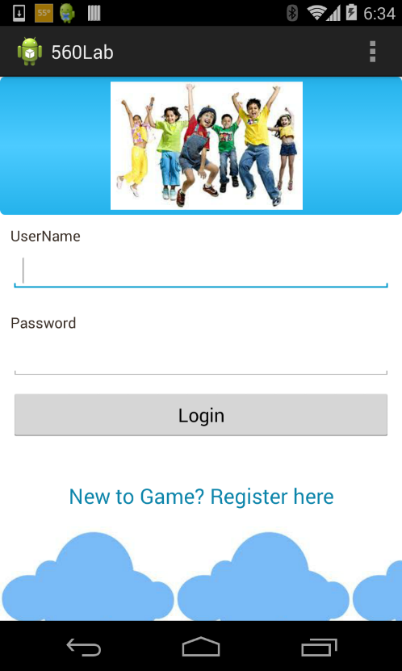 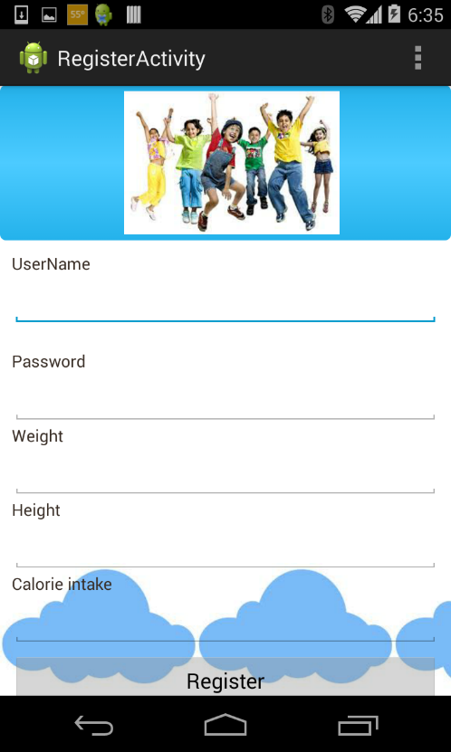

Features of stomp:

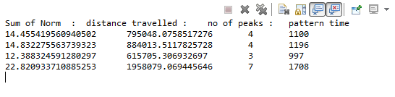

Features of Circle:

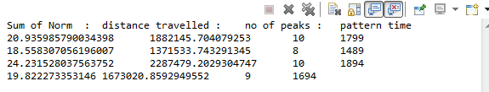

**Project Management:**

Scrum do link:

<https://www.scrumdo.com/projects/project/kdm-project/iteration/92269>

Github link:

<https://github.com/CS560KDM/CS560-Project>

**Schedule for the current increment**

Stories (features): Scenario & Use case specification template

Android application front end development

Feature Extraction

**Project Timelines, Members, Task Responsibility**

Implementation status report

* Work completed:

1. Description

Feature extraction and Analysis of data is done. Found 4 features which uniquely identifies different actions.

1. Responsibility (Task, Person)

Data Analysis -- Malathy

Android front pages – Prakash

Feature selection and Extraction – Prakash and Malathy

1. Time taken (#hours)

Data Analysis and Feature selection required lot of research on pattern recognition.

1 week for the data analysis research (25 hours)

1 week for the development phase (20 hours)

1. Contributions (members/percentage)

Malathy - 50%

Prakash - 50%

* Work to be completed
  + Description

Decide a Classification Algorithm and train the model with the training data set and test it using testing data set.

Analyze the data by sending it to the modeler and check for accuracy.

Connect to Solr and retrieve results.

* + Responsibility (Task, Person)

Connection from mobile to Solr – Prakash

Algorithm analysis and training data – Malathy