Sensor based Mobile Games for Healthy Life

A sensor based mobile application which uses machine learning to detect their movements and gives appropriate recommendation to users on their calorie intake and energy burnt while using the mobile application.

Malathy Krishnan

Prakash Vakka Reddy

**Sensor Based Mobile Games for Healthy Life**

**Iteration II**

**Summary:**

For 2st Iteration, analyzed the accelerometer data completely to identify different actions and to select the features appropriately to identify the actions. Training the data is an important process. Recognized different actions and created a training set. Created a classification model using a classification algorithm with the Training dataset. Tested the data to find if the classification algorithm finds the correct result.

1. **Framework Specification**
2. **Training Data:**

Analyzed different actions which the Filtering algorithm differentiates and created a set of training data. Training data contains all 4 features of the action , along with the action name.

* **System Architecture Diagram**

Raw Data

Training Data-Set

Analyzing Action

**Application**

* **Data Sources**

Data collected from the sensor devices through Data Collection Program.

* **Design of Program**

Detects the sensor and retrieves the x,y,z values from the sensor tag which there is an action.

* **Features, Styles, Technologies, GUI**

Java, Sensor Tag

**Implementation**

One program collects the data from sensor, which is fed as input to the filtering program which extracts 4 features for each action. Each action is given a class name to formulate the training dataset.

1. **Classification Algorithm:**

**System Architecture Diagram**

Raw Data

Classification

Finds Action

**Domain Model**

* **Data Sources**

Data from the sensor tags via mobile devices.

* **Methodologies and Algorithms**

Collected the data and analyzed them to recognize patterns.

* **Analytic Tools**

Weka to Visualise, Excel to plot the data, generate a graph and analyses the data.

* **Analytical Tasks**

To find the required features to detect the motions.

**Application**

Below are the features selected for detecting different actions.

**Features selected:**

1. **Number of peaks in the action**
2. **Distance travelled by the action**
3. **Sum of the Magnitude of the vector(Vector Normalization)**
4. **Time interval for an action**

**Diagram:**

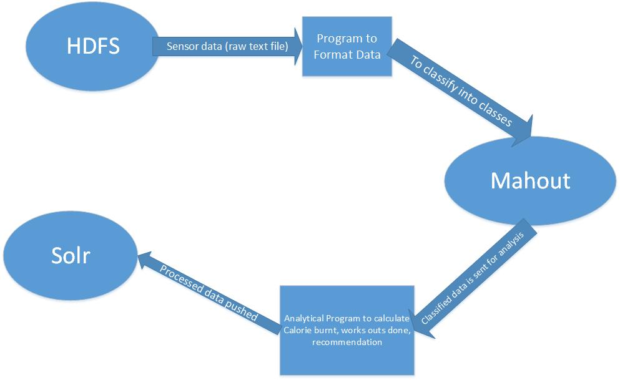

**Service Specification**

* Operational description, Input/output for services

Retrieves the data from the mobile. Input is the raw data ,intermediate is the set of features and the output is to find the action.

* Implementation

Takes the following features for each action:

Number of peaks: see the previous value is lesser or greater than the current value, detect a peak.

Distance travelled formula (ut+ ½(at2)), where u is initial velocity which is 0.

Sum of norms (SQRT(x2+y2+z2)

Time interval between the start and end values.

* Algorithms

Classification Algorithm uses the training data to create a model and then finds the actions of all the movements from the sensor .

Features of stomp:

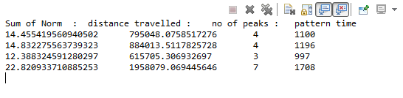

Features of Circle:

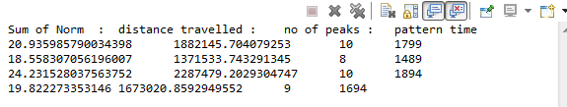

**Project Management:**

Scrum do link:

<https://www.scrumdo.com/projects/project/kdm-project/iteration/92270>

Github link:

<https://github.com/CS560KDM/CS560-Project>

**Schedule for the current increment**

Stories (features): Scenario & Use case specification template

Training Data

Testing Data

Classification

**Project Timelines, Members, Task Responsibility**

Implementation status report

* Work completed:

1. Description

Formulating Training Dataset. Designing a model with the classification algorithm using the training data. Running Testdata samples.

1. Responsibility (Task, Person)

Training Data -- Malathy

Classification Algorithm – Prakash

Testing Data – Prakash and Malathy

1. Time taken (#hours)

Data Analysis and Feature selection required lot of research on pattern recognition.

1 week for the training data (25 hours)

1 week for the development phase (20 hours)

1. Contributions (members/percentage)

Malathy - 50%

Prakash - 50%

* Work to be completed
  + Description

Need to send the data and save it in Solr. Need to query Solr from mobile directly and retrieve the results for report.

* + Responsibility (Task, Person)

Connection from mobile to Solr – Prakash

Reporting the vales to user – Malathy