Sensor based Mobile Games for Healthy Life

A sensor based mobile application which uses machine learning to detect their movements and gives appropriate recommendation to users on their calorie intake and energy burnt while using the mobile application.

Malathy Krishnan

Prakash Vakka Reddy

**Sensor Based Mobile Games for Healthy Life**

**Iteration III**

**Summary:**

For 3rd Iteration, completed the android application which has the registration page to capture user data and save that to SOLR, and login the user into system, based on the username and password saved in SOLR, give the user a game selection page for the user to select different games that he/she want to play, give the user a report/recommendation page where the user can see his history of activities and recommendations based on his activities and profile.

1. **Framework Specification**
2. **Training Data:**

Analyzed different actions which the Filtering algorithm differentiates and created a set of training data. Training data contains all 4 features of the action , along with the action name.

* **System Architecture Diagram**

Raw Data

Training Data-Set

Analyzing Action

**Application**

* **Data Sources**

Data collected from the sensor devices through Data Collection Program.

* **Design of Program**

Detects the sensor and retrieves the x,y,z values from the sensor tag which there is an action.

* **Features, Styles, Technologies, GUI**

Java, Sensor Tag

**Implementation**

The user is shown with a login page when he launches the game, and a registration link in the login page. If the user does not have login details he/she can register for login details, he/she needs to give their personal details or profile to get registered. We have selected, age, gender, height, weight, and calories burnt as the main data with which can provide the recommendations to the users.

The registration page collects the user data and uses the existing SOLR web service to push the data to SOLR database, when the user tries to login again it get the details for SOLR about the user login to verify the password for letting the user login to user the app. This is for handling the login page. Now comes the recommendation and report pages. The report page in the application would show all the different actions that the user has performed using the classification algorithms as done in iteration 2. The recommendation implemented are calculated using the BMR calculations and HBE calculations explained in the below link.

<http://www.bmi-calculator.net/>

The user is shown with different recommendations based on the HBE calculated based on the user BMR and activities. The sensor data from the game is collected in the mobile and save in a file.

1. **Classification Algorithm:**

**System Architecture Diagram**

Raw Data

Classification

Finds Action

**Domain Model**

* **Data Sources**

Data from the sensor tags via mobile devices.

* **Methodologies and Algorithms**

Calculated the recommendations based on the reports and activities.

* **Analytic Tools**

Weka to Visualise, Excel to plot the data, generate a graph and analyses the data.

* **Analytical Tasks**

To figure out different actions and activities and try to figure out the recommendations based on these activities and user profiles.

**Application**

Below are the features selected for detecting different actions.

**Features selected:**

1. **Number of peaks in the action**
2. **Distance travelled by the action**
3. **Sum of the Magnitude of the vector(Vector Normalization)**
4. **Time interval for an action**

**Diagram:**

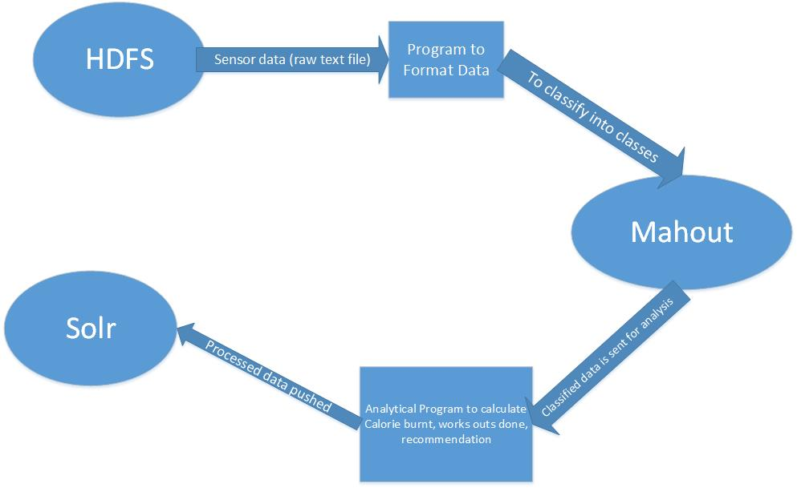

**Service Specification**

* Operational description, Input/output for services

Retrieves the data from the mobile. Input is the raw zdata, intermediate is the set of features and the output is to find the action.

* Implementation

Takes the following features for each action:

Number of peaks: see the previous value is lesser or greater than the current value, detect a peak.

Distance travelled formula (ut+ ½(at2)), where u is initial velocity which is 0.

Sum of norms (SQRT(x2+y2+z2)

Time interval between the start and end values.

* Algorithms

Classification Algorithm uses the training data to create a model and then finds the actions of all the movements from the sensor.

Recommendations based on the user activities and user profiles.

Features of stomp:

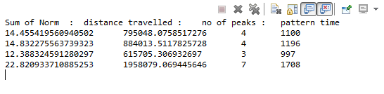

Features of Circle:

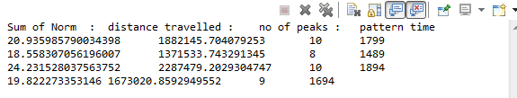

**Screen shots:**

Different types of workout:

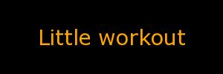 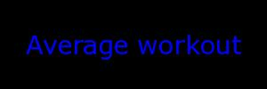  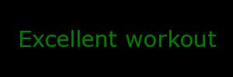

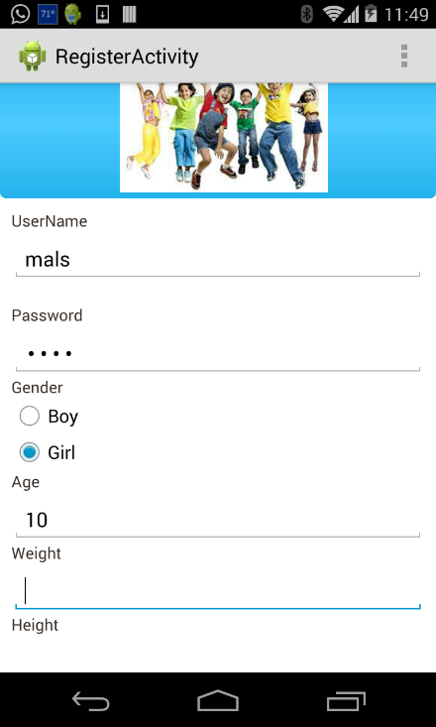

**Registration page with SQLite Database:**

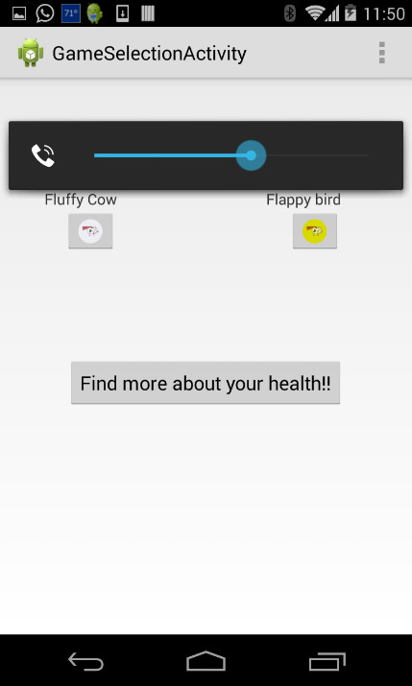

**Selection of games activity:**

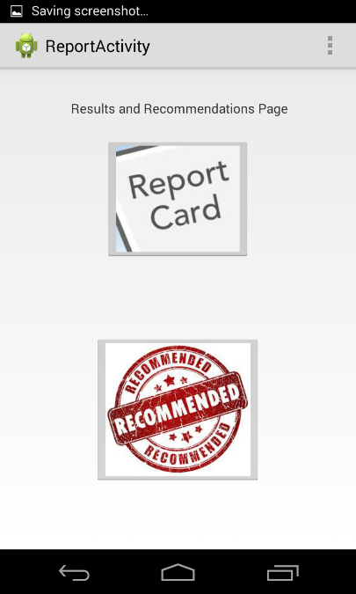

**Repot and Recommendation page:**

**The report page, which gives the user all his details, calculated the BMR and Calories burnt, depending on the activity.**

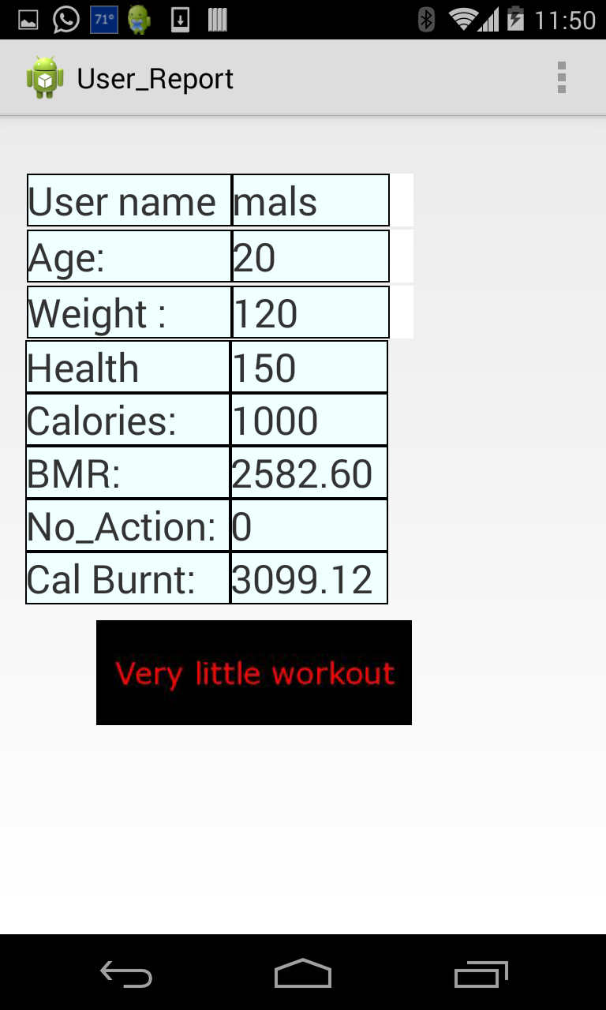

**Formulas:**

Basal Metabolic Rate:

**Women**: BMR = 655 + ( 4.35 x weight in pounds ) + ( 4.7 x height in inches ) - ( 4.7 x age in years )  
**Men**: BMR = 66 + ( 6.23 x weight in pounds ) + ( 12.7 x height in inches ) - ( 6.8 x age in year )

**Harris Benedict Formula to calculate Calories burnt:**

* If you are sedentary (little or no exercise 🡺 <20 actions) : Calorie-Calculation = BMR x 1.2
* If you are lightly active (light exercise/sports 1-3 days/week 🡺 20 -50 actions) : Calorie-Calculation = BMR x 1.375
* If you are moderatetely active (moderate exercise/sports 3-5 days/week 🡺 50 – 90 actions) : Calorie-Calculation = BMR x 1.55
* If you are very active (hard exercise/sports 6-7 days a week 🡺 90 – 150 ctions) : Calorie-Calculation = BMR x 1.725
* If you are extra active (very hard exercise/sports & physical job or 2x training 🡺 >150 action) : Calorie-Calculation = BMR x 1.9

**Project Management:**

Scrum do link:

<https://www.scrumdo.com/projects/project/kdm-project/iteration/92270>

Github link:

<https://github.com/CS560KDM/CS560-Project>

**Schedule for the current increment**

Stories (features): Scenario & Use case specification template

User registrations

User Login

Game integration in App

Recommendations to user

Report of the past activities

**Project Timelines, Members, Task Responsibility**

Implementation status report

* Work completed:

1. Description

Creating a registration and login page which helps and collects user data, reports and recommends the user for the activities should do.

1. Responsibility (Task, Person)

Registration page -- Malathy

Pushing the data to SOLR – Prakash

Report and recommendations pages – Prakash and Malathy

1. Time taken (#hours)

Registration page and DataBase (10 hours)

Game – Identify actions (20 hours)

Report and recommendations (20 hours)

1. Contributions (members/percentage)

Malathy - 50%

Prakash - 50%

* Work to be completed
  + Description

Currently the game works for stomps, but out plan is to show that we can have different games that could be launched from the same game launch activity, the next step would be to set the game with some other motion other than stomp and push that to game selection activity for the user to select that particular game.

* + Responsibility (Task, Person)

Detect different action – Prakash

Fine tune the game logic and recommendations– Malathy