Sensor based Mobile Games for Healthy Life

A sensor based mobile application which uses machine learning to detect their movements and gives appropriate recommendation to users on their calorie intake and energy burnt while using the mobile application.

Malathy Krishnan

Prakash Reddy Vaka

**Sensor Based Mobile Games for Healthy Life**

**Motivation:**

Below are 3 facts about obesity among adults.

1. More than one-third of U.S. adults (34.9%) are obese.
2. Obesity-related conditions include heart disease, stroke, type 2 diabetes and certain types of cancer, some of the leading causes of preventable death.
3. The estimated annual medical cost of obesity in the U.S. was $147 billion in 2008 U.S. dollars; the medical costs for people who are obese were $1,429 higher than those of normal weight.

Some facts about obesity among children.

1. Obesity now affects 17% of all children and adolescents in the United States - triple the rate from just one generation ago.
2. **Lack of daily, quality physical activity in all schools, and the fact that,** in 2009 only 33% attended daily physical education classes.

Our project will take us one step closer to help people overcome obesity and making the process fun for children and adults.

**Idea:**

We found that more than 58% of Americans play video games, and this percentage is alarmingly more in case of children. And there are an average of TWO GAMERS in each game-playing U.S. household. And 43% of them play games on their smartphone. 71% of the parents believe games provide mental stimulation or education. We wanted to take advantage of the fact that more parents wants their kids to play video games but want them to have some physical activity as well, during the process.

Our main goal for the project is to develop a portable game which can be played any time they want and even give them some physical workout. So we choose smartphone as out easiest option, and choose android as the operating platform, since we believe it is the emerging OS in the market. To make the children do some physical activity we had to choose a device which could make them do some physical activity, we found the *Sensor Tag* from Texas instruments which is easily portable and has a lot of sensors which could be used for wide range of games and is available at a very low cost compared to other sensor devices.

We found that more physical activity is done in moving the lower body than that of the upper body, so the simple idea is to make an interactive game with leg movements. We developed made changes to the existing android game “Fluffy Cow” and open source version and tweaked it to work with Sensor Tag. This helped us to achieve what we planned easily.

Saving the data for reports and recommendations to the user (parent/child) was one more task ahead of us. To achieve this we saved the sensor data in to the server with the help of a restful web service using post method and get methods when necessary. Using the machine learning techniques learned in class CS560, we designed a classifier which could predict different actions from the sensor data that is being collected. We have found 5 different features which help us to categorize different actions. Each user will have a unique file save in the server with his sensor data, which would be analyzed by the classifier and the results are saved to SOLR.

We designed an android application which would register the user with his/her profile, taking AGE, Height, Weight, Calorie intake , Age and Name as main fields. We analyses the data and give the user a report and recommendation page, where he/she can see his performance or workout and see the appropriate recommendations based on his/her workout. Calorie calculations are not accurate enough since exact calorie burnt can be calculate only based on the oxygen intake, the report give an estimate of calorie burnt based on the formulae at [BMR](http://www.bmi-calculator.net/bmr-calculator/%20).

**Benefits:**

Below are some of the benefits of our projects.

1. Give parents an estimate of workout being done by their children and the capability to monitor the time they spent playing the game.
2. Help users reduce obesity and increasing their physical activity.
3. Workout on the go.
4. Easy to carry (compact and light weight).
5. Can be integrated with wide variety of games.

**Target users:**

1. Kids
2. Adults

**Requirements:**

1. Smart phone with Bluetooth low energy 4.0 enabled
2. Sensor Tag from Texas Inc
3. Pouch to carry to connect sensor tag to your leg.

**Implementation**

**System Architecture:**

**Use Case diagram:**

**Class Diagram:**

**Activity Diagram:**



**Task 1:**

Connecting Sensor Tag to smart phone.

We wanted to make the process of connecting the sensor tag to smartphone seamless, without the need of user to search and connect the devices, so we made this automatic and we want the user to start his sensor tag before launching the game. We developed a [service](http://developer.android.com/guide/components/services.html) which would connect to sensor tag and detect stomps and sends broadcasts to all activities. All activities listening to this broadcast can hear this intent and the data saved in this intent.

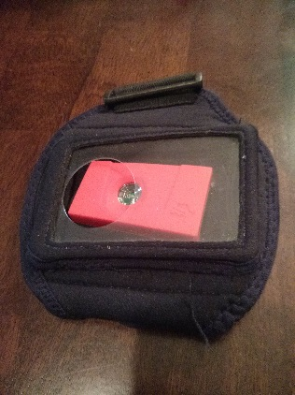 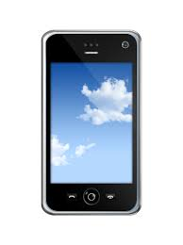

Sensor data collected automatically

**Task 2:**

Building android based Game

We took already working and easy to modify Fluffy Cow game from github and integrated the above developed service into the game, for it to work with stomps instead of touch screen. This game when played with the sensor tag connected to your leg proved to be a real workout, when you play for more than 15 minutes (based on our experience).

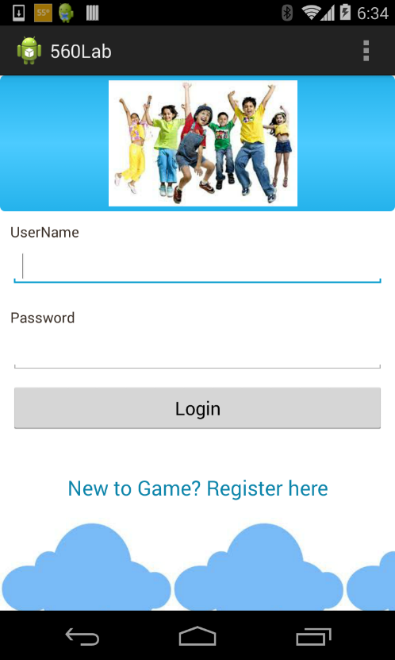 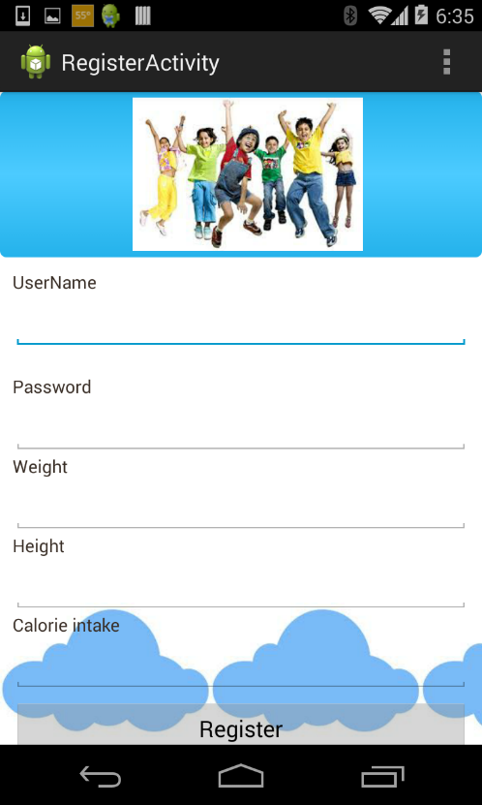

**Task 3:**

Saving sensor data to server

We had to save this sensor data into a server, since we wanted to use this sensor data again and to detect any other action other than stomp during the motion and calculate the report and recommendations based on the data. We developed a web service using Restful API which could receive data and store it in a file in the server with the username. We call this web service when we see the data for any user is more than 200Kb, after sending the file to server we empty the previous file and start a new data load into the file. We developed one more web service to send the username to the server to save the sensor data with the file name.

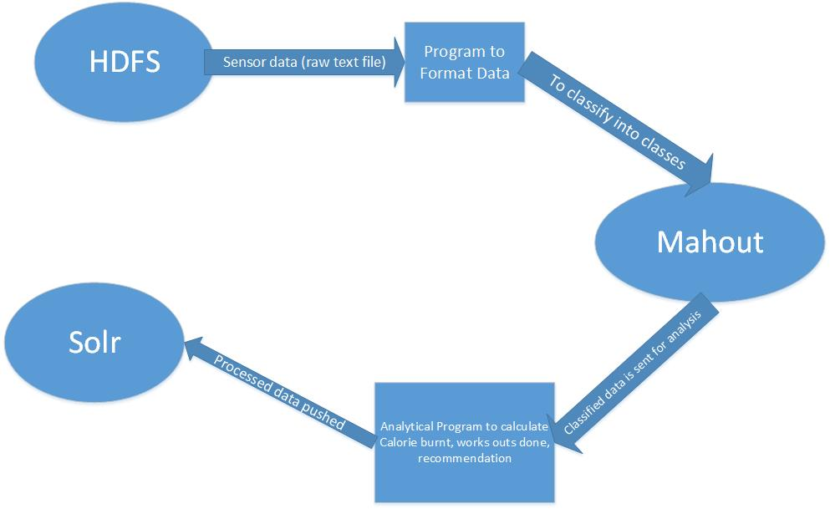

**Task 4:**

Machine learning on sensor data

Before analyzing the new data, we prepared the required model and lableindex with the training data which is already collected based on the features we designed. We use Naïve Bayes Classifier to predict new motions based on the model and labelindex. We run the classifier on the saved data to detect different motions and count them and push the data to SOLR.

Features selected:

1. Number of peaks in the action
2. Distance travelled by the action
3. Sum of the Magnitude of the vector(Vector Normalization)
4. Time interval for an action

Features of Stomp:

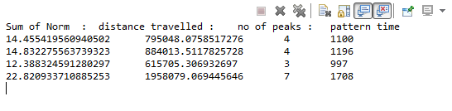

Features of Circle:

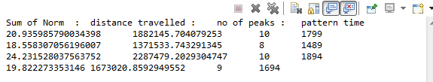

**Task 5:**

Retrieve results from SOLR

SOLR has an inbuilt restful web service which could be used to retrieve data from it. Using the inbuilt service we retrieved the data and showed that in out android application for report and showed recommendations based on the result from the report.

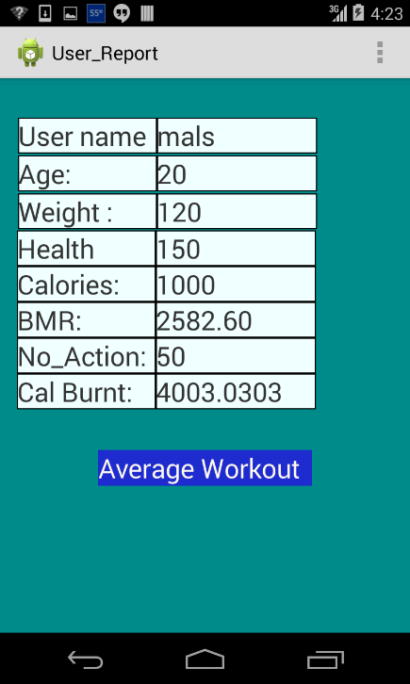 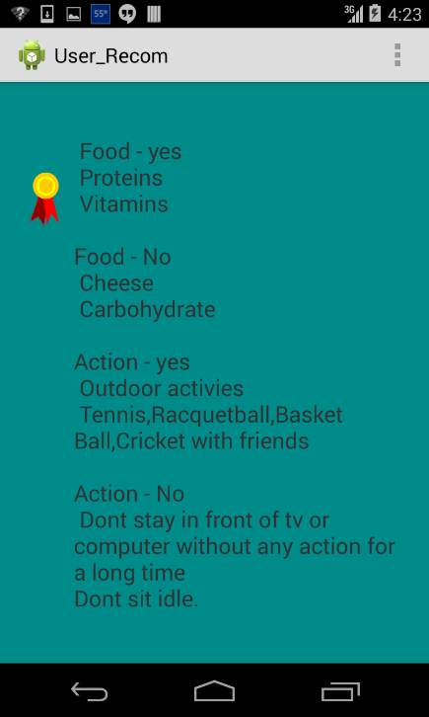

**Domain Model**

* **Data Sources**

Data collected from the sensor. Data has the timestamp, x, y, z values.

The user details are also collected like name, age, weight, height, calorie intake to calculate the calories burnt,BMR, etc.

* **Methodologies and Algorithms**

Classifier Algorithm, Naïve Bayers classifer algorithm to predict and classify the data to respective motions.

* **Analytic Tools**

Weka, R, Mahout, Excel to plot the data, generate a graph and analyses the data.

* **Features, Styles, Technologies, GUI**

Java, Sensor Tag, HDFS, MapReduce, Solr, Android, RESTful web services.

**Project Management:**

Scrum do link:

<https://www.scrumdo.com/projects/project/kdm-project/iteration/92270>

Github link:

<https://github.com/CS560KDM/CS560-Project>

Youtube link:

**Schedule for the task:**

Stories (features):

Sensor and Mobile connection

Android application

Machine learning

Web services

Solr connectivity

Android game

**Project Timelines, Members, Task Responsibility**

Implementation status report

* Work completed:

1. Description

Work for all the user stories.

1. Responsibility (Task, Person)

Sensor and Mobile connection – Prakash

Android Application – Malathy

Machine learning – Malathy

Web services – Prakash

Solr connectivity - Malathy

Android game - Prakash

1. Time taken (#hours)

Sensor and Mobile connection – 50 hours

Android Application – 45 hours

Machine learning – 70 hours

Web services – 30 hours

Solr connectivity – 15 hours

Android game - 50 hours

1. Contributions (members/percentage)

Malathy - 50%

Prakash - 50%

**References**:

jama.jamanetwork.com/article.aspx?articleid=1832542  - Obesity data

http://www.nhlbi.nih.gov/guidelines/obesity/ob_gdlns.htm - diseases based on obesity

http://content.healthaffairs.org/content/28/5/w822.full.pdf+html  - cost of health

http://www.health.gov/paguidelines/  - child health

http://www.cdc.gov/obesity/childhood/problem.html - obesity in general

http://www.theesa.com/facts/pdfs/esa_ef_2013.pdf - Game players data

<http://pecactivegaming.blogspot.com/2010/11/active-gaming-kinecting-traditional-and.html> - images

<http://www.bookishbookshop.com/are-mobile-phones-necessary/> - images