Jeffrey Lanning

Brandon Andrews

Group 6 - Lab 7

For this lab, we used Collaborative filtering to predict the next crime that would occur in the Kansas City area based off user severity rating. Our data set consists of a location identifier, which are integer representations of locations in the KC area, crime identifier, which is an identifier of the type of crime, such as burglary, theft, car break-in, etc. and the severity rating of the crime from user ratings. We then use this information to predict what types of crimes would occur in the future. We calculated the Expected Mean Value to predict the validity of our model.

1. We first loaded the crime data from our CSV file.
2. We built our recommendation system using ALS
3. We then evaluated the model based off rating data
4. Finally, we calculated the mean squared error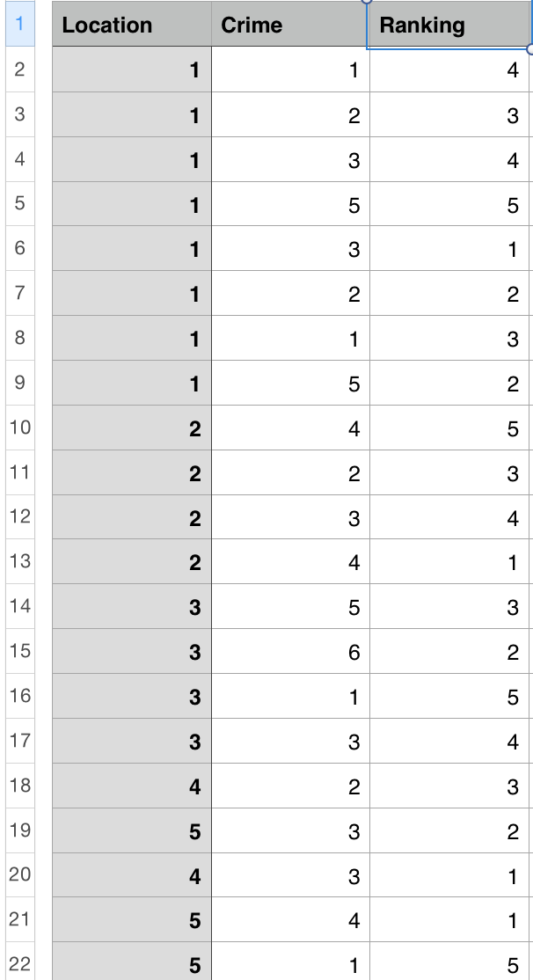

Crime data CSV

Collaborate Filtering/Mean Squared Error results: