SensorWrite

# Increment 1

Group 7: James Clark, Anthony Sommer, Saitejasree Ramala, and James Wehmueller

CS 590BD: Big Data Analytics

Dr. Yugyung Lee

June 20, 2014

University of Missouri - Kansas City

# 

# 

# App Innovation - Possible Project Ideas

## ! Proposed: SensorWrite BLE

- convert human gesture to printed text with a ti sensortag

- classify accelerometer data with R

- map accelerometer data to a corresponding keyboard character

## Alternative: Weather GPS Accelerometer

- visualize travel routes, acceleration data, and gps coordinates on a map

- capture additional barometric and humidity data

- periodically consolidate with weather web service

- mapreduce sensor readings to hbase

- gather test data from gps routes captured on foot, on bicycle, and driving an automobile

*In this app there may be local storage constraints on the android device. We will occasionally need to check the available storage space and make a decision as to when data needs to be moved across the network and off the android device.*

## Wizard Card Game: Branch from SensorWrite BLE

- a turn-based strategy card game

- use two ti sensortags and one android device

- measure accelerometer, gyroscope, and infrared temperature

- map human gesture and temperature reading to corresponding game cards

- develop game logic around card combinations

- mapreduce and store history of games played per device

## Multiplayer Game Server: Branch from Wizard Card Game

- introduce real-time element to turn-based game

- build a back-end game logic engine

- support a one to many ti sensor per device network of games

- get as many ti sensors as possible from classmates and test the game server

- register new user and device pairs for competitive environment

- map reduce games played to hbase

- store cards per player

- unlock new cards by completing achievements

- display card deck to user

## 

## 

## Total Sensors Possible: 7

- ti sensor simple click

- ti sensor accelerometer

- ti sensor gyroscope

- ti sensor infrared temperature

- ti sensor humidity

- ti sensor pressure

- android gps

## Total Data Processed: to be determined

- hbase

- hdfs

- local android files

# Project Goal and Objectives

Capture and classify exaggerated handwriting motion in 3D space using incremental accelerometer data from a Texas Instruments CC2541 SensorTag. Translate gestures to plain text in an Android device.

## Motivation

Converting human gestures to printable text helps children to learn the letters faster as kids move their hands in air. This not only helps in exercising but also provides an easy way of learning for kids.

## Significance

This application will allow users to input text data without having to actually touch any surface. A user could write while facing any direction and putting their hand anywhere, allowing them more freedom of motion.

## Objectives

This system should recognize all letters of the alphabet, including punctuation. It should be highly accurate while also recognizing letters from all users.

## System Features

-Recognizes all letters

-Allows for punctuation

-Users can easily create sentences

# Activity Recognition Scenario and Data Collection

## Devices

### TI CC2541 SensorTag

current firmware version 1.4

upgradeable to firmware version 1.5

connects to minimum version of bluetooth 4.0 on android 4.3

source code available - <http://www.ti.com/tool/sensortag-sw>

### Android

Model number Nexus 5

Android version 4.4.3

Bluetooth v4.0 with A2DP

Full specs: https://support.google.com/nexus/answer/3467463?hl=en

**Sensors**

**TI CC2541 SensorTag**

Accelerometer

Gyroscope

IR temperature Sensor

Humidity Sensor

Pressure Sensor

### Android

GPS

Accelerometer

Gyroscope

Proximity / Ambient Light

Compass

Pressure

## Data Collection

It will be necessary to “teach” our application by doing a number of inputs ourselves.

## Motion/Activity Model

We will normalize the data in 3D space so that it doesn’t matter how the device is oriented. This will involve taking the orientation data to figure out how the device had changed since it was initiated, and modify the acceleration data accordingly.

## Analytical Tasks

We will use machine learning algorithms to teach our application which motions correspond to which letter or “wand” movement.

# Design of Mobile Client

## Features, Styles, Technologies, GUI

### Features

- Identify different alphabets

- provides punctuation marks

- users can generate sentences easily

### Styles

We will use a sleek and modern design to give the impression that our application is at the cutting edge of modern technological capabilities.

### Technologies

-TI CC2541 Sensor Tag

-Nexus 5 Android Mobile

### GUI

The GUI on the Android device will allow the user to connect to the device. Once they are connected, they can select an option to start writing. There will also be a “machine learning” mode that allows the user to further teach the application to be more accurate.

# Related Work

## Projects done by others (include the URLs in Bibliography)

The official TI SensorTag app [Download app](http://itunes.apple.com/app/ti-ble-sensortag/id552918064?l=nb&mt=8)

MyWeatherCenter - Your personal weather station [Download app](https://itunes.apple.com/de/app/my-weather-center/id824900305?ls=1&mt=8) [Website](http://www.myweathercenter.net)

Sensirion Confort Guide [Download app](http://itunes.apple.com/us/app/comfort-guide-sensible/id515236285?mt=8)

Byteworks SensorTag app built using techBASIC [Download app](http://itunes.apple.com/us/app/sensortag/id579408063?mt=8)

Weight Training-Genie [Download app](http://itunes.apple.com/us/app/weight-training-genie/id650541393?mt=8)

Gammapoint Weather Run - Bike, Walk, Hike Tracker [Download app](http://itunes.apple.com/us/app/weather-run-bike-walk-hike/id599397919?mt=8)

<https://play.google.com/store/apps/details?id=com.ti.ble.sensortag>

<https://play.google.com/store/apps/details?id=si.mobili.senseview>

<https://play.google.com/store/apps/details?id=sample.ble.sensortag>

<https://play.google.com/store/apps/details?id=ti.android.ble.sensortagTHR>

<https://play.google.com/store/apps/details?id=com.togosoft.sensortag2>

<https://play.google.com/store/apps/details?id=ti.android.ble.devicemonitor>

# Project Planning with Scrumdo (optional)

mapreduce accelerometer data to hbase

classify accelerometer data with R

print classified characters as plain text

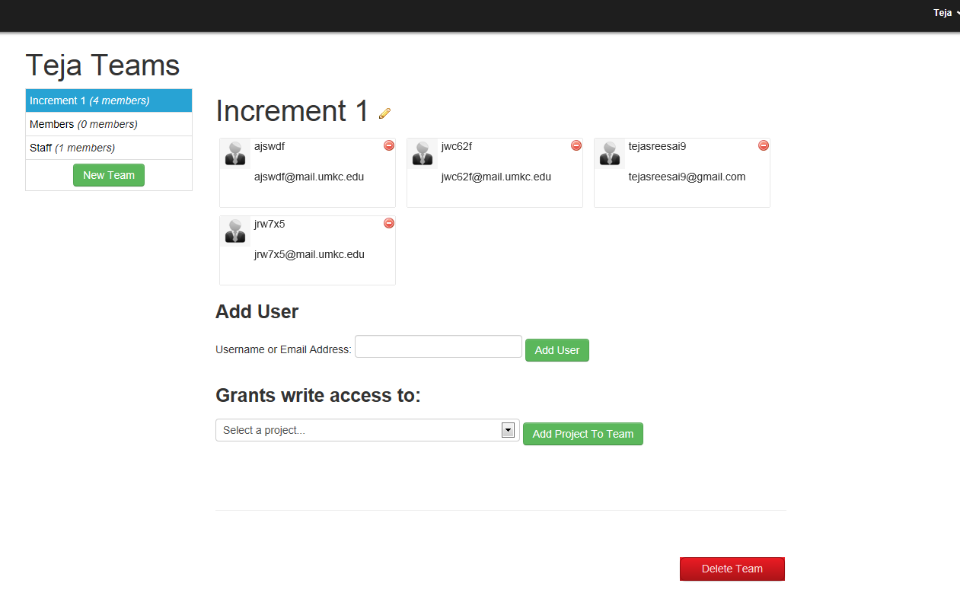

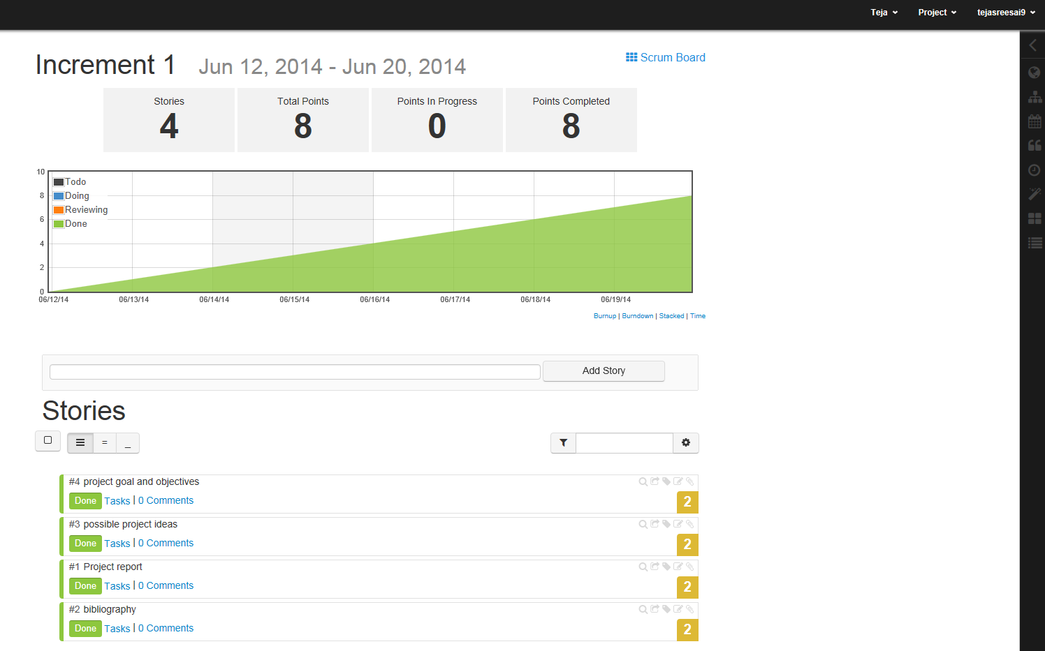

<https://www.scrumdo.com/projects/project/project70/iteration/103670>

# Bibliography

Official site for TI Sensor Tag application:

[http://www.google.com/url?q=http%3A%2F%2Fitunes.apple.com%2Fapp%2Fti-ble-sensortag%2Fid552918064%3Fl%3Dnb%26mt%3D8&sa=D&sntz=1&usg=AFQjCNFQIpdVgwASnbRRI_k_Km2hBfhc9A](http://itunes.apple.com/app/ti-ble-sensortag/id552918064?l=nb&mt=8)

MyWeatherCenter i.e. Your personal weather stationapplication:

[https://www.google.com/url?q=https%3A%2F%2Fitunes.apple.com%2Fde%2Fapp%2Fmy-weather-center%2Fid824900305%3Fls%3D1%26mt%3D8&sa=D&sntz=1&usg=AFQjCNEIRA4k22ddCXVOnxVMXHcgG2TUew](https://itunes.apple.com/de/app/my-weather-center/id824900305?ls=1&mt=8)

Sensirion Comfort Guide application:

[http://www.google.com/url?q=http%3A%2F%2Fitunes.apple.com%2Fus%2Fapp%2Fcomfort-guide-sensible%2Fid515236285%3Fmt%3D8&sa=D&sntz=1&usg=AFQjCNEq8rzng_6Sb3cl2oOuGvkFIOdvJA](http://itunes.apple.com/us/app/comfort-guide-sensible/id515236285?mt=8)

Byteworks SensorTag application which is built using techBASIC:

[http://www.google.com/url?q=http%3A%2F%2Fitunes.apple.com%2Fus%2Fapp%2Fsensortag%2Fid579408063%3Fmt%3D8&sa=D&sntz=1&usg=AFQjCNG4r92Cd-mV4nK0F8-xXjTO--Ga9Q](http://itunes.apple.com/us/app/sensortag/id579408063?mt=8)

Weight Training-Genieapplication:

[http://www.google.com/url?q=http%3A%2F%2Fitunes.apple.com%2Fus%2Fapp%2Fweight-training-genie%2Fid650541393%3Fmt%3D8&sa=D&sntz=1&usg=AFQjCNEK8IRBFPCghtYw_4lneInO9j09Qg](http://itunes.apple.com/us/app/weight-training-genie/id650541393?mt=8)

Weather Run - Cycling, Walk, Hike Tracker application:

[http://www.google.com/url?q=http%3A%2F%2Fitunes.apple.com%2Fus%2Fapp%2Fweather-run-bike-walk-hike%2Fid599397919%3Fmt%3D8&sa=D&sntz=1&usg=AFQjCNGNLjzTmRgS_MFYhAwuDnnvOU4VmA](http://itunes.apple.com/us/app/weather-run-bike-walk-hike/id599397919?mt=8)

[http://www.google.com/url?q=http%3A%2F%2Fitunes.apple.com%2Fus%2Fapp%2Fweight-training-genie%2Fid650541393%3Fmt%3D8&sa=D&sntz=1&usg=AFQjCNEK8IRBFPCghtYw_4lneInO9j09Qg](http://itunes.apple.com/us/app/weight-training-genie/id650541393?mt=8)

[http://www.google.com/url?q=http%3A%2F%2Fitunes.apple.com%2Fus%2Fapp%2Fweight-training-genie%2Fid650541393%3Fmt%3D8&sa=D&sntz=1&usg=AFQjCNEK8IRBFPCghtYw_4lneInO9j09Qg](http://itunes.apple.com/us/app/weight-training-genie/id650541393?mt=8)

[https://www.google.com/url?q=https%3A%2F%2Fplay.google.com%2Fstore%2Fapps%2Fdetails%3Fid%3Dti.android.ble.devicemonitor](https://play.google.com/store/apps/details?id=ti.android.ble.devicemonitor)