**CS673F14P4 Software Engineering** 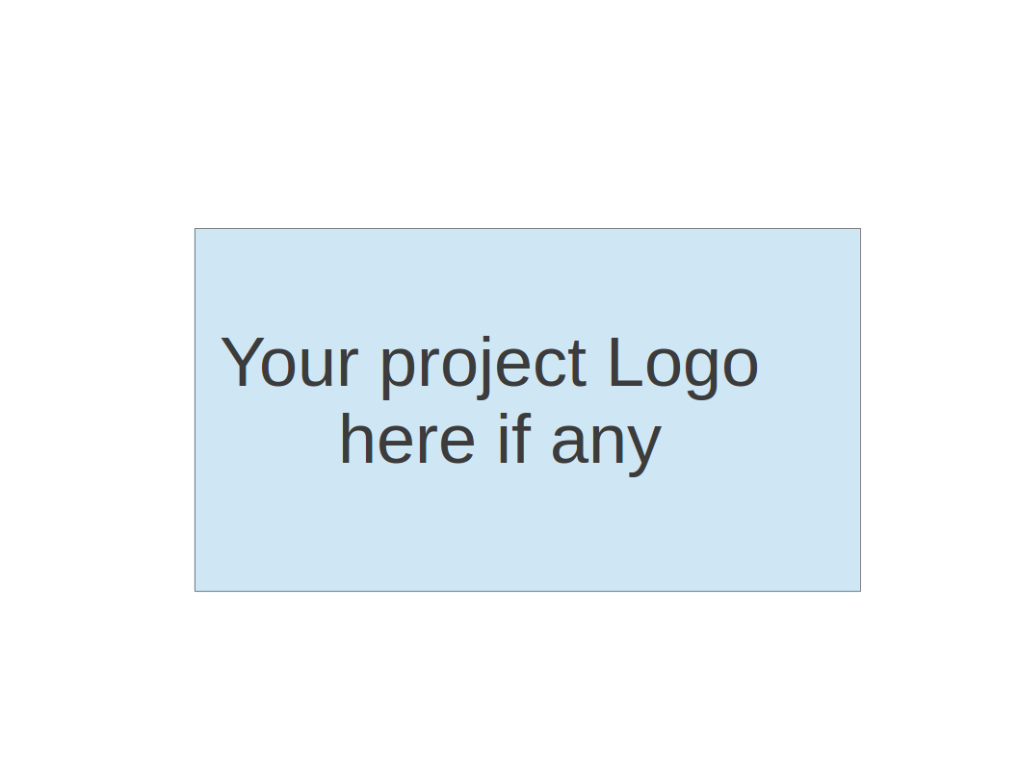

**Group 4 Project - ProManage**

**Software Design Document**

|  |  |  |  |
| --- | --- | --- | --- |
| Team Member | Role(s) | Signature | Date |
| Luis Marion | Project Leader | LM | 10/14/2014 |
| Daniel Abramowitz | Lead Designer | DA | 10/15/2014 |
|  |  |  |  |
|  |  |  |  |
|  |  |  |  |
|  |  |  |  |
|  |  |  |  |
|  |  |  |  |

**Revision history**

|  |  |  |  |
| --- | --- | --- | --- |
| **Version** | **Author** | **Date** | **Change** |
| 1 | Luis Marion | 10/14/2014 | Initial version |
|  |  |  |  |

Introduction

Software Architecture

Design Patterns

Key Algorithms

Classes and Methods

References

Glossary

# Introduction

ProMange is a web-application for managing and tracking Agile based software development projects. The application uses an HTML5/CSS based front-end in order to communicate with the server through AJAX restful service calls. The application enables users to create projects, invite members to projects, and create and assign stories and tasks to those members. The application is hosted on a Tomcat 7.0 server using a MySQL database for persistence. The application is built using Java (jdk1.6).

# Software Architecture

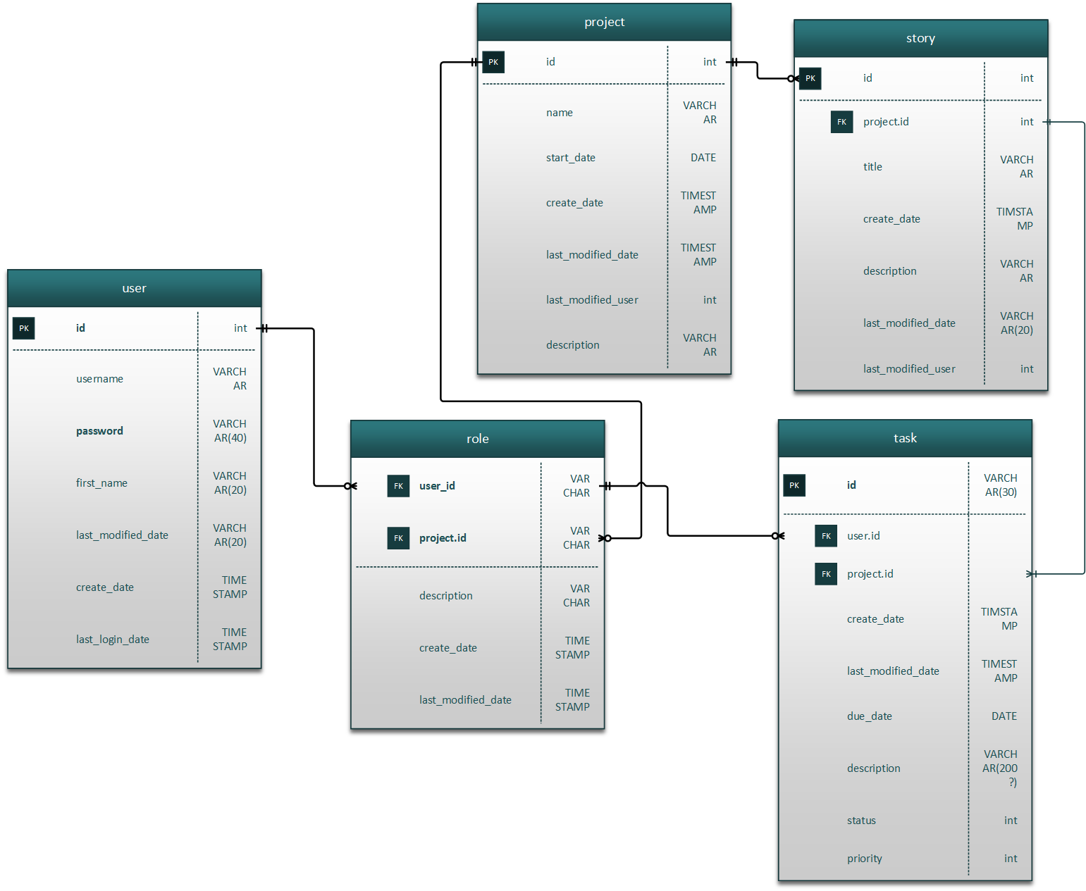

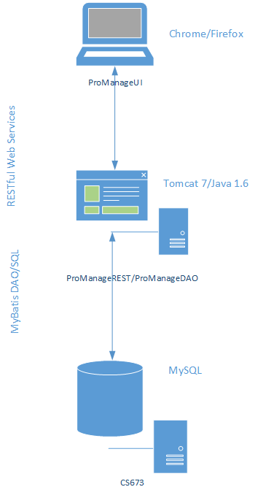

ProManage application uses a tiered application model. The application uses three tiers each with one project to represent the corresponding iter.

ProMangeUI - presentation tier - this is the front-end of the application. It is HTML5 and JQuery front-end using RESTful services and JSON to retrieve and update data on the back-end.

ProManageREST - business logic tier - the RESTful interface exposes the business logic and persistence layer to the ui and acts as the broker between presentation and persistence. Any business logic will live in this tier. The REST project is also responsible for mapping between the DTO objects of the persistence layer into the presentation tier model.

ProManageDAO - persistence tier - this project is strictly responsible for database access. These classes perform the basic CRUD ( Create, Retrieve, Update and Delete ) operations to a MySQL database. The database access is facilitated using mybatis framework.

# Design Patterns

Singleton - singleton pattern is used in order to retrieve the database session (connection). The SqlSessionFactory is recommended to be generated by a singleton through the mybatis framework.

DAO - the data access layer uses data access objects in order to control all of the database related operations.

# Key Algorithms

NA.

# Classes and Methods

.

# References

# Glossary

mybatis - dao persistence framework similar to hibernate (formerly known as ibatis).

dto - data transfer object