OneTeam **Requirement Analysis Document  
μProject**short line

**A micro project management tool**

David Blair

Christian Carducci

Juan Landaverde

Sang-Joon Lee

Jacqueline Pham

Srivathsa Rajagopal

June 13, 2016

# **Table of Contents**

Table of Contents

Section A. Introduction

Purpose of Application

Scope of Application

Target Population

Software Engineering Process

Section B. Requirement Analysis

Queued: Project Management Tool

ChatNow: Chat system

Bugs: Issue Tracker

Section C. Nonfunctional Requirement

Section D. System Models

# 

# 

# **Section A. Introduction**

## **Purpose of Application**

*Purpose of Application:* To provide capabilities to support a software project using Agile methodology through a basic project management tool.

*Major Functionalities:*

* Management Component - manages the project's requirements
* Communication Component - allows project team to communicate via real time chat
* Issue Management Component - manages the project’s issues or defects

*Requirements:*

For each component mentioned above is described as a project within the uProject application. The detail requirement for each component is described in Section B. These component level requirements are flow down from high level requirement document provided by the Client.

## **Scope of Application**

After reviewing the written description provided, a meeting was held with the Client to discuss the details of the application. We addressed the scope of the project. It was agreed that the requested scope of work was far too large given the time available. To solve this, we identified elements of a successful project: basic functionality in each of the three major functional areas with additional elements added as time permits. The details of what basic functionality means and potential elements for additional functionality are outlined in Section B. Once basic functionality is complete, focus will shift to improving the project management component of the application. The functional features are inspired by the examples given by the Client, but in no case should it be assumed any feature will faithfully replicate an example.

## **Target Population**

The target demographic for this application will be small to medium sized (1 to 8 people) software teams using Agile methodology who need a basic tool to support the process.

## **Software Engineering Process**

We will leverage the Agile software development process to improve the quality, process, and outcomes of the final product. It is anticipated that this process will help develop the project in manageable pieces and allow for the maximum amount of Client feedback during the development process. For each iteration, the team will design, develop, test, conduct code reviews, and revise the various components of the product. At the end of an iteration, a sprint review will be conducted, with Client involvement, to review progress, seek feedback, and set priorities for the next iteration.

Each of the three components will be developed to a level of basic functionality and then development will concentrate on the project management and bugs components of the system, with greater emphasis given to project management.

# **Section B. Requirement Analysis**

**Functional Requirements for Queued**

|  |  |
| --- | --- |
| Project Title | Queued: Project Management Tool |
| Project Team | Juan Landaverde, Sang-Joon Lee, Srivathsa Rajagopal, Chris Carducci, Jacqueline Pham |
| Project Goal | To create a project requirements management tool for Agile software development projects which allows user to create a project, stories and manage lifecycle of software development tasks. |
| Project Timeline | May 2016 - August 2016 |

Must haves (functionality necessary for success)

|  |  |
| --- | --- |
| Feature | Create a user account |
| User Story/ Requirement | As a User, I want to be able to create a new user account, so that I can register to use the uProject tool. |
| Acceptance Test | A user is able to log in via github account and register into project and use uProject features. |

|  |  |
| --- | --- |
| Feature | Create a Project |
| User Story/ Requirement | As a user, I want to be able to create a new project, so that I can create, edit, and add other users to the project. |
| Acceptance Test | A user is able to log-in to uProject using github account, then user is able to click on a “Create Project” button, enter title, description, click on members for the project and then save. |

|  |  |
| --- | --- |
| Feature | Archive and unarchive a Project |
| User Story/ Requirement | As a user, I want to be able to archive a project and unarchive a project, so that I remove a project from the project view when it is completed and no longer needed or restore archived project to view it in project view. |
| Acceptance Test | A user is able to log-in to uProject using github account, then user is able to click on a “Archive Project” button and the project will be removed from current project view. A link to view archived project is provided for user to click and view archived projects. |

|  |  |
| --- | --- |
| Feature | Create, edit Stories |
| User Story/ Requirement | As a user, I want to be able to create a new Stories, so that I can create set of requirement for the project. |
| Acceptance Test | - A user clicks on “Queued” on uProject dashboard and sees Queued story view with four lists  - Clicks on “Add Story” and opens a “Create Story” view  - User enters title, description, status, due date, priority and assigned to field and clicks save.  - User is able to click on a story from a list and opens “View Story” view  - User is able to click on “Edit” button and opens editable view  - User modifies any field and able to either click to “Save” or click on “Cancel” to cancel modification |

|  |  |
| --- | --- |
| Feature | Assign, update an owner to a story |
| User Story/ Requirement | As a user, I want to be able to assigned, so that I can assign a user to own a requirement for development. |
| Acceptance Test | - A user clicks on “Queued” on uProject dashboard and sees Queued story view with four lists  - User is able to click on a story to view the details and it opens “Detail View”  - User clicks “Edit” button and fields becomes editable  - User is able to update the details of story, title, description, status, due date, priority and assigned to field and clicks save.  - User is able to update the “assigned To” field to update the owner |

|  |  |
| --- | --- |
| Feature | Assign, update the status of a story |
| User Story/ Requirement | As a user, I want to be able to assign and change the status of a story, so that I can promote the story through software development lifecycle. |
| Acceptance Test | - A user clicks on “Queued” on uProject dashboard and sees Queued story view with four lists  - User is able to click on a story to view the details and it opens “Detail View”  - User clicks “Edit” button and fields becomes editable  - User is able to update the “Status” field and clicks “Save”  - User is able to see “Detail View” and observes that “Status” has been updated. |

|  |  |
| --- | --- |
| Feature | Backlog view of stories |
| User Story/ Requirement | As a user, I want to be able to view list of story in Backlog that has not be started, so that I can analyze set of requirements that has not been started development. |
| Acceptance Test | - A user clicks on “Queued” on uProject dashboard and sees Queued story view with four lists where one of them is Backlog view of Stories |

|  |  |
| --- | --- |
| Feature | Current view of stories |
| User Story/ Requirement | As a user, I want to be able to view list of stories in Current that are currently under development, so that I can update the status of development and promote it for delivery. |
| Acceptance Test | - A user clicks on “Queued” on uProject dashboard and sees Queued story view with four lists where one of them is Current view of Stories |

|  |  |
| --- | --- |
| Feature | Done view of stories |
| User Story/ Requirement | As a user, I want to be able to view list of stories in Completed/Done that are done with development, so that I can keep track of stories are that are completed for the project. |
| Acceptance Test | - A user clicks on “Queued” on uProject dashboard and sees Queued story view with four lists where one of them is Done view of Stories |

|  |  |
| --- | --- |
| Feature | Release view of stories |
| User Story/ Requirement | As a user, I want to be able to view list of stories in Release phase that are done with development, so that I can keep track of stories are that are completed for the project. |
| Acceptance Test | - A user clicks on “Queued” on uProject dashboard and sees Queued story view with four lists where one of them is Release view of Stories |

Wants (functionality to further support system)

|  |  |
| --- | --- |
| Feature | Assign type of story |
| Requirement | As a user, I want to be able to assign the type of stories that are created (feature, bug or release), so that I can organize and prioritize stories for development. |
| Acceptance Test | - A user clicks on “Queued” on uProject dashboard, clicks on a project, and sees Queued story view with four lists  - User is able to click on a story to view the details and it opens “Detail View”  - User clicks “Edit” button and fields becomes editable  - User is able to update the “Type” field and clicks “Save”  - User is able to see “Detail View” and observes that “Type” has been updated. |

Nice to haves (potential functionality)

|  |  |
| --- | --- |
| Feature | Create and manage multiple projects |
| Requirement | As a user, I want to be able to create and manage multiple projects: ability to create, edit, and delete multiple projects, so that I can organize and track multiple projects. |
| Acceptance Test | - A user clicks on “Queued” on uProject dashboard and sees project view  - User clicks on “Create Project” and opens create project view  - User enters title, description, clicks on members to assigned to project then clicks “Save”  - User is able to view project created on project view |

|  |  |
| --- | --- |
| Feature | Prioritization via drag-and-drop |
| Requirement | As a user, I want to be drag-and-drop a story within a list or between lists, so that I can easily assign priority of a story by order and update status by drag -and-drop between lists. |
| Acceptance Test | - A user clicks on “Queued” on uProject dashboard, clicks on a project, and sees Queued story view with four lists  - User is able to click to select a Story from a list and drag within a list to a new position to assign order of priority within a list  - User is able to click to select a Story from a list and drag between 4 types of list to a new position to update the status of a Story |

|  |  |
| --- | --- |
| Feature | View of user owned Stories |
| Requirement | As a user I want to view Stories that I was assigned/owned by me, so that I can quickly visual search for Stories that I need to work on. |
| Acceptance Test | - A user clicks on “Queued” on uProject dashboard, clicks on a project, and sees Queued story view with four lists  - User is able to view indication on each Story user owns |

|  |  |
| --- | --- |
| Feature | Email reminders for Story deadlines |
| Requirement | As a user I want receive an email reminder for stories that I own by 1 day prior to due date at 3pm, so that I can be reminded to complete the task by due date. |
| Acceptance Test | - A user clicks on “Queued” on uProject dashboard, clicks on a project, and sees Queued story view with four lists  - User clicks on a story and opens “Detail View”  - User clicks “Edit” to update the story detail and updates due date  - User clicks “Save” button  - User receives an email from uProject one day prior to deadline at 3pm with Story details and due date. |

|  |  |
| --- | --- |
| Feature | Archive Projects |
| Requirement | As a user I want to be able to archive Projects, so that I can remove Project that are completed or not necessary for viewing. |
| Acceptance Test | - A user clicks on “Queued” on uProject dashboard and view project.  - User clicks on settings icon on top right corner of the project view and opens options for archiving and editing project  - User clicks “Archive” button and led to a project view  - Project is removed from project view |

|  |  |
| --- | --- |
| Feature | Archive Stories |
| Requirement | As a user I want to be able to archive and Stories, so that I can remove Story that are completed or not necessary for viewing. |
| Acceptance Test | - A user clicks on “Queued” on uProject dashboard, clicks on a project, and sees Queued story view with four lists  - User clicks on a story and opens “Detail View”  - User clicks “Edit” to update the story detail and user clicks “Archive”  - User is led to project detail view with list of stories and does not see the Story that was arhived |

|  |  |
| --- | --- |
| Feature | Scroll bar for lists |
| Requirement | As a user I want to be able to scroll through a long list of Stories where appropriate, so that I can scroll through list of Stories. |
| Acceptance Test | - A user clicks on “Queued” on uProject dashboard, clicks on a project, and sees Queued story view with four lists  - User sees scroll bars for the list that are longer than size of the browsing window |

**Functional Requirements for ChatNow**

|  |  |
| --- | --- |
| Project Title | ChatNow: Chat system |
| Project Team | Chris Carducci, David Blair, Juan Landaverde, Srivathsa Rajagopal |
| Project Goal | To create an easy-to-use communication environment that allows a team to share ideas in a virtual chat room setting as an alternative to emails. |
| Project Timeline | May 2016 - August 2016 |

Must haves (functionality necessary for success)

|  |  |
| --- | --- |
| Feature | Create a channel - ability to create a public chat room |
| Requirement | As a user, I want to be able create a channel and send a message on it |
| Acceptance Test | - A user opens chatNow view  - A user clicks on “Channels” tab to view available chat rooms  - user clicks “Create a Channel” to create a new channel  - user enters name of new channel  - user automatically enters a new channel with empty chat room |

|  |  |
| --- | --- |
| Feature | View old chat history |
| Requirement | As a user, I want to be able to view old chat history |
| Acceptance Test | - A user clicks “Channel” tab and enters chat room  - User clicks available chat room  - User is able to view old chat history |

|  |  |
| --- | --- |
| Feature | Archive chat history |
| Requirement | As a user, I want to be able to make chat history persistent (not session based, but always visible), so that all users can view chat history in a channel. |
| Acceptance Test | - A user clicks “Channel” tab and select “Archive a Channel”  - User selects a chat room name from list view then clicks “Archive”  - User is not able to see channel name from “Channels” tab list |

Wants (functionality to further support system)

|  |  |
| --- | --- |
| Feature | Search Archive chat history |
| Requirement | As a user, I want to be able to search archived chat history for keywords |
| Acceptance Test | - A user clicks “Search” tab and new window slides open  - User enters text into “search box”  - Shows list of all matching results |

|  |  |
| --- | --- |
| Feature | Send private messages to other members |
| Requirement | As a user, I want to be able to send private messages |
| Acceptance Test | - A user clicks “Direct Message” tab and list of users drops down  - Selects a user to send a private message and new chat room opens  - Types in new message to message box |

|  |  |
| --- | --- |
| Feature | Send mail to offline private messages |
| User Story/ Requirement | As a user, I want to be able to send email to user if s/he receives a private message while offline |
| Acceptance Test | - A user clicks “Direct Message” tab and list of users drops down  - Selects a user to send a private message and new chat room opens  - Types in new message to message box  - An email is sent to target user |

|  |  |
| --- | --- |
| Feature | Enable/Disable Email Notification |
| User Story/ Requirement | As a user, I want to be able to add a setting for enabling/disabling email notifications |
| Acceptance Test | - A user clicks user name on top menu tab and selects “Settings”  - Settings view open and then user clicks on “ChatNow” tab to see enable/disable button  - User toggles tab to enable or disable email notification feature |

|  |  |
| --- | --- |
| Feature | Online Tracking |
| User Story/ Requirement | As a user, I want to be able to track who is online |
| Acceptance Test | - A user clicks “Direct Message” tab and list of users drops down  - User drop down list shows color “Green” for those who are current online. |

|  |  |
| --- | --- |
| Feature | Time zone for chat message |
| User Story/ Requirement | As a user, I want to view the messages grouped under a date headline, with the individual messages displaying military time with timezone |
| Acceptance Test | - A user clicks “Direct Message” tab and list of users in a drop down list  - User sees time stamp on the right-side of each chat message history  - User sees date on middle of the chat history in a single row with date stamp |

Nice to haves (potential functionality)

|  |  |
| --- | --- |
| Feature | Mobile View |
| User Story/ Requirement | As a user, I want the front end to be mobile friendly and easy to use |
| Acceptance Test | - A user is able to open ChatNow on mobile device and be able to use chatNow features available on desktop |

|  |  |
| --- | --- |
| Feature | Unread Message Count |
| User Story/ Requirement | Add unread message count to header on page refresh |
| Acceptance Test | - A logs in to uProject and sees unread messages on Dashboard for ChatNow |

|  |  |
| --- | --- |
| Feature | Infinite Scrolling |
| User Story/ Requirement | Enable infinite scrolling or segmented chat history by 30 previous messages, so that user can view previous messages without loading entire database of chat history. |
| Acceptance Test | - A user clicks “Channel” tab and enters chat room  - User clicks available chat room  - user is able to view previous history, when scrolling up, 30 previous history is loaded into chatroom. |

|  |  |
| --- | --- |
| Feature | Dashboard Chat History Display |
| User Story/ Requirement | On the dashboard, display the most recent message from the 3 most recent channels. |
| Acceptance Test | - A logs in to uProject and sees messages on Dashboard for ChatNow to snapshot of the message |

**Functional Requirements for Bugs**

|  |  |
| --- | --- |
| Project Title | Bugs: Issue Tracker |
| Project Team | David Blair, Jacqueline Pham, Sang-Joon Lee, Chris Carducci |
| Project Goal | To develop a basic tracking system to create, assign, update and resolve issues. |
| Project Timeline | May 2016 - August 2016 |

Must haves (functionality necessary for success)

|  |  |
| --- | --- |
| Feature | Create Issue |
| User Story/ Requirement | As a user, I want to be able to create an issue so that I can manage and track an issue |
| Acceptance Test | - A user is able to create a story.  - A 'create issue' button is present on the page |

|  |  |
| --- | --- |
| Feature | Edit and Save an Issue |
| User Story/ Requirement | As a user, I want to be able to save an issue so that I can return to the issue and view the details. |
| Acceptance Test | - A user is able to have the data persist  - There is a 'save' button on the issue detail page |

|  |  |
| --- | --- |
| Feature | Summary of Issues |
| User Story/ Requirement | As a user, I want to be presented with a list of all 'open' and 'closed' issues, displaying the issue summary, status, priority and number of comments so that I can navigate to an issue detail page. |
| Acceptance Test | - A user is able to view the list of issues  - A user does not see 'resolved' issues  - A user is able to view links to navigate to the issue detail page |

|  |  |
| --- | --- |
| Feature | Archive issues |
| User Story/ Requirement | As a user, I want to be able to archive an issue so that I can remove issues created erroneously. |
| Acceptance Test | - A user is able to delete an issue  - There is a 'delete issue' button on the issue detail page  - A user no longer sees the issue present in the issue log view |

|  |  |
| --- | --- |
| Feature | Set Status on Issue |
| User Story/ Requirement | As a user, I want to be able to set the status of an issue so that I can effectively track issues.  Values:  New  Reopened  Assigned  In Progress  Resolved  Testing  Deployment  Closed  Rejected |
| Acceptance Test | - A user is able to change the status of an issue and have it persist |

|  |  |
| --- | --- |
| Feature | Unable to edit System Field for Issue details |
| User Story/ Requirement | As a user, I do not want to be able to edit the system fields so that the data can not be manipulated by anyone |
| Acceptance Test | - A user cannot edit createdBy, createdDate, lastModifiedBy, lastModifiedDate fields |

|  |  |
| --- | --- |
| Feature | Unique ID for Issues |
| User Story/ Requirement | As a user, I want to be able to identify issues with a unique identifier so I can easily reference an issue. |
| Acceptance Test | - A user is able to see a unique identifier per issue  - A user is not able to edit the unique identifier |

|  |  |
| --- | --- |
| Feature | Creator of Issues |
| User Story/ Requirement | As a user, I want to be able to view who created an issue so that I can effectively track who reported the issue. |
| Acceptance Test | - A user is able to view who created an issue  - A user is not able to edit who created an issue |

|  |  |
| --- | --- |
| Feature | Status default to NEW |
| User Story/ Requirement | As a user, I want the issue status to be defaulted to new upon creation |
| Acceptance Test | - A user is not able to set the issue status upon creation  - A new issue defaults to 'new' status upon creation |

|  |  |
| --- | --- |
| Feature | Non-null Summary |
| User Story/ Requirement | As a user, I want to be restricted from creating a issue with a null summary so that I don't create bad data. |
| Acceptance Test | - A user is not able to create an issue with an empty summary  - A user is not able to edit/save an issue with an empty summary |

|  |  |
| --- | --- |
| Feature | Severity of an Issue |
| User Story/ Requirement | As a user, I want to be able to set the severity of an issue so that I can effectively track issues  Values:  Low  Moderate  Major  Critical |
| Acceptance Test | - A user is able to set the severity of the issue to any of the values listed above |

|  |  |
| --- | --- |
| Feature | Priority of Issue |
| User Story/ Requirement | As a user, I want to be able to set the priority of an issue so that I can effectively track issues.  Priority values:  Low  Medium  High  Urgent |
| Acceptance Test | - A user is able to set the priority field to any of the values above |

|  |  |
| --- | --- |
| Feature | Add Description to an Issue |
| User Story/ Requirement | As a user, I want to be able to add a description to an issue so that I can add useful details describing an issue. |
| Acceptance Test | - A user is able to add text to the description field of the issue and have it persist |

|  |  |
| --- | --- |
| Feature | View Issues for Duration with Open Status |
| User Story/ Requirement | As a user, I want to be able to view when an issue was created so that I can compute how long an issue has been open |
| Acceptance Test | - A user is able to view a datetimestamp of when an issue was reported  - A user cannot modify the created date field |

|  |  |
| --- | --- |
| Feature | Last Modified Date and Time of an Issue |
| User Story/ Requirement | As a user, I want to be able to view when an issue was last modified so that I can effectively track when an issue was updated. |
| Acceptance Test | - A user is able to view a datetimestamp of when an issue was last modified  - A user cannot modify the last modified date field |

|  |  |
| --- | --- |
| Feature | Last Modified Author of an issue |
| User Story/ Requirement | As a user, I want to be able to view who last modified an issue so I can effectively track who update the issue |
| Acceptance Test | - A user is able to view who last modified an issue  - A user cannot modify the last modified by field |

|  |  |
| --- | --- |
| Feature | Owner of an Issue |
| User Story/ Requirement | As a user, I want to be able to view who created an issue so I can effectively track who reported the issue |
| Acceptance Test | - A user is able to view who reported an issue  - A user is not able to edit who created an issue |

|  |  |
| --- | --- |
| Feature | Update Status of an Issue |
| User Story/ Requirement | As a user, I want to be able to update an issue so that I can track progress and add more detail |
| Acceptance Test | - A user is able to 'edit' the issue  - The data change is persisted |

|  |  |
| --- | --- |
| Feature | Read-only mode view Issues |
| User Story/ Requirement | As a user, I want to be able to view an issue detail page in read only mode so I do not accidentally modify the issue |
| Acceptance Test | A user is able to view issues without ability to edit fields |

|  |  |
| --- | --- |
| Feature | Add Issues |
| User Story/ Requirement | As a user, I want to be able to add an issue summary so I can quickly view what an issue is regarding. |
| Acceptance Test | - A user is able to add text and save to the issue summary field |

Wants (functionality to further support system)

|  |  |
| --- | --- |
| Feature | Assign a issues |
| User Story/ Requirement | As a user, I want to be able to assign an issue to a user so that someone is on point to resolve the issue |
| Acceptance Test | A user is able to choose a user for assignment |

|  |  |
| --- | --- |
| Feature | Comment on issues |
| User Story/ Requirement | As a user, I want to be able to comment on an issue so that I can communicate with either the user who reported or is assigned to the issue |
| Acceptance Test | A user can add a comment to an issue  A user is not able to edit or delete the comment |

|  |  |
| --- | --- |
| Feature | Add a screenshot to an issue |
| User Story/ Requirement | As a user, I want to be able to add a screenshot to an issue that so that other users are able to understand the context surrounding the issue |
| Acceptance Test | A user can upload a jpg or png image  A user can open and view a jpg or png image  A user cannot click submit until an image is selected |

Nice to haves (potential functionality)

|  |  |
| --- | --- |
| Feature | Search and Sort Issues |
| User Story/ Requirement | As a user, I want to be able to search and sort by issues on the log view page so that I am able to find an issue quickly |
| Acceptance Test | - A user is able to click a filter icon  - A user is able to type text for a specific field to pull back matching text |

# **Section C. Nonfunctional Requirement**

**Usability**

* A User shall be able to use the application on both desktop and mobile

**Reliability**

* A user shall be able to browse and use the application successfully throughout a project of any size and small team without observing failure.

**Performance**

* A user shall be able to use the uProject application tool with reasonable response time

#### 

# **Section D. System Models**

**User Interface - navigational paths and screen mock-ups**

Home Page UI Mock-up

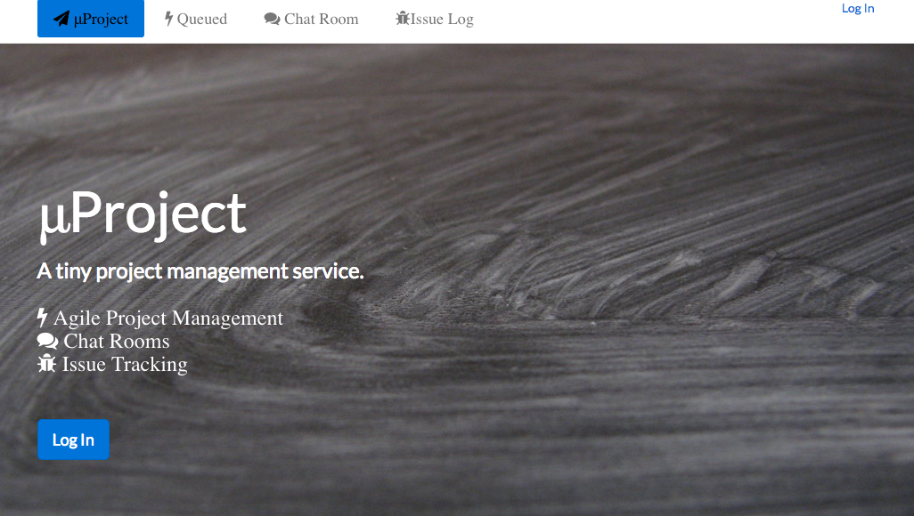

Queued Project View

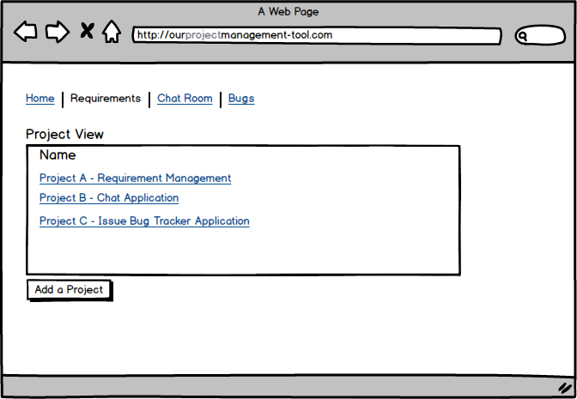

Queued Add a New Project UI Layout

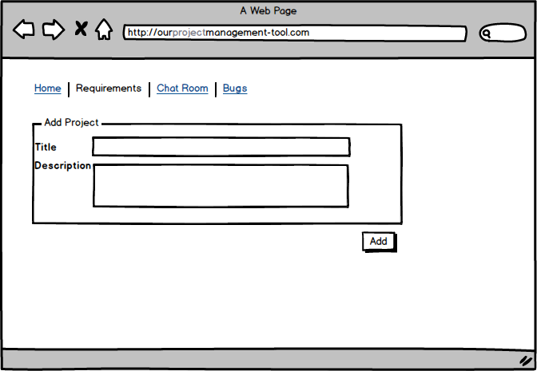

Queued Story View UI Layout

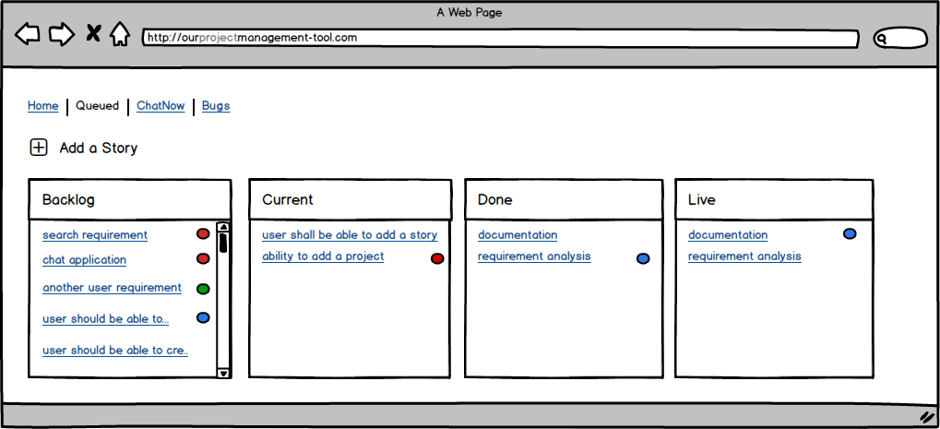

Queued Add a Story UI Layout

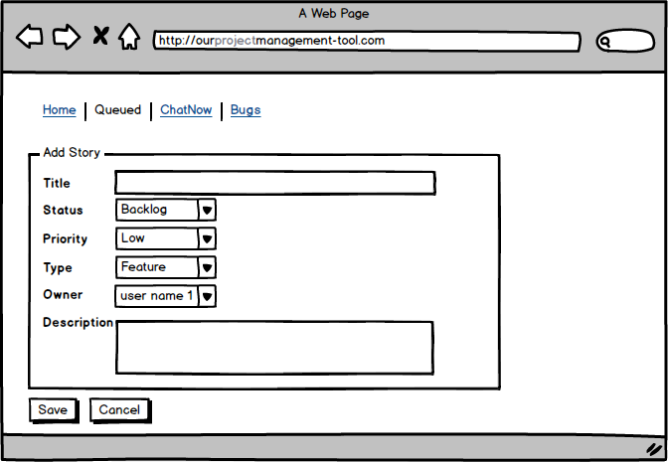

Queued Edit a Story UI Layout

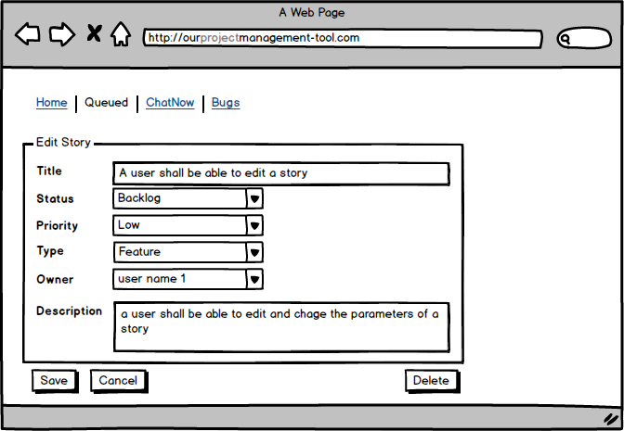

ChatNow App UI

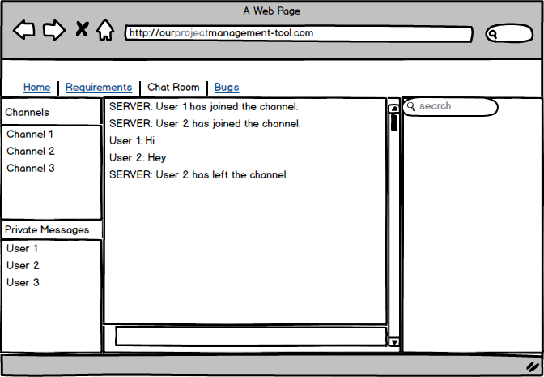

Bugs App UI

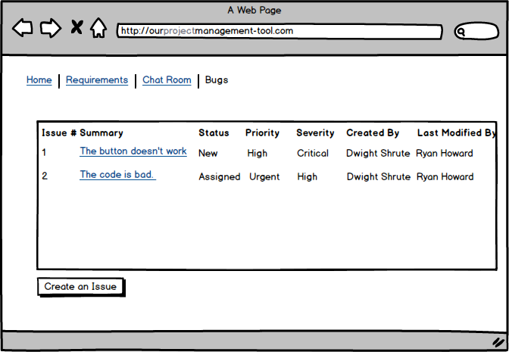

Bugs Create Issue UI Layout

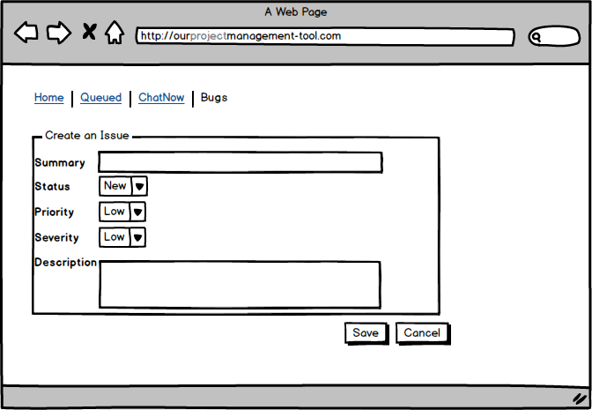

## Bugs Edit Issue UI Layout

