Contents

1. Scope 2
2. Instruments 2

Stocks 2

Futures 2

Option 2

1. Criteria for Liquid Strikes: 2
2. Data Harvestig : 3

Future and Options 3

Stocks 3

|  |  |  |
| --- | --- | --- |
|  |  |  |
| 16-11-24 | Additions base on brain storming exercise | A1 |
| 05-10-24 | First Issue | A0 |
| Date | Description | Revision |

# Scope

This document provides guidelines for UI-Screen design and Output presentation.

# Screen Design

Input For Optimization



Output Screen design



# Features

User Input for:

* Brokerage
* Slipages

The Optimization input and table must be available for Future reference on left side of Optimization Input Screen.

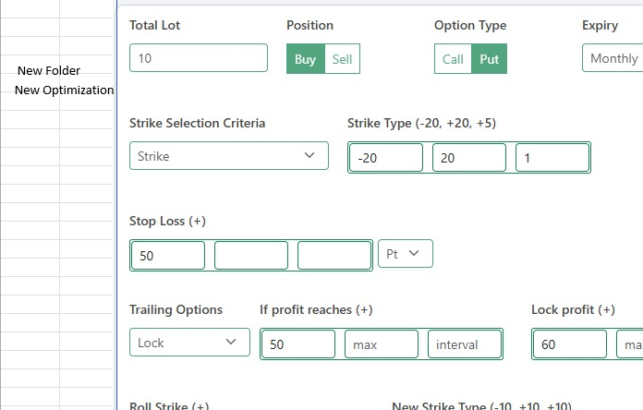

## Stocks

Stocks for all stocks listed under Index named Nifty Total Market.

## Futures

Futures of all Indices (Nifty, BankNifty, FinNifty, MidcpNifty, NiftyNxt50, Sensex and Bankex ), Expiries for Current and Next

## Option

* + Nifty and Sensex:
    - Call and Put for Expires-
      * Current Week
      * Next Week
      * Current Month
      * other expiries.
    - Strike Selection:
      * For the current expiry (weekly and monthly), include all strikes within a 5% range of the stock price on the starting day of the expiry contract. For example, if the stock price is 1,000, add strikes from 950 to 1050 (inclusive).
      * Add liquid strikes those are not included in list above for Current and other expiries.
      * Keep Adding strikes to the list above as the price moves on EOD Basis as the range expands or more strikes getting liquid.
  + BankNifty, FinNifty, MidcpNifty, Sensex, NiftyNxt50, and Bankex:
    - Call and Put for Expires-
      * Current Month
      * Other expiries.
    - Strike Selection:
      * For the current expiry (weekly and monthly), include all strikes within a 5% range of the stock price on the starting day of the expiry contract. For example, if the stock price is 1,000, add strikes from 950 to 1050 (inclusive).
      * Add liquid strikes those are not included in list above for Current and other expiries.
      * Keep Adding strikes to the list above as the price moves on EOD Basis as the range expands or more strikes getting liquid.

# Criteria for Liquid Strikes:

Download FNO bhavcopy daily, flag the strikes those have minimum of 2000 Lots traded or more as liquid strikes and add to the above watch list

# Data Harvestig :

## Future and Options

Harvest the tick data for all Futures and Options as listed above and refill the table with EOD data every minute with 2sec historical data.

## Stocks

Harvest One minute EOD data every minute.