# List of Figures

* + 1. Image of a bullet land from a confocal light microscope at 20 fold magni- fication (top) and a chart of the corresponding signature of the same land (bottom). The dotted lines connect some peaks visible in both visualizations.
    2. Bullet land profile (left) and the corresponding signature (right) for one of

the lands of Hamby-44.

* + 1. Sketch of same-shift pairings (top) and different-shift pairings (bottom).

Filled in rectangles show pairings resulting in correlations, unfilled rectangles

are segments without a match.

* + 1. Two same-source markings. For convenience, the markings are moved into phase on the left and out-of phase on the right. In-phase (left) and out- of-phase (right) samples are shown by the light grey background. The Chumbley-score is based on a Mann-Whitney U test of the correlations de-

rived from these two sets of samples.

* + 1. Sketch of adjusted different-shift pairings. Pairings are side from opposite ends of the two markings. For an odd number of pairings the middle pair is left out. At most one of the same-shift pairings can not be matched with a

different-shift pair under algorithm (CS2).

* + 1. Percent of failed land-to-land comparisons using an optimization window *wo* = 120 and a coarseness of *c* = 0*.*25. With an increase in the size of  the validation window a higher percentage of tests fails under both methods (CS1) and (CS2), but the percentage of failed tests is much smaller under

(CS2). Observed failure rates of (CS1) are higher than expected rates.

* + 1. Overview of the effect of different coarseness parameters *c* on the profile shown in Figure 2 (top). The bottom row shows histograms of the (relative) optimal locations *to* identified in the optimization step for different values of

the coarseness parameter *c**.*

* + 1. ROC curves of methods CS1 and CS2 for different sizes of optimization window *wo*. Best performances with respect to ROC curves are reached for optimization windows of sizes 150 and higher. Points of equal error rates (EERs) can be found at the intersection of the dotted line and the ROC curves.
    2. Comparison of results for CS1 and CS2 using area under the curve (AUC)

and equal error rates (EER).

* + 1. Comparison of observed and nominal type I error rates across a range of window sizes for optimization *wo*. The horizontal line in each facet indicates

the nominal type I error rate.

* + 1. AUC and EER for methods CS1 and CS2 based on high resolution scans of Hamby 44.
    2. Sketch of different-shift pairings. For CS1 no different-shift pairs can be identified, resulting in a failed test.

20

* + 1. Sketch of same-shift pairings. When the lag between optimal reference points is too large to accommodate a validation window in both signatures, both

CS1 and CS2 fail.

* + 1. Type II error rates observed across a range of window sizes for optimization *wo*. For a window size of *wo* = 130 we see a minimum in type II error rate across all type I rates considered. Smaller validation sizes *wv* are typically

associated with a smaller type II error.

21

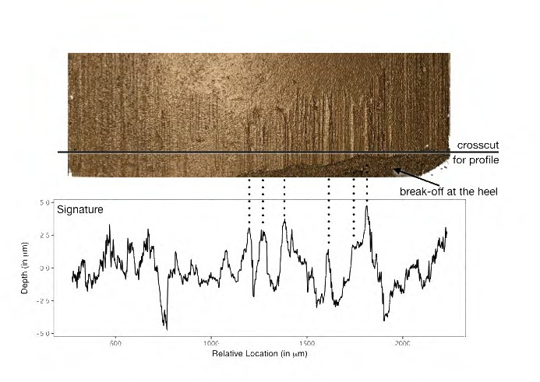

Figure 1: Image of a bullet land from a confocal light microscope at 20 fold magnification (top) and a chart of the corresponding signature of the same land (bottom). The dotted lines connect some peaks visible in both visualizations.

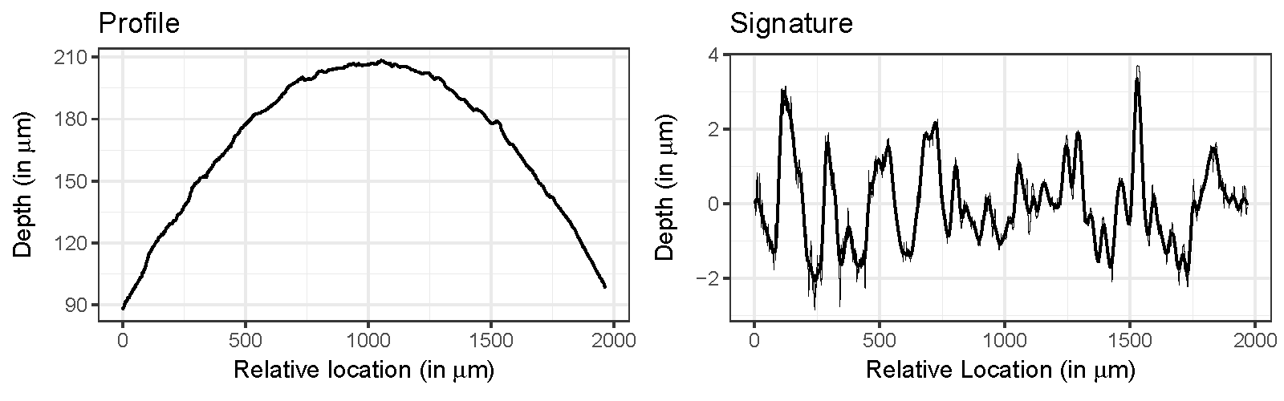

Figure 2: Bullet land profile (left) and the corresponding signature (right) for one of the lands of Hamby-44.

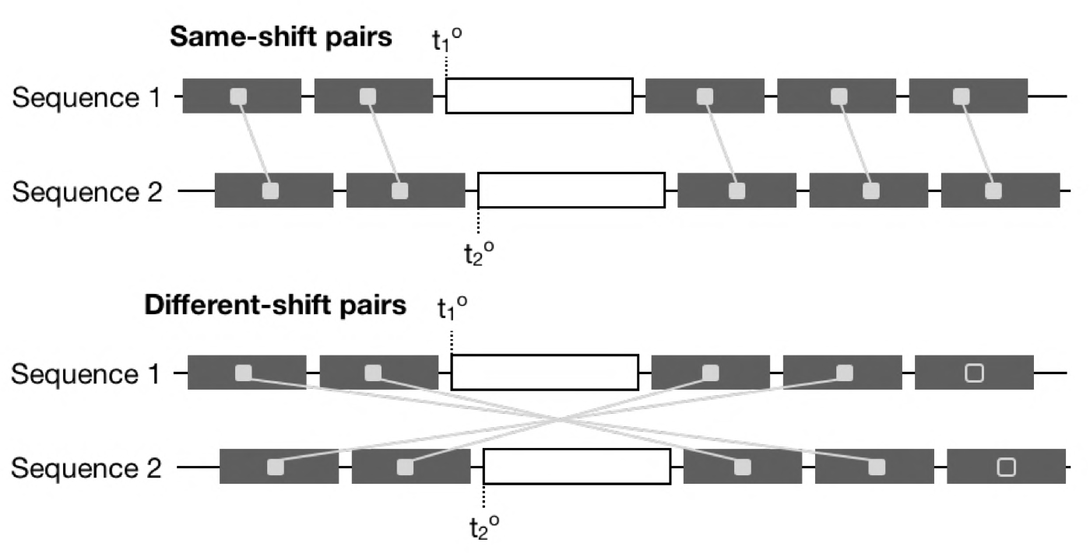

Figure 3: Sketch of same-shift pairings (top) and different-shift pairings (bottom). Filled in rectangles show pairings resulting in correlations, unfilled rectangles are segments without a match.

0 500 1000 1500 2000

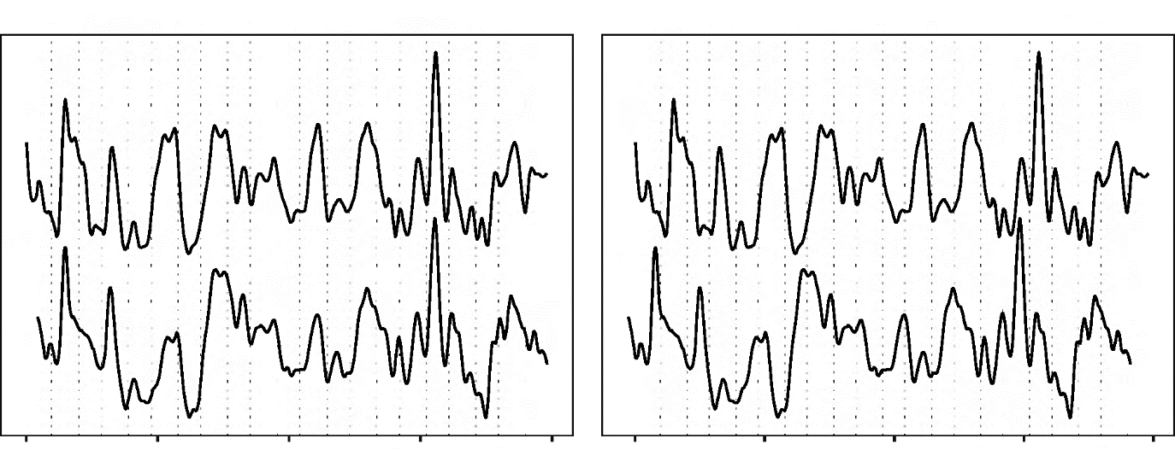

In−phase sample

Out−of−phase sample

Relative Location (in m)

0 500 1000 1500 2000

Relative Location (in m)

Figure 4: Two same-source markings. For convenience, the markings are moved into phase on the left and out-of phase on the right. In-phase (left) and out-of-phase (right) samples are shown by the light grey background. The Chumbley-score is based on a Mann-Whitney U test of the correlations derived from these two sets of samples.

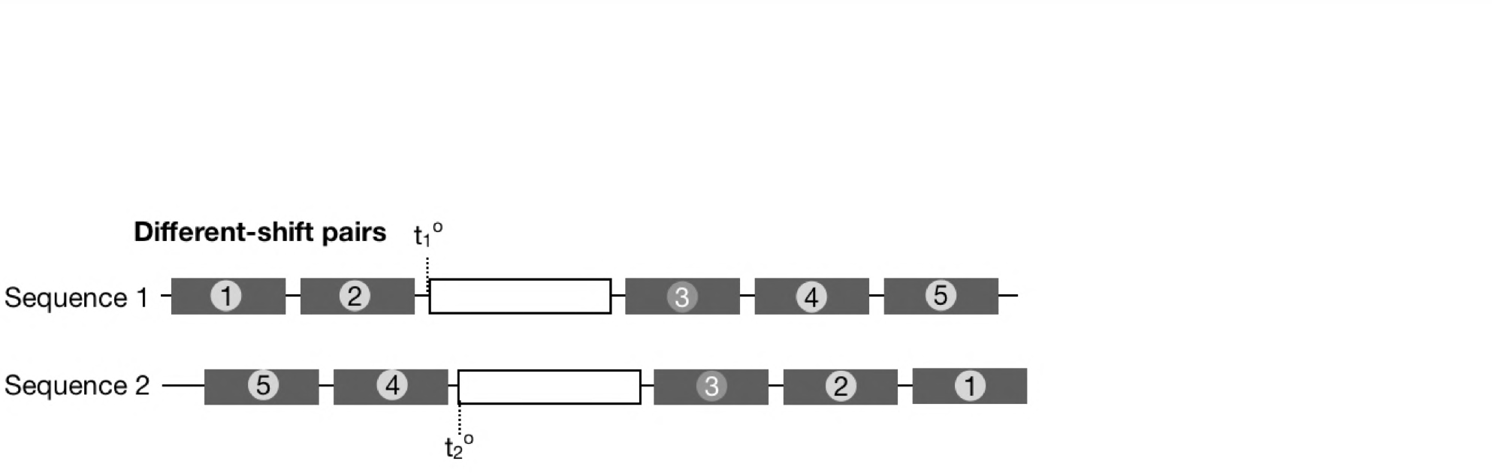Figure 5: Sketch of adjusted different-shift pairings. Pairings are side from opposite ends of the two markings. For an odd number of pairings the middle pair is left out. At most one of the same-shift pairings can not be matched with a different-shift pair under algorithm (CS2).

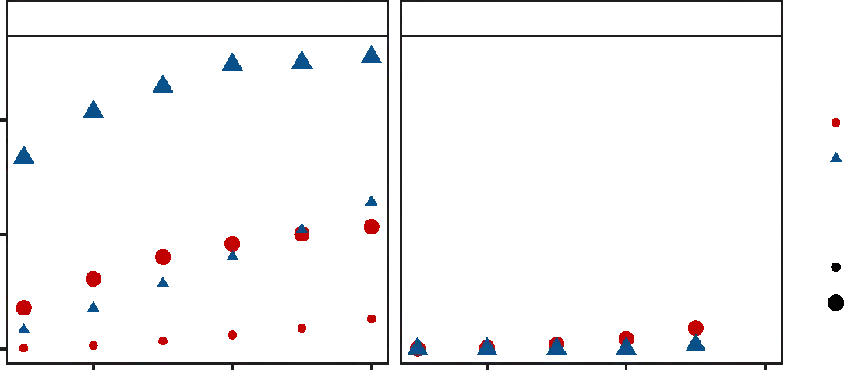method: CS1 method: CS2

Same−source

Percent of failed tests

10 FALSE

TRUE

5 Failures

Expected Observed

0

20 40 60 20 40 60

Size of validation window wv in pixels

Figure 6: Percent of failed land-to-land comparisons using an optimization window *wo* = 120 and a coarseness of *c* = 0*.*25. With an increase in the size of the validation window a higher percentage of tests fails under both methods (CS1) and (CS2), but the percentage of failed tests is much smaller under (CS2). Observed failure rates of (CS1) are higher than expected rates.

Depth (in m)

Figure 7: Overview of the effect of different coarseness parameters *c* on the profile shown in Figure 2 (top). The bottom row shows histograms of the (relative) optimal locations *to* identified in the optimization step for different values of the coarseness parameter *c*.

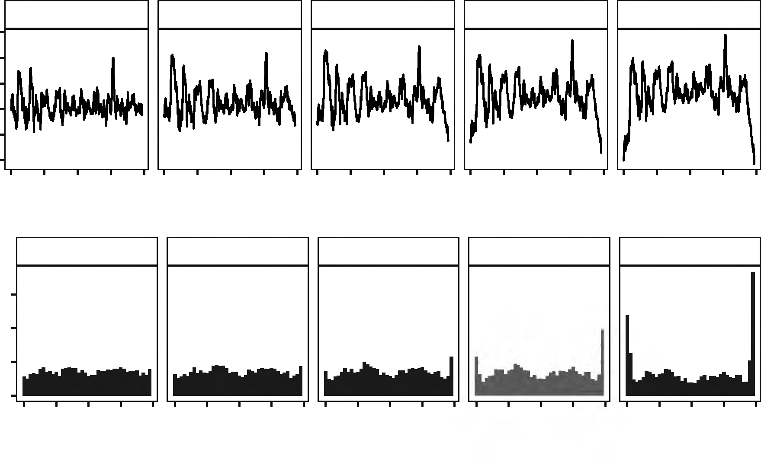

c: 0.1

c: 0.15

c: 0.2

c: 0.25

c: 0.3

6

4

2

0

−2

−4

0.0 0.5 1.0 1.5 2.00.0 0.5 1.0 1.5 2.00.0 0.5 1.0 1.5 2.00.0 0.5 1.0 1.5 2.00.0 0.5 1.0 1.5 2.0

Relative Location (in mm)

coarseness: 0.1 coarseness: 0.15

coarseness: 0.2 coarseness: 0.25

coarseness: 0.3

9000

6000

3000

0

0 0.25 0.50 0.75 1 0 0.25 0.50 0.75 1 0 0.25 0.50 0.75 1 0 0.25 0.50 0.75 1 0 0.25 0.50 0.75 1

Relative optimal location t*

Number of profiles

1.00

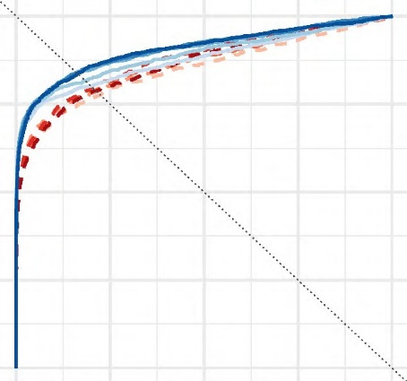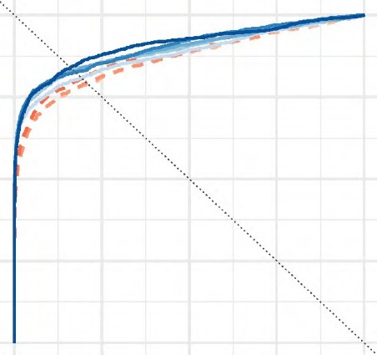

wv  30

wv  50

True Positives Rate (Sensitivity)

0.75

0.50

0.25

Method / Optimization window size wo

CS1 / 90

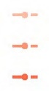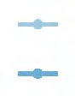

CS1 / 120

CS1 / 150

CS1 / 180

CS1 / 210

CS2 / 90

CS2 / 120

CS2 / 150

CS2 / 180

CS2 / 210

0.00

0.00 0.25 0.50 0.75 1.00 0.00 0.25 0.50 0.75 1.00

False Positives Rate (1 − Specificity)

Figure 8: ROC curves of methods CS1 and CS2 for different sizes of optimization window *wo*. Best performances with respect to ROC curves are reached for optimization windows of sizes 150 and higher. Points of equal error rates (EERs) can be found at the intersection of the dotted line and the ROC curves.

0.25

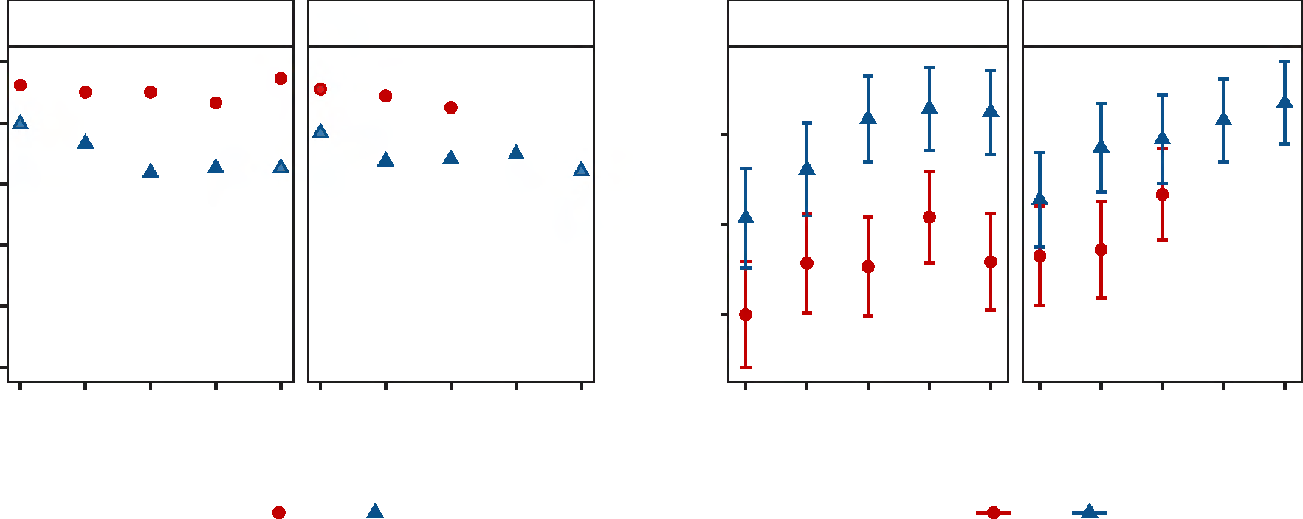

wv  30

wv  50

wv  30

wv  50

0.900

0.875

0.850

90 120 150 180 210 90 120 150 180 210

Size of optimization window in pixels

90 120 150 180 210 90 120 150 180 210

Size of optimization window in pixels

Method CS1 CS2

Method CS1 CS2

Area under the curve (AUC)

0.20

Equal Error rate (EER)

0.15

0.10

0.05

0.00

Figure 9: Comparison of results for CS1 and CS2 using area under the curve (AUC) and equal error rates (EER).

0.0025

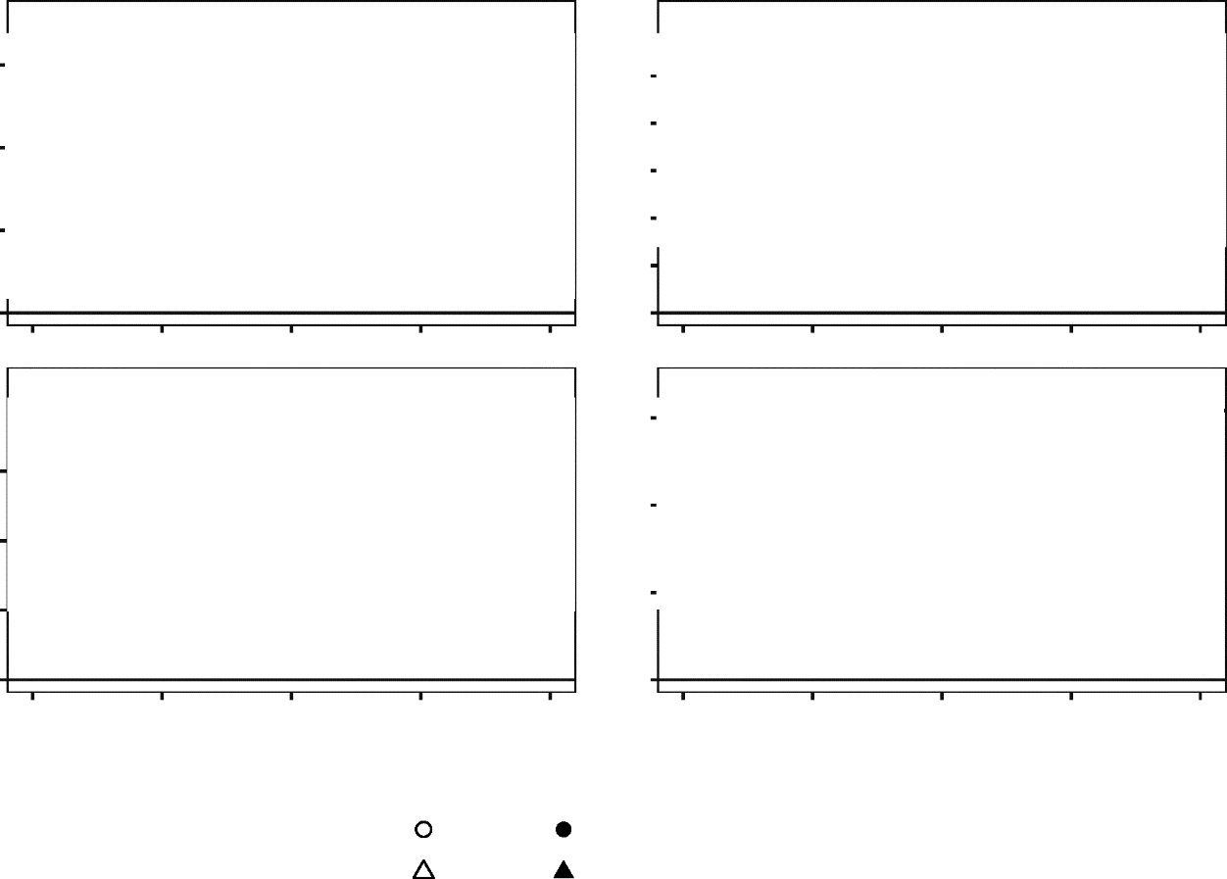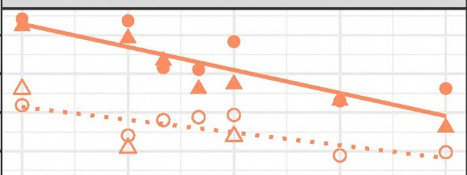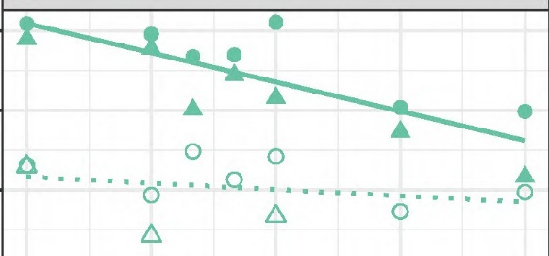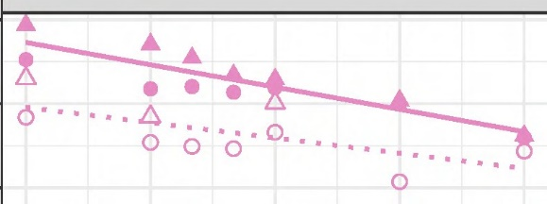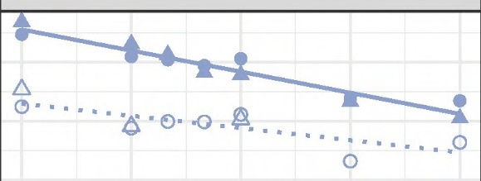

  0.001

  0.005

0.010

0.009

0.008

0.007

0.006

0.005

90

120

150

  0.01

180

210

90

120

150

  0.05

180

210

0.08

0.07

0.06

0.05

90

120

150

180

210

90

120

150

180

210

Window size for optimization wo

CS1 / 30 CS2 / 30

Method / Validation window wv

CS1 / 50 CS2 / 50

Nominal type I error 0.001

0.005

0.01

0.05

0.0020

0.0015

^

Observed type I error rate

0.0010

0.0175

0.0150

0.0125

0.0100

Figure 10: Comparison of observed and nominal type I error rates across a range of window sizes for optimization *wo*. The horizontal line in each facet indicates the nominal type I error rate.

0.82

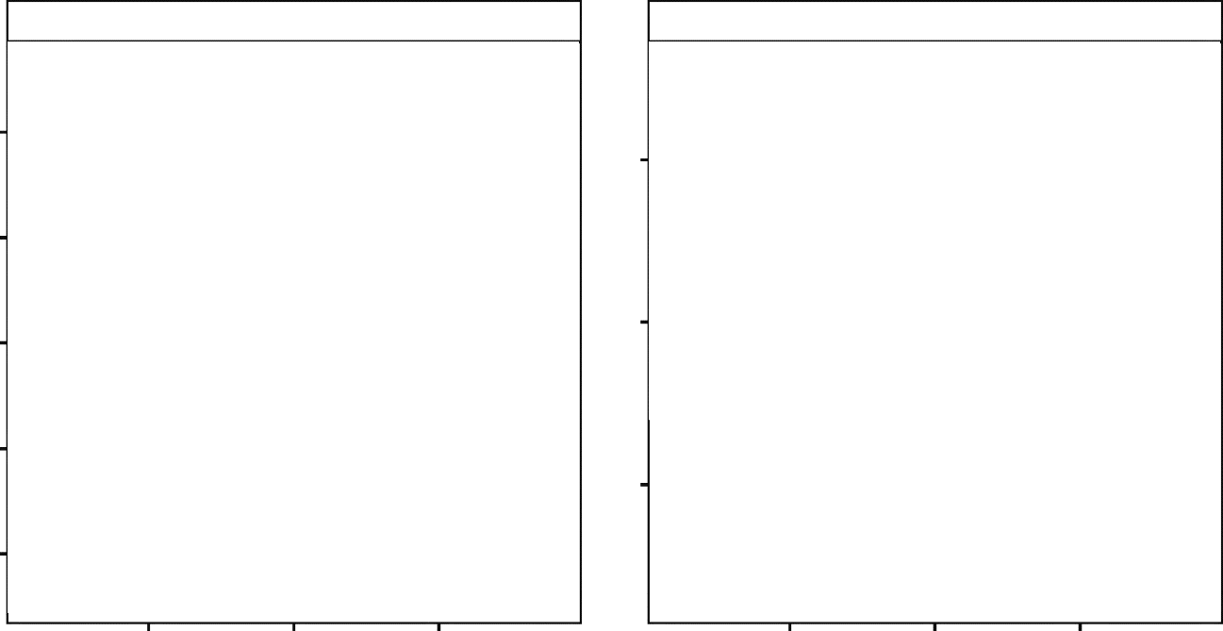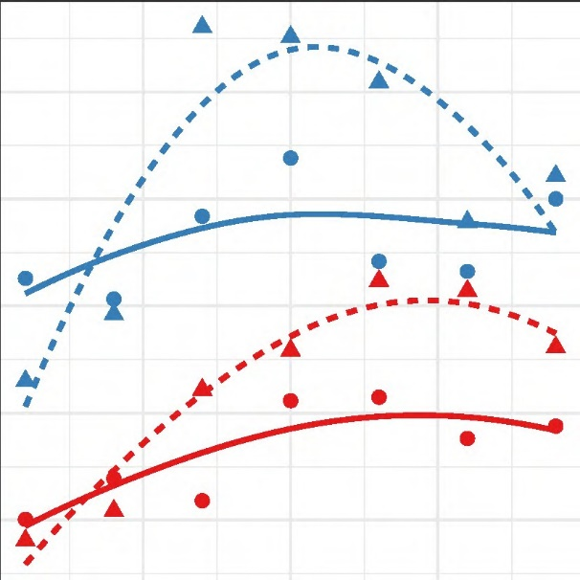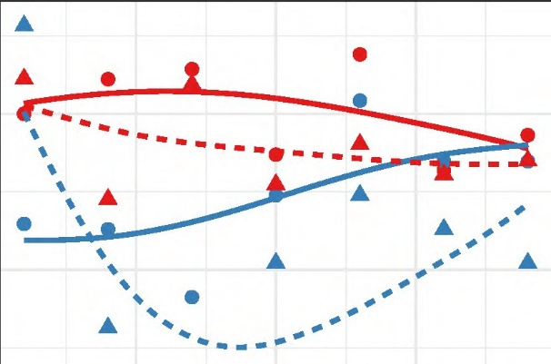

AUC

EER

0.28

0.26

0.24

0.81

0.80

Value

0.79

0.78

250 300 350 250 300 350

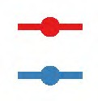Size of optimization window wo in pixels

Size of validation window wv in pixels

Method



75

125

CS1 CS2

Figure 11: AUC and EER for methods CS1 and CS2 based on high resolution scans of Hamby 44.

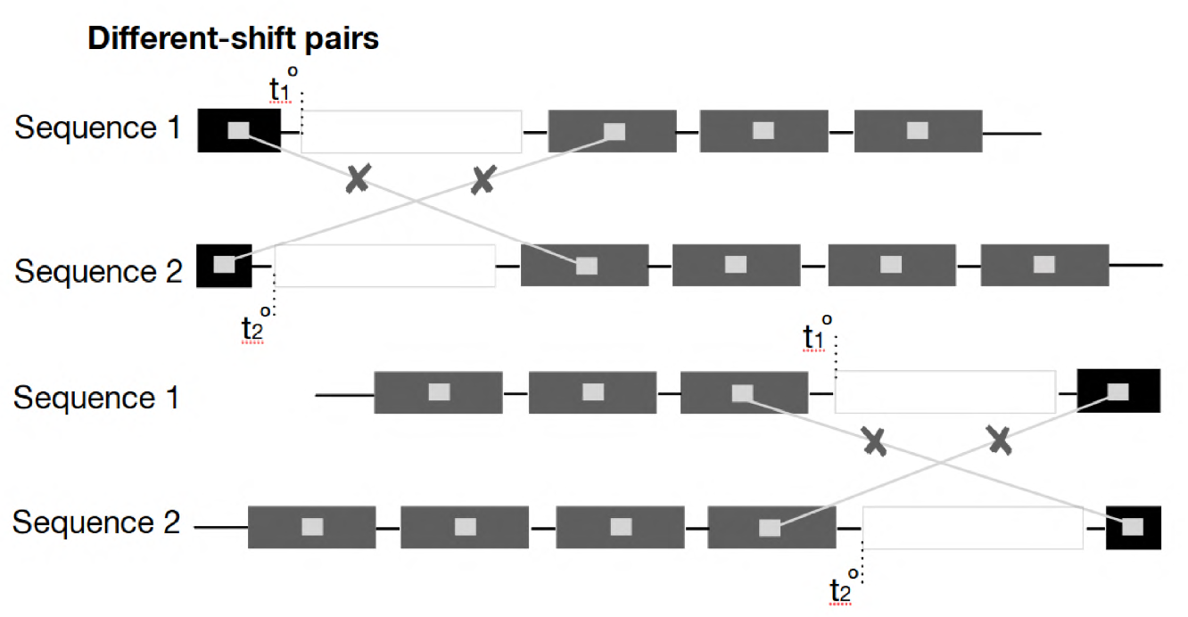

Figure 12: Sketch of different-shift pairings. For CS1 no different-shift pairs can be identi- fied, resulting in a failed test.

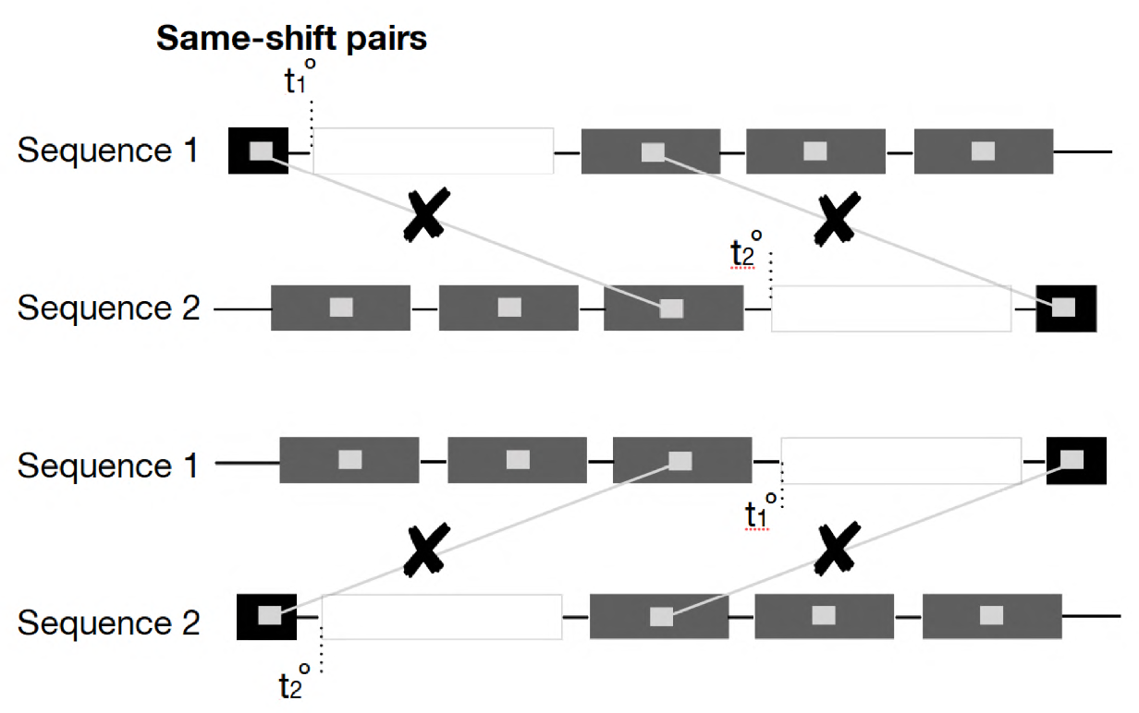

Figure 13: Sketch of same-shift pairings. When the lag between optimal reference points is too large to accommodate a validation window in both signatures, both CS1 and CS2 fail.

0.6

0.5

Type II error rate

0.4

0.3

0.2

method: CS1 method: CS2

Figure 14: Type II error rates observed across a range of window sizes for optimization *wo*. For a window size of *wo* = 130 we see a minimum in type II error rate across all type I rates considered. Smaller validation sizes *wv* are typically associated with a smaller type II error.

90 120 150 180 210 90 120 150 180 210

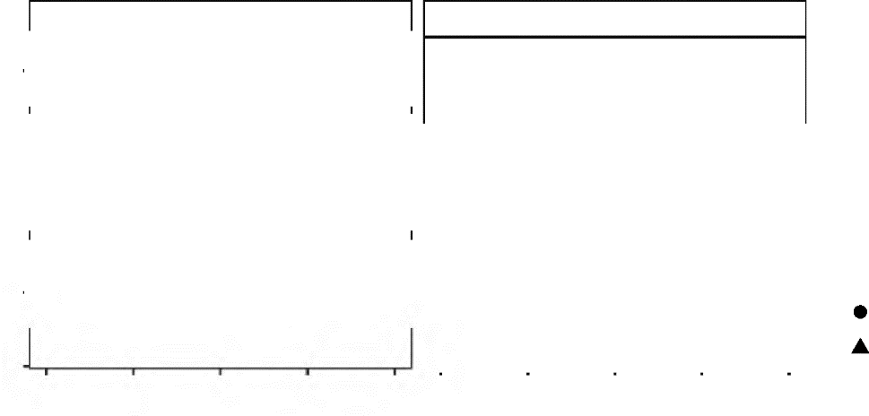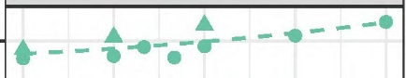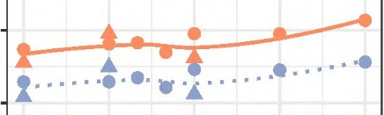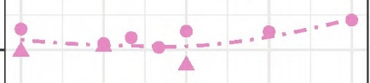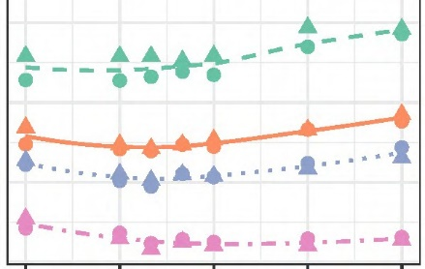

Window size for optimization wo

Nominal type I error 

0.001

0.005

0.01

0.05

Size of

validation window wv

30