**1.INPUT 3 NUMBERS AND FIND SUM AND AVERAGE**

**SOURCE CODE:**

1. **a=eval(input("enter number:"))**
2. **b=eval(input("enter number:"))**
3. **c=eval(input("enter number:"))**
4. **s=a+b+c**
5. **avg=s/3**
6. **print("sum:",s,"\naverage:",avg)**

**OUTPUT:**

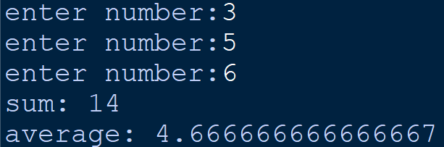**2.MENU DRIVEN –ALL ARITHMETIC OPERATIONS**

**SOURCE CODE:**

1. **n1,n2=eval(input("enter first number:")),eval(input("enter second number:"))**
2. **o=input("""+ for addition\n- for subtraction\nx for multiplicaton**
3. **/ for division\n^ for exponentiation\nenter operation:""")**
4. **if o == "+":**
5. **print("sum is",n1+n2)**
6. **elif o == "-":**
7. **print("difference is",n1-n2)**
8. **elif o == "x":**
9. **print("product is",n1*n2)**
10. **elif o == "/":**
11. **try:**
12. **print("quotient is",n1//n2)**
13. **print("remainder is",n1%n2)**
14. **except ZeroDivisionError:**
15. **print("""you cannot divide a number by zero**
16. **any number divided by zero is not defined""")**
17. **elif o == "^":**
18. **print("",n1**n2)**
19. **else:**
20. **print("invalid operator")**

**OUTPUT:**

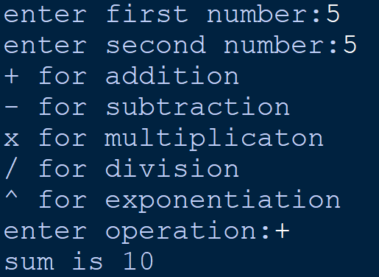

**3.AREA AND PERIMETER OF RECTANGLE**

**SOURCE CODE:**

1. **l =eval(input("enter breadth:"))**
2. **b=eval(input("enter length:"))**
3. **print("area:",l*b,"\nperimeter:",2*(l+b))**

**OUTPUT:**

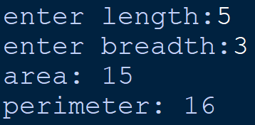

**4.SUM OF N NATURAL NUMBERS**

**SOURCE CODE:**

1. **n=int(input("enter number:"))**
2. **s=0**
3. **for i in range(1,n+1):**
4. **s+=i**
5. **print("sum of",n,"natural numbers is",s)**

**OUTPUT:**

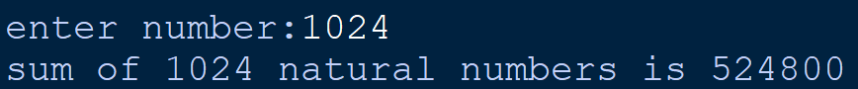

**5.FACTORIAL OF A NUMBER**

**SOURCE CODE:**

1. **n=int(input("enter a number:"))**
2. **p=1**
3. **for i in range(1,n+1):**

**p*=i**

1. **print(n,"factorial is",p)**

**OUTPUT:**

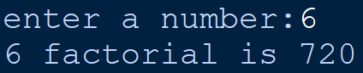

**6.MULTIPLICATION TABLE OF A NUMBER**

**SOURCE CODE:**

1. **n=int(input("enter a number:"))**
2. **print("\nMULTIPLICATION TABLE")**
3. **for i in range(1,11):**
4. **print(str(n),"x",str(i),"=",str(n*i))**

**OUTPUT:**

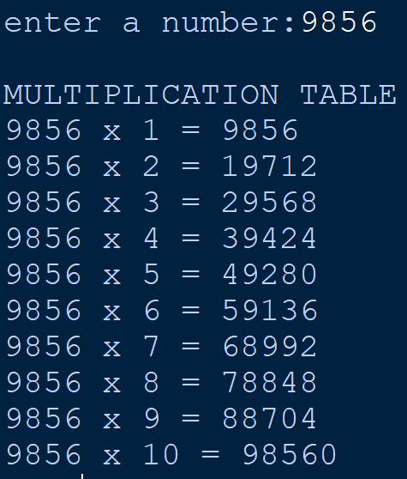

**7.FIBONACCI SERIES**

**SOURCE CODE:**

1. **n=int(input("enter no. of terms:"))**
2. **n1=0**
3. **n2=1**
4. **print("fibonacci series of",n,"numbers")**
5. **i=0**
6. **while i<n:**
7. **print(n1,end=" ")**
8. **s=n1+n2**
9. **n1=n2**
10. **n2=s**
11. **i+=1**

**OUTPUT:**

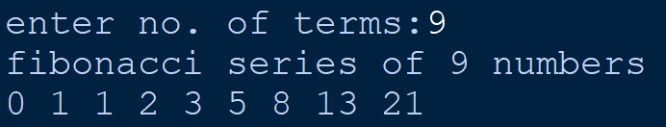

**8.ELIGIBLE TO VOTE OR NOT**

**SOURCE CODE:**

1. **age=eval(input("enter your age:"))**
2. **if age>=18:**
3. **print("you are eligible to vote")**
4. **else:**
5. **print("you are not eligible to vote")**

**OUTPUT:**

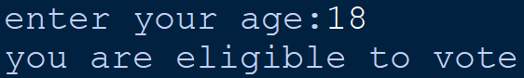

**9.GRADE OF STUDENTS-USING ELIF**

**SOURCE CODE:**

1. **grade = int(input("enter your percentage"))**
2. **if grade >= 90:**
3. **print("EXCELLENT!!! YOUR GRADE IS A1")**
4. **elif grade >= 80:**
5. **print("WONDERFUL YOUR GRADE IS A2")**
6. **elif grade >= 70:**
7. **print("YOUR GRADE IS B1")**
8. **elif grade >= 60:**
9. **print("YOUR GRADE IS B2")**
10. **elif grade >= 50:**
11. **print("YOUR GRADE IS C1")**
12. **elif grade >= 40:**
13. **print("YOUR GRADE IS C2")**
14. **else:**
15. **print("you failed")**

**OUTPUT:**

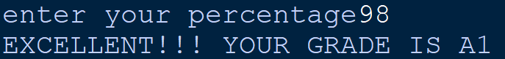

**10.WHETHER A NUMBER**

**PALINDROME OR NOT**

**SOURCE CODE:**

1. **n=int(eval(input("enter number:")))**
2. **t=n**
3. **rev=0**
4. **while t != 0:**
5. **rev=(rev*10)+(t%10)**
6. **t=int(t/10)**
7. **if n == rev:**
8. **print("number is palindrome")**
9. **else:**
10. **print("number is not palindrome")**

**OUTPUT:**

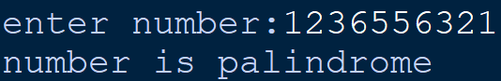

**11. WHETHER A STRING**

**PALINDROME OR NOT**

**SOURCE CODE:**

1. **n=input("enter string:")**
2. **n=n.casefold()**
3. **if n == n[::-1]:**
4. **print("THIS IS A PALINDROME")**
5. **else:**
6. **print("THIS IS NOT A PALINDROME")**

**OUTPUT:**

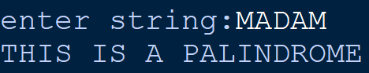

**12.COUNT NUMBER OF WORDS AND VOWELS IN A STRING**

**SOURCE CODE:**

1. **b=input("enter anything:")**
2. **a,c=0,0**
3. **x=b.split()**
4. **for i in x:**
5. **a+=1**
6. **for i in b:**
7. **if i in "aeiouAEIOU":**
8. **c+=1**
9. **print("Words:",a,"\nVowells:",c)**

**OUTPUT:**



**13.SORT EACH WORD IN A STRING**

**SOURCE CODE:**

1. **a=input("ENTER ANYTHING:")**
2. **b=a.split()**
3. **for j in range(len(b)-1):**
4. **for i in range(len(b)-1):**
5. **if b[i]>b[i+1]:**
6. **b[i],b[i+1]=b[i+1],b[i]**
7. **print("LIST AFTER SORTING:",b)**

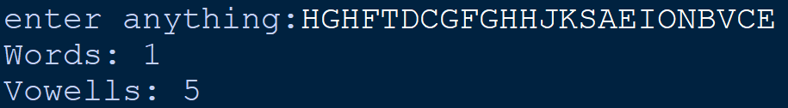**OUTPUT:**

**14.TO FIND SUM AND AVERAGE OF ELEMENTS IN A LIST**

**SOURCE CODE:**

1. **n=None**
2. **while n==None:**
3. **try:**
4. **n=int(input("enter limit:"))**
5. **except ValueError:**
6. **print("limit is a number")**
7. **n=None**
8. **s,a,i=0,[],0**
9. **print()**
10. **while i<n:**
11. **try:**
12. **g=int(input("enter a number:"))**
13. **a.append(g)**
14. **i+=1**
15. **except ValueError:**
16. **print("you are supposed to only enter numbers")**
17. **for i in range(len(a)):**
18. **s+=a[i]**
19. **avg=s/n**
20. **print("\nsum:",s,"\naverage:",avg)**

**OUTPUT:**

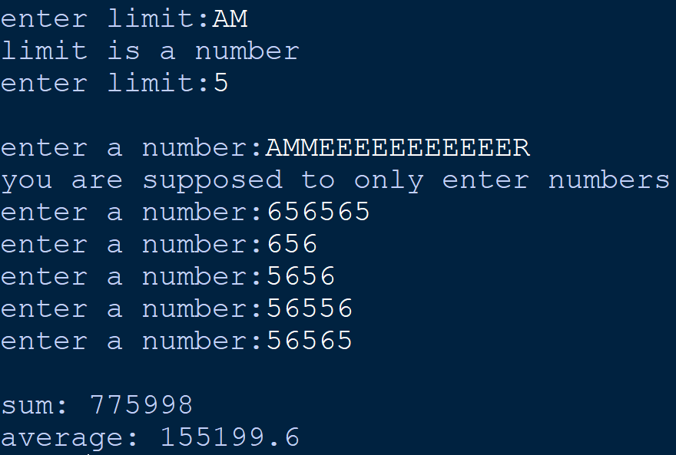

**15.TO FIND LARGEST ELEMENT IN A LIST**

**SOURCE CODE:**

1. **n=int(input("enter limit:"))**
2. **a=[]**
3. **i=0**
4. **while i<n:**
5. **try:**
6. **g=int(input("enter a number:"))**
7. **a.append(g)**
8. **i+=1**
9. **except ValueError:**
10. **print("you are supposed to only enter numbers")**
11. **print("largest element is",max(a))**

**OUTPUT:**

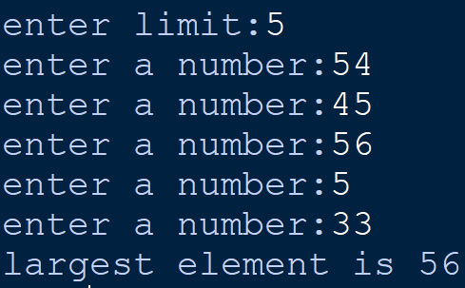

**16.TO PRINT ANY PATTERN (NESTED LOOP)**

**SOURCE CODE:**

1. **for i in range(5):**
2. **for j in range(i):**
3. **print("*",end=" ")**
4. **print()**

**OUTPUT:**



**17.TO PERFORM LINEAR SEARCH**

**SOURCE CODE:**

1. **n=int(input("limit:"))**
2. **l=[]**
3. **for i in range(n):**
4. **item=eval(input("enter number:"))**
5. **l.append(item)**
6. **p=eval(input("enter no to search:"))**
7. **pos=-25**
8. **for i in range(n):**
9. **if l[i]==p:**
10. **pos=i**
11. **if pos==-25:**
12. **print("item not found")**
13. **else:**
14. **print("\nITEM FOUND AT\nindex:",pos,"\nand position",pos+1)**

**OUTPUT:**

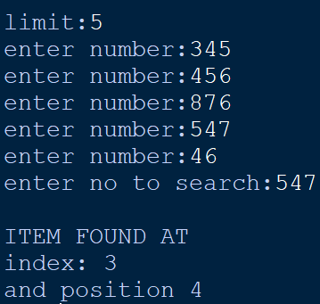

**18.TO IMPLEMENT BUBBLE SORT**

1. **a=int(input ("enter limit:"))**
2. **list=[]**
3. **for num in range(a):**
4. **item=int(input("enter number:"))**
5. **list.append(item)**
6. **for i in range(a-1):**
7. **for j in range(a-i-1):**
8. **if list[j]>list[j+1]:**
9. **list[j],list[j+1]=list[j+1],list[j]**
10. **print("after sorting:",list)**

**OUTPUT:**

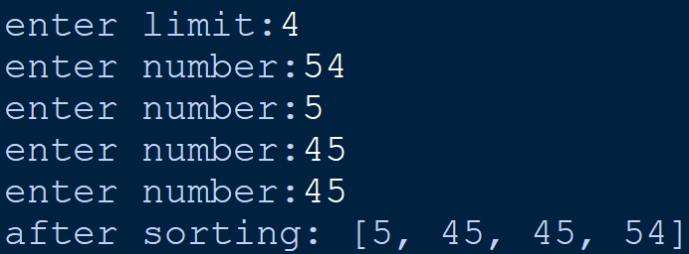

**19.TO IMPLEMENT INSERTION SORT**

**SOURCE CODE:**

1. **y=int(input("enter limit:"))**
2. **list=[]**
3. **for i in range(y):**
4. **item=int(input("enter number:"))**
5. **list.append(item)**
6. **for i in list:**
7. **j=list.index(i)**
8. **while j>0:**
9. **if list[j-1]>list[j]:**
10. **list[j-1],list[j]=list[j],list[j-1]**
11. **else:**
12. **break**
13. **j-=1**
14. **print(list)**

**OUTPUT:**

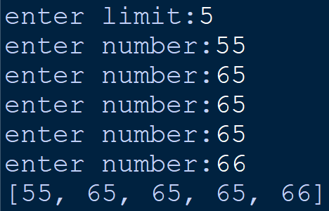

**20.INPUT 2 TUPLES AND SWAP THEIR DATA**

**SOURCE CODE:**

1. **t=()**
2. **t2=()**
3. **n=int(input("limit OF FIRST TUPLE:"))**
4. **i=0**
5. **while i<n:**
6. **a=int(input("enter number:"))**
7. **t+=(a,)**
8. **i+=1**
9. **n2=int(input("\nlimit of SECOND TUPLE:"))**
10. **for i in range(n2):**
11. **d=int(input("enter number:"))**
12. **t2+=(d,)**
13. **print("BEFORE SWAPPING\nfirst tuple:",t,**
14. **"\nsecond tuple:",t2)**
15. **t,t2=t2,t**
16. **print("\nafter swapping","\nfirst tuple:",**
17. **t,"\nsecond tuple:",t2)**

**OUTPUT:**

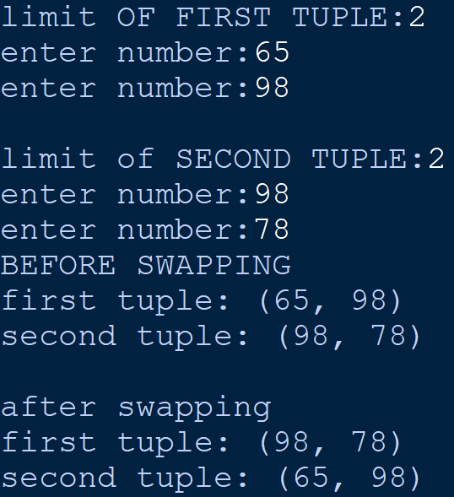

**21.TO FIND MAXIMUM AND MINIMUM VALUE IN A TUPLE**

**SOURCE CODE:**

1. **t=()**
2. **t2=()**
3. **n=int(input("limit:"))**
4. **i=0**
5. **s=0**
6. **while i<n:**
7. **a=int(input("enter number:"))**
8. **t+=(a,)**
9. **i+=1**
10. **print("\ntuple is",t,"\nmaximum of tuple:",max(t),**
11. **"\nminimum of tuple:",min(t))**

**OUTPUT:**

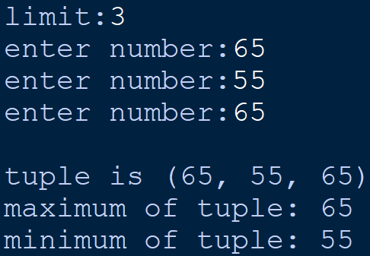

**22.TO FIND PHONE NUMBER BY NAME**

**SOURCE CODE:**

1. **phone = dict()**
2. **n = int(input("Enter number of entries:"))**
3. **for i in range(1,n+1):**
4. **name = input("Enter name:")**
5. **phone_no = int(input("Enter phone number:"))**
6. **phone[name] = phone_no**
7. **li = phone.keys()**
8. **x = input("Enter Name to search for Phone_number:")**
9. **for i in li:**

1. **if i == x:**
2. **print(phone[i])**

**OUTPUT:**

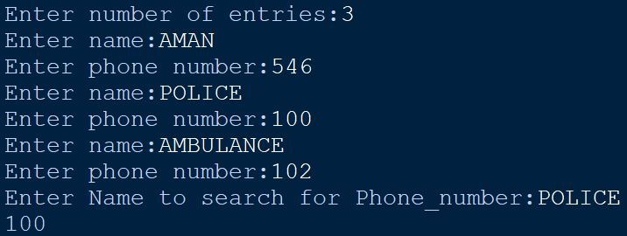

**23.TO FIND SALARY OF EMPLOYEES**

**SOURCE CODE:**

1. **emp = dict()**
2. **n = int(input("Enter number of entries:"))**
3. **for i in range(n):**
4. **name = input("Enter name:")**
5. **basic = float(input("Enter basic salary:"))**
6. **hra = float(input("Enter House Rent Allowance:"))**
7. **ca = float(input("Enter Conveyance Allowance:"))**
8. **emp[name] = (basic, hra, ca)**
9. **l = emp.keys()**
10. **print("\nName\t\t\tNet Salary")**
11. **for i in l:**
12. **salary = 0**
13. **z=emp[i]**
14. **for j in z:**
15. **salary+=j**
16. **print(i,"\t\t\t",salary)**

**OUTPUT:**

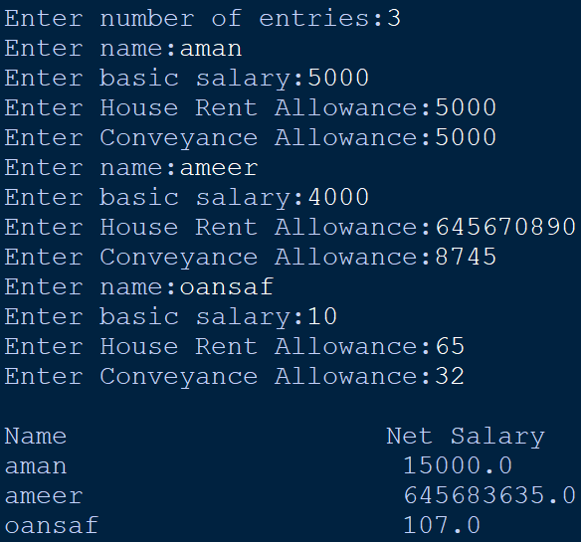



**24.PROGRAM TO INPUT COUNTRIES AND THEIR CURRENCIES USING DICTIONARY**

**SOURCE CODE:**

1. **count = dict()**
2. **n = int(input("Enter Number of Countries:"))**
3. **for i in range(n):**
4. **co = input("Enter Country Name:")**
5. **ca = input("Enter Country Capital Name:")**
6. **cu = input("Enter Country Currency Name:")**
7. **count[co] = (ca,cu)**
8. **l = count.keys()**
9. **print("\nCountry\t\tCapital\t\tCurrency")**
10. **for i in l:**
11. **z = count[i]**
12. **print("\n",i,"\t",end="\t")**
13. **for j in z:**
14. **print(j,"\t",end="")**
15. **x = input("\nEnter Country to Search:")**
16. **for i in l:**
17. **if i == x:**
18. **print("\nCountry\t\tCapital\t\tCurrency")**
19. **z = count[i]**
20. **print(i,"\t\t",end="")**
21. **for j in z:**
22. **print(j,"\t",end="")**
23. **Break**

**OUTPUT:**

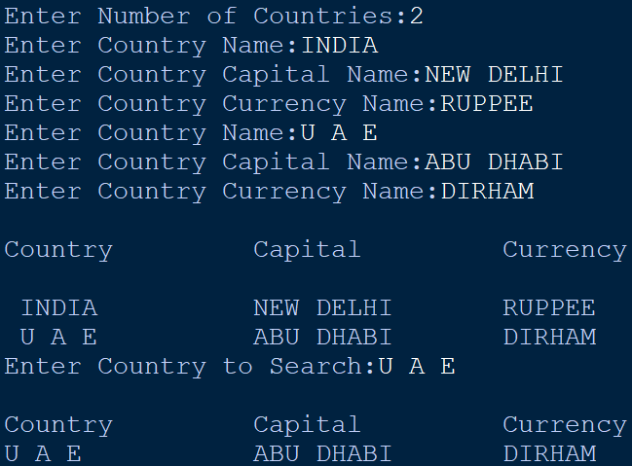

**25.TO CALCULATE AVERAGE AND MEDIAN OF HEIGHT**

**SOURCE CODE:**

1. **from statistics import \***
2. **n = int(input("Enter number of students:"))**
3. **l=list()**
4. **for i in range(n):**

**height = float(input("enter height of student:"))**

**l.append(height)**

1. **avg = mean(l)**
2. **med = median(l)**
3. **print("Average height is ",int(avg),"\nMedian height is ",int(med))**

**OUTPUT:**

