**Methods for preparing zooplankton data for model input**

**Revised 12/27/2019**

The methods used to populate the previous version of the model with inputs of zooplankton food for delta smelt (Appendix A in Rose et al. 2013a) have been altered in various ways to accommodate the objectives and design of this project (Table 1). In the previous version, zooplankton in six taxonomic groups were used to represent food of delta smelt. Data on abundance (number m-3) were obtained from the Interagency Ecological Program zooplankton monitoring database and the CDFW 20-mm survey. The zooplankton program has collected zooplankton abundance data monthly at 16–22 stations during the period represented by the model of 1995–2005. The 20-mm survey has sampled at 49–52 stations each year, generally during March or April to July. These were used with estimates of carbon mass per individual to obtain estimates of biomass (mgC m-3) for each taxon (species or higher taxonomic level) and major life stage. Data for each taxon, spatial box, and sampling date were increased by a small number (to allow for zeros), log-transformed, and averaged. Then data were interpolated to each date in the model run by the use of a moving window of 45 days on each side of the date and averaging all values within that window for the taxon and box. A similar process was used to determine standard deviations.

Our expansion of the spatial and temporal frame of the model, together with new information about delta smelt and their habitat, led us to reconsider the sources of data and the method of converting the available data to model input.

Objective: to extend the time frame of the zooplankton data to include water years 1991 through 2011, incorporate all available zooplankton data, expand the zooplankton groups, improve the method of assigning values to boxes, and revise the parameters for prey consumption as a step in the calibration process.

Overview: Data on zooplankton abundance were obtained from all available data sets from ongoing monitoring, and converted to biomass using previously determined carbon masses per individual by species and life stage (Fig. 1). Taxa were assigned to one of 12 taxonomic and life stage prey groups (“taxa”), and stations were assigned to spatial boxes in the IBM. Biomass data were converted to matrices of proportion zero catch and log mean of non-zero data, for each day of the simulation, spatial box, and taxon for input to the IBM. Then the parameters of the functional response of the four major delta smelt life stages were determined iteratively to give reasonable proportions of prey taxa consumed and gave a mean overall consumption rate of 75% of maximum during the calibration period (Fig. 2). These parameters were also used as input to the IBM.

Data sources: Zooplankton data are available from four monitoring programs (Tables 1, 2). The three fish-monitoring programs take zooplankton samples mainly to provide information for studies of fish diets. The durations, seasons, and stations differ among these programs, and in particular the spatial extent of these programs differs widely. Sample collection and processing is more consistent among the programs, with a slightly larger mesh size used in the three fish programs, and some slight differences in sample processing and levels of species identification. In the zooplankton monitoring program an additional pump sample is taken to collect the smaller fraction (45–154 µm), which is the only suitable source of data for two of the prey taxa, copepod nauplii and *Limnoithona* spp.

Taxon codes in the three fish programs are based on those in the longer-running zooplankton program, so for most taxa there is no ambiguity. However, the level of identification differs somewhat among programs and has changed through time in all programs, presenting a challenge for finding a common description of the zooplankton assemblage. Adult copepods are usually (not always) identified to species, while juveniles are usually identified to genus; for most genera there is only one abundant species in the model domain.

Data processing: Processing the data required two principal steps: assembling the data sets and reconciling differences in identification. The data are available from CDFW through an FTP site (accessible through <http://wdl.water.ca.gov/iep/products/data.cfm>). The zooplankton data are provided as Excel files for each of the sampling gears. The fish data and associated zooplankton data are in Microsoft Access files. For analysis I exported all tables and imported them into R, then saved the data as lists of data tables in .Rdata files and wrote query functions to extract the data of interest from these lists. This resulted in smaller files and easier queries than available in Access. Data from the summer townet and fall midwater trawl surveys have identical formats, so these were combined.

We reconciled taxon names among sampling programs by merging the taxon lists from all programs and then examining the resulting table for taxa that were missing from one or two of the three data sets. These were adjusted as follows: 1) If one name was used for different taxa among data sets, the name was changed in one or two data sets to match the other(s); 2) If the taxon was either too large (e.g., mysids) or too small (e.g., rotifers) to be collected quantitatively in the net samples, the taxon was eliminated; or 3) If the taxon was described at different levels of resolution in different data sets, the coarser level of resolution was used.

Small forms such as copepod nauplii and small copepods (e.g., *Limnoithona* sp.) are collected int the zooplankton program using a pump sampler. Although these are also reported by the fish-monitoring programs, the nets used do not collect them quantitatively so data for these taxa were taken only from the pump data taken by the zooplankton program. Data for large and small zooplankton were processed separately because of the large difference in sampling density.

Stations: The association between fixed stations and boxes was determined previously for Rose et al. (2013a), except that we removed the Cache Slough complex from Box 1 (upper Sacramento) and placed it in new Box 12. Stations were assigned to boxes they were in and also to nearby boxes to increase the number of data points for each sampling day (see Appendix in Rose et al. 2013a).

Starting in 1994 the zooplankton monitoring program has also visited movable stations, one at salinity ~1 and the other at salinity ~3.2. When these salinities were found in the Delta, samples were taken in the Sacramento River, except that beginning in 2014 samples were also taken at these salinities in the San Joaquin River. One or more of these stations are omitted if the salinity at a fixed station (the substitute) is close to the target value. Beginning in 2004 the coordinates of the movable stations and any substitute station were listed in a series of spreadsheets. We eliminated movable stations that had a substitute (to avoid double-counting data) and used these coordinates to assign each movable station to the nearest box.

For data before 2004 we compared the salinity recorded for the movable stations with that recorded at fixed stations in the same survey, and eliminated four data points from movable stations where the salinity matched . Then for each survey we constructed a relationship of salinity vs. distance up the axis of the estuary (km) and interpolated to convert salinity recorded at the movable stations to distance. This was then used to assign the movable stations to boxes. In four cases salinity was not recorded at any station, and these four values were dropped.

**Selecting taxonomic groups**

Equation 10 in Rose et al. (2013a) specifies the realized ingestion rate of a given prey group by an individual fish, rearranged here:

 (1)

where Cj' is the ratio of ingestion rate to the maximum Cmax scaled to the weight of the fish W; that is, Cj' is a measure of the “success” of the fish because the growth rate of the fish will be maximized when Cj' is 1. Zj is biomass of taxon j, Vj is vulnerability, a switch (0 or 1) to turn feeding on the species group on or off, and Kj is the half-saturation constant. Subscripts j refer to the individual prey group, which may be one or more life stages, species, or other groupings, and k refers to all prey groups. With only one prey group Eqn. 2 reduces to the familiar Holling Type II functional response, a rectangular hyperbola, in which the maximum is 1 and the half-saturation constant is Kj.

If two or more species groups have the same V and K parameters, total mass consumption by a fish does not change if the groups are entered individually or combined. Therefore species groups need be entered separately only if their parameters differ for any life stage of delta smelt. Other groups may also be entered separately for convenience during calibration or when comparing among time periods (above), boxes, or sampling programs.

The criteria for selecting taxonomic groups and either lumping them or keeping them separate are:

1. Relatively abundant during at least part of the model period.
2. Abundant in all sampling programs or in one or more boxes.
3. Known or likely difference in feeding parameters for any delta smelt life stage
4. Different spatial and temporal distributions from other taxa that could affect delta smelt
5. No more than 12 prey groups

Based on these criteria we selected 12 zooplankton groups (Table 3). Copepods include adults of two species, adults and juveniles of two species combined (*Limnoithona* spp.), juveniles of three species (*Pseudodiaptomus* spp.), other calanoid adults and juveniles, other cyclopoids, and copepod nauplii (larvae). Additional taxa are *Daphnia* spp. cladocera, other cladocera, and other taxa.

**Developing master zooplankton data set**

The sampling programs report abundance (number m-3) based on counts of subsamples. I converted these to biomass using carbon mass measured on several adult copepods and other taxa (e.g., Kimmerer 2006, Gould and Kimmerer 2010, Kimmerer et al. 2017). Copepodites (juvenile copepods) were assumed to have about 25% of the carbon mass of adults based on their median life stage (copepodite 3) and the ratios of copepodite to adult masses for several species discussed in the above references. Masses for several other taxa were estimated from their size using literature values.

Large zooplankton were collected with 154–160 µm mesh nets towed obliquely through the water column. I used the combined data from all zooplankton monitoring studies. The first steps were to remove taxa that were not reported in the EMP zooplankton database and those with a mean biomass among all samples less than 0.05 mgC m-3. Then I examined the biomass of each taxon in the three databases, as well as biomass in the low-salinity zone and the Cache Slough complex. There was general agreement among the databases and locations for most taxa.

Biomass data were natural-log-transformed with zeros in the original data flagged and replaced with a value of -5 which is below the minimum non-zero value. Data for each box, taxon, and sampling date were placed in two arrays, the first containing the log-transformed data excluding zeros (or -5 if all were zero). The second array contained a value of 1 for each zero value in the raw data. Then data in each array were averaged across all samples within a box, taxon, and date, though not all dates had complete samples. In addition box 12 was sampled only beginning in 1995, and then only in the southern portion of the box and during spring. In 2005 additional sampling began in summer–fall.

To fill out the data for Box 12 I first examined the data for correlations among boxes. Biomass in boxes 2-5 had strong relationships with that in Box 12, depending on the taxon. We therefore calculated models in which Box 12 biomass was modeled as a linear combination of data from Boxes 2-5. These models were used to predict the mean of the log-transformed non-zero values for Box 12 when data were missing. The proportion of zeros could not be modeled this way because much of the available data in Box 12 comprised only a single sample, but all the taxa had strong seasonal patterns of presence/absence. Therefore for each taxon we modeled the proportion of zeros as a smoothed function of julian day with a binomial error distribution (function *gam* in R package *mgcv*) and used that to predict the proportions of zeros for each taxon.

The next step was to extend the data for each sampling event in each box into each day of the model period. As before (Rose et al. 2013a) we applied a moving window of ± 45 d around each date, and calculated means of all non-missing data for a given box and taxon within that window. Because sampling ceased during winter of 1989–1993, gaps in the data were too wide to be filled by the moving window, so I interpolated the data linearly across the gaps. Then the data were exported as individual files for each taxon, each of which contained the year, julian day, and for each box either the mean log biomass or the proportion of zeros. The data are then used in the IBM by taking antilogs, then sampling from a binomial distribution using the proportion of zeros to get the probability of getting a zero; if a uniform (0,1) random number exceeds this probability the result is set to zero.

Small zooplankton (collected with a pump, EMP only): The pump sample is filtered through a 154 µm mesh before it is concentrated at 45 µm for counting, so the values (m-3) calculated from counts of the net and the pump samples are considered additive. The pump collects mostly rotifers, nauplii, and small copepods such as *Limnoithona* spp. Rotifers have been uncommon in the estuary since the late 1980s, and have not been reported as common in delta smelt. Copepod nauplii have not been consistently identified to genus or species, so they formed a discrete group, and *Limnoithona* another one from the small zooplankton.

Data for small zooplankton were analyzed as above, except that data were available for fewer dates, so a 60-day window was used for interpolation. Also no monitoring data for small zooplankton have been gathered in the Cache Slough complex, so the means of Boxes 4 and 5 were used to populate Box 12.

**Feeding rate parameters and outcomes**

Values of preyK and preyV (Eqn. 1, Fig. 2) were determined iteratively to achieve three objectives: 1) Set the mean proportion of maximum feeding among all samples in the calibration period (WY 1991-2001) at about 75%; 2) Prevent fish from eating prey they are not found to eat at their life stage, probably because the prey are too large or too small; and 3) Have the model fish eat prey in approximate proportion to the available data on food consumption. This was done in R by box and sampling date; because I did not weight boxes by smelt abundance this method does not constitute a calibration of food consumption within the IBM but is meant to provide a starting point for that calibration.

A data set of prey availability was constructed by selecting each sampling event during the calibration period (water years 1991–2001) when both large and small zooplankton were collected (i.e., the IEP-EMP sampling events) and calculating the biomass of each prey type from each event in each box. These excluded Box 12 because no small-zooplankton samples have been taken there, and that region has not been sampled for most of the period of record. The data for each sample date, box, and taxon included the mean natural log of biomass (zeros excluded) and the proportion of zeros. Antilogs of the means were enhanced by half of the variance (0.842/2) to account for the skewness in the lognormal distribution. Then the antilog values were multiplied by the proportion of zeros in the raw data. The values resulting from this calculation were used to calculate feeding by each life stage for months when these life stages were abundant in the model: March–May (larvae), April–July (post-larvae), July–December (juveniles), and January–March (adults).

First the preyV values were set to limit the range of prey for each life stage. We assumed that larvae could not feed successfully on adult calanoid copepods or any cladocerans (Nobriga 2002), that post-larvae could consume all prey except the large cladoceran *Daphnia*, and juveniles could consume all prey except copepod nauplii (Nobriga 2002). We assumed that adults also would not eat nauplii, and would rarely detect the small, cryptic cyclopoid copepod *Limnoithona* spp., which in any case is not very abundant before March when abundance of adult smelt declines.

Then the preyK values were adjusted to make the proportions of each taxon in the diets reflect the proportions shown in the literature on delta smelt diets by life stage (Feyrer et al. 1993, Lott 1998, Nobriga 2002, Baxter et al. 2010, and Slater and Baxter 2014). Most of these data are aggregated across dates and locations, and some are for gut contents only and corresponding plankton counts are not reported. Therefore comparisons of model output to information in these reports were qualitative, and done by life stage within their season of abundance since both the life stages and the composition of the ambient zooplankton have a strong seasonal pattern.

Initial guesses at the preyK values were based on the calibration of Rose et al. (2013a), expanded to include the additional taxa. I adjusted these iteratively by changing values by small amounts, then comparing proportional consumption with literature reports. Then the preyK values with non-zero preyV values for each stage (i.e, the prey that could be consumed by the stage) were adjusted up or down proportionally until the mean value of the proportion of maximum consumption (Cj' in Eqn. 1) was close to 0.75. These preyK values (Table 4) were then used in a similar analysis for the validation period, and as initial input to the IBM.

The realized consumption rates for the calibration period were close to the target but with wide ranges, especially for the younger stages (Table 5, Fig. 3). The statistics changed only slightly when the zooplankton data from the validation period was used (Table 5). Differences among boxes are apparent, likely a result of spatial patterns in abundance of zooplankton taxa with low preyK values; for example, values for larvae and postlarvae in Box 1 (Sacramento River) were generally lower than those in other boxes, reflecting dilution of zooplankton during the low-flow spring and early summer. Values for juveniles were generally higher in boxes 1–5 than in boxes 7-11, reflecting low abundance of adult and juvenile *P. forbesi* (see below).

To examine feeding by prey type with the selected values of preyK (Eqn. 1) I took 50 random samples from data for each life stage, sorted the samples to make adjacent samples most similar in relative prey composition, and plotted the proportions by biomass of each taxon in the available prey and in the calculated daily consumption by taxon from Eqn. 1.

Figures 4–7 show the proportions of biomass available and proportions eaten by taxon for each life stage of delta smelt, including only prey taxa with preyV=1 for a given life stage. The food available to larvae (Fig. 4) was dominated by copepod nauplii and juvenile copepods. The larvae consumed mainly juvenile copepods, primarily *P. forbesi* and other calanoids. Post-larvae are able to consume a larger array of prey types than larvae (Fig. 5); the more diverse prey field contained high proportions of copepod nauplii, juvenile and adult copepods, and some cladocerans, but the fish ate mostly juvenile copepods. The juvenile prey field was also diverse, partly because of seasonal decreases in abundance of warm-water species such as *P. forbesi* (Fig. 7). Consumption was similarly diverse though it emphasized adult copepods when they were available, especially *P. forbesi,* and total consumption was positively related to abundance of *P. forbesi.* The diets included some cladocerans and *Limnoithona* when there was little else to eat, which is consistent with gut-content data (Slater and Baxter 2014). The food availability in late winter-early spring when adults were present was much richer in cladocerans such as *Daphnia*, substantial proportions of cyclopoid copepods, and some calanoids. Adults (Fig. 7) consumed mainly adult calanoids and *Daphnia* spp., feeding at the larger end of the prey spectrum.

Feeding during the validation period resulted in similar overall consumption rates (Figs. 8–11) but prey availability and therefore feeding during the validation period was rather different because of shifts in the prey abundance patterns. For postlarvae adult copepods made up a lower proportion of the available prey, and nauplii a higher proportion, than during the calibration period, but proportions of consumption of the prey were not much different between the two periods because parameters for postlarvae were set so they did not eat many nauplii. The prey available to juveniles was very different during validation than calibration, with a much higher proportion of *Limnoithona* and *Acartiella* at the expense of *P. forbesi*. These differences are reflected in the proportions consumed. For adults the principal difference in the prey field was a lower proportion of cyclopoids and a higher proportion of calanoids, so that consumption was about split between calanoids and cladocerans.

The longer-term feeding picture (Figs. 12, 13) shows high variability in space and time. In the Delta the Sacramento box often had the lowest feeding rate, which is consistent with the low zooplankton abundance owing to dilution by river flow. The Delta does not show a consistent downward trend across life stages, and for juveniles, feeding was more consistent and usually somewhat higher after the early 1990s than before. In Suisun Bay there were several years of very low feeding around 1990, and after that a consistently lower feeding rate for juveniles than before that period. Suisun Marsh (Box 9) was somewhat anomalous in its pattern.

Table 1. Changes made to algorithm for assigning zooplankton abundance to boxes.

|  |  |  |
| --- | --- | --- |
| **Feature** | **Rose et al. 2013a** | **Changes in current version** |
| Time frame | 1995–2005 | Water years 1991–2001 for calibration, 2001–2011 for validation |
| Number of taxa | 6 | 10 large 2 small |
| Method for zero catch | e-8 for large zoops, e-4 small so data could be log transformed. | Zero-inflated method with two parameters per box & day: mean of ln(biomass) for non-zero values, and proportion zeros. |
| Standard deviation | Calculated and expanded as for mean | Constant value of 0.84 based on data |
| Number of boxes | 11 | 12 with CSC split off from Box 1 (Sac) |
| Stations included | 41 from 20mm, 29 EMP | 51 from 20mm, 45 TNS, 41 MWT,  30 EMP + ~30 salinity-based stations/year starting 1994 |
| EMP sampling | Monthly sampling | Before 1989 EMP sampled twice monthly but not in winter.  1990-1993 throughout year; from 1994 monthly at ~40% of stations, and added 2–4 salinity-based stations. |
| 20mm sampling | Consistent | Box 12 1 station 1995, up to 12 by 2011 |
| TNS sampling | NA | Started in 2005 |
| MWT sampling | NA | Started in 2005 |
|  |  |  |
|  |  |  |

Table 2. Characteristics of data sources for zooplankton abundance. All programs continue, but years listed include all for which data were available in May 2017.

|  |  |  |  |  |  |
| --- | --- | --- | --- | --- | --- |
| Source | Years | Months | Stations | Net mesh | Small zoops |
| Zooplankton monitoring | 1972–2017 | Jan–Dec* | 37 ( 6–60) | 154 µm | 45–154 µm |
| 20mm survey | 1995–2016 | Mar–Aug | 41 ( 5–52) | 160 um | — |
| Summer townet survey | 2005­–2015 | Jun–Aug | 32 ( 9–32) | 160 um | — |
| Fall midwater trawl survey | 2005­–2015 | Sep–Dec | 32 (23–40) | 160 um | — |

* Mar–Nov in 1972–1976 and 1984–1994

Table 3. Zooplankton taxonomic groups and links to individual taxa. The size class is based on either sampling with a net (Large) or pump (Small). Species code is that used in the EMP zooplankton monitoring program. Taxon names are the species codes unless the group includes >1 code.

|  |  |  |  |  |  |
| --- | --- | --- | --- | --- | --- |
| Size class | Species code | Genus | Species | Taxon name | Comments |
| Large | acartela | *Acartiella* | *sinensis* | acartela | Prominent in diets in late summer (Start 1994) |
| daphnia | *Daphnia* | spp. | daphnia | Very abundant in freshwater |
| eurytem | *Eurytemora* | *affinis* | eurytem | Historically abundant, still common in spring |
| pdiapfor | *Pseudodiaptomus* | *forbesi* | pdiapfor | Most common prey (Starting 1989) |
| pdiapjuv | *Pseudodiaptomus* | spp. | pdiapjuv | Second most abundant zoop group (Starting 1990) |
| acartia | *Acartia* | spp. | othcalad | Other calanoid adults. These collectively are important prey but no particular species is that abundant in delta smelt habitat. |
| diaptom | *Diaptomus* | spp. | othcalad |
| osphran | *Osphranticum* | *labronectum* | othcalad |
| pdiapeu | *Pseudodiaptomus* | *euryhalinus* | othcalad |
| pdiapmar | *Pseudodiaptomus* | *marinus* | othcalad |
| sinocal | *Sinocalanus* | *doerrii* | othcalad |
| tortanus | *Tortanus* | sp. | othcalad |
| othcalad |  |  | othcalad |
| acarjuv | *Acartia* |  | othcaljuv | Other calanoid copepodites - as for other calanoid adults. |
| asinejuv | *Acartiella* |  | othcaljuv |
| diaptjuv | *Diaptomus* |  | othcaljuv |
| euryjuv | *Eurytemora* | *affinis* | othcaljuv |
| sinocaljuv | *Sinocalanus* |  | othcaljuv |
| tortjuv | *Tortanus* |  | othcaljuv |
| othcaljuv |  |  | othcaljuv |
| avernal | *Acanthocyclops* | *vernalis* | othcyc | Cyclopoid copepods (all stages) can be abundant at times and occur in delta smelt guts. |
| oithdav | *Oithona* | *davisae* | othcyc |
| oithsim | *Oithona* | *similis* | othcyc |
| oithspp | *Oithona* | spp | othcyc |
| cycjuv |  |  | othcyc |
| othcycad |  |  | othcyc |
| bosmina | *Bosmina* | *longirostris* | othclad | Other cladocera can be abundant at times. |
| ceriodap | *Ceriodaphnia* | spp. | othclad |
| diaphan | *Diaphanosoma* | spp. | othclad |
| othclado |  |  | othclad |
| harpact |  |  | other | Other taxa to complete the list |
| annelid |  |  | other |
| barnnaup |  |  | other |
| chironomid |  |  | other |
| crabzoea |  |  | other |
| cumac |  |  | other |
| ostrac |  |  | other |
| Small | limno | *Limnoithona* | spp. | limno | Extremely abundant, sometimes eaten (Start 1994) |
| allcopnaup |  |  | copnaup | Copepod nauplii eaten by larvae |

Table 4. Calibrated values of preyK, left blank where preyV is zero. At any prey concentration, higher levels of preyK correspond to lower feeding rates. These values were used in all subsequent analyses

|  |  |  |  |  |  |  |
| --- | --- | --- | --- | --- | --- | --- |
| Taxonomic group |  |  | preyK values for all preyV not 0 | | | |
|  | Description | Larvae | Post-larvae | Juveniles | Adults |
| acartela |  | *Acartiella sinensis* (copepod) adults |  | 75 | 2 | 0.15 |
| eurytem |  | *Eurytemora affinis* (copepod) adults |  | 13 | 1 | 0.15 |
| pdiapfor |  | *Pseudodiaptomus forbesi*  (copepod) adults |  | 5.2 | 0.9 | 1.5 |
| othcalad |  | Other calanoid copepod adults |  | 13 | 2 | 0.45 |
| pdiapjuv |  | *Pseudodiaptomus forbesi* copepodites | 0.3 | 0.5 | 3 | 1.5 |
| othcaljuv |  | Other calanoid copepodites | 0.3 | 0.5 | 5 | 1.5 |
| limno |  | *Limnoithona* spp. copepods (all stages) | 1.8 | 4.5 | 10 | 13.5 |
| othcyc |  | Other cyclopoid copepods (all stages) | 1.2 | 2.2 | 3 | 1.5 |
| allcopnaup |  | Copepod nauplii (all spp.) | 5.4 | 50 |  |  |
| daphnia |  | *Daphnia* spp. (cladocerans) |  | 75 | 3 | 0.15 |
| othclad |  | Other cladocerans |  | 50 | 10 | 0.7 |
| other |  | All other taxa |  | 24 | 15 | 1.5 |
|  |  |  |  |  |  |  |

Table 5. Summary statistics for maximum proportional feeding rate (Eqn. 1) using parameters in Table 4. Parameters preyK for the calibration period were adjusted to get a mean proportional feeding rate of ~0.75. Parameters were then used for the validation period without adjustment. N is total number of samples, and all maxima were over 0.97.

|  |  |  |  |  |
| --- | --- | --- | --- | --- |
|  | N | Mean ± SD | Median | Minimum |
| Calibration period | | | | |
| Larvae | 420 | 0.75 ± 0.18 | 0.79 | 0.23 |
| Post-larvae | 597 | 0.75 ± 0.18 | 0.79 | 0.13 |
| Juveniles | 813 | 0.75 ± 0.17 | 0.80 | 0.20 |
| Adults | 268 | 0.76 ± 0.13 | 0.77 | 0.41 |
| Validation period | | | | |
| Larvae | 329 | 0.77 ± 0.17 | 0.83 | 0.26 |
| Post-larvae | 439 | 0.76 ± 0.16 | 0.79 | 0.16 |
| Juveniles | 659 | 0.71 ± 0.18 | 0.75 | 0.19 |
| Adults | 329 | 0.78 ± 0.12 | 0.79 | 0.49 |

Figure 1. Flow diagram summarizing the process for preparing zooplankton biomass data for input to the IBM. Each text box represents a process, and blue gridded boxes represent matrices or arrays of data.

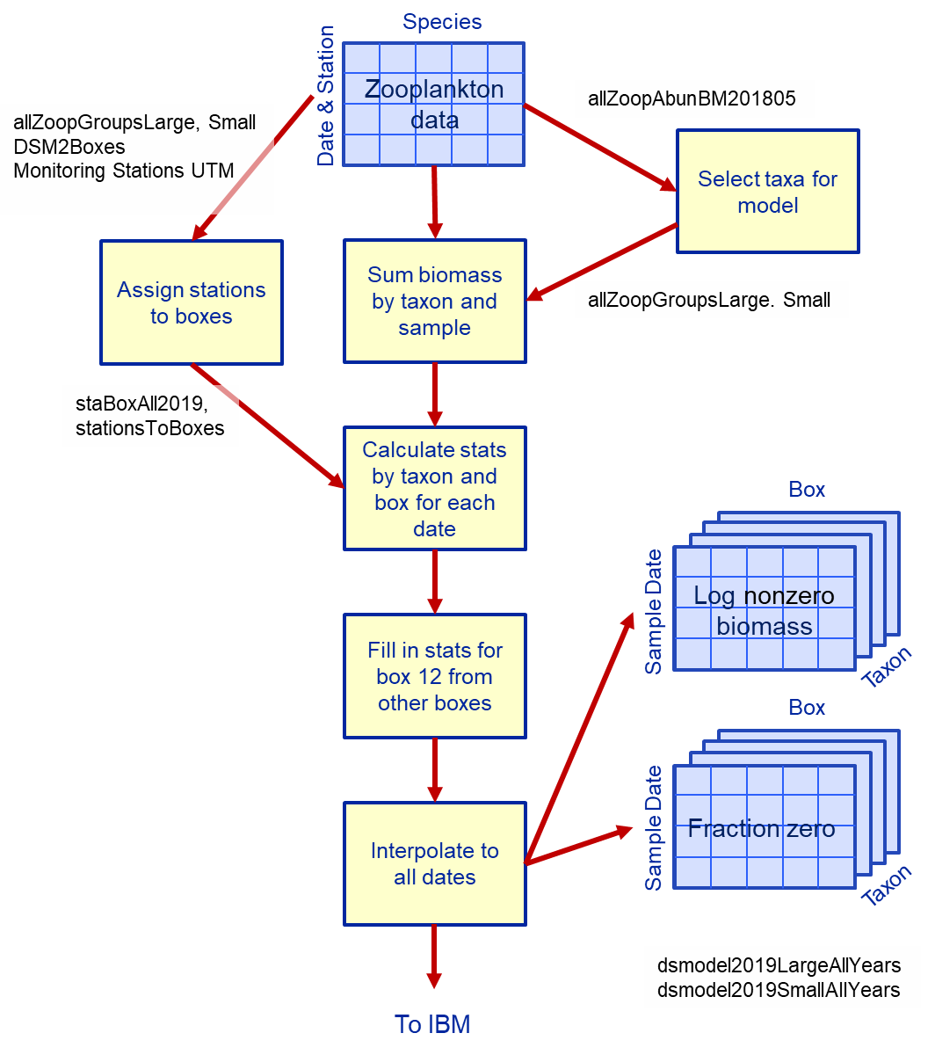

Figure 2. Flow diagram summarizing the process for determining preyV and preyK values for input to the IBM. Shapes as in Fig. 1. 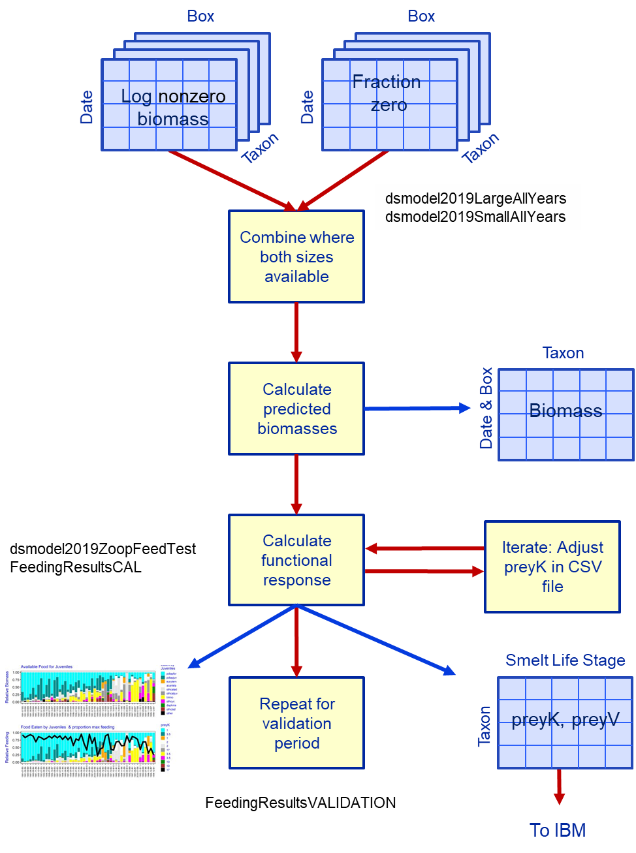

Figure 3. Boxplot of the proportion of maximum consumption (Cj' in Eqn. 1) by spatial box by delta smelt life stage for the calibration and validation periods.

Figure 4. Calibration period. Prey available and feeding by larval delta smelt. Upper panel shows relative biomass of prey taxa and lower panel shows relative feeding on each taxon, with the heavy line indicating the proportion of maximum consumption (Cj' in Eqn. 1). Data were randomly selected from the total available (Table 5) and ordered to keep similar samples close together. Labels on the X axis denote year-month-Box. Taxon names are identified in Table 3.

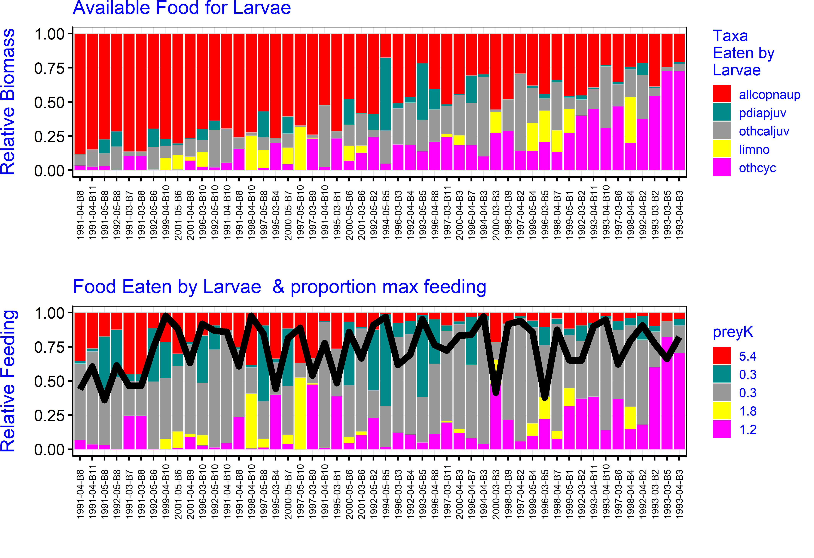

Figure 5. As in Fig. 4 for postlarvae.

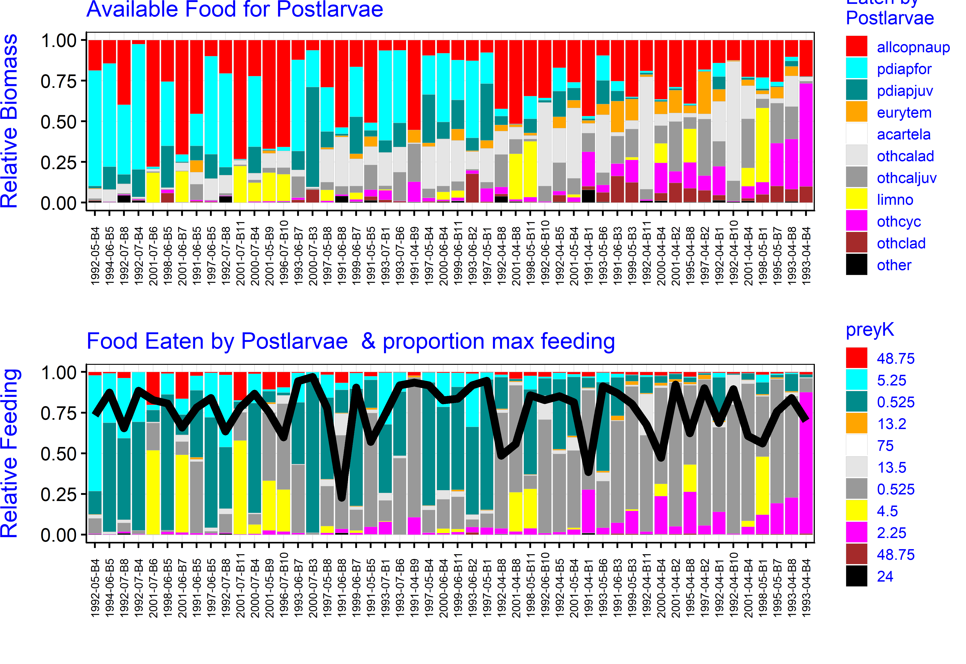

Figure 6. As in Fig. 4 for juveniles.

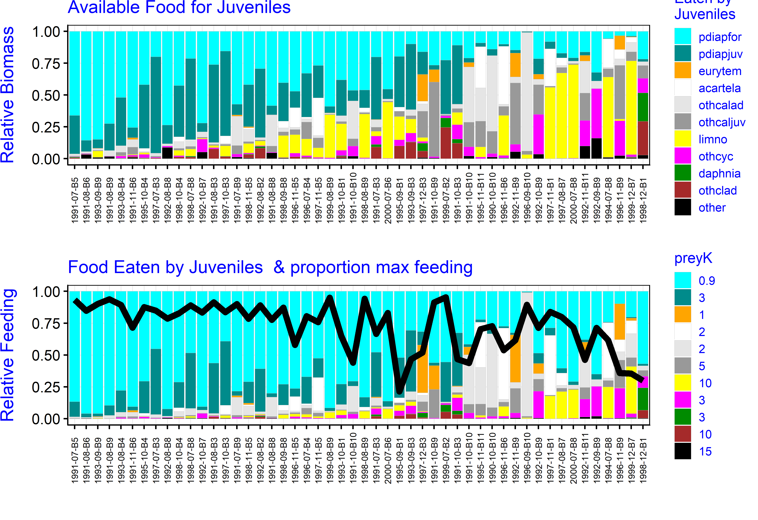

Figure 7. As in Fig. 4 for adults.

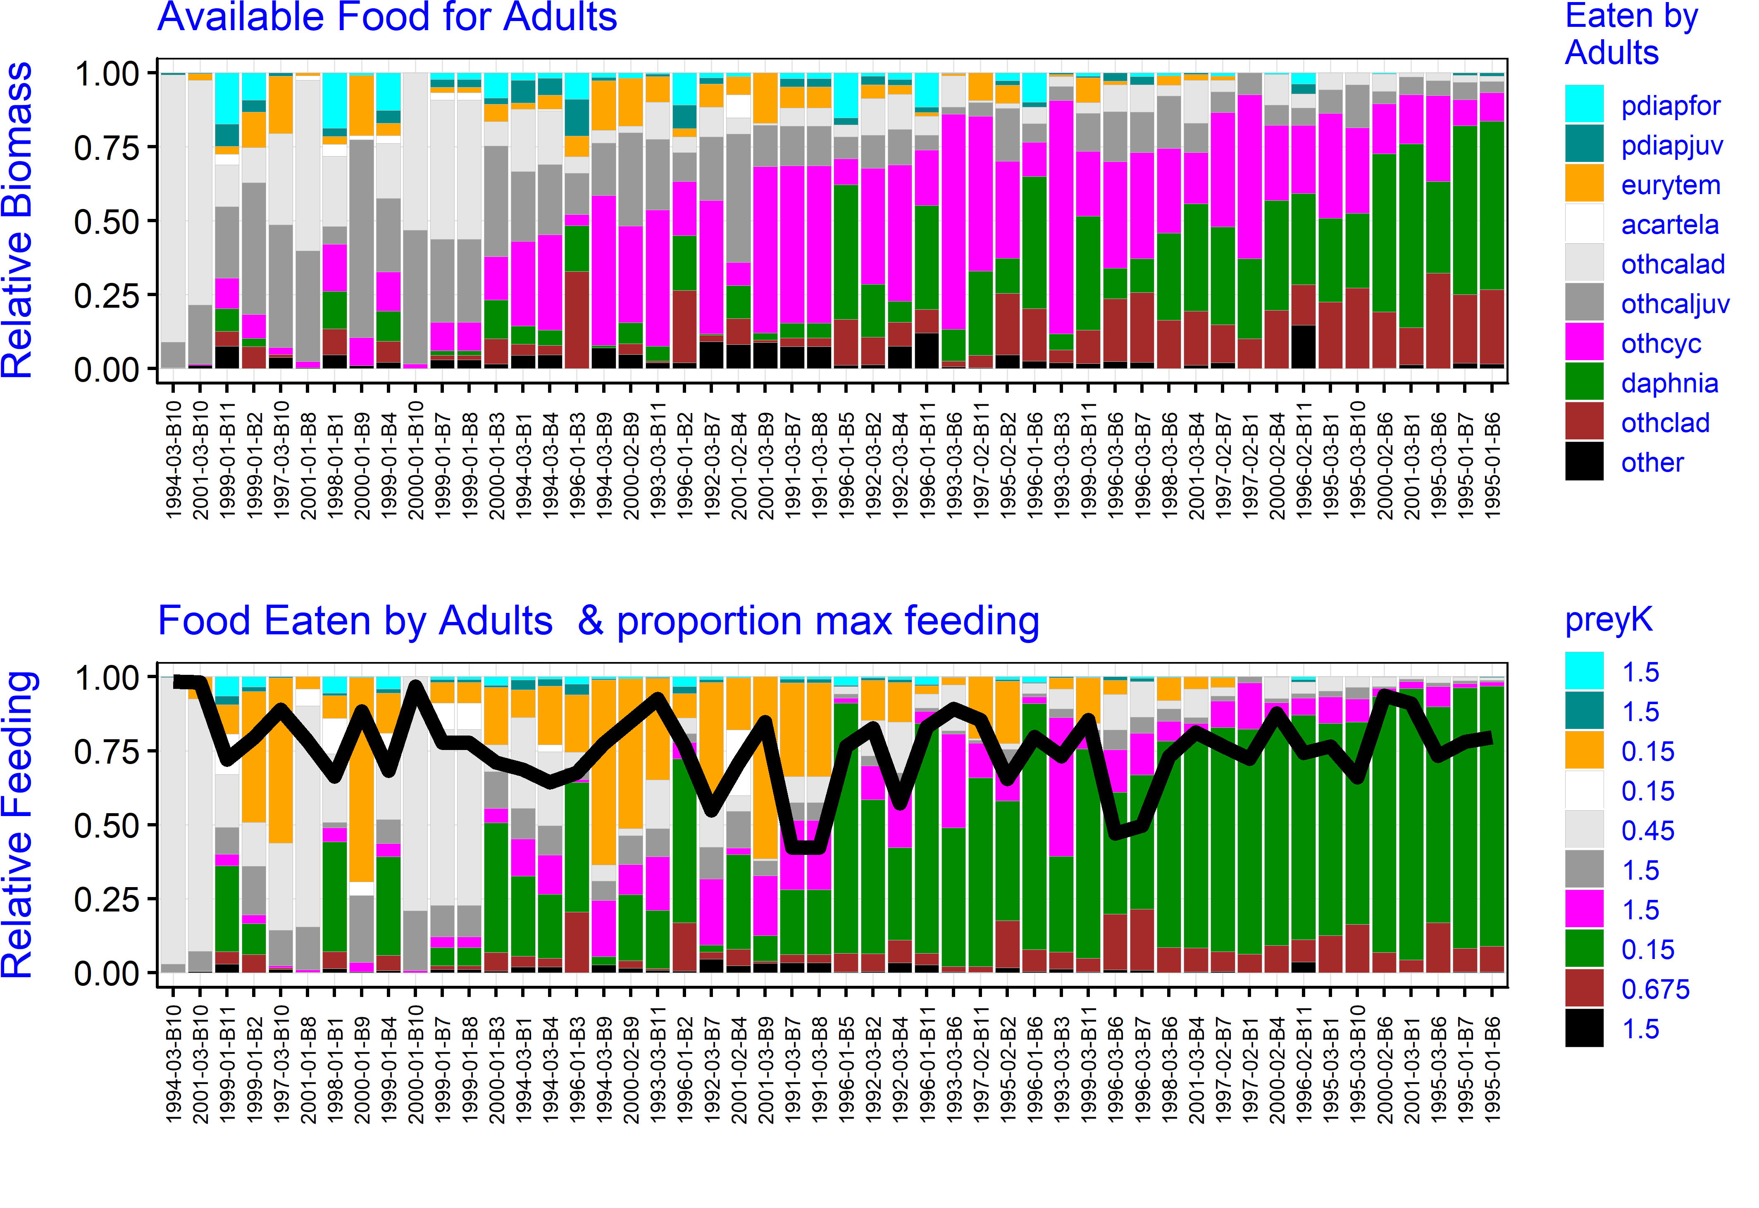

Figure 8. As in Fig. 4 for larvae in the validation period.

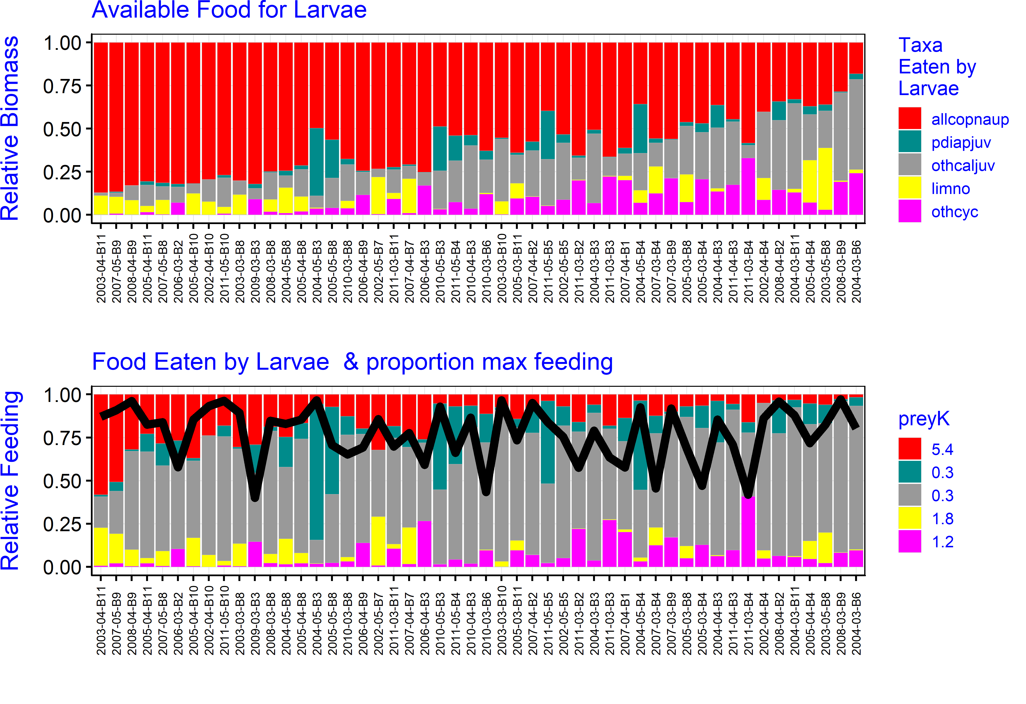

Figure 9. As in Fig. 4 for postlarvae in the validation period.

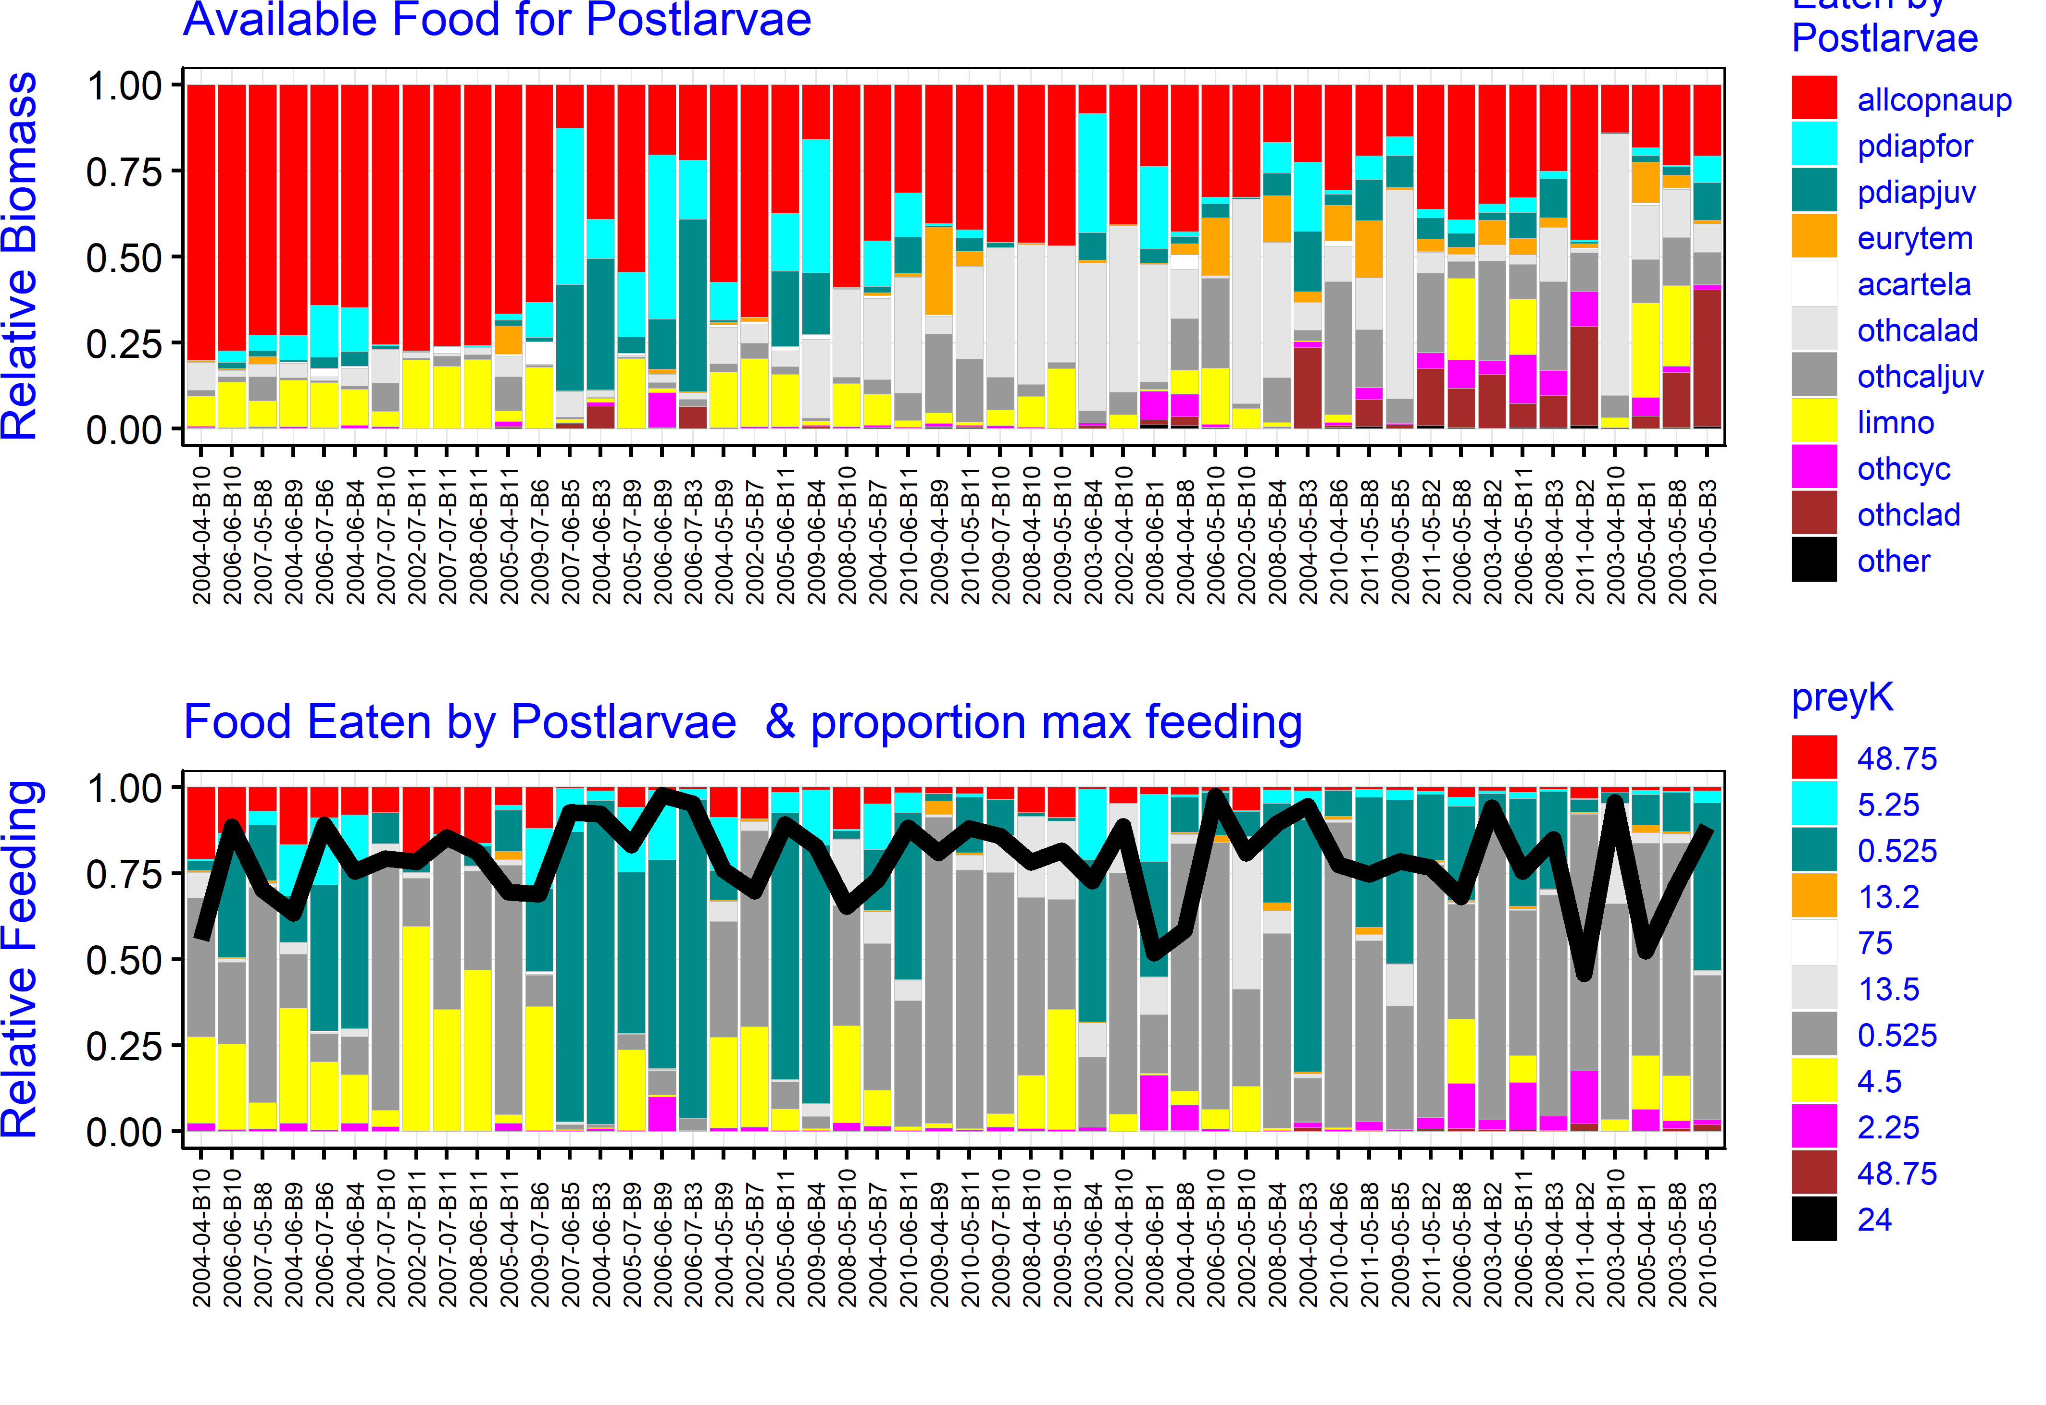

Figure 10. As in Fig. 4 for juveniles in the validation period.

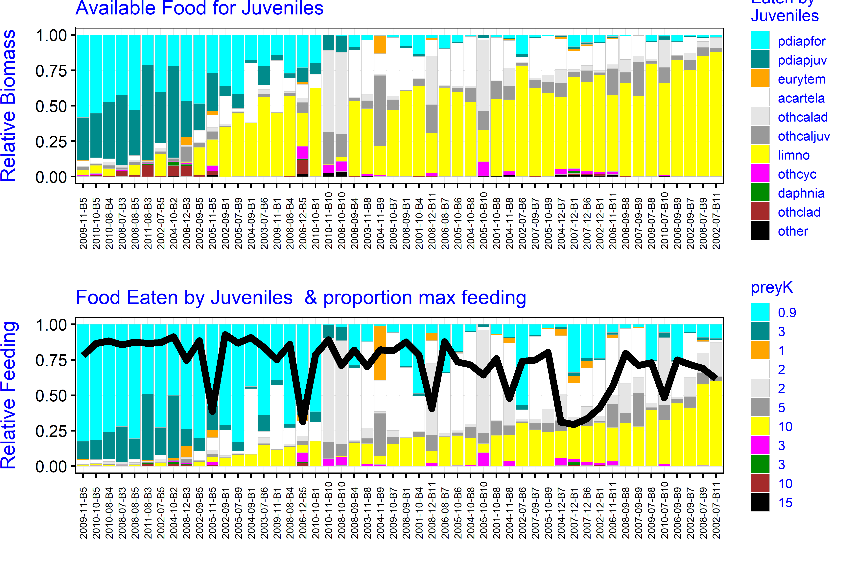

Figure 11. As in Fig. 4 for adults in the validation period.

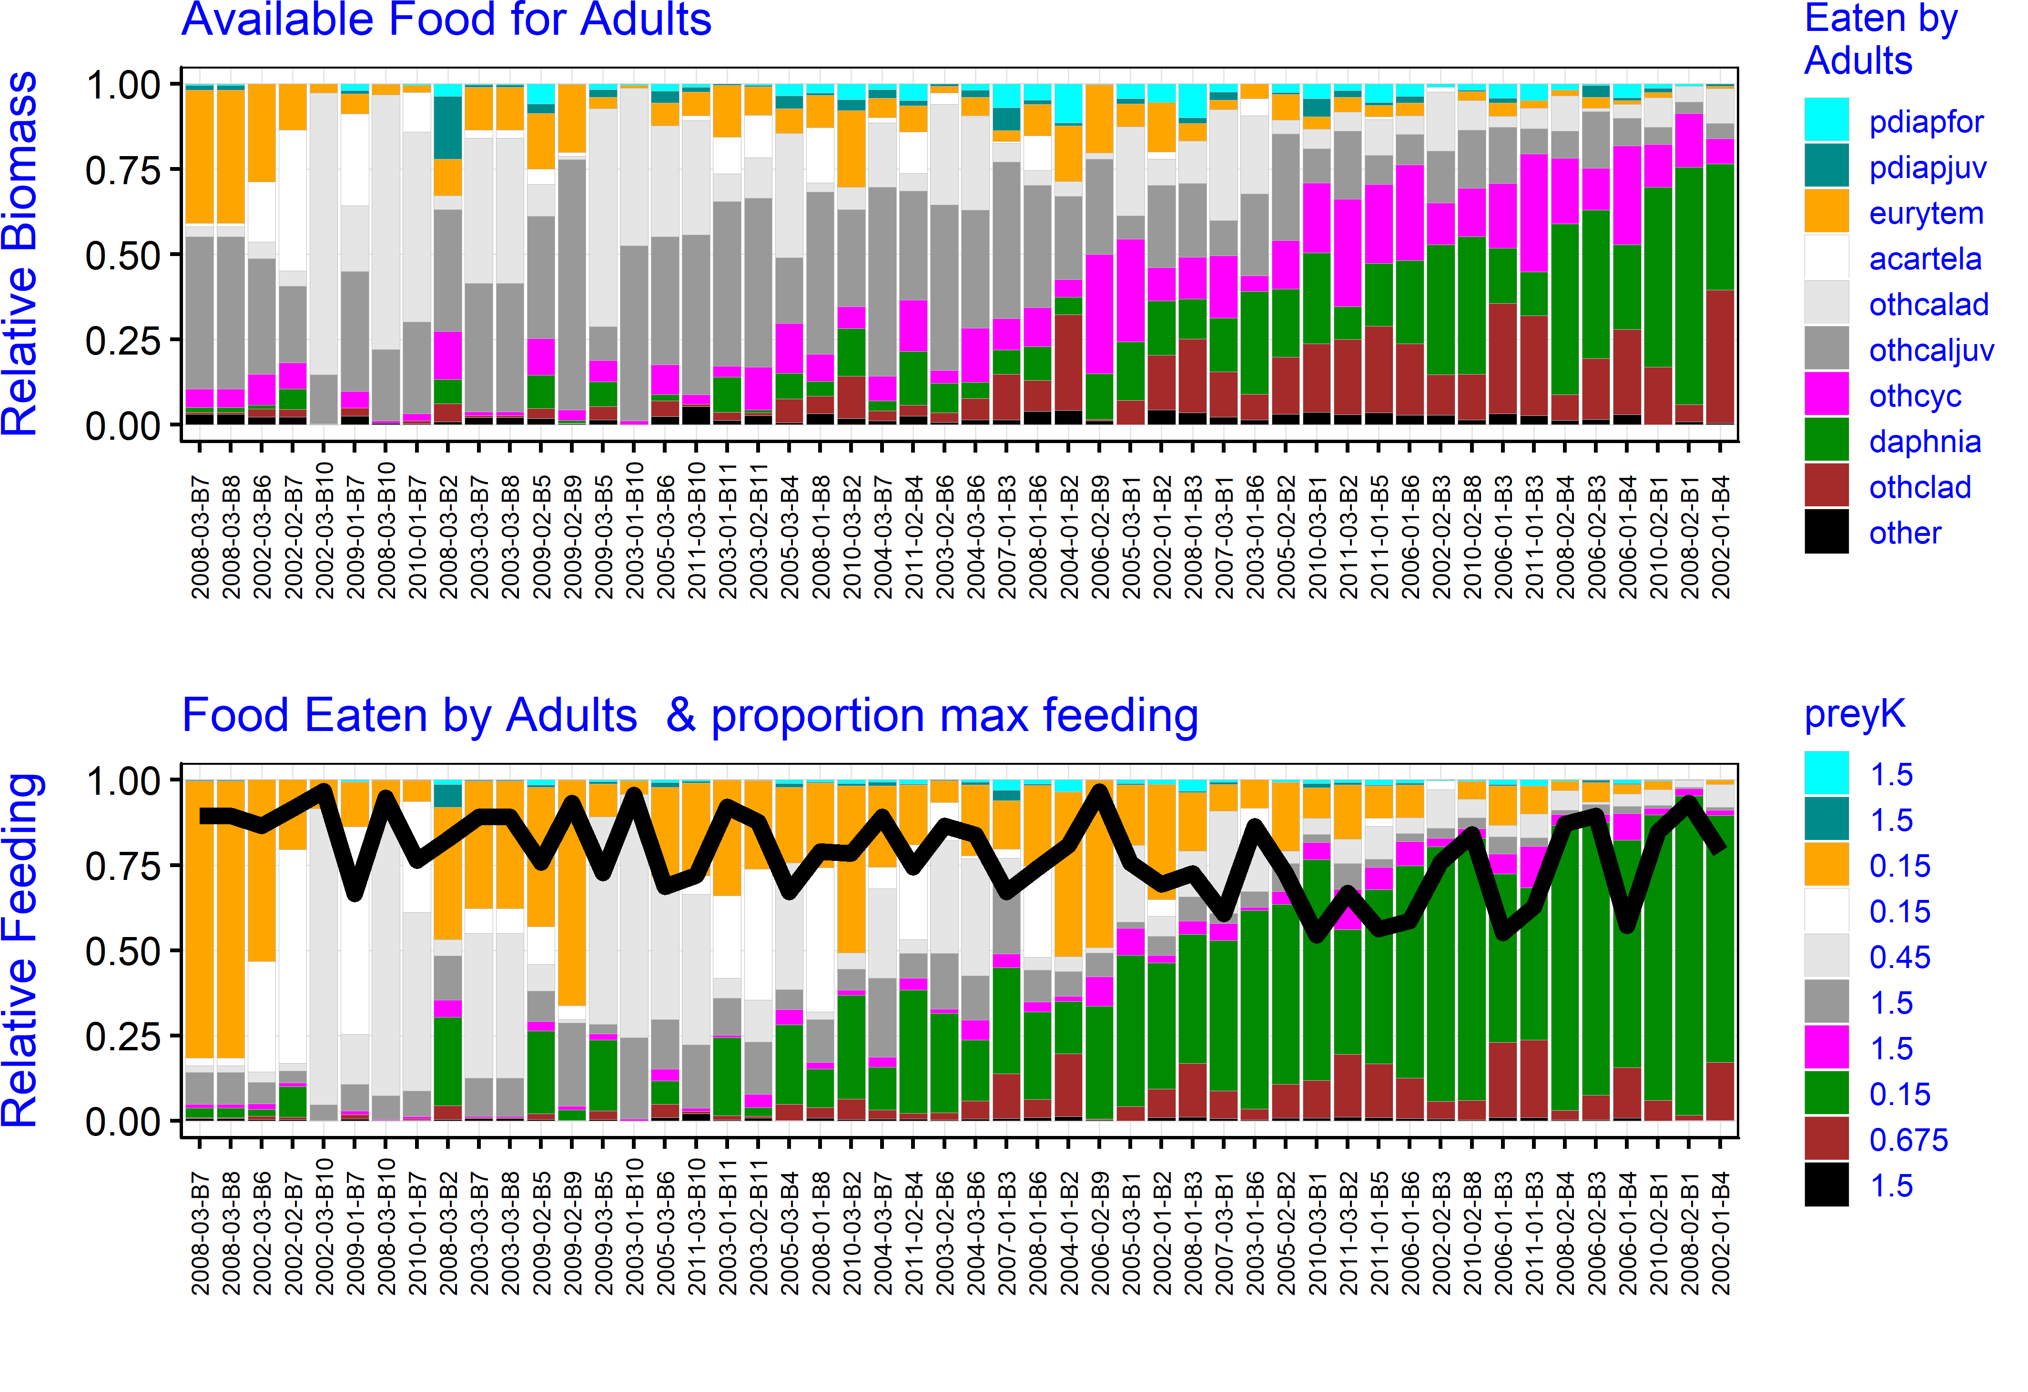

Figure 12. Fraction of maximum feeding rate vs. year by life stage for Delta (boxes 1-6) and Suisun Bay and Marsh. Values are means by year for the season of abundance of the life stage.

Figure 13. Data in Fig. 12 arranged as boxplots for three time periods reflecting major periods of change in the estuarine food web.

