Check out the

Alexa-powered Christmas Tree

|  |  |
| --- | --- |
| Germany flag icon - free download For German speakers: | The United Kingdom flag vector - free download For English speakers: |
| **Unmute the German Echo** device and **mute the English Echo** device | **Unmute the English Echo** device **and mute the German Echo** device |
| Speak to the Echo device  *“Alexa, frage Weihnachtsbaum nach Farbe* ***blau****”*  where you could replace “blau” with bunt, weiss, rot, grün, hellblau, hellgrün, gelb, gold, lila, magenta, orange, pink, rosa, dunkelrot, dunkelgrün, dunkelblau or himmelblau.  Do you want more fun? Then go for  *“Alexa, frage Weihnachtsbaum nach einer Show”* | Speak to the Echo device  *“Alexa, tell Christmas tree to turn* ***blue****”*  where you could replace “blue” with  colorful, white, red, green, blue, light blue, light green, yellow, gold, purple, magenta, orange, pink, dark red, dark green, dark blue, sky blue  Do you want more fun? Then go for  *“Alexa, ask Christmas tree for a show”* |

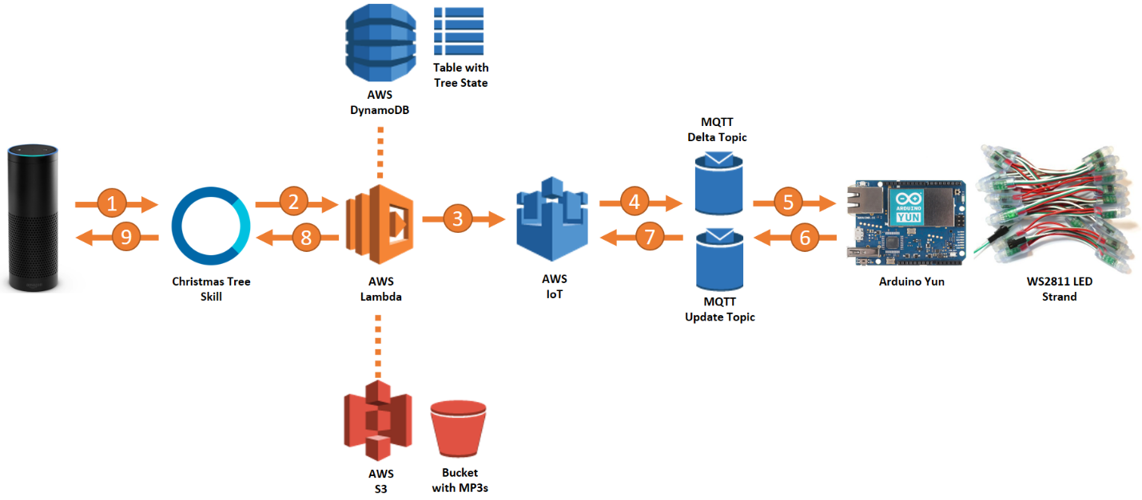

This project is open sourced and documented at <https://github.com/KayLerch/alexa-xmas-tree>

If you have any question, feel free to contact me [kaylerch@amazon.de](mailto:kaylerch@amazon.de)