Instructions for how to download and use Behave in Pycharm using BDD Framework

**Installation and downloads**:

First make sure to download the following:

* Download Python

To download the Python ,click on the link and download the Python based on the platform you are using. <https://www.python.org/downloads/>

After download , Set the Path for Command Prompt

* Download PyCharm

PyCharm is a dedicated Python Integrated Development Environment (IDE) providing a wide range of essential tools for Python developers, tightly integrated to create a convenient environment for productive [Python](https://www.jetbrains.com/help/pycharm/python.html), [web](https://www.jetbrains.com/help/pycharm/web-frameworks.html), and [data science](https://www.jetbrains.com/help/pycharm/scientific-tools.html) development. PyCharm is a cross-platform IDE that works on Windows, macOS, and Linux.

There is two versions available Community Version (free and Open sourced) and Professional Version(paid). Download Community version.

<https://www.jetbrains.com/pycharm/download/#section=windows>

Then to install Selenium in command line Type:

* Install selenium directories.

Open command Prompt -->**Type Pip install selenium**

Installing selenium should look like this:

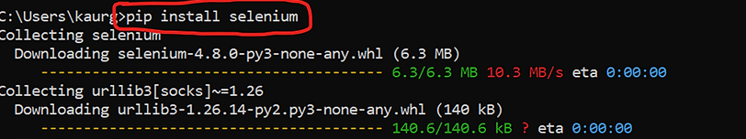

Then to install Behave in command line Type:

**Pip install behave**

This is what it looks like:

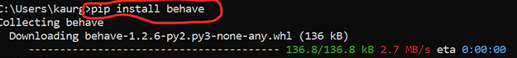

Getting Started:

Now that all the plugins and directories are installed let’s do our first project.

The project has been created.

You have successfully downloaded all corresponding files associated with this project.

**Creating the (BDD) framework for a project:**

Now let’s start creating the BDD (Behave Driven Development) for our Project.

In the BDD we will need

* Feature Directory To create the features file for all scenarios.
* Steps Directory Which will be used to create the steps.



Here is what it should look like:

Next You will need to create a new feature file under the feature folder.

To do this you need to:

Go to feature folder -> right click-> new->file->(filename)->.feature

*Make sure the file ends with the **.feature:**

Should look very similar to the following:

This will turn your feature file into a file that the Gherkin language will function properly within. More information on the Gherkin language at the following.

Green circle means the Gherkin plugin has been added to the file

More info on the Gherkin language Here:

[Gherkin Reference - Cucumber Documentation](https://cucumber.io/docs/gherkin/reference/)

**Your First Feature Using Gherkin Keywords :**

For this tutorial I’m going to use the Formy website. Here is my feature for the Formy website this feature is to validate the Formy Checkbox link page.

The following is my Feature I’m verifying:

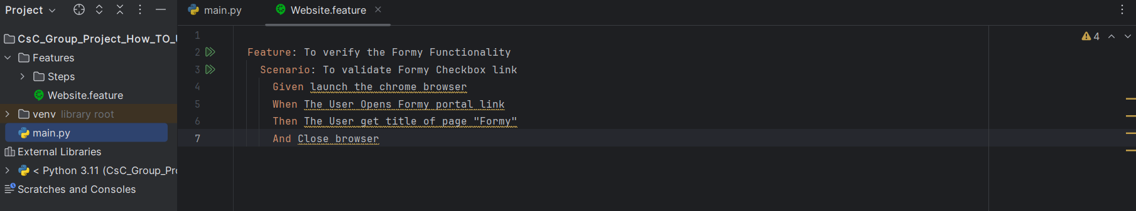

**Writing the steps for your feature**:

Next is to create the steps for your feature. To do this you have to go to your terminal and type **behave Features/(feature file name).feature**, then enter.

Here is an example:

Next screen shot explains output after enter:

After Pressing Enter:

You can see the steps that are needed to create to run the test script.

* Create a new Python File Under the Directory Steps:

Go to Steps Directory -> Right click ->New -> Python File ->(filename).py

* Make user filename ends with (py)

Past all the steps here:

* Import all the Gherkins from behave.
* Import web driver from selenium.

You can change the names of the functions because feature file will associate with the syntax you wrote in gherkins. Then Write the code for all the steps.

Below is my code for all the steps:

* To run the code

Go to the terminal --> type Features/(Feature file name) -->press Enter

It will execute all your codes.

The following is my code executing:

Enjoy code

Remember for more information on the Gherkin Language pleases visit:

[Gherkin Reference - Cucumber Documentation](https://cucumber.io/docs/gherkin/reference/)