Game Development Report 3

-Vapor Works-

Main Hero

* User created - Male and Female models to choose from.
  + Stat Creation Screen

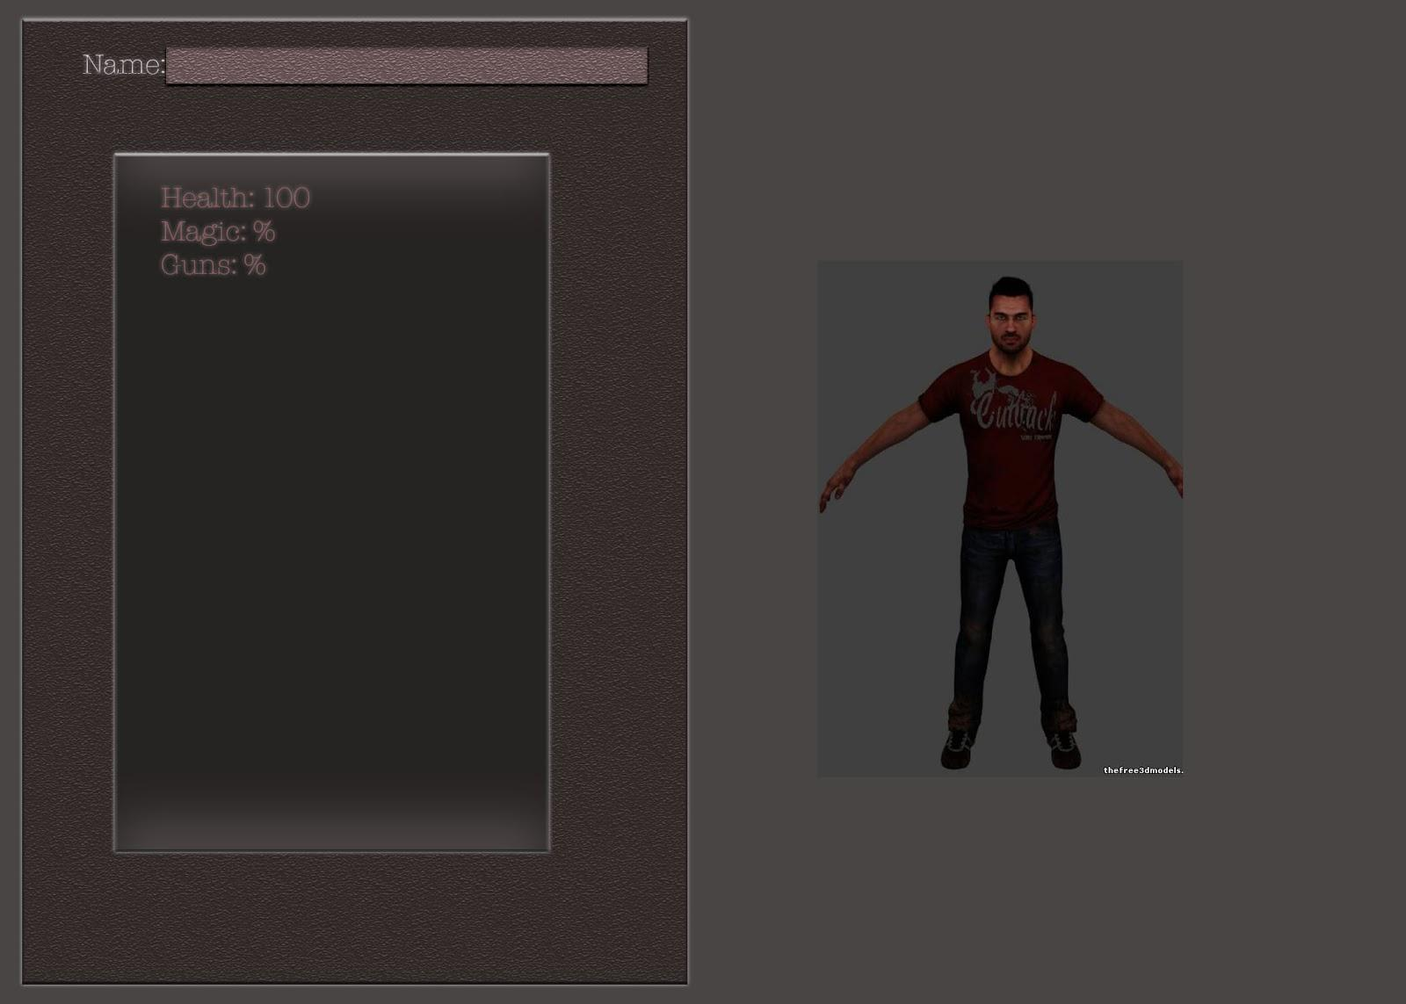

Models

Male: http://tf3dm.com/3d-model/grant-brody-2910.html

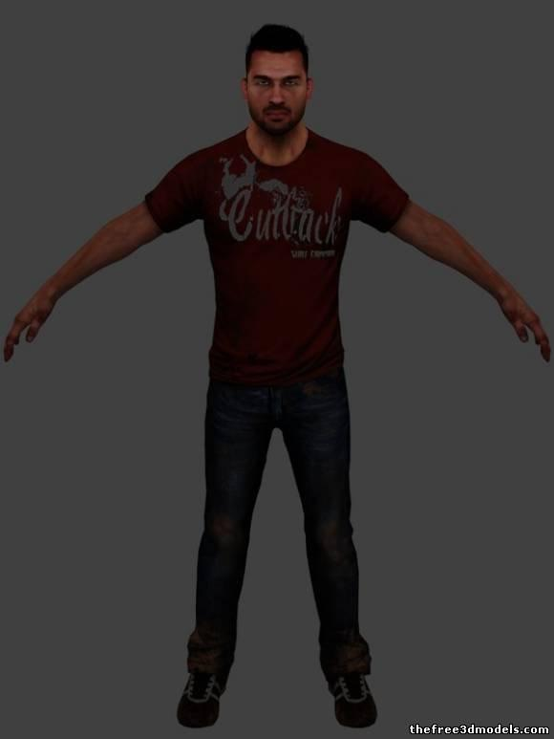

Female: <http://tf3dm.com/3d-model/annie-49170.html>

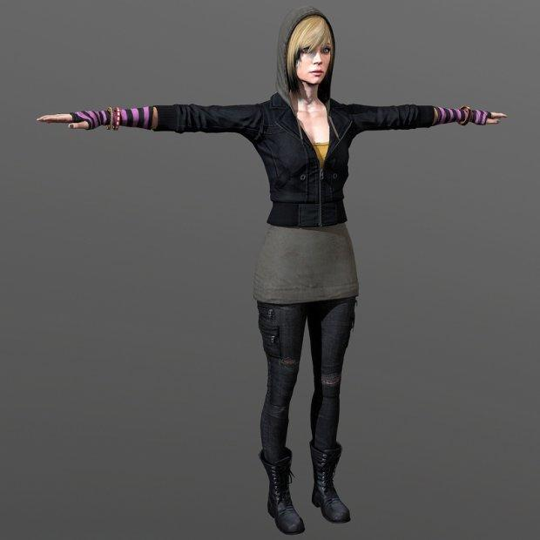

* Initial Abilities:
  + Player will pick (1) Initial Ability
    - (To be decided later)
* Final Abilities:
  + Depending on (Point) distribution, the Player can have 1-(ALL) Abilities
  + Minimum of (1) Ability
* Initial Skills:
  + Player will pick (1) Initial Skill
    - (To be decided later)
* Final Skills:
  + Depending on (Point) distribution, the Player can have 1-(ALL) Skills
  + Minimum of (1) Skill
  + Some Skills will be hidden or have requirements to unlock (Quest/Level)
* Initial Weaknesses/Faults:
  + Will start at Level 1 (or equivalent)
  + Will be weaker than the majority of Enemies
* Final Weaknesses/Faults:
  + Depending on (Point) distribution, (most/all) weaknesses/faults can be negated
  + If Ability/Skill distribution is done incorrectly, the Player may end up with:
    - High Damage/Low Health
    - High Health/Low Speed/Medium Damage
    - etc.

Main Villains

* Maffia Grunts - In the outside world, your basic goons for hire. In the sim, super powered/ ultra skilled brutes, capable of inflicting high damage in little time. They do not relent if aggro’d, chasing players for miles before giving up. They hope to unlock the secrets of transferring these skills to the outside world to enhance the mafia’s power.
  + Types: Ursa - a large beast of a man that uses crushing and smashing attacks including a particularly brutal bear hug.
  + Lupus - Vicious and brutal, using sharp melee weapons from swords to claws. Their strategy is to keep applying pressure until their opponent caves.
  + Vulpes - Crafty and sneaky, using traps and medium to long range throwing weapons, along with daggers if their foes get too close.
  + Accipiter - Long range specialists, they use sniper rifles, spike launchers, and some have the ability to fly/ hover.
  + Vipera - Stealth and poison are tools of this insurgent. they have swift attacks, but prefer to rely on tricks and poison over actual combat prowess.



Image: http://www.elultimoweb.com/imagenes/2013/Diciembre/31-mafioso.jpg

* Anarchist Punkz - Another gang from the outside that has invaded the sim world. Unlike the mafia, they seek only to wreak havoc. If they can somehow manage to bring their powers from the sim to real life, it may be the end of peaceful civilization, and of all clothing fibers except denim.
  + Types: Brutez - Large Biker thug that uses brute strength and chains to attack. They aren’t particularly special, just insane.
  + Pyroz - Pyrophiliacs with a lot of fire power. Not much to say really, they just set stuff on fire.
  + Cutterz - Lovers of big swords. Impossibly large weapons allow these characters to be deadly from a slightly farther range than your average melee fighter.
  + Necroz - Necromancers, plain and simple. They revive fallen party Punkz.

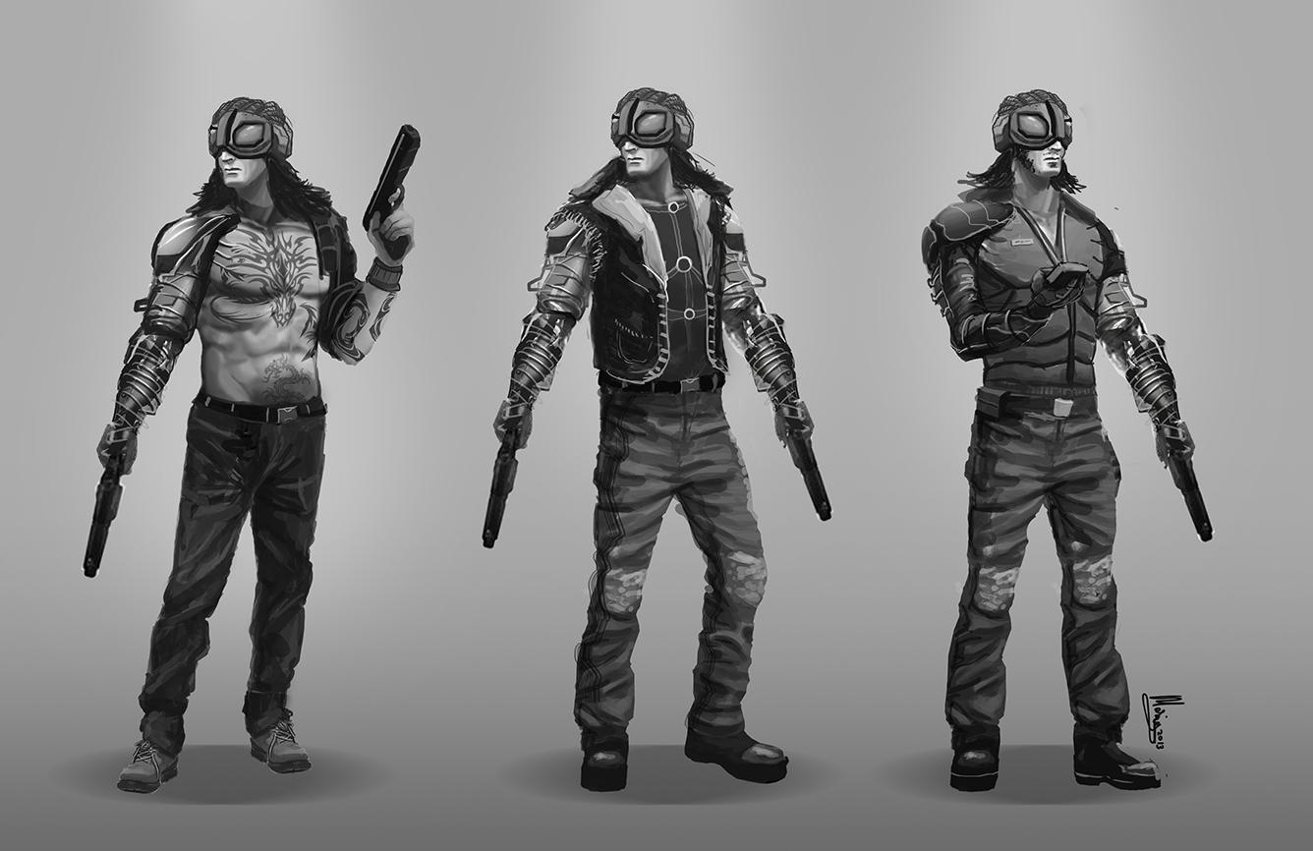

image: <https://mariusandrei.files.wordpress.com/2013/02/punk-characters.jpg>

* Anonymous - Origin - Unknown/ 4chan, Goals - Unknown, Appearance - Tall, slim, faceless individuals that tend to mind their own business, but when attacked move very quickly and attack in strange patterns. The may be telekinetic and/or psychic.

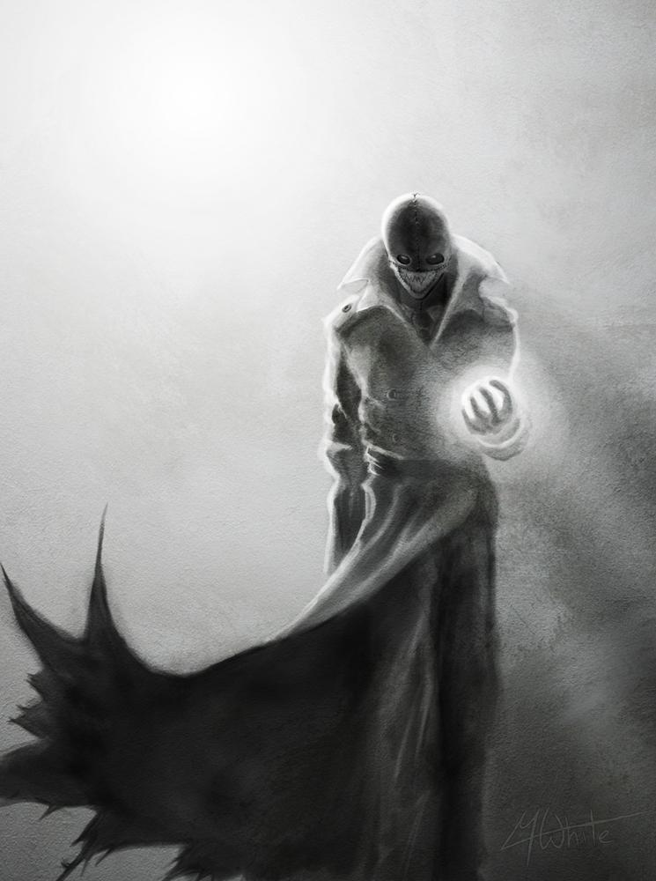

image: http://fc01.deviantart.net/fs27/f/2008/153/9/9/Masked_Man_in_the_Mist_by_TheWhiteLight.jpg

* Sim Secure™ Security Robots - A large group of robots that work for the sim to keep peace, their only real distinguishing feature is their equipment loadout. My personal favorites are the jet pack sniper troop.

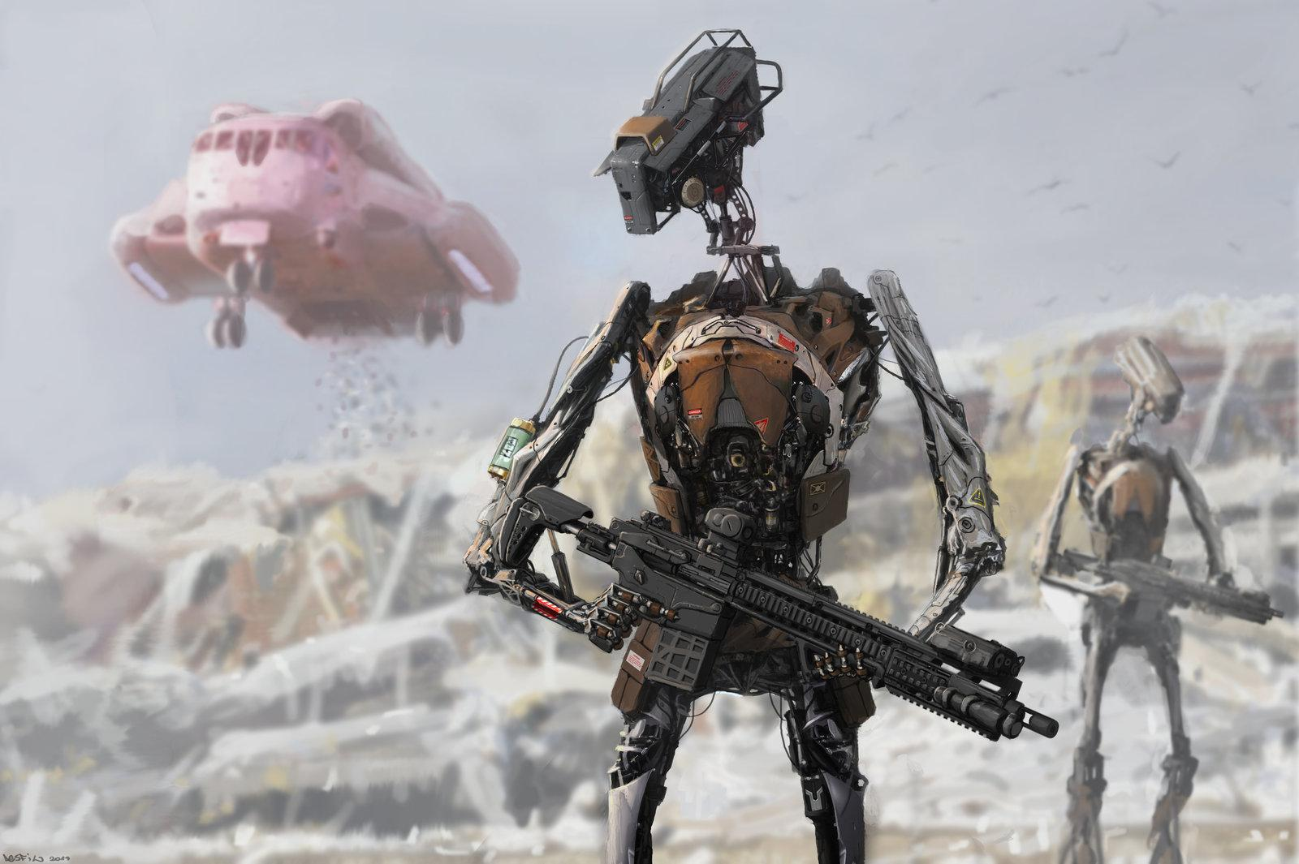

image: <http://fc06.deviantart.net/fs70/i/2013/303/d/7/landfill_security_by_5ofnovember-d6sdkpz.jpg>

* Wild Animals (Lions, Tigers, Bears, Wolves, etc)
  + May be (1) Boss animal of each type

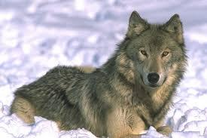

<http://www.cascwild.org/wp-content/uploads/2013/03/wolf-adjusted.jpg>



<https://encrypted-tbn3.gstatic.com/images?q=tbn:ANd9GcSMphYA0nphjWNtzFlBUzSA664VGz3n5fnjA2DO-K8L5NTGfJbL-Q>

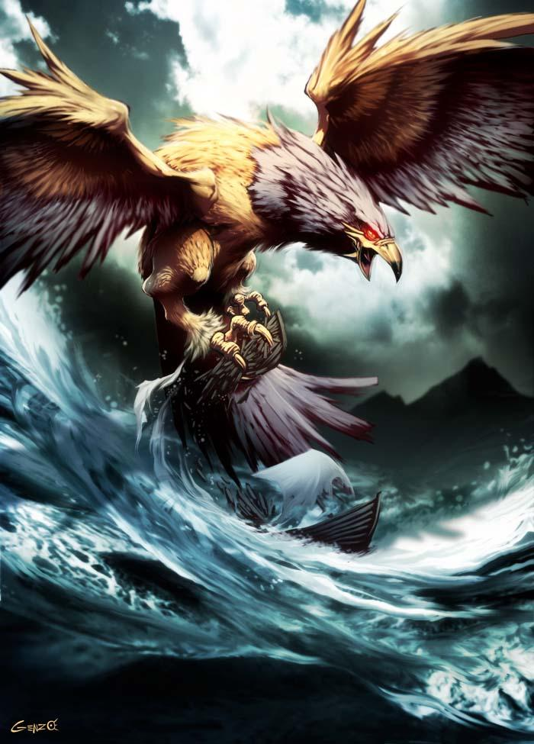

<http://fc05.deviantart.net/fs31/f/2008/232/e/5/Roc_by_GENZOMAN.jpg>

* At this point in time, there is NO Main Villain
* Each Group will have (1) Boss, (1-5) Lieutenants, (10-20) Enforcer-class, (25+) Grunts
  + ALL except the Boss will/can Respawn (as needed)
* Each Class of Enemy will have (1) Special Ability and (0+) Special Skill(s)
  + Each Special Ability will be dependant on their description above
* Initial/Final AI:
  + Boss:
    - Basic Object Avoidance
    - Will attack the Player if:
      * Can (see) the Player if:
        + Within 50 feet
  + Lieutenant:
    - Basic Object Avoidance
    - Will attack the Player if:
      * Can (see) the Player if:
        + Within 20 feet
        + The Player’s (Sneak) Skill is low enough
        + The Player is NOT invisible

Will be 50/50 if Lieutenant can see through Invisibility

* + Enforcer:
    - Basic Object Avoidance
    - Will attack the Player if:
      * Can (see) the Player if:
        + Within 15 feet
        + The Player’s (Sneak) Skill is low enough
        + The Player is NOT invisible
  + Grunt:
    - Basic Object Avoidance
    - Will attack the Player if:
      * Can (see) the Player if:
        + Within 10 feet
        + The Player’s (Sneak) Skill is low enough
        + The Player is NOT invisible

Support Characters

* Quest givers
  + Should be around 5 per level. 1-2 for main quests. 3 for side quests.
* NPCs whose purpose is immersion and providing background on the setting
  + Should appear in any populated region or non-battle zone.
* Item sellers
  + Can appear in many roles such as:
    - Modern Armor Merchant
    - Modern Arms Merchant
    - Fantasy Weapons Merchant
    - Fantasy Armor Merchant
    - Special Items Merchant
  + Should appear on every level, so the main character can upgrade.
* A.I. support character
  + Purpose is to always stand by main character: Gives out info/hints for quests, etc.
  + “Good” opening - A co worker assists you by giving out world information, telling you about hidden caches, and perhaps even dropping special items for you occasionally.
  + “Evil” opening - someone from an unspecified special interest group has taken control of your pod and is giving you certain objectives towards an unknown goal. May perform many of the same actions.
* Support characters do not have abilities, skills or weaknesses
  + Die in one hit. (Appear when entering level again due to world being virtual and not actually dying)
  + Intelligence is limited to possible movement in the world.

Weapons

Type = Type of Weapon

Damage = Base Damage done by weapon (before modifiers)

Cost = Cost of Weapon from a shop

Max Modifier = Maximum modifier that can be added to weapon (enchantments)

Durability = How durable the weapon is, How long until it breaks

Speed = How fast an attack is (1-5 where 1 is fastest, 5 is slowest)

* Fantasy
  + Melee:

|  |  |  |  |  |  |  |
| --- | --- | --- | --- | --- | --- | --- |
| **Type** | **Damage** | **Cost** | **Max Modifier** | **Durability** | **Speed** | **Description** |
| Dagger | 1-5 | 5 | +5 | 20 | 1 | Cheap blade often used by two-bit thugs. |
| Short Sword | 10-20 | 15 | +10 | 75 | 2 | One of the oldest weapons of humanity. |
| Long Sword | 20-40 | 25 | +15 | 100 | 3 | The short sword improved by making the blade a bit longer. |
| Staff | 7-18 | 10 | +7 | 35 | 4 | Good for those who prefer breaking bones rather than cutting them. |
| Halberd | 21-35 | 25 | +12 | 55 | 4 | A staff with an axe put on at the end. |

* + Ranged:

|  |  |  |  |  |  |  |
| --- | --- | --- | --- | --- | --- | --- |
| **Type** | **Damage** | **Cost** | **Max Modifier** | **Durability** | **Speed** | **Description** |
| Throwing Dagger | 1-2 | 3 | +2 | 20 | 1 | Daggers modified for those too scared to get close. |
| Bow | 5-40 | 35 | +10 | 60 | 5 | Made by humanity when they realized most animals ran faster than they could get close with a sword. |
| Crossbow | 7-20 | 50 | +15 | 85 | 3 | Made to pierce through armor from long-range. |

* Modern
  + Melee:

|  |  |  |  |  |  |  |
| --- | --- | --- | --- | --- | --- | --- |
| **Type** | **Damage** | **Cost** | **Max Modifier** | **Durability** | **Speed** | **Description** |
| Fist | 1-5 | 0 | +5 | 50 | 1 | Fighters rely on these when they’re too poor to afford a weapon. |
| Brass Knuckles | 5-10 | 20 | +10 | 60 | 1 | For those better at pounding than precision. |
| Switchblade | 15-25 | 15 | +5 | 40 | 2 | More powerful than a short sword and easier to hide-to-boot. |
| Bat | 10-20 | 25 | +15 | 80 | 3 | For those who don’t have a weapon, but played baseball in their youth. |

* + Ranged:

|  |  |  |  |  |  |  |
| --- | --- | --- | --- | --- | --- | --- |
| **Type** | **Damage** | **Cost** | **Max Modifier** | **Durability** | **Speed** | **Description** |
| Molotov Cocktail | 2-3 | 3 | +0 | 20 | 2 | A weapon for those with pyromaniac urges. |
| Pistol | 10-15 | 20 | +5 | 50 | 2 | A.K.A. the Hand Cannon. Holds 13 rounds of ammo before reloading. |
| Assault Rifle | 15-25 | 40 | +10 | 65 | 3 | The gun for those who expect to find themselves in war. Holds 30 rounds and has a much higher rate of fire than pistol. |
| Sniper Rifle | 25-40 | 80 | +15 | 80 | 4 | The gun for the paranoid to take out people before they take them out. Longer rate of fire is made up by damage and distance. |

Magic

Name = Name of Spell

Damage = Base Damage done by spell

Cost = Cost of Spell in Mana Points (MP)

Max Modifier = Maximum modifier that can be added to weapon (enchantments)

Type = Type of Spell (Attack, Defense, Support)

Speed = How fast the spell may be cast (1-5 where 1 is fastest, 5 is slowest)

Description = Description of the spell

|  |  |  |  |  |  |  |
| --- | --- | --- | --- | --- | --- | --- |
| **Name** | **Damage** | **Cost** | **Max Modifier** | **Type** | **Speed** | **Description** |
| Fireball | 20 | 25 | +5 | Attack | 2 | For pyromaniacs with magic. |
| Fire Wall | 40 | 50 | +10 | Attack | 2 | For pyromaniacs who dream of making a house made of fire. |
| Heal | -25 | 30 | --- | Defense | 1 | For those who can’t afford health care. |
| Teleport | --- | 50 | --- | Support | 3 | For those who can’t afford vehicles. |
| Summon Creature | --- | 25 | --- | Support | 3 | For those who can’t afford pets. |
| Shield | --- | 30 | --- | Defense | 1 | For those who can’t afford armor. |

Armor

Type = Type of Armor

Defense = Base Defense of Armor (before modifiers)

Cost = Cost of Armor from a shop

Max Modifier = Maximum modifier that can be added to armor (enchantments)

Durability = How durable the armor is, How long until it breaks

* Fantasy:

|  |  |  |  |  |  |
| --- | --- | --- | --- | --- | --- |
| **Type** | **Defense** | **Cost** | **Max Modifier** | **Durability** | **Description** |
| Cloth | 1 | 1 | +0 | 100 | Protects against mosquitoes. |
| Leather | 6 | 10 | +5 | 150 | Provides padding against blunt and sharp objects. |
| Scale Mail | 10 | 20 | +10 | 250 | Provides protection against blunt and sharp objects. |

* Modern:

|  |  |  |  |  |  |
| --- | --- | --- | --- | --- | --- |
| **Type** | **Defense** | **Cost** | **Max Modifier** | **Durability** | **Description** |
| Cloth | 2 | 2 | +1 | 125 | Like Fantasy Cloth except more used outside of renaissance fairs. |
| Leather | 4 | 6 | +5 | 130 | A leather jacket for slight padding and looking cool. |
| Kevlar | 15 | 30 | +10 | 300 | For protection against bullets, blunt, and sharp objects. |

Accessories:

Type = Type of Accessory

Cost = Cost of Accessory

Description = Description of the Accessory

|  |  |  |
| --- | --- | --- |
| **Type** | **Cost** | **Description** |
| Backpack | 50 | Allows you to carry more than however many items you can hold. |
| Food/Drink | Varies | Food/drink can be used to heal or boost morale. |

Items:

* Useable:

|  |  |  |
| --- | --- | --- |
| **Type** | **Cost** | **Description** |
| Item Modifiers | Varied cost | Item modifiers improve weapons, armor, etc. |
| Spell Training | Varied cost | Player must be trained in spells to upgrade them. |
| Journal | 10 | Cheap item to help player track progress. |

* Valuable:

|  |  |  |
| --- | --- | --- |
| **Type** | **Cost** | **Description** |
| Keys | Varied cost | One-time use items to open certain doors, cabinets, etc. |
| Plot-Relevant Items | None (unless needed to buy) | Items needed to continue game whether its to give to an NPC or to be put in places. (Quest Items) |

* Other:

|  |  |  |
| --- | --- | --- |
| **Type** | **Value** | **Description** |
| Chair | 1-5 | To sit in. |
| Campfire | --- | To sit by. |
| Logs | 1-20(stack) | To chop. |
| Miscellaneous Stuff | 0+ | Generic Clutter in the World - Has no use except to sell to Random people |

Note: Think Gothic series as far as interactive items go.

Special Items:

|  |  |  |  |
| --- | --- | --- | --- |
| **Type** | **Name** | **Value** | **Description** |
| Weapon | Bunny Kunai | --- | Special Throwing Dagger   1. Types (Modifiers) |
| Weapon | Bunny Sword | 10-1000 | Leveling Sword |
| Accessory | Ring of the Bunny | --- | +(5-15) Speed |
| Magic |  | 1-1000 | All Magic Spells may fall into the Category of (Specials) |

* All Special Items (others to be added as needed) will/can be found early on, but will have specific Level/Quest requirements to fully unlock their abilities
* The Bunny Sword(s) will be able to grow in power the more they are used
  + Will be initially weaker than almost all other weapons in the game
  + Will have Levels attributed to it
  + Will have Abilities available to it

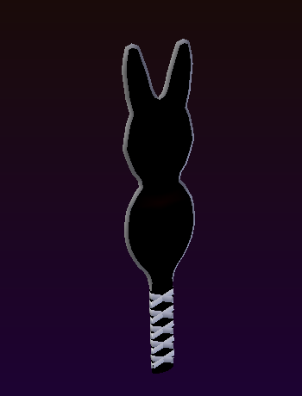Image: Justin Dunnihoo

Game Mechanics:

* We are still working on the Final Game Mechanics at this time.

Group Contribution:

Dominick Carro: Format Editing, Images

Zachary Denton: Item Editing, Support Characters

Conor Cleary: Item Editing, Main Character

Justin Dunnihoo: Item Editing, AI, Villains

Jeremy Jardee: Item Editing, Villains, Support Characters