Game Development Report 2

Team: VaporWorks

Game: Nature vs Nurture

* FPRPS (First Person Role Playing Shooter)
* Age: 10+
* Targeting Unreal Engine For PC
* Single Player and Multiplayer
* 3D First/Third Person Mode

**Background Story:**

In the (near) future, the prison system has been given over to private contractors. The governments are no longer allowed to control the prison system, as overall they have proven to be ineffective in the rehabilitation of prisoners, i.e. offenders usually become repeat offenders and those prisoners who spend too much time inside are ultimately unable to function in the outside world.

The company of (company name here) has found a way to create a mutually shared virtual prison that allows the “blanking”, or suppressing of memories, of prisoners that has so far shown itself to be 100% effective in the rehabilitation of said prisoners. A prisoner gets sentenced, gets tranquilized, and effectively wakes up 1 year later completely rehabilitated and unable to commit the original crime again. (The 1 year time frame is due to a mandatory ruling by the World Government on the minimum length of time a prisoner must be held for the prison to receive funding for housing said prisoners. Minimum length takes into account the grief cycle of the victim or victim’s family, in the event of the crime being homicide.)

As with any form of technology, there are always those who wish to use it for their own benefits. Old and outdated “stasis pods” (prisoner containment units - PCU) can be found on the Black Market for an exorbitant price (for a properly functioning one) that allow their users to join the universal Prison World without having to be incarcerated first. These pods are PCU’s are generally being used by gangs to assassinate rival members. Rumors have surfaced that (the company name) has been engaged in the outright selling of units to various gangs and that they have been housing innocent people (political rivals/etc) within the Prison World while doctoring records to show that they have been “properly” convicted.

Recently there has been some major progress in a new type of unit that has a variable time limit (currently the unit functions at 1 year real time to up to 70 years game time) and physical benefits being transferred to the user (the benefits of exercising affecting the user at a rate of 1/100 or 1/1000). Currently talks are being held to discuss the possibility of selling these to the elite and/or the entertainment industry, but a shipment of prototypes has been hijacked and disappeared.

(This section decides the starting point and/or the main objective(s) of the game)

***Good***:

The main character is a technician responsible for updating/upgrading the software for the new PCU’s. As these units are still within the prototype phase, you are running generic tests on the unit. You are attacked and forcibly placed within the unit you are testing, a live unit connected to the main Prison World, and now must escape from the world, either through completion of your sentence (currently set at 50/70 years) or must show that the rumors are indeed true and that (the company name) has been doing what the rumors suggest, or worse.

***Evil:***

The main character’s lover/husband/wife/child/family has been brutally murdered by a rival gang member or members, and is currently incarcerated within the system. After having tracked down one of the prototype units, you are ready to go in and deliver your own brand of “justice” to all members of that gang. While entering the system, you are told that (the company name) may have been behind the assassination of your people. Multiple quests will available to execute rival gang members. To escape the world, you must complete your missions and/or break the Prison World (if you find evidence the company was behind the assassinations - only becomes a quest if evidence is found).

***Neutral:*** (Single Player Game)

You are sentenced for a crime you did not commit. At sentencing you are “selected” to test the prototype PCU. With access to your memories, you must escape the system as quickly as possible, due to the possibility of breaking your mind as you feel the passage of time and know its not “real.”

**Game World:**

<http://img.picsa.ru/pictures/0/000/113/738/113738.jpg>

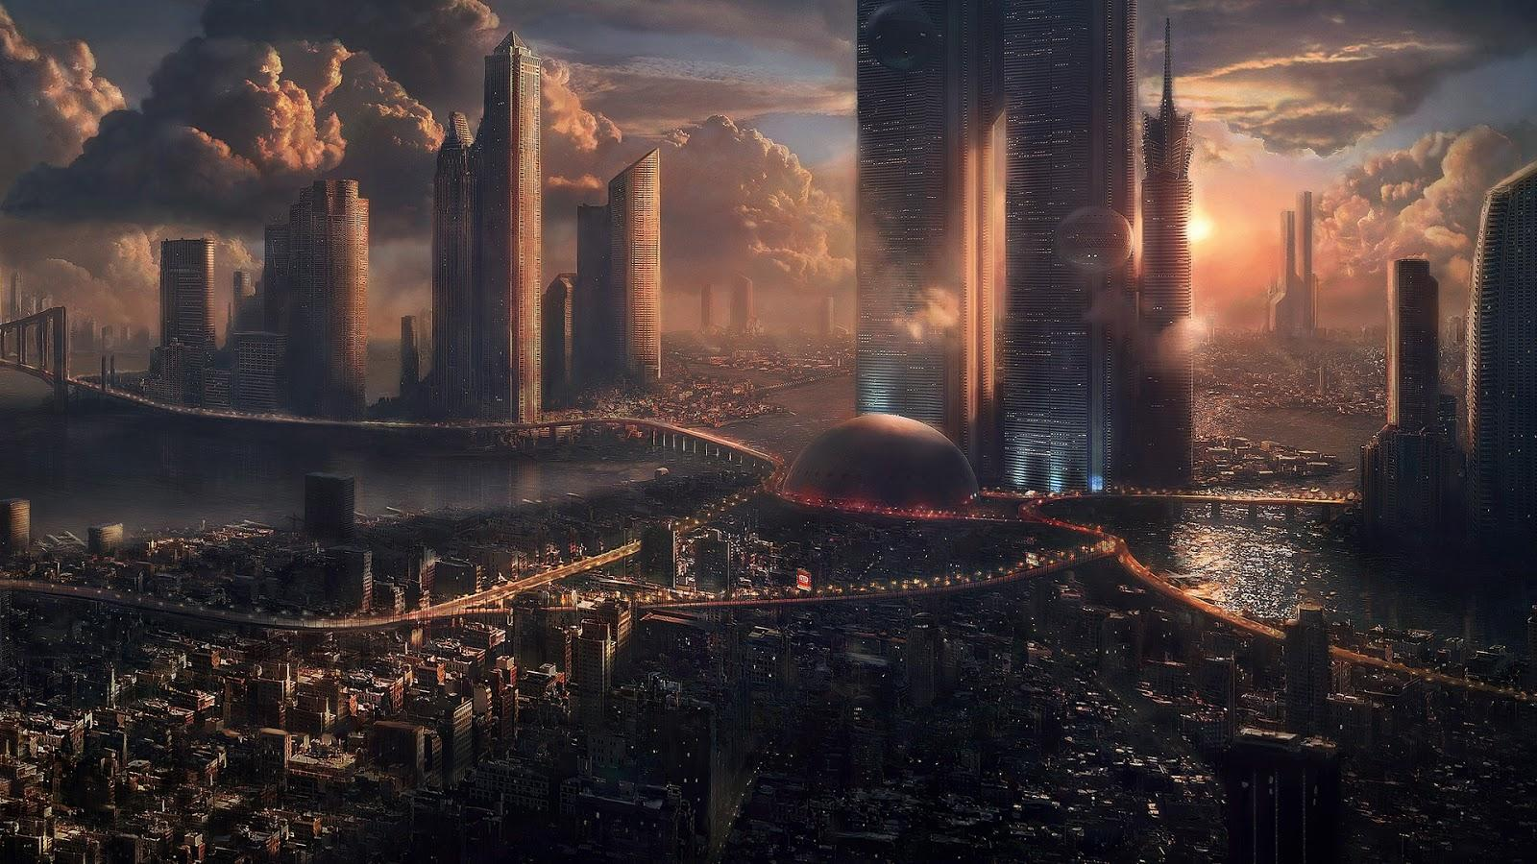

Above Picture: The “Real World”

http://2.bp.blogspot.com/-g5s-g_0f0D8/T-lKF97lkrI/AAAAAAAAATk/qdWAz4UJSbY/s400/Avatar+suspended+animation.jpg

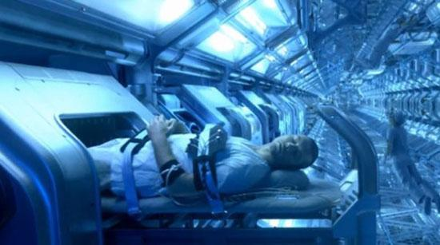

Above Picture: An idea of how the statis units could be set up.

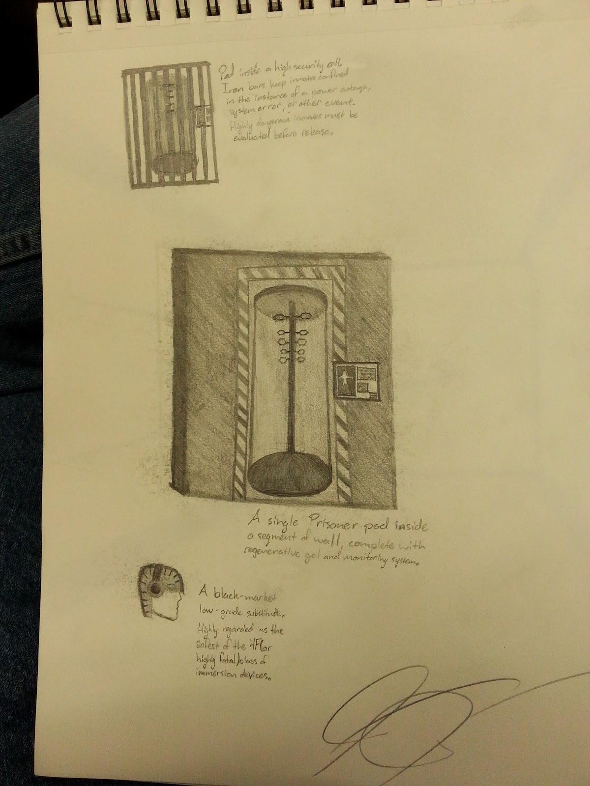

Artwork: Jeremy Jardee

Option 1:

The game world is a prison system where the protagonist is locked inside a virtual world.

http://fc06.deviantart.net/fs17/i/2007/170/b/6/Prison_corridor_1_by_astrokevin.jpg

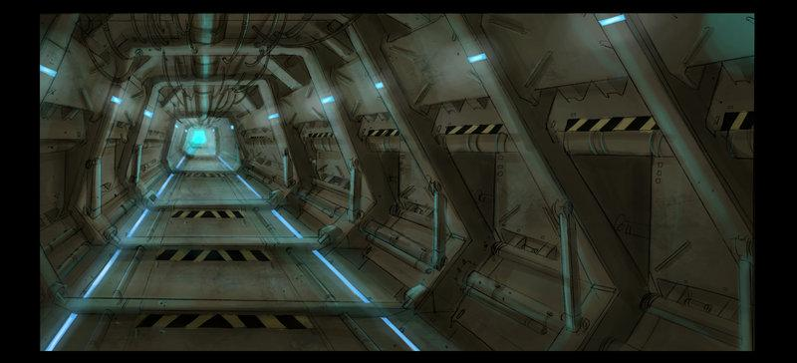

Above picture: Prison in which protagonist is trapped in the real world and/or game world.

The starting point, whether you take the good or evil route to begin with, is the prison cell that the player is housed in. Prison cells, communal gathering areas, a prison “yard” and areas in which the player completes quests will be added. A solitary confinement wing if your karma dips low may be used as your character commits “crimes” within the system. Size of the jail (number of “sections”, prisoners, etc.) will be determined based on difficulty level and/or type of game started (good/neutral/evil).

Option 2:

The “real world” will only be shown during the intro CGI for the game. The character enters the “prison world” by either (stolen) containment system in their room/warehouse/etc or a test unit in a lab, or has a more neutral start, i.e. the character starts by being sentenced for a random crime (did not commit) but keeps their memories/sense of self/etc through being “volunteered” to test a prototype system.

<http://cache.desktopnexus.com/thumbnails/728444-bigthumbnail.jpg>

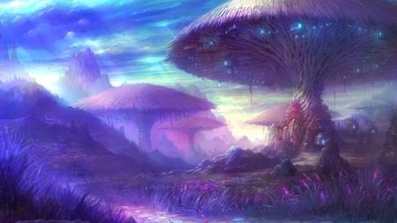

Above Picture: Part of Game World

Due to the protagonist being trapped in a virtual world, it allows us a wide variety of settings without necessarily having to worry about real-world physics (though the simulation should try to mirror many real-world physics to make it easier for the prisoners).

For the main settings, the game would be focused in a city and inside of buildings. The general atmosphere should be dark and cloudy when outside. Most buildings should be either dark or dimly lighted. There should also be times where the simulation “glitches”. When this happens, parts of the setting are just “missing”, and it obviously shows the world is a simulation. If the character walks on a piece of floor missing due to the world glitching, he will fall down until he “dies” and “respawn” afterwards.

http://i.dailymail.co.uk/i/pix/2014/08/01/article-2713292-202DA23300000578-760_964x632.jpg

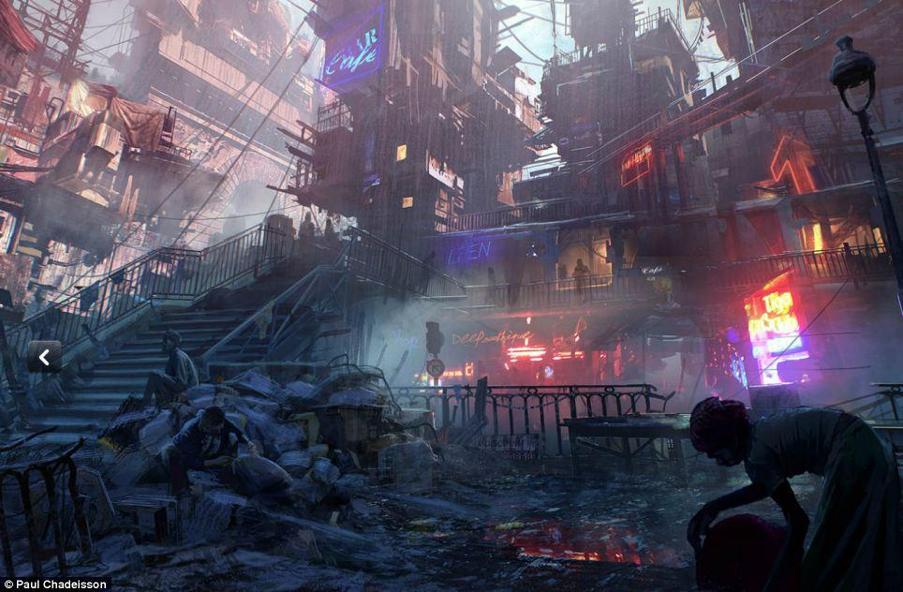

Above Picture: An idea of how the run down city would look like.

**Possible Game World**: (Based upon a mixture of Option 1 and 2)

The character wakes up in a pod (similar to The Matrix) in an underground prison, due to power/pod failure. The tutorial would consist of escaping this prison, where the introduction quests will be completed. The prison (may) have several items hidden within it, (may) be crawling with large amounts of enemies, or may be bypassed altogether (to be implemented later). When the character escapes from the prison, he/she emerges into a ruined city (similar to the picture above). This would give a logical progression for the player, or the NPCs that follow this starting point. These NPCs would be followers/companions of the player (if implemented). The ruined cities are remnants of the “old world” which was destroyed in chemical fire during World War 3 (or 4). These ruined cities are controlled by gangs which may/will play a large part later in the game (multiple missions of both Good/Evil). Underneath these cities exist the prisons that you go to when you commit crimes. Outside of these cities are the towns that everyone else (NPCs) live in. These towns are medieval/fantasy type towns. There are the typical fantasy towns, floating islands, underwater cities, and more.

**Starting Location:**

Normal characters (NPCs) wake up in some environment (hospital, waystation, etc.) with amnesia. Your character will wake up in one of 3 (for now) starting points which are chosen depending on the type of game you play (Good/Neutral/Evil). Your character knows that this is a simulation but not how to get out. Your character also has access to a minimap (maybe), quest system, inventory, equipment, etc.

Hospital:

<https://encrypted-tbn1.gstatic.com/images?q=tbn:ANd9GcS0goGhrsPtysrokUTPBbCMsmNRC7BgqWpEAuvui1xj4y2wa7fMIg>

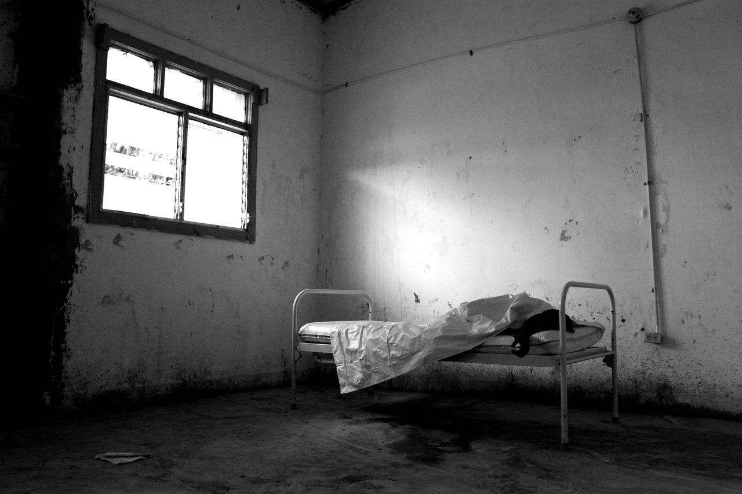

Above Picture: One of the possible hospital starting points = Abandoned Hospital

Waystation:

<http://ad009cdnb.archdaily.net/wp-content/uploads/2008/09/1541025636_torvdalshalsen01-ss-1-527x450.jpg>

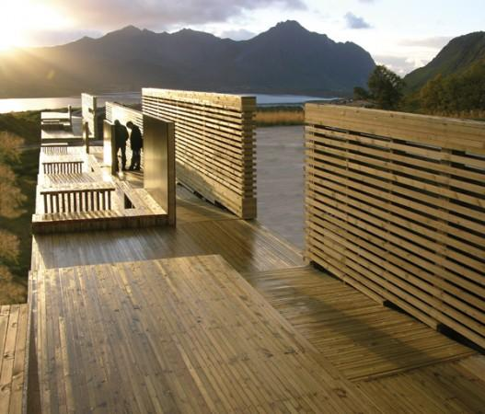

Above Picture: An outside waystation (if above ground/outdoors is used)

**Game Mechanics:**

Game mechanics are mainly influenced by the background story of the character that the player chooses at the beginning of the game. Certain quests/items/endings will only be available if that option is played, i.e. the Good ending will not appear in a Neutral game, though the Neutral game may have a Good-type ending.

The game will be a 3D game played in the first or third person perspective. The game will have rpg elements that allow you to craft a character of some sorts. The character will have stats that determine the effectiveness of certain skills/abilities, i.e. some stealth elements - if you have high sneak you can easily attack without being seen or steal from other actors in the game, diplomacy can give you other options, so you can remain more peaceful, charming characters in order to complete quests or obtain items (bartering), and others.

A leveling system will be set in place for the game. The player will obtain experience by performing certain actions with the act of completing quests being the main source of experience. The amount of experience awarded by completing a quest will vary depending on the difficulty of the quest. To get to level 2, 100 experience will be required. The amount of experience required for each subsequent level is double the previous level requirement such as 100, 200, 400, 800, etc. Experience gained for killing people/creatures not attached to quests will be determined by the level difference between character and enemy: a difference of -7 or more levels will result in 1 experience being gained (character is level 10, enemy is level 3), a difference of +2 or more levels will result in a multiplier being added (character is level 5, enemy is level 7+ = double experience).

Three difficulties for the game will be added: Easy, Normal, Hard. Easy will lower the number of enemies and their stats with the intention that as long as the player levels up the character, they should be able to make it through the game while rarely dying as long as they try. Normal will be the default/intended version of the game with a balance between boring and frustrating. Hard will add the number of enemies while increasing their stats with the intention that the player truly knows what they’re doing. The ability to change the difficulty level mid-game may be added later.

Player will choose one skill:

Skills:

* Fishing
* Mining
* Diplomacy
* Sneak
* (more to be added)

Monetary System:

One unit of currency to buy combat-related items → Name: Gold

* Short Sword == 5-100 gold
* Long Sword == 20-200 gold
* Dagger == 1-20 gold
* Helm == 10-50 gold
* Breast Plate == 100-500 gold
* Boots == 10-50 gold
* Shield == 15-75 gold
* Spells == 1-1000 gold
* Health Potion == 5-100 gold
* Accessories == 1-1000 gold

Quest System:

* Introduction quests:
  + introduce controls/combat
  + introduce inventory/equipment/loot/etc.
* Good quests:
  + Save (person)
  + Save (town)
* Neutral quests:
  + Deliver (item/message)
  + Escort (person/caravan/etc)
* Evil quests:
  + Kill (person)
  + Destroy (town)

Karma:

* Decides the remaining length of your sentence (gameplay)
  + Good quests reduce your time (Good Karma)
  + Evil quests increase your time (Evil Karma)
  + Neutral quests have no effect on the players Karma level
* Decides types of quests/items/enemies available
  + Good Karma:
    - More Good quests
    - Bandits
    - Monsters
  + Evil Karma:
    - More Evil quests
    - Guards (NPCs)
    - Animals
  + Neutral Karma:
    - Both types of quests
    - Animals/Monsters/Bandits
* The player must be decidedly Good/Evil for quests/enemies to not register you as Neutral

Death:

* Character can “respawn”
  + Easy: Infinite number of times
  + Normal: restart closest save infinite times (including autosave)
  + Hard: Have a set number of “lives”, no autosave
* “Named” NPCs
  + Required for quests
  + can be permanently killed if killed (X) number of times
  + will attempt to combat character
* “Unnamed” NPCs
  + can be killed
  + not required for quests (usually)
  + may/may not attempt to combat character (depending on NPC job)
* Enemies
  + will respawn after a random amount of time
  + consists of Bandits/Unnamed NPCs, animals, creatures/monsters

Religion:

* May be implemented (?)
* Good God(s)
  + donate/quest for Good Karma
* Evil God(s)
  + donate/sacrifice/quest for Evil Karma

“Game Breaker” Items:

* These are items that may break gameplay
* Some are only available if certain requirements are met
  + Level - level based items
    - Mainly weapon/armor
  + Karma - available if you meet the karma requirement
    - will become inactive if requirements are not met
      * Good item deactivates if you become Evil, etc.
    - certain weapons
    - certain accessories
  + Quest - only available if certain quests are completed or failed

**Time Frame:**

Open ended → wide range of time frames

Example: The player chooses the “good” path and can get out sooner, or the do enough bad things and their sentence keeps extending. A game day will be a simulated 24 hours broken down to 60 minutes of actual (real world) time. All activities, such as quests, can be committed throughout the day. There is a mandatory sleep period where the game would save (only place the game autosaves), unless the game is played under the Easy mode (permanent autosave enabled). However, the mandatory sleep period can be bypassed at the expense of health (will/may be required for several quests). An example of this is: the player has 100 possible hit points (maximum), after bypassing the sleep cycle, the player has 75 possible hit points (maximum). All health lost through bypassing the sleep cycle can only be regained when the character sleeps.

**Goals of Game:**

The End Game quest is determined based on which game you play (Good/Neutral/Evil). The base end game is to either break the system (take down the company (Good/Evil)) and get out of prison or reduce your sentence enough to be “rehabilitated” (neutral). A player with a “good” sense of morality (Karma) and commits acts that would be considered lawful and moral would end up getting the rehabilitated (Neutral) ending. Breaking the system and/or committing horrible acts would lead the character to breaking out of prison in some certain fashion which could be dependent on which game is played (Good/Evil). Game breaker items will have level requirements and are lightly detailed in the Game Mechanics Section. There may be optional quests to locate these items, depending on what the requirements of the item(s) are. Some of these items may be randomly found through the course of normal gameplay, but if the requirements of use are not met, they will be useless until the requirements are met.

**Report Contribution**:

Justin Dunnihoo - Background Story, Game Ideas, Fine Tuning

Conor Cleary - Did a little of everything

Zachary Denton - Game Mechanics, Game World

Jeremy Jardee - Game setting, sketches

Dominick Carro - Editing, Pictures, Game Setting