CSC 431  
  
ALPHA  
  
  
Software Requirements Specification (SRS)

**<Team number>**

|  |  |
| --- | --- |
| Borui Wang | Developer |
| Morgan Ritter | Developer |
| Ross Pierson | Developer |
| Maya Miller | Developer |
| Hayeon Oh | Team Leader, Developer |
| Zhenyuan Wang | Developer |
| Dorel Last | Developer |

Notes:

1. **Utility**
2. All grades and quizzes and grades to generate grade
3. i.e. mini planner
4. Add class assignment deadlines
5. Real time data
6. Guess participation requirement
7. Profile needed
8. Text boxes
9. User can add links to professor websites
10. look
11. cover page is semesters
12. cons/tiles for each class (folder)
13. below is updates of deadlines
14. in icon:
15. external links
16. assingments/quizzes with grades
17. all editable
18. calculating each time but shows what you’ve inputted
19. profile page🡪 pre-existing or not ?? tentative
20. School email
21. calculating page 🡪 can be editable
22. all classes on one page
23. hardest part 🡪 calculating data
24. **current grade for all classes inputted**
25. 10 max
26. Per semester

For feb 26th 2020:

Version History

|  |  |  |  |
| --- | --- | --- | --- |
| Version | Date | Author(s) | Change Comments |
| 1 | Feb 3, 2020 | “Feed Me” Team | Creating Document |
| 2 | Feb 19, 2020 | Julio Perez | General comment on how to write scenario/use cases with diagram standard Graphical Representation |
| 3 | Feb 26, 2020 | “Alpha” Team | Use cases modeling and basic flow |
|  |  |  |  |

# 

# 

# 

# 

# 

# 

# 

# 

# 

# 

# 

# 

# 

# 

# 

# Table of Contents

**Version History** **3**

**Table of Contents** **4**

**Table of Tables** **5**

**Table of Figures** **6**

System Requirements **7**

Functional Requirements 7

Requirement Title 7

Non-Functional Requirements 7

Requirement Title 7

System Constraints **8**

Tool Constraints 8

Requirement Title 8

Language Constraints 8

Requirement Title 8

Platform Constraints 8

Requirement Title 8

Hardware Constraints 8

Requirement Title 8

Network Constraints 9

Requirement Title 9

Deployment Constraints 9

Requirement Title 9

Transition & Support Constraints 9

Requirement Title 9

Budget & Schedule Constraints 9

Requirement Title 9

Miscellaneous Constraints 10

Requirement Title 10

Requirements Modeling **10**

Requirement Title 10

Evolutionary Requirements **10**

Functional Requirements 10

Requirement Title 10

Non-Functional Requirements 11

Requirement Title 11

# Table of Tables

<Generate table here>

# 

# Table of Figures

<Generate table here>

# System Requirements

### Functional Requirements

### Course Tiles

|  |  |
| --- | --- |
| ID | FR1 |
| Title | Course Tiles |
| Description | Clickable squares that contain information for each class |
| Priority | 0 |
| Precondition(s) | The user must sign up or login |
| Basic Flow | 1. User clicks the desired course button 2. The system directs the user to the corresponding class page |
| Postconditions(s) | Basic information will be displayed per tile's category that the user can click to expand to another page. |
| Use Case | display class page |

### 

### Signup

|  |  |
| --- | --- |
| ID | FR2 |
| Title | Sign up |
| Description | Enable new users to add credentials and information to the system. |
| Priority | 0 |
| Precondition(s) | None |
| Basic Flow | 1. System requests user to sign up 2. user enters his credentials 3. the system registers the user information 4. directs the user to login |
| Postconditions(s) | User is directed to login to the program |
| Use Case | signup |

### 

### Login

|  |  |
| --- | --- |
| ID | FR3 |
| Title | Login |
| Description | Login or sign up page that pops up when the user first goes to the website. Includes username, password, email |
| Priority | 0 |
| Precondition(s) | The user goes to the correct website |
| Basic Flow | 1. The system requests that the actor enter his/her name and password. 2. The actor enters his/her name and password. 3. The system validates the entered name and password and logs the actor into the system. |
| Postconditions(s) | The user will either be a returning user and be directed to the homepage, or be a new user and be directed to fill out their user basic info and class info. |
| Use Case Diagram | login credential |

### 

### Editable Grade Sheet

|  |  |
| --- | --- |
| ID | FR4 |
| Title | Editable Grade Sheet |
| Description | The system should allow the ability to edit grades continuously to calculate overall grade |
| Priority | 0 |
| Precondition(s) | The user must click on the Class Info Icon Tile |
| Basic Flow | 1. User enters grade information to the grade sheet 2. The system calculates the resulting grades 3. The system saves the input and calculated results 4. The system displays the grades to the user |
| Postconditions(s) | <What happens as a result> |
| Use Case Diagram | Display Grades |

### 

### Add Class

|  |  |
| --- | --- |
| ID | FR5 |
| Title | Add Class |
| Description | Allows the user to create the class tile from the home page. |
| Priority | 0 |
| Precondition(s) | The user needs to click on the corresponding icon tile on the home page |
| Basic flow | 1. User selects the add class tile from the home 2. The system creates new course tile in the home page 3. The system directs user to input course information 4. The system saves the new course information |
| Postconditions(s) | The system will create another icon tile onto the home page |
| Use Case Diagram | Add/delete a class |

### Delete Class

|  |  |
| --- | --- |
| ID | FR6 |
| Title | Delete/drop class |
| Description | The system should allow the option to remove a class from the users directory |
| Priority | 0 |
| Precondition(s) | The user needs to have a class to delete, and the user needs to be on the homepage. |
| Basic flow | 1. User selects to delete course 2. System invalidates the course information from the directory 3. The system dispose the selected course tile from home |
| Postconditions(s) | The corresponding tile will disappear from the home page. |
| Use Case Diagram | Add/delete a class |

### 

### Add External Link

|  |  |
| --- | --- |
| ID | FR7 |
| Title | External Links - Add Option |
| Description | The system should allow for external links to be added or to be deleted that lead to relevant class information. |
| Priority | 0 |
| Precondition(s) | The user needs to click on the corresponding class tile to be directed to each individual class page to input the external link |
| Basic Flow | 1. User enters the address of the external link 2. The system saves the link to the class page |
| Postconditions(s) | The link will be added to the class page |
| Use Case Diagram | Add external link |

### Open External Link

|  |  |
| --- | --- |
| ID | FR8 |
| Title | External Links - go to Link Option |
| Description | The system will open the link’s website in a new tab. |
| Priority | 0 |
| Precondition(s) | The user must first add a link. once the external link is added, the user can click it and go to the link’s page |
| Basic Flow | 1. user clicks on the external link 2. The system opens the link on the new tab |
| Postconditions(s) | The linkpage will be open in a new tab |
| Use Case Diagram | Go to external link |

##### 

### Edit Class

|  |  |
| --- | --- |
| ID | FR9 |
| Title | Edit Class |
| Description | The system should allow to edit the components of the grade, inside the class page |
| Priority | 0 |
| Precondition(s) | Once the class is created, a click on the class from the home page, opens the page of the class. |
| Basic flow | 1. user clicks on edit class 2. User enters/ deletes entries of the class changes 3. The system saves the changes made by the user |
| Postconditions(s) | The current class page with the components |
| Use Case Diagram | Edit class |

### Logout

|  |  |
| --- | --- |
| ID | FR10 |
| Title | Logout |
| Description | The system should allow the user to logout or change the account. |
| Priority | 0 |
| Precondition(s) | The user should have an account and login. |
| Basic flow | 1. user clicks on the logout option 2. The system logs the user out and invalidates the cookie/session 3. the system takes user to default logout page |
| Postconditions(s) | The page will get back to the guest / default setting. |
| Use Case Diagram | Logout |

### Home Button

|  |  |
| --- | --- |
| ID | FR11 |
| Title | Home Button |
| Description | The system should allow the user to return back to the homepage from anywhere |
| Priority | 1 |
| Precondition(s) | The user should have an account and login. |
| Basic flow | 1. user clicks on the home button 2. system takes user to the home page |
| Postconditions(s) | The page will get back to the home page. |
| Use Case Diagram | Return home |

## Non-Functional Requirements

< List all non-functional requirements in the following example format >

### Max classes per semester

|  |  |
| --- | --- |
| Title | Maximum Classes per semester |
| Description | The system should only handle up to 10 new classes per semester |
| Priority | 3 |
| Applicable FR(s) | FR5 Add/Delete Class |

### 

### Real time data

|  |  |
| --- | --- |
| Title | Real-time data |
| Description | The system should be calculating grades everytime the page is pulled up |
| Priority | 0 |
| Applicable FR(s) | FR9 Grade Calculation and FR4 Editable Grade Sheet |

# 

# 

# System Constraints

### Tool Constraints

< List all tool constraints in the following example format >

### Web Application Framework

|  |  |
| --- | --- |
| ID | TC1 |
| Title | Web Application Framework |
| Description | Built with a web application framework to allow easy access and visibility to user |
| Priority | 0 |

### Language Constraints

< List all language constraints in the following example format >

### Language 1

|  |  |
| --- | --- |
| ID | LC2 |
| Title | Javascript, HTML, bootstrap(CSS) |
| Description | UI features of application will be written as a combination of HTML, Javascript, and CSS |
| Priority | 0 |

### Language 2

|  |  |
| --- | --- |
| ID | LC3 |
| Title | SQLDBM |
| Description | Storage of grades and calculations will be done with SQL |
| Priority | 0 |

### Platform Constraints

< List all platform constraints in the following example format >

### Web service platform

|  |  |
| --- | --- |
| ID | PC1 |
| Title | Web Service Platform |
| Description | Its platform is on the internet as a tool (as compared to an app) |
| Priority | <Priority from 0 (highest) – 5 (lowest)> |

### Hardware Constraints

< List all hardware constraints in the following example format >

### Requirement Title

|  |  |
| --- | --- |
| ID | <a unique ID for the constraint, e.g., C1)> |
| Title | <Insert title> |
| Description | <A one or two sentence description> |
| Priority | <Priority from 0 (highest) – 5 (lowest)> |

### Network Constraints

< List all network constraints in the following example format >

### Requirement Title

|  |  |
| --- | --- |
| ID | <a unique ID for the constraint, e.g., C1)> |
| Title | <Insert title> |
| Description | <A one or two sentence description> |
| Priority | <Priority from 0 (highest) – 5 (lowest)> |

### Deployment Constraints

< List all deployment constraints in the following example format >

### Requirement Title

|  |  |
| --- | --- |
| ID | <a unique ID for the constraint, e.g., C1)> |
| Title | <Insert title> |
| Description | <A one or two sentence description> |
| Priority | <Priority from 0 (highest) – 5 (lowest)> |

### Transition & Support Constraints

< List all transition & support constraints in the following example format >

### Requirement Title

|  |  |
| --- | --- |
| ID | <a unique ID for the constraint, e.g., C1)> |
| Title | <Insert title> |
| Description | <A one or two sentence description> |
| Priority | <Priority from 0 (highest) – 5 (lowest)> |

### Budget & Schedule Constraints

< List all budget & schedule constraints in the following example format >

### Time Constraint

|  |  |
| --- | --- |
| ID | BSC1 |
| Title | Time Constraint |
| Description | This service must have a working prototype before the end of the semester |
| Priority | <Priority from 0 (highest) – 5 (lowest)> |

### 

### Budget Constraint

|  |  |
| --- | --- |
| ID | BSC2 |
| Title | Budget Constraint |
| Description | There is no money or budget made available |
| Priority | <Priority from 0 (highest) – 5 (lowest)> |

### Miscellaneous Constraints

< List all miscellaneous constraints in the following example format >

### Requirement Title

|  |  |
| --- | --- |
| ID | <a unique ID for the constraint, e.g., C1)> |
| Title | <Insert title> |
| Description | <A one or two sentence description> |
| Priority | <Priority from 0 (highest) – 5 (lowest)> |

# Use-Case Modelling

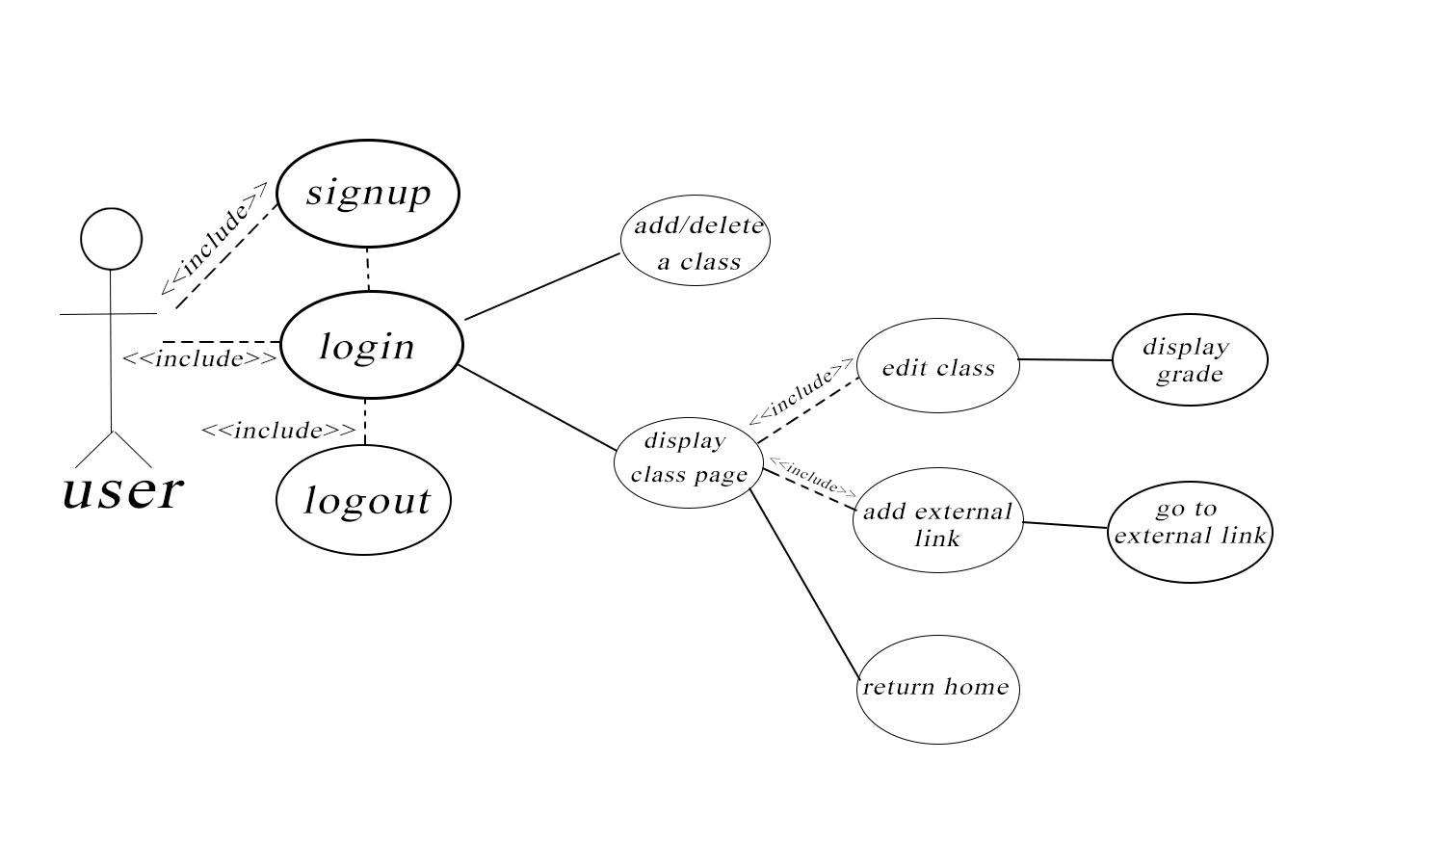

# Evolutionary Requirements

### Functional Requirements

< List all functional requirements in the following example format >

### Requirement Title

|  |  |
| --- | --- |
| Title | <Insert title> |
| Description | <A one or two sentence description> |
| Priority | <Priority from 0 (highest) – 5 (lowest)> |
| Precondition(s) | <What needs to happen before> |
| Postconditions(s) | <What happens as a result> |
| Use Case Diagram | <Link or number, if present> |

### Non-Functional Requirements

*< List all non-functional requirements in the following example format >*

### Requirement Title

|  |  |
| --- | --- |
| Title | <Insert title> |
| Description | <A one or two sentence description> |
| Priority | <Priority from 0 (highest) – 5 (lowest)> |
| Applicable FR(s) | <Which functional requirement(s) is this applicable to?> |