NKUNet

Design Document

*Version: Iteration 1*

|  |  |  |
| --- | --- | --- |
| **Revision History** | | |
| March 15, 2017 | I5S Team | Initial version |
| March 16, 2017 | I5S Team | Revise ERD |

Table of Contents

Class Diagram 2

Sequence Diagrams 2

UC-1 2

UC-2 3

UC-3 3

UC-4 4

Design Decisions 4

UI Design 4

System Design 5

Database Design 6

ERD 6

Database Discussion 7

Rails Database Commands 7

Exit Criteria 7

# Class Diagram

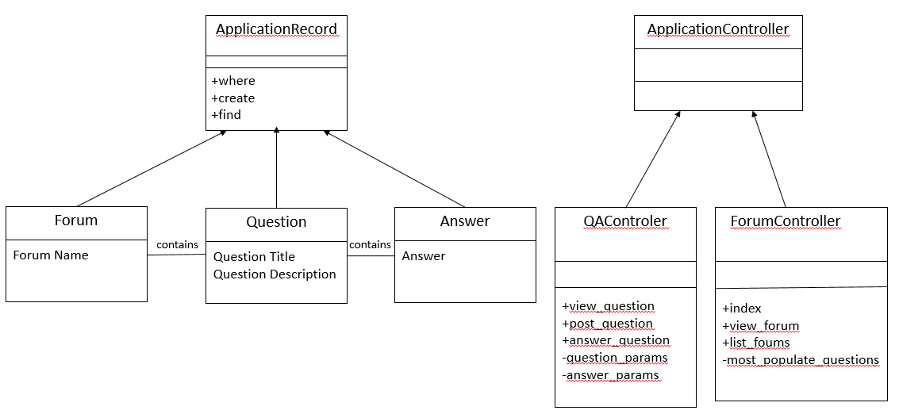

# Sequence Diagrams

## UC-1

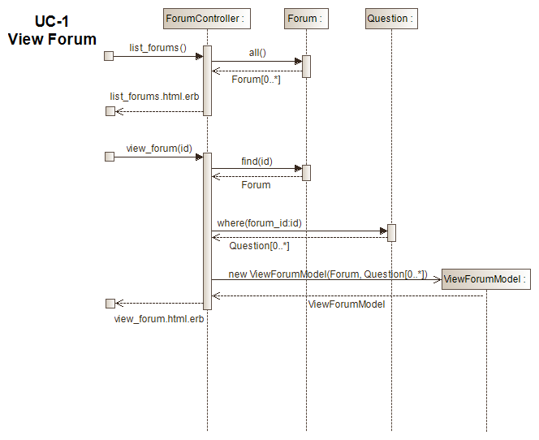

## UC-2

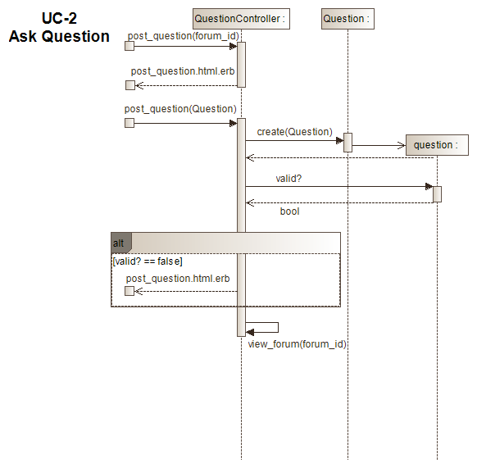

## UC-3

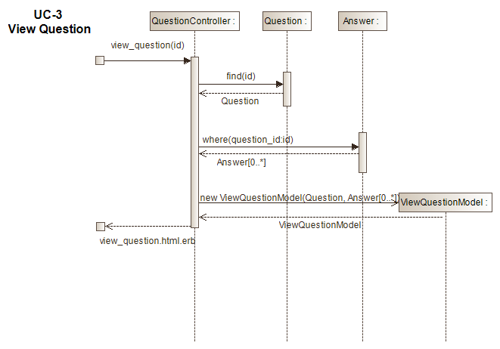

## UC-4

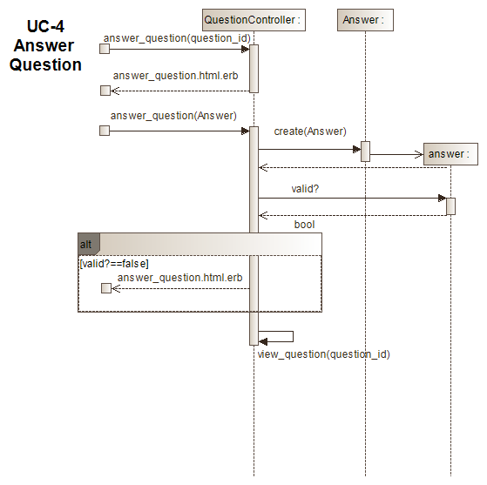

# Design Decisions

## UI Design

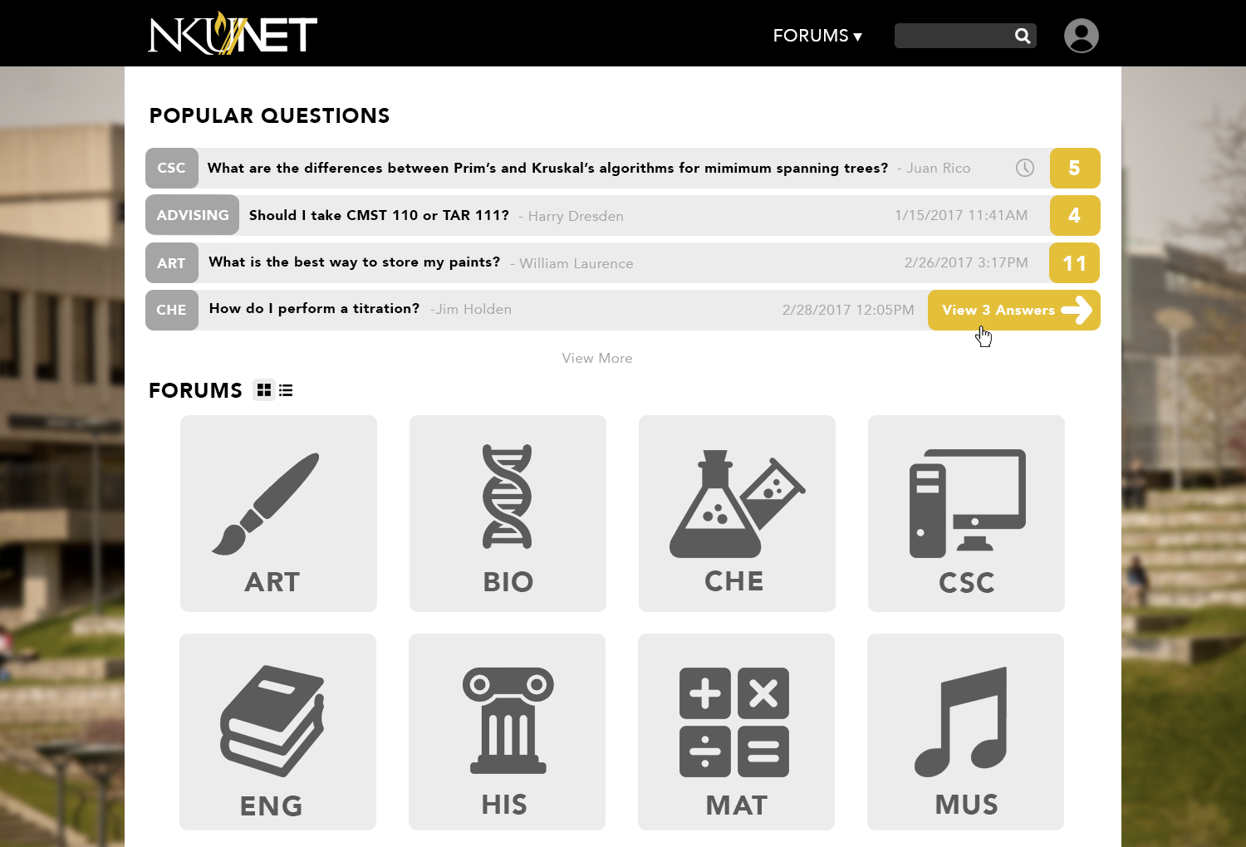

## System Design

In Iteration 1, we focused mainly on learning how to implement the Rails framework. We chose use cases that were essential, but relatively straight-forward with limited alternate paths. Other factors driving our design decisions were the availability of resources and the deadline.

The use cases selected were:

* View Forum
* Ask Question
* View Question
* Answer Question

It was our desire to create an aesthetically pleasing website that is easy to navigate, looks Nuevo and has familiar functionality to many of today’s websites. However, as we progressed through Iteration 1 we realized we needed to start looking at the functionality before the aesthetics. It is our hope to be able to incorporate a more interactive UI in a later iteration.

No one on our team had experience with either Ruby or Rails. The learning curve proved to be steeper than we had anticipated. To get us all on the same footing, we decided to group code with all team members present. While this proved to be very productive, it was a time drain on our development cycle.

One item of interest is that the object we have been calling Resource has been implemented as UserFile. Apparently, “resource” is a reserve word and could not be used as a database object.

# Database Design

## ERD

## Database Discussion

Our database model falls into roughly three parts:   
1. User-related tables (represented in green section of ERD)  
2. Course-related tables (represented in yellow of ERD)  
3. Forum-related tables (represented in purple ERD)

All tables are in third-normal form.

Iteration 1 focuses mainly on Forum-related tables. In this iteration, we implemented Forum, Question and Answer. We also implemented User, Role and Resource as some of the other tables have foreign keys into the User table. It was advantageous to define these tables now, even though we will not be implementing their functionality until a later iteration.

## Rails Database Commands

* rails generate model Role role:string
* rails generate model User user_name:string password:string role:references
* rails generate model UserFile resource_text:string resource_url:string attached_file:binary user:references
* rails generate model Forum forum_name:string forum_description:string resource_url:string
* rails generate model Question title:string text:string active:boolean user:references forum:references #change migration script::> t.boolean :active, :default => true
* rails generate model Answer text:string active:boolean user:references question:references #change migration script::> t.boolean :active, :default => true
* rake db:reset

# Exit Criteria

The following exit criteria is required to complete Iteration 1.

1. System must compile without errors.
2. 95% of the following test cases must pass.
   1. The Home Page displays the latest Questions that have been asked and a list of Forums.
   2. A specific Forum is displayed when selected from the Home Page. The Forum will contain a list of Questions that have been posted.
   3. A new Question can be entered into a Forum by supplying the Question Title and Question Description. The Forum will be refreshed automatically so that the Question is visible.
   4. Attempting to add a Question without supplying a Question Title will leave you in enter mode for that Question.
   5. Attempting to add a Question without supplying a Question Description will leave you in enter mode for that Question.
   6. Selecting a Question will display the list of Answers for it.
   7. A new Answer can be entered into a Question by supplying the answer text. The Question will be refreshed automatically so that the Answer is visible.
   8. Attempting to add an Answer without supplying an Answer Text will leave you in enter mode for that Answer.
   9. Approval from Mr. McCord based on our presentation.
   10. General approval of other project teams based on our presentation.