NKUNet

Requirements Document

*Version: Iteration 1*

|  |  |  |
| --- | --- | --- |
| **Revision History** | | |
| March 15, 2017 | I5S Team | Initial version |

Table of Contents

Use Case Model 2

Roles and Actors Diagram 2

Use Case Context Diagram 2

Use Cases Implemented in Interation 1 (Fully Dressed) 3

UC-1 3

UC-2 3

UC-3 4

UC-4 5

Use Cases Implemented Deferred to later Iteration (Fully Dressed) 5

UC-6 5

UC-10 6

UC-11 7

Use Cases (Brief) 8

UC-5 8

UC-8 9

UC-9 10

UC-12 10

UC-13 10

Domain Model 11

System Sequence Diagrams 12

UC-1 12

UC-2 12

UC-2 (alternate flow) 13

UC-3 13

UC-4 14

# Use Case Model

## *Roles and Actors Diagram*

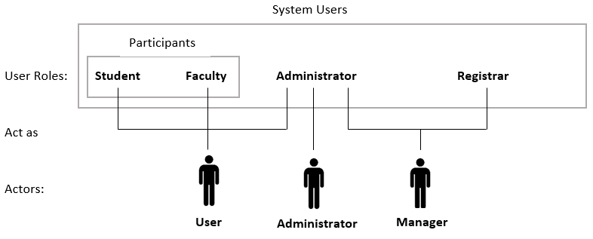

## *Use Case Context Diagram*

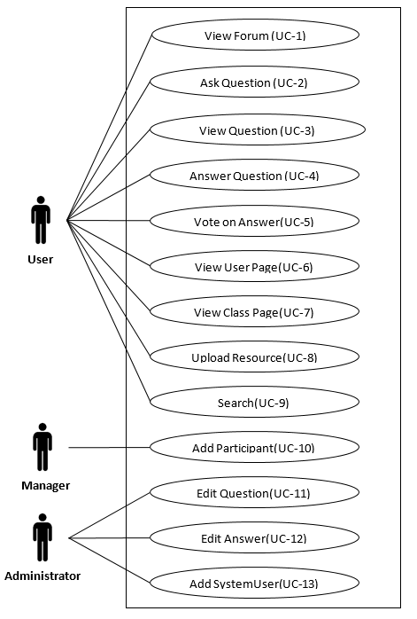

## Use Cases Implemented in Interation 1 (Fully Dressed)

|  |  |
| --- | --- |
| UC-1 | **Name**: View Forum |
|  | **Level**: User Goal |
|  | **Scope**: NKUNet |
|  | **Primary Actor**: User |
|  | **Stakeholders and Interests**:  1.   User: Wants to view a list of questions by topic. |
|  | **Preconditions**: User is logged in. |
|  | **Success Guarantee (or Post conditions)**: Forum is displayed to user. |
|  | **Main Success Scenario (or Basic Flow)**:  1.    User accesses system.  2.    System presents a list of forums.  3.    User selects a forum.  4.    System presents a list of questions posted in that forum and summary information for each question. |
|  | **Extensions (or Alternative Flows)**:  a*. At any time, the student cancels the activity: the current activity will cease. |
|  | **Special Requirements**: None |
|  | **Technology and Data Variations List**: None |
|  | **Frequency of Occurrence**: Could be nearly continuous. |
|  | **Open Issues**:   1. User Authentication procedures need to be established. |

|  |  |
| --- | --- |
| UC-2 | **Name**: Ask Question |
|  | **Level**:  User Goal |
|  | **Scope**:  NKUNet |
|  | **Primary Actor**: User |
|  | **Stakeholders and Interests**:  1.   User: Wants to ask other NKUNet users a question. |
|  | **Preconditions**: User has navigated to a forum. |
|  | **Success Guarantee (or Post conditions)**: Question is posted to forum. |
|  | **Main Success Scenario (or Basic Flow)**:  1. User selects Ask Question as desired activity.  2. User enters: Question Title, Question Description.  3. User submits question.  4. System saves question.  5. System presents the new question within the forum. |
|  | **Extensions (or Alternative Flows)**:  a*. At any time, the system fails.   1. The current activity will cease. 2. Entered information that was not submitted will be lost.   b*. At any time, the student cancels the activity.   1. The current activity will cease. 2. Entered information that was not submitted will be lost.   3a. User submits a question without a Title and/or a Question Description   1. System will not save question. 2. User will be prompted to enter missing information. |
|  | **Special Requirements**: None |
|  | **Technology and Data Variations List**: None |
|  | **Frequency of Occurrence**: Could be nearly continuous. |
|  | **Open Issues**:   1. Should there be the option to change forum while asking question? |

|  |  |
| --- | --- |
| UC-3 | **Name**: View Question |
|  | **Level**:  User Goal |
|  | **Scope**:  NKUNet |
|  | **Primary Actor**: User |
|  | **Stakeholders and Interests**:  1.   User: Wants to see the description of a particular question and view answers to that question. |
|  | **Preconditions**: User has navigated to a forum. |
|  | **Success Guarantee (or Post conditions)**: Selected question and its answers are displayed to user. |
|  | **Main Success Scenario (or Basic Flow)**:  1. User selects a question.  2. System presents question description and answers posted to the question. |
|  | **Extensions (or Alternative Flows)**:  a*. At any time, the student cancels the activity: the current activity will cease. |
|  | **Special Requirements**: None |
|  | **Technology and Data Variations List**: None |
|  | **Frequency of Occurrence**: Could be nearly continuous. |
|  | **Open Issues**: None |

|  |  |
| --- | --- |
| UC-4 | **Name**: Answer Question |
|  | **Level**:  User Goal |
|  | **Scope**:  NKUNet |
|  | **Primary Actor**: User |
|  | **Stakeholders and Interests**:  1.   User: Wants to post an answer to a viewed question. |
|  | **Preconditions**: User has navigated to a question. |
|  | **Success Guarantee (or Post conditions)**: Answer is posted. |
|  | **Main Success Scenario (or Basic Flow)**:  1. User chooses Answer Question as the desired activity.  2. User enters answer.  3. User submits answer.  4. System saves answer.  5. System presents the question and answers, including the new answer. |
|  | **Extensions (or Alternative Flows)**:  a*. At any time, the system fails.   1. The current activity will cease. 2. Entered information that was not submitted will be lost.   b*. At any time, the student cancels the activity.   1. The current activity will cease. 2. Entered information that was not submitted will be lost.   3a. User submits without entering an answer     1. System will not save answer.     2. User will be prompted to enter missing information. |
|  | **Special Requirements**: None |
|  | **Technology and Data Variations List**: None |
|  | **Frequency of Occurrence**: Could be nearly continuous. |
|  | **Open Issues**:   1. Should users be able to edit their own answers? |

## Use Cases Implemented Deferred to later Iteration (Fully Dressed)

|  |  |
| --- | --- |
| UC-6 | **Name:** View User Page |
|  | **Level**: User Goal |
|  | **Scope**: NKUNet |
|  | **Primary Actor**: User |
|  | **Stakeholders and Interests**:  1. User: Wants to view information about another user that might be helpful, including questions and answers they have recently posted.  Wants to view their own reputation. |
|  | **Preconditions**:  1. User is either viewing a question posted by a User, viewing an answer posted by a User, viewing information regarding a class that contains faculty and enrolled students or is viewing user information on himself/herself. |
|  | **Success Guarantee (or Post conditions)**: User information is presented. |
|  | **Main Success Scenario (or Basic Flow)**:  1.       User selects the name of another User who posted a question.  2.       System presents information for the other User:      a.       Classes where student is/was enrolled      b.       Reputation (upvotes, downvotes, number of questions answered)      c.       Most recent questions posted      d.       Most recent answers posted      e.       Educational resources posted |
|  | **Extensions (or Alternative Flows)**:  a*.  At any time, the student cancels the activity:  the current activity will cease.  1a.  User selects the name of another User who posted an answer.  1b.  Admins who post either questions or answers cannot be selected as there is no user information.  1c.  User selects the name of another User who is enrolled in a class.  1d.  User selects himself/herself.  2a.  System presents Educational Resource options if User viewing his/her own user information (UC-8). |
|  | **Special Requirements**: None |
|  | **Technology and Data Variations List**: None |
|  | **Frequency of Occurrence**: Could be nearly continuous. |
|  | **Open Issues**:  1.    Navigation preconditions – where are all the opportunities to view a user page?  2.    Reputation calculation?  3.    How many recently posted questions/answers posted should be displayed on this page? |

|  |  |
| --- | --- |
| UC-10 | **Name**: Add Participant |
|  | **Level**:  User Goal |
|  | **Scope**:  NKUNet |
|  | **Primary Actor**: Manager |
|  | **Stakeholders and Interests**:   1. Manager:  Successfully add a user to NKUNet 2. Participant:  Wants to be added to NKUNet |
|  | **Preconditions**:  Participant information is provided to Manager.  Participant information is edited and added to a CSV file. |
|  | **Success Guarantee (or Post conditions)**: Participant added successfully to NKUNet. |
|  | **Main Success Scenario (or Basic Flow)**:  1. Manager uploads CSV file into system.  2. System adds Participants.  3. System reports upload status to Manager. |
|  | **Extensions (or Alternative Flows)**:  a*. At any time, System Fails:  System does not retain any information from failed upload.  b*.  At any time the Manager cancels the activity:   1. No changes made since the beginning of the activity will be retained. 2. Current activity will cease. |
|  | **Special Requirements**: None |
|  | **Technology and Data Variations List**:  1a. Locally saved CSV is uploaded to the system.  1b. Centrally saved file is uploaded to the system. |
|  | **Frequency of Occurrence**: Could be nearly continuous. |
|  | **Open Issues**:  1.   Student/Faculty may need to be added differently.  2.   Class schedule information needs to be added at a later time AND addressed in a different iteration.  3.   How will Participant be notified that they were added to the system? |

|  |  |
| --- | --- |
| UC-11 | **Name**: Edit Question |
|  | **Level**:  User Goal |
|  | **Scope**:  NKUNet |
|  | **Primary Actor**: Administrator |
|  | **Stakeholders and Interests**:  1.   Administrator: Wants to successfully delete or edit an inappropriate question posted.  2.   University: Wants to protect the integrity, safety and legitimacy of the forum system. |
|  | **Preconditions**: Questions entered. |
|  | **Success Guarantee (or Post conditions)**: Question is removed or edited. |
|  | **Main Success Scenario (or Basic Flow)**:  1. Administrator selects Question.  2. Administrator selects Edit as desired activity.  3. Administrator inputs changes.  4. System saves changes. |
|  | **Extensions (or Alternative Flows)**:  a*. At any time, System fails:  1. System retains all data and deletion/edit will not occur.  2. After recovery, users can access systems questions and answers.  b*. At any time, the Administrator cancels the activity.  1.  No changes made since the beginning of the activity will be retained.  2.  Current activity will cease.  2a. Administrator wants to delete a question.  1. Administrator selects to delete a question.  2. System removes the question.  2b. Administrator wants to edit a question.  1.  Administrator selects to edit a question.  2.  Administrator submits changes to question. |
|  | **Special Requirements**: None |
|  | **Technology and Data Variations List**: None |
|  | **Frequency of Occurrence**: Could be nearly continuous. |
|  | **Open Issues**:  1.    Should all answers to a deleted question also be deleted?  2.    Should all answers to a deleted question still be viewable?  3.    Should the original ‘bad’ text be retained, but visibility reduced?  4.       Should there be a tracking mechanism to ‘ban’ users who have frequent questions (and answers deleted)?  5.    Should users be made aware if a question is deleted? |

## *Use Cases (Brief)*

|  |  |
| --- | --- |
| UC-5 | **Name:** Vote on Answer |
|  | **Primary Actor:** User |
|  | **Goal:** Upvote or downvote an answer. |
|  | **Summary:** User rates answer that they are viewing.  **Basic Flow:**  1. User selects upvote.  2. System updates answer’s score, reputation for User and activity score of the question.  **Alternate Flows:**  1a. User selects downvote.  1-2b. User had previously rated the question.  1.   User previously selected the same rating (upvote or downvote):  no effect to rating.  2.   User previously selected the opposite rating (upvote or downvote).  a.    Effects of previous rating negated.  b.    New rating applied. |

|  |  |
| --- | --- |
| UC-7 | **Name:** View Class Page |
|  | **Primary Actor:** User |
|  | **Goal:** View class information. |
|  | **Summary:** User selects Class.  Class information is presented.  **Basic Flow:**  1. User selects a class while viewing user information.  2. System presents class information:  description, Faculty teaching the class, Student(s) enrolled.  **Alternate Flows:**  1a. User selects one of his/her classes. |

|  |  |
| --- | --- |
| UC-8 | **Name:** Upload Resource |
|  | **Primary Actor:** User |
|  | **Goal:** Add educational resource. |
|  | **Summary:** User adds educational resource for others to access.  **Basic Flow:**  1.  User selects Upload Resource as desired activity while viewing his/her own user information.  2.  User inputs information as text.  3. System saves resource.  4. System presents User information:  schedule (classes), reputation (upvotes, downvotes, questions answered), recent questions posted, recent answers posted, educational resources.  (Resource just posted is included.)  **Alternate Flows:**  1a. User selects Update Resource as desired activity and selects resource.  1-3b. User selects Remove Resource as desired activity and selects resource.  2a. User inputs information as link.  2b. User inputs information as attachment. |

|  |  |
| --- | --- |
| UC-9 | **Name:** Search |
|  | **Primary Actor:** User |
|  | **Goal:** Search for a question or class. |
|  | **Summary:** User searches for question by subject, user, post title or post keyword or a combination of these or user searches for class by name or instructor.  **Basic Flow:**  1. User selects Search as desired activity.  2. User selects Question.  3. User enters search terms (subject, user, title, keyword or some combination).  4. System presents search results.  **Alternate Flows:**  2-3a. User selects Class.  Search terms are name or instructor. |

|  |  |
| --- | --- |
| UC-12 | **Name**: Edit Answer |
|  | **Primary Actor**: Administrator |
|  | **Goal**: Edit an answer. |
|  | **Summary:** Administrator edits an answer.  **Basic Flow:**  1. Administrator selects Answer.  2. Administrator selects Edit as desired activity.  3. Administrator inputs changes.  4. System saves changes. |

|  |  |
| --- | --- |
| UC-13 | **Name**: Add SystemUser |
|  | **Primary Actor**: Administrator |
|  | **Goal**: Add a SystemUser. |
|  | **Summary:** Administrator adds a SystemUser.  **Basic Flow:**  1. Administrator adds a new SystemUser.  2. System adds SystemUser. |

# Domain Model

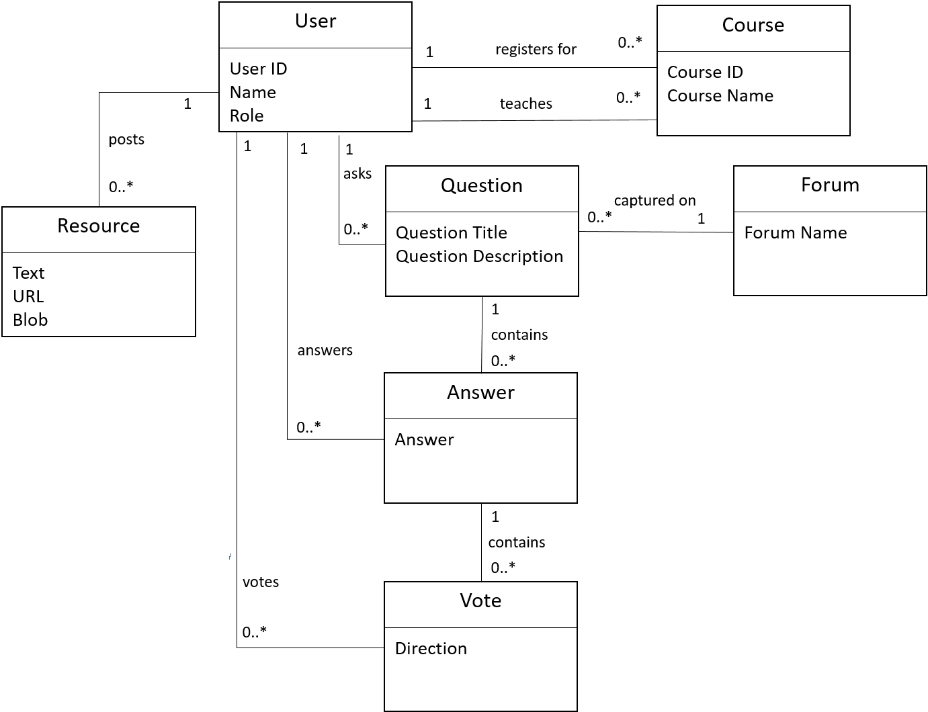

# System Sequence Diagrams

### UC-1

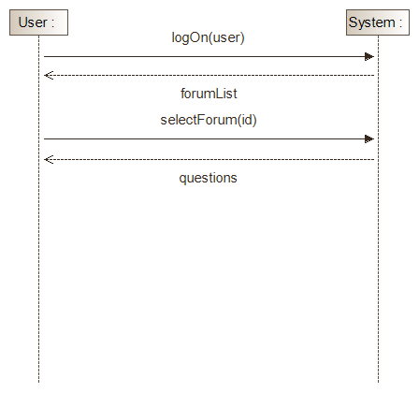

### UC-2

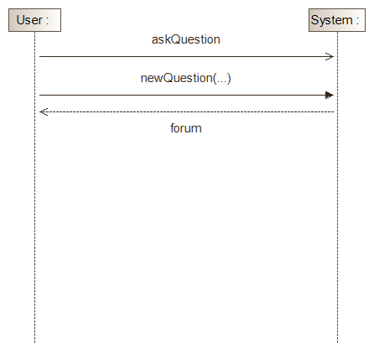

### UC-2 (alternate flow)

Question Title and Question Description not supplied.

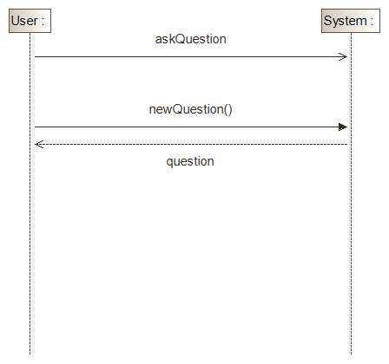

### UC-3

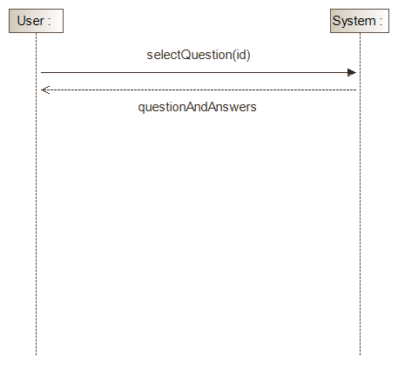

### UC-4

