**Design Document**

**Team 17: Ethan Perry, Jared Bryant,**

**Brian Vach, Chris Fitgerald**

**Table of Contents**

Database Design Decisions 2

Overall Design Decisions 2

Design Class Diagram 3

UC4: Post Question Design Diagram 4

UC5: Answer Question Design Diagram 5

UC5: Alternate Flow Design Diagram 6

**Database Design Decisions:**

The database for the CSC Iteration 1 Demo App consists of 4 tables. These tables are “Courses”, “Users”, “Questions, and “Answers”. The decision was made to limit the database to these 4 tables for now for simplicity. Later in the project, more tables may be added. First, let’s look at the “Courses” table. It was decided that this table only needed three fields for now, Name, Description, and Professor. This was enough to get meaningful data stored for a demo. Next is “Users”. This table contains Name, Email, and Course_ID. It was decided that for now, a user will only belong to one course. Later this will be changed. Next is the table “Questions”. This table contains Course_ID, Title, User_ID, and Content. It was decided that a question can only belong to one class, and one user. We do not anticipate this to change. The last table is “Answers”. This table is very similar to “Questions”. It contains Question_ID, User_ID, and Content. An answer should only belong to one question and one user. Again, we do not expect this to change.

**Overall Design Decisions**

The CSC 440 Iteration 1 Demo App was built using Ruby on Rails, taking advantage of the scaffolding feature that is made available in Rails. Upon loading the website, the user is presented with a list of courses, each with a link to questions related to the course. The user can then click on one of these links, and view the questions, or submit a new one. If the user clicks on a question, they are show answers for that question, and a link to submit new answers. At the top of every page is a nav bar with a link to the home courses page, and to a user management page, where new users can be created and existing users edited. There is also a search bar with functionality that has not been implemented yet. It was decided to use Bootstrap as the CSS framework because it integrates with Rails extremely well, and is very easy to implement. The courses, questions, and answers are displayed as bootstrap “cards” because the card offers a built-in border with rounded edges that we liked. For the headers of the card lists on the questions and answers pages, we used a “jumbotron” object that complements the cards well. Overall we chose a blue/grey theme (except for the search button, which is green for a complement).

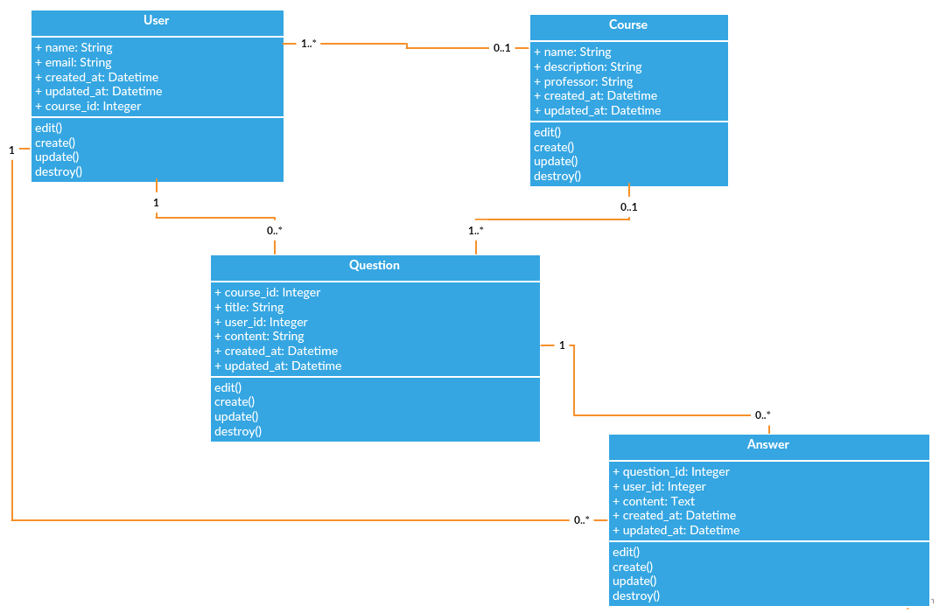

**Design Class Diagram**

