**Table of Contents**

Use Case 1: Log in to system 2

Use Case 2: Create Accounts 3

Use Case 3: Post Question 5

System Level Sequence Diagram 6

Design Level Sequence Diagram 7

Use Case 4: Answer Question 8

System Level Sequence Diagram 9

Design Level Sequence Diagram 10

Use Case 6: View Schdule 12

Use Case 5: Search for Questions 13

Context Model Diagram 14

**Use Case UC1:** Log in to system

**Primary Actor:** Administrator, Faculty, Registrar, Student

**Stakeholders and Interests:**

* All actors must be able to authenticate their username and passwords in order to access the system

**Preconditions:**

* The user has a valid username and password
* An account exists for the user in the system
* The system is available

**Postconditions:**

* The user is authenticated, and redirected to the homepage of the system

**Summary:** The user navigates to the landing page of the system, types in their username and password, clicks login, then is redirected to the homepage.

**Basic Flow**:

1. User navigates to the landing page
2. User selects the username field
3. User enters their username in the correct format
4. User selects the password field
5. User enters their password
6. User clicks the login button
7. User is redirected to the homepage

**Alternate Flows:**

*a. The system crashes or becomes unavailable

1. A custom error page is displayed with the IT helpdesk contact information

3a. User enters their username in an incorrect format

1. The field is turned red, and the user is alerted that the username is not in the correct format, and the correct format is shown

6a. Username or password are incorrect

1. Red text is displayed below the login button stating that either the username or password is incorrect, with a link to where the user can reset their password. The IT helpdesk contact info is also shown.

6b. Either the username or password has not been entered

1. Whichever field has not been entered is turned red

**Use Case UC2:** Create Accounts

**Primary Actor:** Administrator, Registrar

**Stakeholders and Interests:**

* Administrator: Must ensure all faculty and registrar have an account and can access the system
* Registrar: Must ensure that all student accounts are created before classes begin

**Preconditions:**

* The user has logged into the system
* The user is an administrator or a registrar type user
* The system is available

**Postconditions:**

* One or multiple user accounts are added to the database

**Summary:** The user logs into the system, navigates to the admin page, and selects create users. The user can either complete a form by entering the first name, last name, account name, and password of the account to create, or they can upload a csv file containing a list of these values. Uploading a csv file will bulk add users. If an administrator is creating a user, they will also have the option to specify if the new user will also be an administrator

**Basic Flow**:

This flow describes the set of steps for a registrar user to create one new account

1. User navigates to the landing page
2. User logs into the system
3. User clicks the link to the admin page, and is redirected there
4. User selects “create users” option on admin page, and is redirected to the create users page
5. User fills out the form, specifying the first name, last name, account name, and password for the new user
6. User clicks the “Create User” button
7. User is shown a confirmation popup that the new user has been created
8. User returns to the homepage

**Alternate Flows:**

*a. The system crashes or becomes unavailable

1. A custom error page is displayed with the IT helpdesk contact information

*b. The user clicks the logout button

1. The user is logged out and redirected to the landing page

4a. The user is not an admin or registrar user

1. The admin button will not be shown

5a. User would instead prefer to bulk upload users

1. User clicks the Bulk Upload button
2. User is presented with a file picker dialog
3. User selects a .csv file containing the users to create, and the file is uploaded
4. The user clicks Create Users
5. User is shown a confirmation user stating how many users have been created by the bulk upload
   1. If the create fails, the user is instead shown a dialog stating that there was a problem creating the users, and to check the format of the .csv file.

5b. The user is an administrator, and would like to create another admin users

1. If the logged in user is an admin, and additional field will be present in the form, and will be required. This field will be a checkbox for whether the created user should be an admin or not.
   1. If this box is checked, the bulk upload button will no longer appear. Admins should only be able to create new admins one at a time.

7a. Any of the fields in the form have not been completed

1. Whichever field has not been completed is turned red

**Use Case UC3:** Post Question

**Primary Actor:** Student

**Stakeholders and Interests:**

* Student: Wants to ask question to better understand material or if they have a question about the course

**Preconditions:**

* Student is logged in
* The system is available

**Postconditions:**

* The Students question is posted where other users can see and vote on the question

**Summary:** The Student navigates to the question board. Student selects new question option, enters question, and selects post. The question is then posted to the question board.

**Basic Flow**:

1. Student navigates to question board.
2. Student selects the option to post a new question.
3. Student enters question.
4. Question is posted to question board.

**Alternate Flows:**

*a. The system crashes or becomes unavailable

1. A custom error page is displayed with the IT helpdesk contact information

*b. Student logs out

1. Return to log in screen

3a. Student navigates away before posting question

1. Post is discarded

4b. Question is not posted

1. Display error and ask to try posting again later

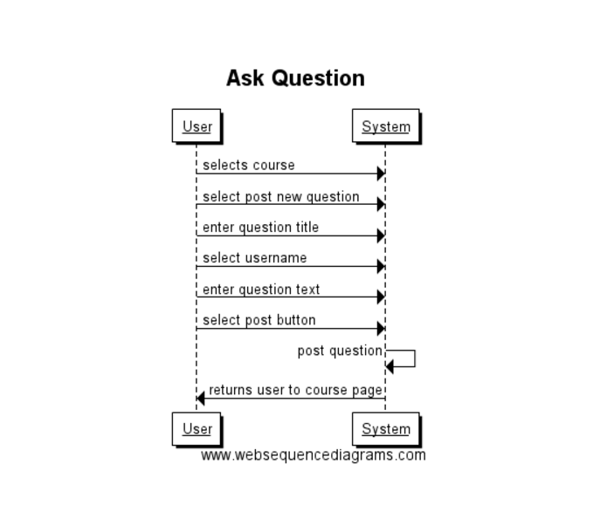

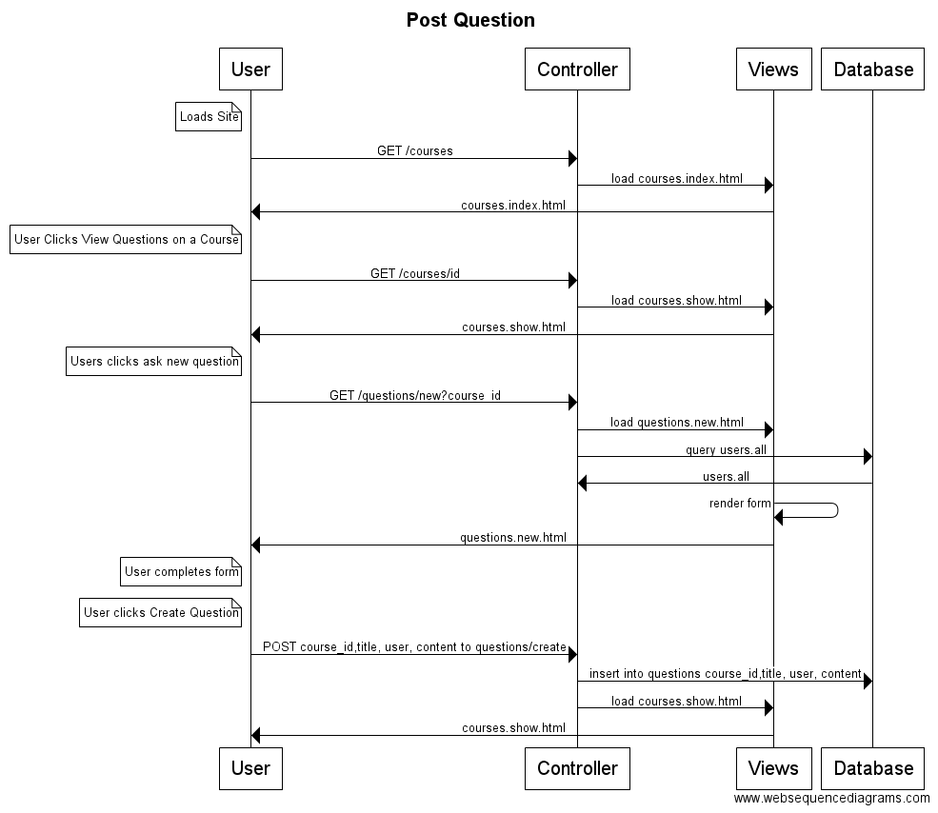

**Use Case UC4:** Answer Question

**Primary Actor:** Student

**Stakeholders and Interests:**

* Student: Wants to help classmate by answering question

**Preconditions:**

* Student is logged in
* The system is available
* There must be at least one question on the question board

**Postconditions:**

* The Students response is posted to the question

**Summary:** The Student navigates to the question board. Student selects the question they want to answer, enters response, and selects post. The response is then posted to the original question.

**Basic Flow**:

1. Student navigates to question board.
2. Student selects the question they want to respond to.
3. Student enters response.
4. Response is posted to original question.

**Alternate Flows:**

*a. The system crashes or becomes unavailable

1. A custom error page is displayed with the IT helpdesk contact information

*b. Student logs out

1. Return to log in screen

3a. Student navigates away before posting response

1. response is discarded

4b. Response is not posted

1. Display error and ask to try posting again later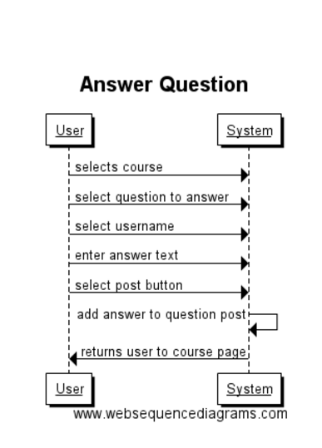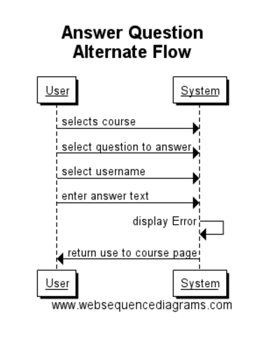

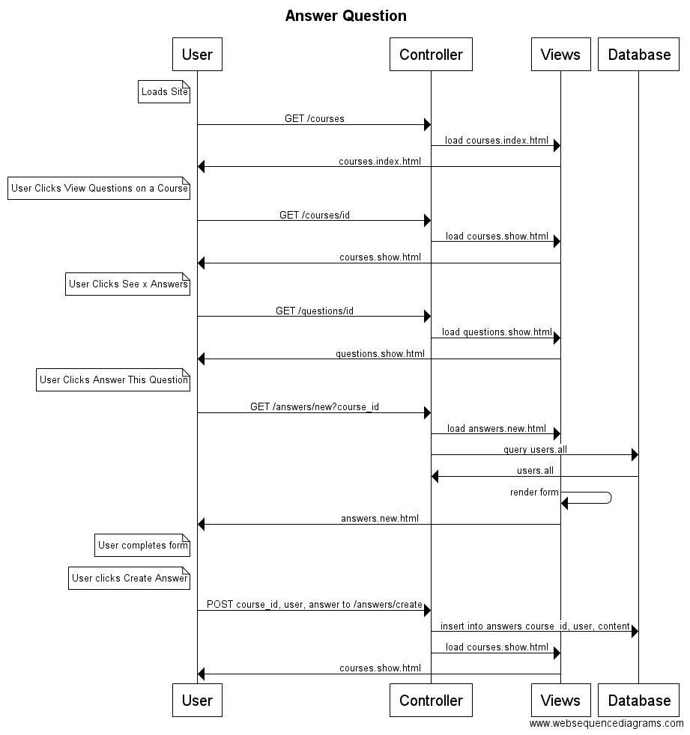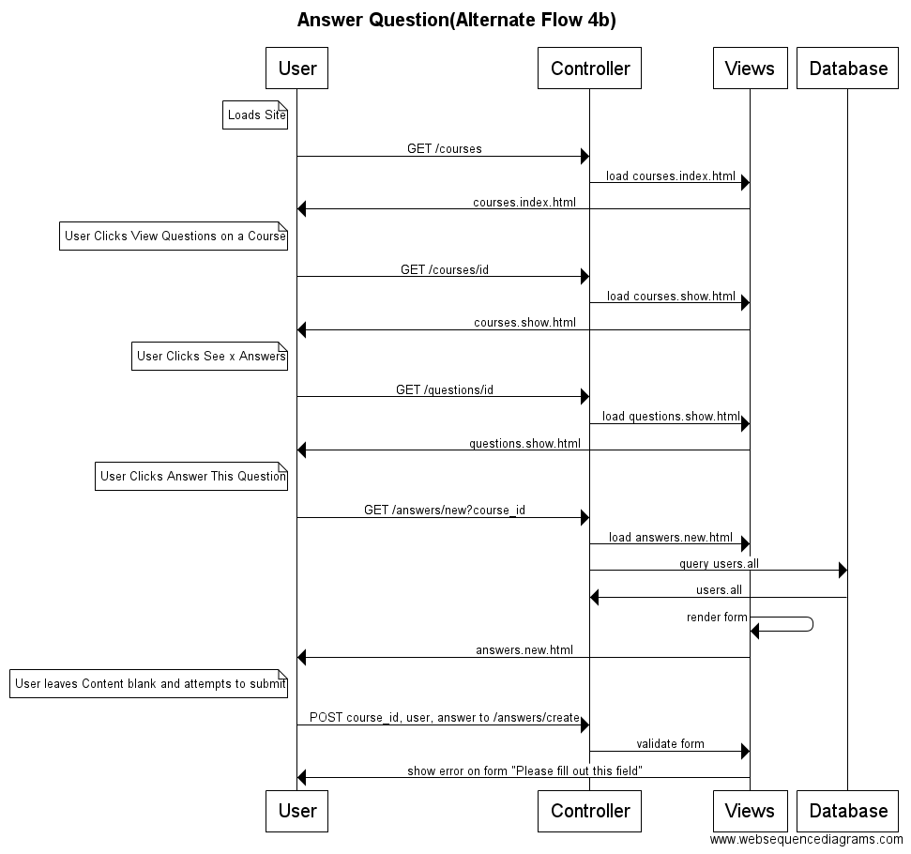

**Use Case UC5**: View Schedule

**Primary Actor:** Student

**Stakeholders and Interests:**

* Student: The student should be able to view their schedule so that they know which classes they need to attend.
* University: The university wants to make sure that students have accurate class information so they are able to show up to the classes that they signed up for.

**Preconditions:**

* User is properly identified and authenticated.
* User is enrolled in the university in the current semester.

**Postconditions:**

* User views their schedule

**Summary:** The user logs into the system. The user then clicks on view schedule and then views their schedule. They log out of the system when they are done.

**Basic Flow:**

1. User logs into the system.
2. User clicks on “View Schedule”.
3. User views the schedule.
4. User logs out of the system.

**Alternate Flows:**

*a. The system crashes or becomes unavailable

1. A custom error page is displayed with the IT helpdesk contact information

*b. Student logs out

1. Return to log in screen

**Use Case UC6:** Search for Question

**Primary Actor:** Student, Faculty

**Stakeholders and Interests:**

* Student: Students need to be able to look up previous questions for quick answers so that they do not post questions that have already been asked before.
* Faculty: Be able to look up frequently asked questions to modify their courses to better cover certain subjects.
* University: The university wants to make sure that information is easily available for students.

**Preconditions:**

* User is properly identified and authenticated.
* User is currently enrolled in the university

**Postconditions:**

* User can view a previous thread.
* The user is prompted to ask a new question if the system cannot find a similar question.

**Summary:** The user logs into the system and clicks on search. The user then types in search words to find a similar question. The user then can click on the thread with a similar question or creates their own. The user then logs out of the system when they are done.

**Basic Flow**:

1. User logs into the system.
2. User clicks on the search bar on the page.
3. User types in key phrases similar to their question.
4. User then views the results from the page.
5. User clicks on the question related to their search.
6. User logs out of the system.

**Alternate Flows:**

*a. The system crashes or becomes unavailable

1. A custom error page is displayed with the IT helpdesk contact information

*b. Student logs out

1. Return to log in screen

4a. Page returns no similar questions

1. A button appears that allows the user to post a new question regarding this topic

**Context Model Diagram:**

