Contents

Classes 2

Controllers 2

Class Diagram 3

Sequence Diagrams 4

Database 6

# Classes

The basis of User interaction revolves around three main classes: forum, post and reply (all of which inherit from the ApplicationRecord).

**forum** – Each instance of a forum has an id and a forum\_subject. Forum access is mediated by the forums\_controller.

**post** – Each instance has a content and a title and is linked to a forum. Post access is mediated by the posts\_controller.

**reply** – Each instance has a content and is linked to an associated post. Reply access is mediated by the replies\_controller.

# Controllers

Access to the above classes is moderated by three controllers: forums\_controller, post\_controller and replies\_controller (all of which inherit from the ApplicationController).

**forum\_controller** – Given a subject\_name, the forum\_controller will use the necessary CRUD operation to create an instance of the forum class.

**post\_controller** – Given a title, content and the forum\_id of an existing forum instance, the post\_controller will call upon the proper CRUD operation to create a new instance of the post class.

**replies\_controller** – Given a content and the post\_id of an existing post instance, the replies\_controller will create an instance of the reply class.

In addition, all the above controllers have CRUD operations to the modify and delete entity instances (update and destroy respectively).

## Class DiagramMacintosh HD:Users:nickborne:Desktop:class_diagram.png

# Sequence Diagrams

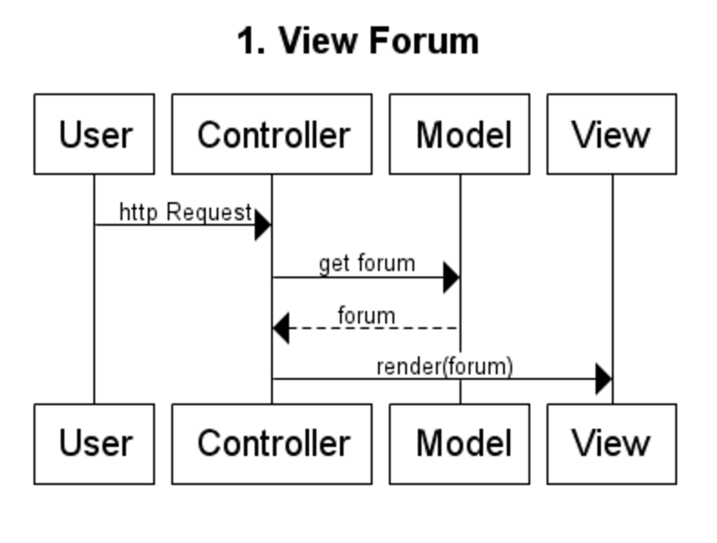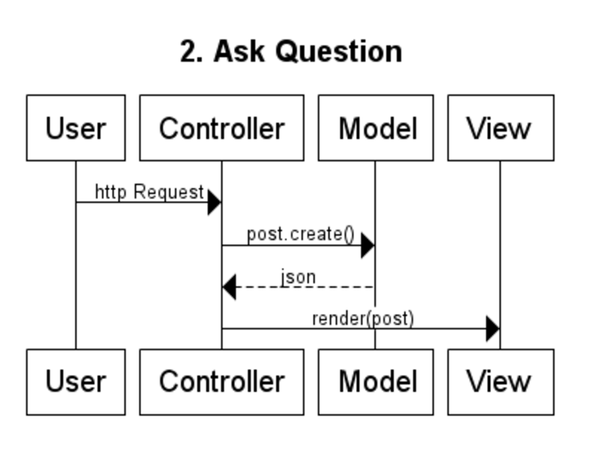

# Macintosh HD:Users:nickborne:Desktop:sequence_diags:3.pngMacintosh HD:Users:nickborne:Desktop:sequence_diags:4.png

# Database

Tables:

Forum (corresponds to the forum model):

* id: integer
* date\_created
* date\_modified

Post (corresponds to the post model):

* id: integer
* forum\_id: integer FK
* title: string
* content: string
* date\_created
* date\_modified

Reply (corresponds to the reply model):

* id: integer
* content: string
* date\_created
* date\_modified

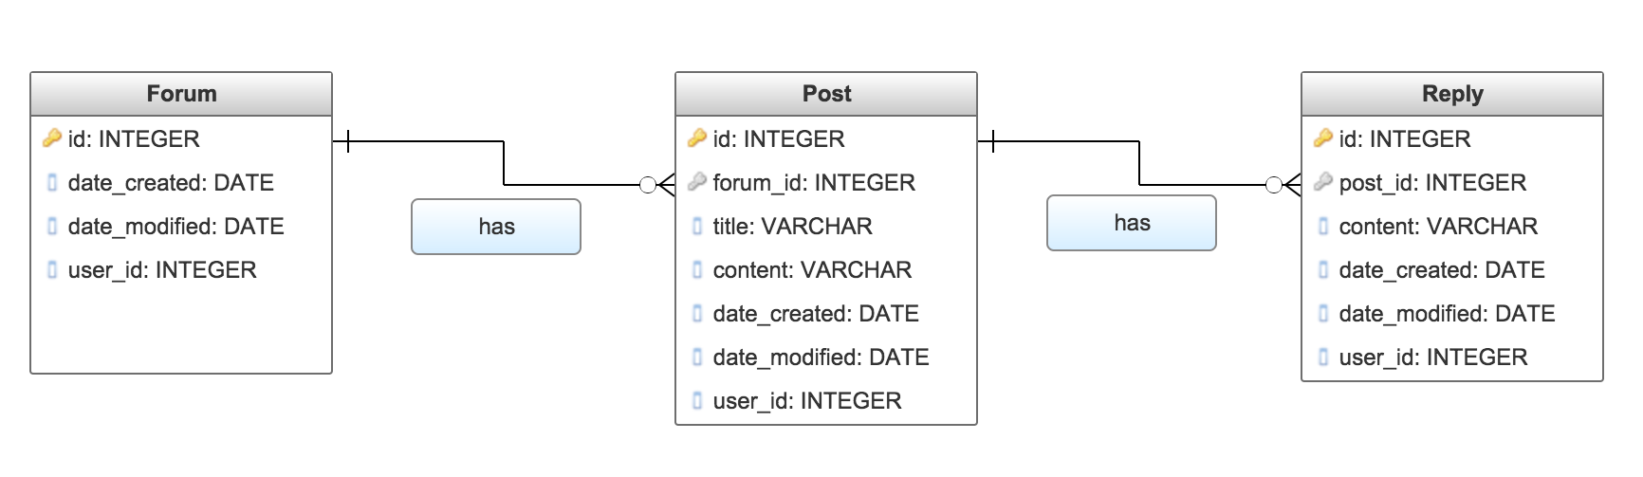

Forum has 0…\* Post entities associated to it. forum\_id is a foreign key in the Post table.

Post has 0…\* Reply entities associated to it. post\_id is a f oreign key in the Reply table.

## Rails Console Commands

Forum.create(subject: "subject name")

Post.create(forum\_id: ”forum\_id”, title: “title”, content: “content”)

Reply.create(post\_id: “post\_id”, content: “content”)