Individual Design Specification SDG 4– Quality Education (Roman Kriuchkov 40488199)

Scenario Overview
This system is built for organisations like ITU digital inclusion programmes or national ministries of education that run ICT training. It gives them one place to manage programmes, courses, trainers and participants across different regions. Staff can add enrolments, track how participants are doing and run reports to see where digital skills are still lacking.

Real-World Challenge
The ITU Facts and Figures 2025 report shows that 74% of people worldwide are now online, but 2.2 billion still are not — mostly in low and middle income countries. Many organisations trying to fix this problem have no proper system to track who they are training, whether it is working, or which groups they are missing. This platform gives them a structured way to manage training delivery and see real results, so decisions are based on data rather than guesswork.

SDG Alignment
This system supports SDG 4 – Quality Education, specifically target 4.4, which aims to increase the number of young people and adults with digital skills. The ITU measures this using indicator 4.4.1 — the share of people with ICT skills. This platform helps organisations track exactly who got trained, what they learned and which groups are still being missed.

Proposed System and Key Users
The system is a web-based application that covers the whole training cycle from setting up programmes and assigning trainers to registering participants and recording results. Data administrators handle all the data entry: adding participants, linking trainers to courses and updating scores. Education officers and policy analysts use the reporting side to check completion rates, compare regions and spot gaps but they cannot change any data directly.

Data Sources and Evidence Base
The design is based on two ITU reports, its Measuring Digital Development Facts and Figures 2024 and 2025. The 2025 report highlights that while most of the world is online, big gaps remain women are 6% less likely to be online than men, rural users are far behind urban ones (58% vs 85%), and ICT skill levels vary a lot by income group. These patterns shaped the database directly: gender and areaType in tblParticipant come from the gender and urban-rural data; skillCategory in tblCourse maps to the five ITU skill areas; and the pre/post scores in tblEnrolment follow how indicator 4.4.1 measures skill progress.

Data Integrity and Security Considerations
Every table has a primary key to make sure each record is unique and can always be found. Foreign keys protect the relationships between tables, without them it would be possible to link a trainer to a programme that does not exist and that would make the data meaningless. NOT NULL constraints on fields like enrolDate and preAssessmentScore prevent incomplete records that could break reports. A UNIQUE constraint on participantID and pcID together in tblEnrolment stops the same person being accidentally enrolled twice in the same course. Restricting fields like gender, completionStatus, and difficultyLevel to set values keeps the data consistent, which matters especially when filtering or comparing groups in reports. Derived values like scoreImprovement and duration are calculated at query time rather than stored, so they are always accurate and never out of sync with the source data. Front-end validation — for example checking scores are between 0 and 100, or that end dates come after start dates — catches mistakes before they reach the database. Confirmation dialogs before deleting programmes or participants reduce the risk of accidental data loss. Finally, separating administrator and read-only roles means education officers can never accidentally modify or delete records they should only be viewing.

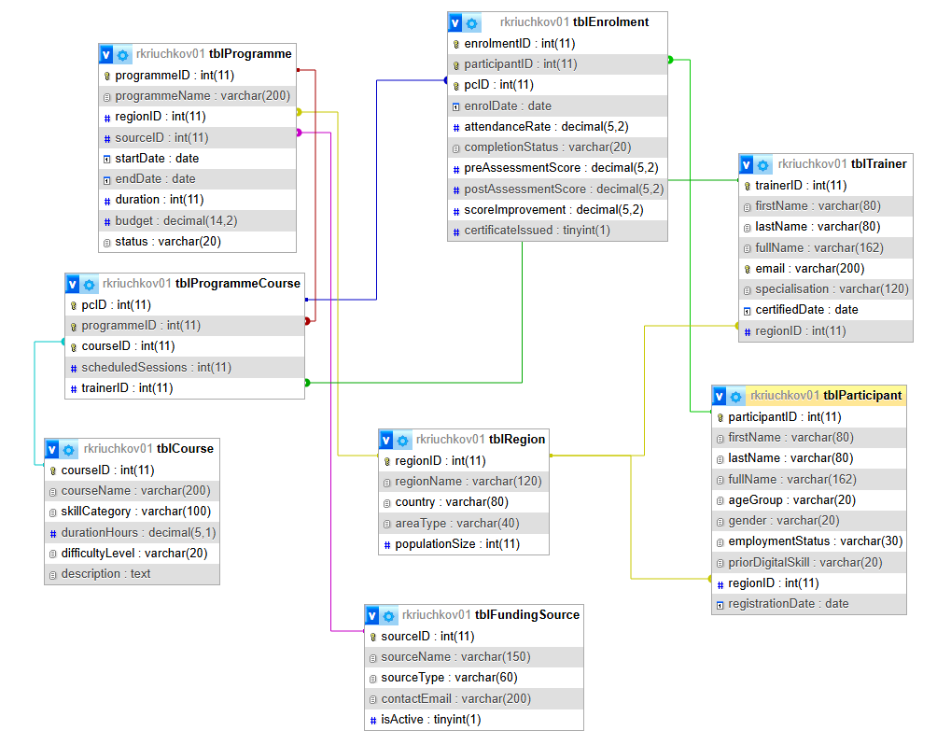
Initial Data Model (ERD)

Key CRUD Functionality
Create
- Add a new participant and enrol them in a programme course
- Create a new training programme and add courses to it
- Record pre and post assessment scores for a participant
- Add a new trainer and link them to a region
Update
- Update a participant's enrolment status (e.g. Enrolled ->Completed)
- Update programme status (e.g. Planned -> Active -> Completed)
- Reassign a trainer to a different programme course
Delete
- Remove a cancelled programme and its linked course records
- Delete a participant who has not yet been enrolled in anything
Reporting Ideas (parameterised by)
- Which regions have the lowest completion rates? -> region, date range
- What is the average score improvement per course? -> course, difficulty level
- Which demographic groups are least represented? -> gender, age group, area type
- Which trainers have the best completion rates? -> region, programme
- How have enrolment numbers changed over time? -> quarter, year, region
- Which funding sources back the most active programmes? -> status, region

