CSC154 Software Development
Sprint 3 Planning Deliverable

Project Name: Phoenix Video Rental
Team Number: 7
Project Manager: Krithika krishnan
Team Members: Yuki Fukushima, Brannon Christopher Copeland, Francis Giles, Makalo Charles
Sprint 3 Dates: 03/11/2026 - 03/17/2026

------------------------------------------------------------------------------------------------------------------
- Sprint 3 Goal
The goal of Sprint 3 is to develop the High-Level Design (SRS Version 2) by defining system architecture, database design, security, user experience, and core components. The team will create initial diagrams (ERD, DFD, Class Diagram) and refine requirements to prepare for system implementation.

- Product Backlog (Updated Version)
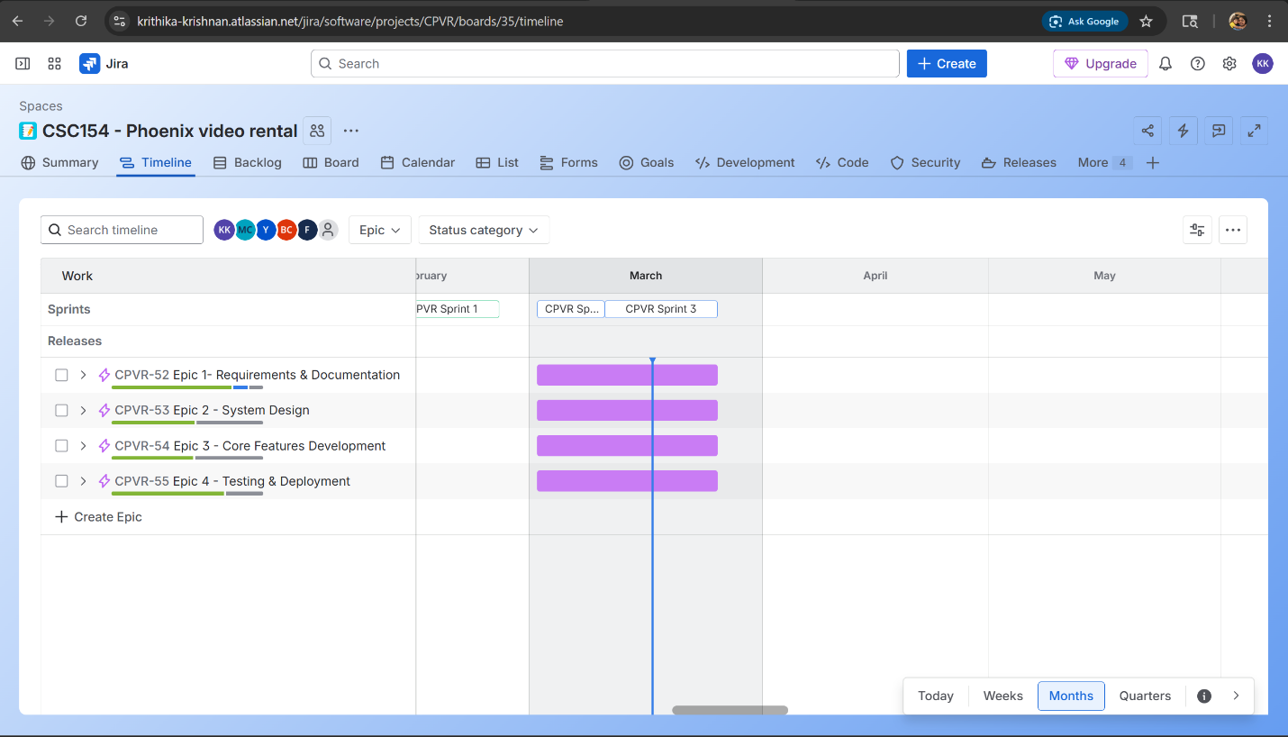

- Sprint 3 Backlog
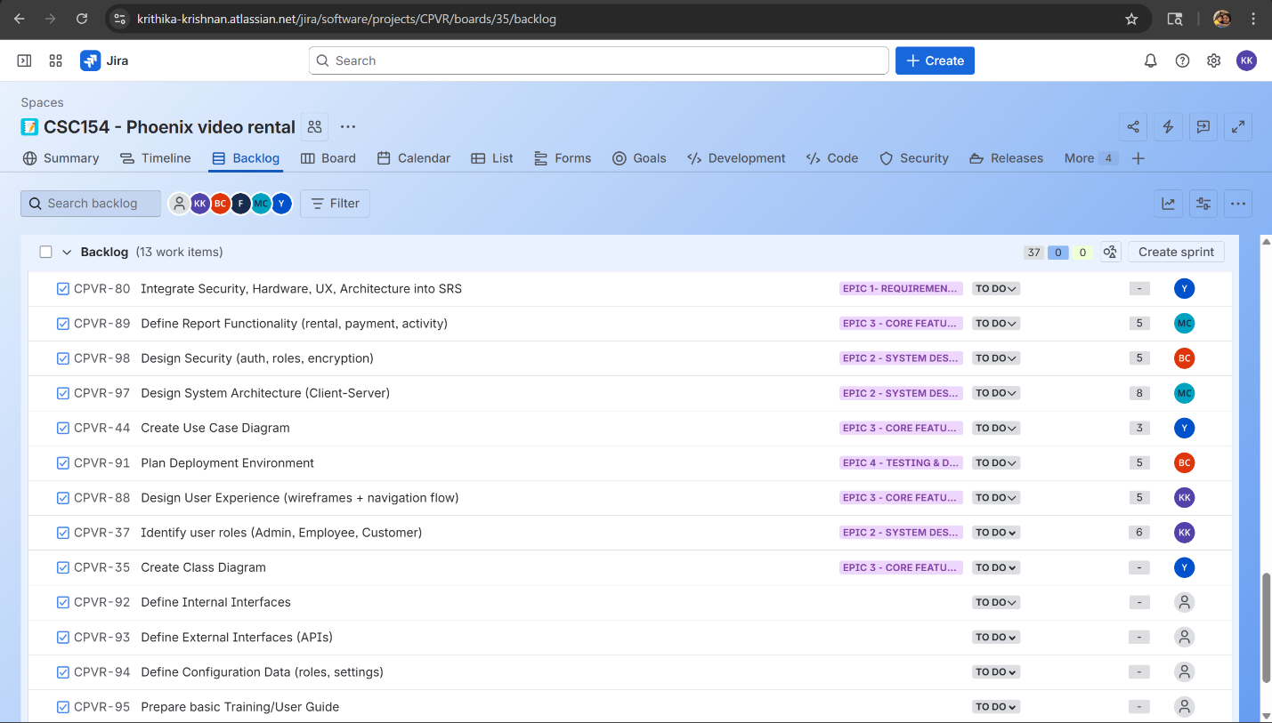

- Project Board Setup
