

Phoenix Video Rental

Software Requirements Specification
Version 2

Team Number: Group7
Project Manager: Krithika krishnan
Team Members: Yuki Fukushima, Brannon Christopher Copeland, Francis Giles, Makalo Charles

Revisions
Version | Primary  Author(s) | Description of Version | Date Completed
1.0 | Group 7 | Initial version of SRS including project objectives, requirements, and use cases | Mar 03/26
1.1 | Group 7 | Added Use Case tables and formatted all requirements (BR, UR, FR, NFR, IR) | Mar 03/10
2 | Group 7 | Added High level design with initial details. Updated ERD and use case diagrams. | Mar 03/17

Review History
Reviewer | Version Reviewed | Date
Instructor / Peer Reviewer
Instructor / Peer Reviewer

Table of Contents (Version 2)

- Introduction
  - Project Objectives
  - Project Scope
  - Project Overview
- Project Description
  - Project Features / Functions
  - User Stories
  - Use Cases
  - Project Assumptions and Dependencies
  - Project Collaboration and Documentation
  - Project Management
- Requirements Specification
  - Business Requirements
  - User Requirements
  - Functional Requirements
  - Non-Functional Requirements
  - Implementation (Performance) Requirements (Optional)

4. High-Level Design

4.1 Security

4.2 Hardware

4.3 User Experience

4.4 Architecture

4.5 Database

4.6 Top-level Classes

4.7 Data Flow and States

4.8 Reports

4.9 Internal Interfaces

4.10 External Interfaces

4.11 Other Outputs

4.12 Configuration Data

4.13 Training

- Introduction
  - Project Objectives
The objective of the Phoenix Video Rental System is to develop a web-based application that allows customers to browse, rent, and return movies online. The system will help manage movie inventory, customer accounts, and rental transactions efficiently.

  - Project Scope

Included Features:
- User registration and login
- Browse and search movies
- Rent and return movies
- Admin inventory management
Excluded Features:
- Online movie streaming
- Physical delivery services
- Mobile application (Version 1)

  - Project Overview

The project will follow Agile methodology with multiple sprints including planning, development, testing, and deployment. The final delivery will be a working web application with database integration and documentation.

- Project Description
  - Project Features / Functions

- User registration and authentication
- Movie browsing and search functionality
- Movie rental and return tracking
- Admin dashboard for inventory management
- Rental history tracking

  - User Stories
- As a customer, I want to create an account so that I can rent movies.
- As a customer, I want to search for movies so that I can find titles easily.
- As an admin, I want to manage movie inventory so that records stay updated.
- As a customer, I want to view my rental history so that I can track past rentals.

User Stories Diagram:
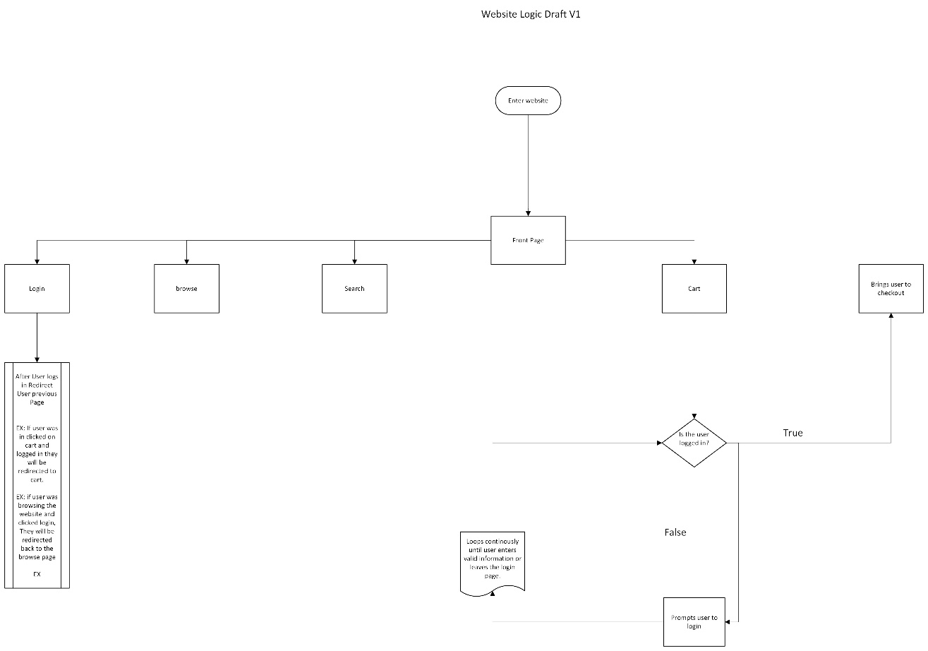

  - Use Case

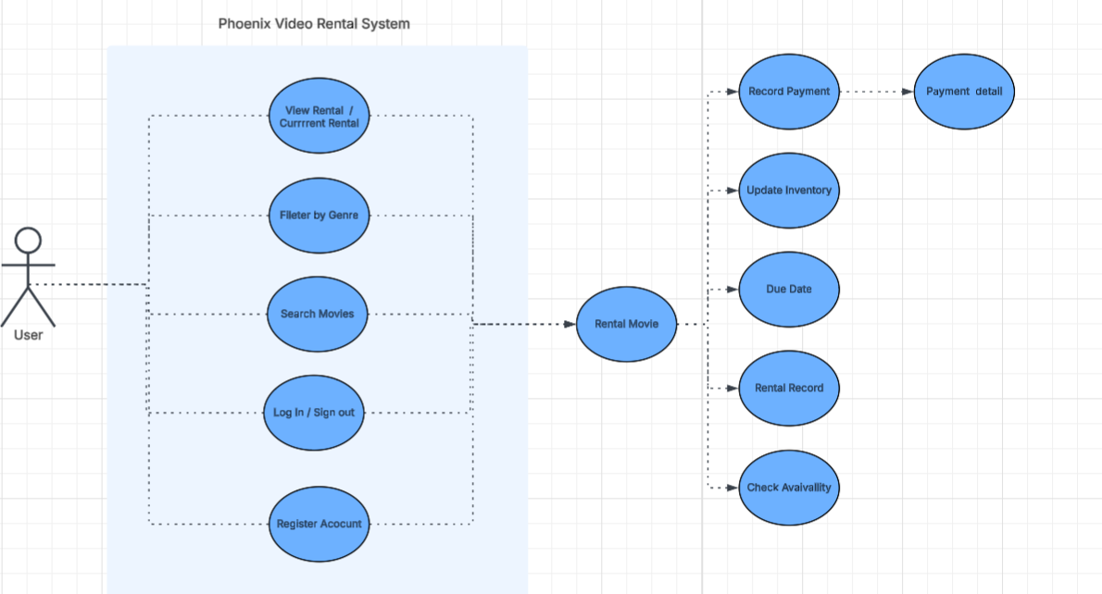

Use Case ID | UC1 | UC2 | UC3
Use Case Name | User Registration | Rent Movie | Manage Movie Inventory
Actors(s) | New Customer | Registered Customer | Admin
Precondition | User does not already have an account | Users are logged in and movie is available | Admin is logged in
Main flow | - User enters personal information.  -System validates the information.  -System creates new account.  -Confirmation message displayed. | -User searches for movie.  -User selects movie.  -User clicks Rent.  -System updates inventory.  -Confirmation message displayed. | -Admin selects Add/Edit movie.  -Admin enters movie details.  -System validates information.  -System updates database.
Alternate Flow | If email already exists, system displays error message. | If movie is unavailable, system shows 'Out of Stock' message. | If required fields are missing, system displays validation error.
Post condition | New user account is stored in database. | Rental transaction saved and inventory updated | Movie inventory updated successfully.

  - Project Assumptions and Dependencies
- Users have internet access
- Team uses GitHub and Jira
- MySQL database is available

  - Project Collaboration and Documentation

The team will use Jira for sprint tracking, GitHub for version control, Microsoft Teams for communication, and Google Drive for document sharing.

  - Project Management
The team will follow Agile Scrum methodology with 3-week sprints, sprint planning meetings, and sprint retrospectives

- Requirements Specification
  - Business Requirements

ID | Description | MOSCOW
BR1 | The system must provide an online platform to manage movie rentals, customers, and payments efficiently. | M
BR2 | The system must improve operational efficiency by reducing manual record-keeping and paperwork. | M
BR3 | The system must ensure accurate tracking of inventory, rentals, and financial transactions. | M
BR4 | The system should enhance customer satisfaction by providing faster rental processing and easy access to rental history. | S
BR5 | The system should provide management with basic reporting capabilities for business decision-making. | S
BR6 | The system could support future expansion such as online payments or cloud deployment. | C
BR7 | Give users suggestions based on previously rented items | C
BR8 | Add Website theming or accessibility options for those who prefer personalization or are disabled (background color, high contrast, screen reader) | C
BR9 | The Website should have a support bot that users can chat to if they encounter problems with the website or purchasing rentals | W

  - User Requirements.

ID | Description | MOSCOW
UR1 | The system must allow users to securely register and log in. | M
UR2 | The system must allow employees to create, view, update, search, and delete customer records (if no active rentals exist). | M
UR3 | The system must allow employees to add, update, search, assign genres, manage inventory copies, and delete movies (if no inventory exists). | M
UR4 | The system must track and display inventory status (Available, Rented, Damaged). | M
UR5 | The system must allow users to process rentals and returns while recording rental date, due date, and return date.
UR6 | The system must allow employees to view active and overdue rentals | M
UR7 | The system must record and track payment details including payment date, amount, method, and status. | M
UR8 | The system should allow users to view rental history and payment records. | S
UR9 | The system could generate basic reports such as rental history, payment summary, and inventory status. | C
UR10 | Website theming & personalization | C

  - Functional Requirements

ID | Description | MOSCOW
FR1 | The system shall authenticate users using secure login credentials. | M
FR2 | The system shall create, store, update, retrieve, search, and delete customer records in the database. | M
FR3 | The system shall create, update, retrieve, search, categorize (by genre), and delete movie records in the database. | M
FR4 | The system shall allow employees to add and manage inventory copies for each movie. | M
FR5 | The system shall update inventory status automatically when a movie is rented, returned, or marked as damaged. | M
FR6 | The system shall record rental transactions including rental date, due date, and return date. | M
FR7 | The system shall calculate overdue status based on due date and current date. | M
FR8 | The system shall record and store payment transactions including payment date, amount, method, and status. | M
FR9 | The system shall allow users to view rental history and payment history. | S
FR10 | The system shall generate basic reports for rental history, payment summaries, and inventory status. | C

  - Non-Functional Requirements

ID | Description | MOSCOW
NFR1 | The system shall be available at least 99% of the time during business hours. | M
NFR2 | The system shall respond to user requests within 3 seconds under normal operating conditions. | M
NFR3 | The system shall encrypt all user passwords and sensitive data using secure encryption standards. | M
NFR4 | The system shall restrict access based on user roles (Admin, Employee, Customer). | M
NFR5 | The system shall maintain data integrity and prevent unauthorized data modification. | M
NFR6 | The system should provide a simple and user-friendly interface requiring minimal training. | S
NFR7 | The system should support at least 50 concurrent users without performance degradation. | S
NFR8 | The system could maintain automated daily database backups. | C

  - Implementation (Performance) Requirements (Optional)

ID | Description | MOSCOW
IR1 | The system shall be developed using JavaScript / Python for backend development. | M
IR2 | The system shall use PostgreSQL as the relational database management system. | M
IR3 | The system shall be developed and managed using Visual Studio Code and GitHub for version control. | M
IR4 | The system shall be deployed on a web server environment supporting Java applications. | M
IR5 | The system should follow Agile/Scrum methodology with three-week sprint cycles. | S
IR6 | The system could be deployed on a cloud-based hosting platform in future versions. | C

4. High-Level Design
This section defines the overall design and structure of the Phoenix Video Rental System. It describes how different components of the system will function and interact.

4.1 Security
4.1.1 Specification 1
- Requirement ID: SEC1
- Description: User Authentication
- Requirement: The system shall allow users to log in using a username and password, and passwords shall be stored in encrypted format to protect user data.

4.1.2 Specification 2
- Requirement ID: SEC2
- Description: Role-Based Access Control
- Requirement: The system shall restrict access based on user roles (Admin, Employee, Customer) to prevent unauthorized access to sensitive features.

4.2 Hardware
4.2.1 Specification 1
- Requirement ID: HW1
- Description: Server System
- Requirement: The system shall be hosted on a centralized server with at least 8 GB RAM and a modern processor for handling application requests.

4.2.2 Specification 2
- Requirement ID: HW2
- Description: Client Devices
- Requirement: The system shall be accessible through desktop or laptop devices with internet connection.

4.2.3 Specification 3
- Requirement ID: HW3
- Description: Network Requirement
- Requirement: The system shall require a stable internet connection for communication between client and server.

4.3 User Experience
4.3.1 Specification 1
- Requirement ID: UX1
- Description: Login Interface
- Requirement: The system shall provide a simple and responsive login interface that allows users to log in within a few steps.

4.3.2 Specification 2
- Requirement ID: UX2
- Description: Navigation and Usability
- Requirement: The system shall provide easy navigation for browsing movies, renting, and returning items.

4.3.3 User Interface Diagram
Wireframes for the user interface will be created using tools like Figma or Draw.io.

4.4 Architecture
4.4.1 Specification 1
- Requirement ID: ARCH1
- Description: Client-Server Architecture
- Requirement: The system shall follow a client-server architecture where the front end communicates with the backend through HTTP requests.

4.4.2 Specification 2
- Requirement ID: ARCH2
- Description: System Components
- Requirement: The system shall include frontend (user interface), backend (application logic), and database components working together.

4.5 Database
4.5.1 Specification 1
- Requirement ID: DB1
- Description: Database System
- Requirement: The system shall use PostgreSQL as the relational database to store customer, movie, rental, inventory, and payment data.

4.5.2 Specification 2
- Requirement ID: DB2
- Description: Data Management
- Requirement: The system shall store data in relational tables using primary keys and foreign keys to maintain relationships and ensure data consistency using transactions.

4.5.3 Entity Relationship Diagram
Basic Model of ERD
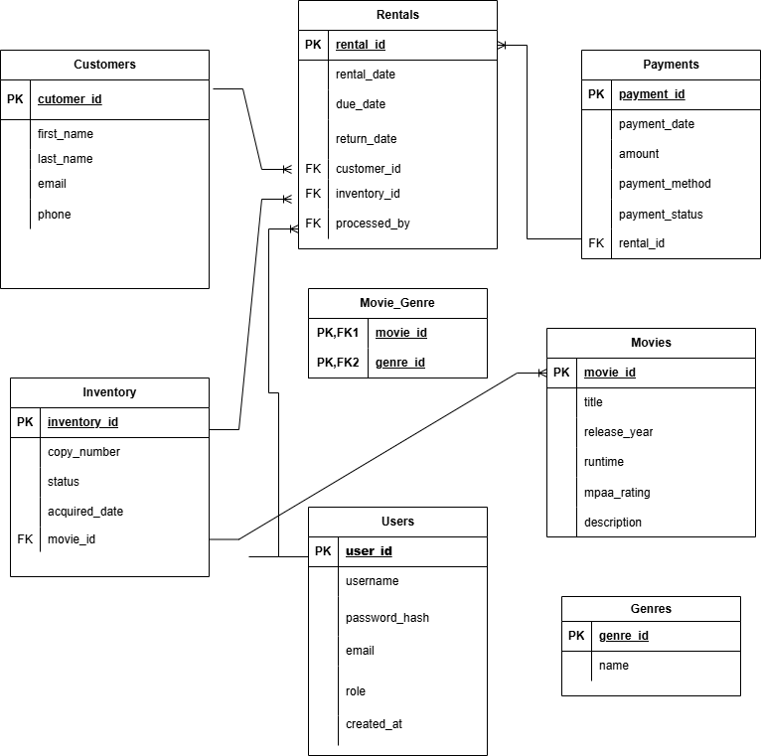
4.6 Top-level Classes
4.6.1 Specification 1
- Requirement ID: CLASS1
- Description: User Class
- Requirement: The User class shall include attributes such as name, email, password, and role.

4.6.2 Specification 2
- Requirement ID: CLASS2
- Description: Movie Class
- Requirement: The Movie class shall include attributes such as title, genre, and availability status.

4.6.3 Class Diagram
The class diagram will be created in the next sprint to show relationships between classes.

4.7 Data Flow and States
4.7.1 Specification 1
- Requirement ID: DF1
- Description: Data Flow
- Requirement: The system shall process user inputs and store and retrieve data from the database during operations like login, rental, and return.

4.7.2 Specification 2
- Requirement ID: DF2
- Description: System States
- Requirement: The system shall manage movie states such as Available, Rented, and Damaged, and update status automatically when transactions occur.

4.7.3 Data Flow Diagram (DFD)

4.8 Reports
4.8.1 Specification 1
- Requirement ID: REPORT1
- Description: Rental Report
- Requirement: The system shall generate reports showing rental history for customers.
4.8.2 Specification 2
- Requirement ID: REPORT2
- Description: Payment Report
- Requirement: The system shall generate reports showing payment details and transaction history.

4.9 Internal Interfaces
The system will allow communication between frontend, backend, and database modules internally.

4.10 External Interfaces
The system may integrate with external services such as payment systems in future versions.

4.11 Other Outputs
The system may generate outputs such as notifications and alerts for overdue rentals.

4.12 Configuration Data
The system shall allow configuration of user roles, permissions, and system settings.

4.13 Training
Basic documentation or user guides will be provided to help users understand the system.

