Introduction and Roles:

TaNasha Hilton – Back-end Development: scripts (Python), MYSQL database (SQL), version control (git)

Nicholas Wisdom – Front End Development: scripts (JavaScript), page structure (HTML), (CSS)

Software Design (incl. Functionality):

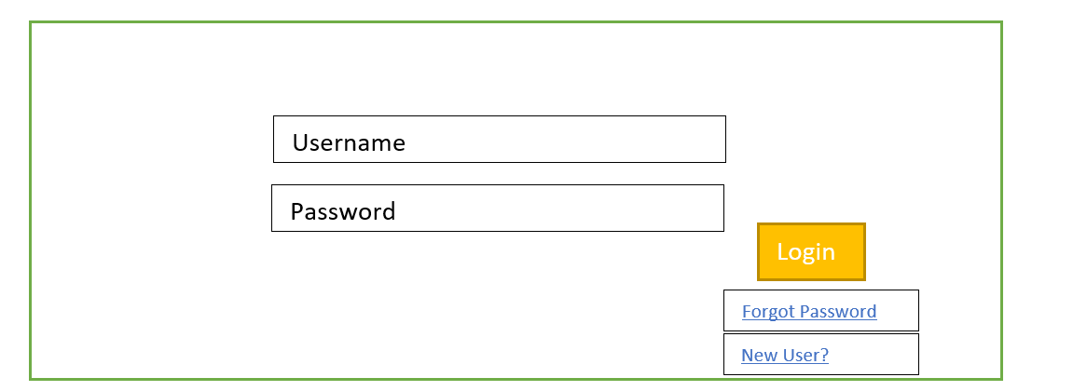

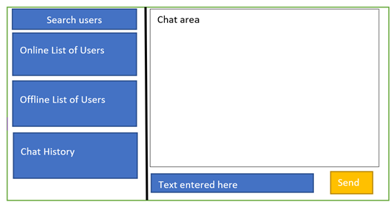

Functions:

* Account creation
* Login w/ password authentication
* Chat history
* List of users (incl. online/offline status
* Search field to look for users
* Select user(s) to enter new chat
* Creation of new chatroom
* Continue old chat
* Send timestamped message (text, image, link) to user(s)
* Receive and read message sent by other user(s)
* Push notification for new messages
* Audio cues for sending and receiving messages.
* See when users are typing in the chat room.

Development Environment:

* Visual Studio Code
* DBreaver – for SQL database
* PyCharm

Timeline:

|  |  |  |
| --- | --- | --- |
| Date | Functionality | Team Member |
| Week 4-6 | **Back-end:**   * Database set-up * Login w/ password authentication * Storage of user information in database (profile management) * Set up program to query user database to return a list of users * Search and return users script * Create data structure for messages queuing * Setup message history   **Front-end:**   * Creation of form for account creation * Creation of basic chat design (links, buttons, layout, etc.)   **Both:** Connect back-end to front-end (i.e. form data sent to database to be stored) |  |
| Week 7-9 | **Back-end:**   * Set up socket for multi-user chat * Creation of chatrooms * Push notifications * Security basics   **Front-end:**   * Introduce interactivity * A way for a user to join the chat room by entering a name |  |
| Weeks 10-12 | **Back-end:**   * Encryption & Security at application, transport layer * Encrypt messages sent   **Front-end:**   * Clickable buttons and animations for sending and receiving messages * Audio cues for certain commands |  |
| Week 13-14 | **Back-end:**   * Security at the IP layer, SSH * Code review and final testing   **Front-end:**   * Added UI Features (Usernames appearing next to their messages, chat bubble colors, notifications when a user joins and leaves a chat, etc) * Cleaning up UI and finalizing any errors. * Testing to ensure all features work as they should. |  |
| Week 15 | **Project Demo** |  |