DocStream: Educational AI Agent

Contributors: Luis Varoni, Reda Mahboub, Ryan Pankratz, Sam Richer, Victoria Wu, Victor Shea

Table of Contents 2
1. Executive Summary 3
2. Project Background & Context 3
3. Problem Definition 4
3.1 Unstructured and Noisy Terminal Logs 4
3.2 Absence of Dataset 4
3.3 Gap in Education for Onboarding 5
3.4 Difficulty Configuring Model Prompts 5
4. Proposed Solution 5
4.1 Previous Team Attempts 5
4.2 Current Implementation 6
5. Technical Implementation Summary 7
5.1 Model 0 7
5.2 Model 1 8
5.3 Metrics for both models 9
5.4 Demo Pipeline Display 10
6. Ethical, Social, or Community Implications 10
7. Recommendations & Future Work 11
References 13

1. Executive Summary
Documentation and deployment form the backbone of modern software development, yet they are often treated as low-priority tasks. Developers move quickly, fix problems as they go, and rarely leave behind a detailed record of what actually happened in the terminal. DocStream is an open-source AI system that converts raw terminal activity into structured, mistake-aware, and reproducible developer documentation. The system addresses a pervasive challenge in modern software teams: developers frequently struggle to understand complex command-line workflows, detect mistakes, and reproduce deployment steps when documentation is missing, incomplete, or outdated.
To solve this, DocStream introduces a multi-model architecture. Model 0 segments noisy streaming terminal logs into coherent XML events, while Model 1 produces hierarchical summaries and structured annotations that reflect each step of a terminal workflow. Together, they form a reproducible pipeline that transforms raw Asciinema input into actionable documentation. A downstream Dockerizer model exists in the broader project vision, but this cohort deliberately focused on upstream interpretive layers, as they determine whether the rest of the pipeline can function reliably.
Through fine-tuning, dataset creation, benchmarking, and systematic prompt analysis, the team significantly improved segmentation accuracy and annotation consistency. The project now provides a clean foundation, including datasets, infrastructure, evaluation metrics, and prompts for future teams to refine and extend the system, especially in areas such as annotation fine-tuning and Dockerfile generation.

2. Project Background & Context
DocStream is part of a broader initiative led by the Human Feedback Foundation and supported by the Linux Foundation to build open-source, ethically sourced AI systems for developer education. The project collaborates closely with a small developer team in Germany led by Julia Longtin, who record all coding, troubleshooting, and technical discussions using a custom Asciinema annotator. These recordings capture both the raw terminal actions and detailed explanations of what occurred, forming a high-quality dataset for training and evaluating AI models.
A core principle of this initiative is ethical data generation. All training data is created in-house, with fully verifiable licensing and no externally scraped material. This ensures transparency, avoids copyright risks, and supports open distribution of both the dataset and the resulting models.
Earlier versions of DocStream developed by previous UofT teams lacked the stability, segmentation accuracy, and dataset scale needed for reliable documentation generation. When the Fall 2025 team began, it became clear that the system required a restart. This iteration rebuilt the entire pipeline, models, prompts, dataset processing, and evaluation methods from the ground up. The new architecture is designed around streaming data, reduced hallucinations through model separation, and reproducible outputs, establishing a solid foundation for future teams to refine, scale, and extend the system.

3. Problem Definition
Terminal-based workflows present significant challenges for AI systems due to their unstructured nature, the scarcity of ethically sourced datasets, and the lack of educational support for understanding real developer behavior.

3.1 Unstructured and Noisy Terminal Logs
Asciinema outputs contain interleaved system/user IO, timestamp noise, broken keystrokes, screen-wrapped content, and large machine-generated blocks. These characteristics make them challenging for both humans and LLMs to interpret. In the past iteration of DocSteam this noise adversely affected the outputs of the models preventing correct interpretation of the logs.

3.2 Absence of Dataset
Terminal-based workflows are almost never captured, annotated, or released publicly, and when they are, they commonly include sensitive information such as credentials, hostnames, or internal directory structures. As a result, the overwhelming majority of terminal logs remain private, confidential, or proprietary, making ethically licensable datasets exceedingly rare. Moreover, no public dataset exists that pairs streamed terminal activity with segmentation labels or hierarchical annotations, which means that all training data must be generated in-house.
An additional challenge arises from the natural distribution of terminal events: in real Asciinema sessions, most lines belong to the same ongoing action, while true event boundaries occur infrequently. This leads to a highly imbalanced dataset where “current event” labels dominate and “new event” transitions are disproportionately scarce, complicating model training and evaluation.

3.3 Gap in Education for Onboarding
Most AI systems excel at providing answers, yet they do not teach users how or why a sequence of actions unfolded. Large language models can suggest a command or correct an error, but they rarely clarify what actually happened in the terminal, what caused a failure, or how an experienced developer diagnosed and resolved the issue. For newcomers, this gap is significant. Onboarding difficulties arise not from a lack of solutions but from a lack of visibility into the underlying process, the developer’s intent, and the reasoning behind each step. These elements are almost never documented, and they are difficult to learn without explicit guidance.

3.4 Difficulty Configuring Model Prompts
As the end goal of Docstream is to process streamed terminal input, the prompting methodology had to be modified to process streamed data, which presents a considerably different challenge to parsing over a complete file.

4. Proposed Solution

4.1 Previous Team Attempts
The previous team’s iteration of the project attempted to resolve the gap in education for onboarding by introducing a multimodal pipeline that transformed raw Asciinema recordings into more organized representations. Their approach relied on a multi stage pipeline to break down issues such as unstructured and noisy terminal logs into individual components. First the pipeline converts the terminal session into XML formatting which separates user input from system output, allowing model 0 to identify event boundaries and segment the recording into coherent units. These grouped events are then passed to model 1 which generates 1 sentence summaries with hierarchical depth values to be passed into the latter models such as a markdown text formatter.

The previous team aimed to reduce complexity, limit hallucination, and create cleaner intermediate states that each component could use. While this solution provided a useful starting point, the progress made by previous groups were limited in actuality to Model 0 and a basic front end interface. It also remained tied to batch processing and additional issues such as limitations in stability, dataset scale, and prompt design prevented the previous architecture from operating reliably in a practical setting. This iteration rebuilds the early pipeline to address these foundational issues.

4.2 Current Implementation
In the current pipeline, Model 0 and Model 1 operate as a two stage pipeline that segments raw Asciinema terminal recordings into annotations with hierarchical levels. This iteration chose to focus primarily on the first two models in the architecture in the interest of time and to understand and refine the most integral components of the overall pipeline in order to address the issue of unstructured and noisy terminal logs.

Model 0 represents the first stage of the pipeline by breaking the continuous stream of terminal input into coherent events with the goal of identifying where one high level action ends and the next begins. These event boundaries are passed in order to Model 1 which focuses on understanding what each event represents in the broader task the user is performing. As Model 0 streams events forward, Model 1 processes them one at a time using the surrounding context to decide whether the event begins a new subtask or continues the current one, or completes a previous step. For every event passed through Model 0, Model 1 generates a short summary describing the action and assigns a depth value that reflects its place in the task hierarchy. Together the two models would transform raw noisy terminal logs into a structured sequence of goals, subtasks and explanations. Unlike previous iterations that only operated on entire files at a time, the current system would process activity as it happens and with updated models supports more accurate contextual reasoning and event partitioning.

Additionally, to address some of the dataset related issues, the data for Model 0 and Model 1 was refined. In Model 0, the data was modified so that it deliberately included a better distribution of event transitions vs non-event transitions to prevent the model from defaulting to continue. For Model 1, more data was annotated from the provided samples in order to create a more robust set for fine tuning. This expanded dataset should provide a more representative distribution of terminal behaviors for both models.

Finally, to refine prompting methodology to process streamed data, iterative prompt analysis and experimentation with different instruction formats was performed. Through repeated refinement and evaluation, prompts were developed that remain stable when applied to streaming data.

5. Technical Implementation Summary

5.1 Model 0
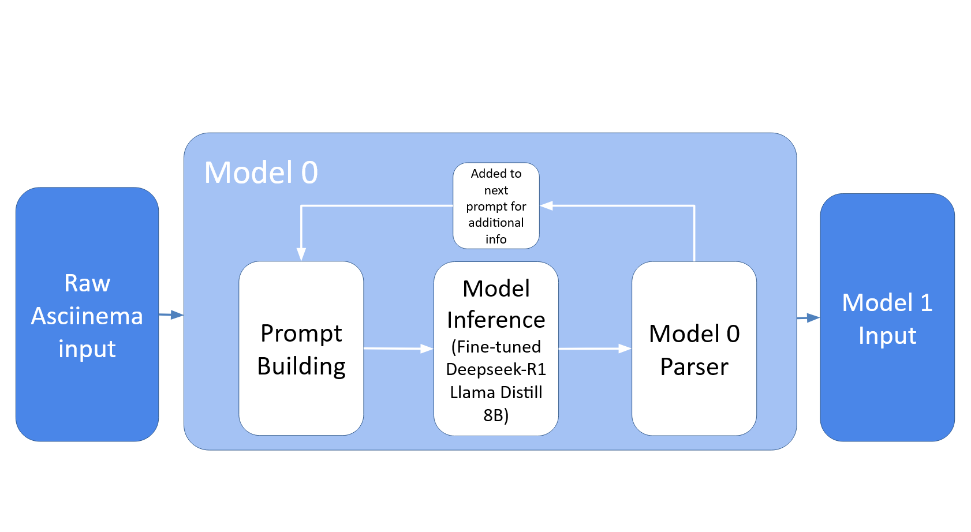
This model is designed to be fed streamed raw data from Asciinema. Therefore, the dataset of whole files needs to be chunked into smaller portions for streaming in order to fine tune properly on the expected input style. In order to implement this functionality, a script was created to prepare the data using a sliding window of around 4 thousand tokens included in order to balance between context and runtime.

After chunking the dataset into sliding windows, another problem emerges. Given that this task is almost a binary classification (NEW or the current group number) the model dataset needs to be stratified to include around 50% NEW answers, which signifies the beginning of a new event. Otherwise, after fine tuning the model will learn that it should output the previous group number most of the time, as there are far less lines that signify a new event than there are ones part of the previous group. Therefore, another script was created in order to split the data into training/test sets with a 50% stratification of NEW and the current group and upload them to hugging face. This significantly reduces the overall dataset available for fine tuning, so more research should be done on how to counteract this pitfall for future iterations of this project.

This dataset was then used to fine tune the baseline Deepseek Llama 8B Distilled model using Axolotl. The fine tuning is done on the training split of the dataset uploaded to huggingface. The finetune used the parameters as defined in the axolotl config found in the repository, and six epochs were completed. This was then tested on the created metrics defined in section 5.3, where an accuracy of 80% was achieved.

5.2 Model 1
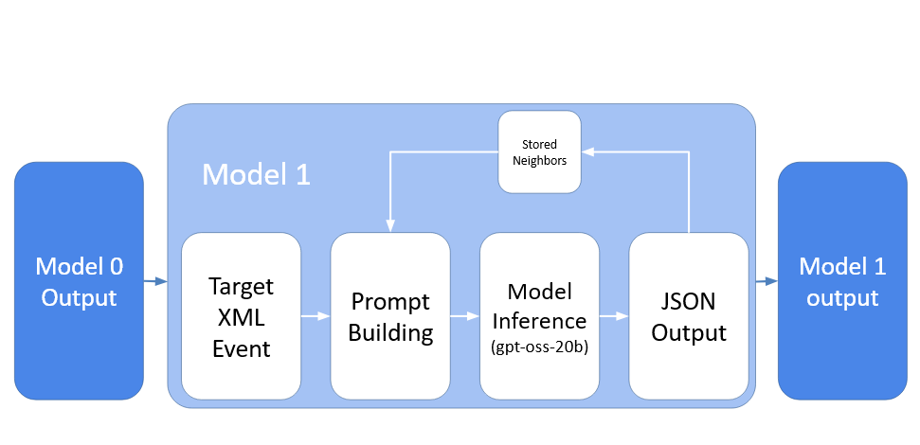
Model 1 operates as a streamed event annotator that converts the XML event chunks emitted by Model 0 into structured depth-annotated summaries. For each incoming event, the system constructs a flush package containing the target XML event, a fixed-window of preceding events (“stored neighbors”), and the current inferred task depth computed from all prior predictions. This package is transformed into an XML-based instruction block containing the reconstructed event content, neighbor summaries, the current depth state, and optional few-shot examples. The final prompt is passed to a vLLM-served instance of gpt-oss-20b, which generates a JSON object of the form {"annotation": "...", "depth": <int>}. The output is parsed using a tolerant JSON-extraction routine that locates valid objects inside the model’s full reasoning trace. Before committing the prediction, depth values are normalized through a stack-invariant check: depth −1 opens a new subtask, positive depths close tasks, and all transitions must maintain a non-positive cumulative depth. Once validated, the depth and summary are written back into the global event buffer and immediately become part of the neighbor context for subsequent events. This loop, package construction, prompt assembly, model inference, JSON extraction, and state update, runs once per event, enabling Model 1 to operate incrementally and produce real-time hierarchical annotations from streamed terminal data.

5.3 Metrics for both models
One of the challenges for previous groups has been the manual prompt testing and evaluation of model performance across both models 0 and 1. Thus, one of the main objectives of this sprint was to implement a reusable and extendable LLM testing harness and metrics in order to evaluate the performance of both models. EleutherAI’s lm evaluation harness was extended in order to accomplish this goal. This allows for future extension of metrics, as well as the custom ones defined this sprint, all in the same evaluation harness. This section will discuss the implemented metrics for both model 0 and model 1.

Model 0 has two tasks implemented, and one additional metric. The first task is for general testing after fine tuning, and the other is for evaluating the prompting and editing it in order to achieve a stronger output.

First, the task to evaluate the performance of the model after fine tuning was implemented. Since the goal of model 0 is to detect the boundary of the event, this is essentially a classification task between the current group or a new one. Therefore, the main metric used for evaluating the performance after fine tuning is a standard accuracy metric. This way, the model can be evaluated on its performance overall on how it would actually classify the different data in the testing set.

In order to evaluate the prompting, there is an additional LLM as a judge implemented for a metric that uses Mistral 7B Instruct v0.3. This allows for a qualitative judgement to be made on the baseline deepseek’s reasoning, thus allowing a stronger prompt to be fine tuned on. This should be used in future work to do ablation testing on model 0’s prompt to get even stronger baseline performance before fine tuning.

Model 1 has two additional metrics implemented in one task YAML file. These metrics are designed to aid in qualitative testing on the model’s output. Given that the annotations and reasoning of model 1 should both be evaluated, two LLM as a judge rubrics were created in order to score these independently.

The annotations are scored on both the coherence of the output annotation, and the correctness compared to the baseline reference annotation created for model 1’s dataset. These scores are both between 1-5, and then summed to get a score with a max of 10. This metric can be used to test the model 1 performance after a fine tune is done on the datasets once they have been extended more.

For the reasoning, it is scored from 1-5 on coherence, ensuring the model considers the output answer in its reasoning score (Good reasoning that gets the wrong answer should not be scored a 5, maxing around 3). Both of these metrics are averaged over all the test cases to get the accuracy. These metrics can be further improved by updating the rubric level scores, using a stronger model for judgement, or by adding more dimensions to the rubric. These metrics should aid in the further development of model 1, and allow for a more measured analysis of prompting for model 1.

5.4 Demo Pipeline Display
In addition to the above technical implementations, a front-end visualization page was created in order to display the explanations and answers outputted for both models 0 and 1. This can be used to demonstrate how the two models can be connected in a pipeline to create one pipelined architecture for future presentations of this open source project.

6. Ethical, Social, or Community Implications
This model processes terminal session data. This means that the contents can contain sensitive information such as IP addresses, usernames, filepaths, command history, or anything else displayed by the system output. If a real user’s passed into the model there is a risk of unintentionally exposing credentials and other confidential information. This model doesn’t perform any filtering or redaction on its own, and so this could be a concern that would warrant implementing some form of data scrubbing. Beyond this, the datasets used are fully open source and transparent, and so are the models and evaluation metrics. Thus, there should be little implications beyond the ones listed above.

7. Recommendations & Future Work
The first is to experiment with modifying the model 0 task to be a binary classification. There has been little issue with having the model output the current group when it needs to, however the model may see a slight performance improvement if the task is changed to a binary classification of NEW or CURRENT instead. This is worth investigating to see if any more performance improvements can be made.

The second is with regards to the output of model 0 (which is the input to model 1). There are certain events that contain thousands of lines of system output that add little new information that the annotator could not gather already from a subset of the inputted event. For example, when downloading a large package in the asciinema xml, there are often thousands of lines of system output explaining the progress of the download. These events are often around ten thousand tokens worth of input to model 1, these greatly reduce average inference time. These lines are often similar in terms of text contained, and so some level of filtering based on token similarity thresholding could greatly improve the inference time of model 1 in these trivial long context scenarios.

The third is for model 1. Many additional annotated examples have been created for the dataset to assist in fine tuning model 1 in the future. This includes examples with example thinking for fine tuning with reasoning. Doing this using axolotl similar to model 0 would likely greatly increase the overall performance of model 1.

The fourth is for the evaluation harness of both model 0 and mode 1. Here, rubrics have been created in order to evaluate the reasoning capabilities of model 0 and model 1’s base prompts, and to judge the outputted annotation for model 1. These rubrics are tested to work with the model Mistral-7B-Instruct-v0.3. However, there may be additional improvements that can be made to these LLM-as-a-judge metrics, or further added metrics available on lm_eval.

The next is to improve the Dockerizer model. This model turns the outputted annotated events from model 1 into documentation to be used for whoever makes use of this open-source tool. This model has remained unchanged by us, and so more effort should be dedicated to this model to improve its overall performance.

The final recommendation for future work is to consider when documentation should be updated. Consider the scenario when there is already existing documentation from this model’s earlier outputs, but then a fresher run of the model outputs a slightly different documentation than the currently existing one. In this case, the best solution to merge these documents should be investigated. This could involve creating yet another model for this task, or some other solution to resolve any disagreements and decide which provides a better explanation.

References
EleutherAI. LM Evaluation Harness. Version 4.9.1, GitHub, 2025, github.com/EleutherAI/lm-evaluation-harness.
LLM Citation - fine-tuned DeepSeek-R1 Distill 8B model
LLM Citation- OpenAI. GPT-OSS-20b Hugging Face, 2025, https://huggingface.co/openai/gpt-oss-20b
Summer 2025 team project details. https://github.com/CSC392-CSC492-Building-AI-ML-systems/educational-AI-agent, 2025. Accessed: 2025-09-06
Winter 2025 team project details. https://drive.google.com/drive/folders/1rBhexkE-hcf6kk0zd22KykmWv9gQR1ey?usp=sharing, 2025. Accessed: 2025-09-06.
Wolf, Arhur. “Librecode Annotation Standard.” Github, 2025, https://gist.github.com/arthurwolf/c4521a8baa306c016efd50ee23ffe56e. Accessed 21 Nov. 2025.

