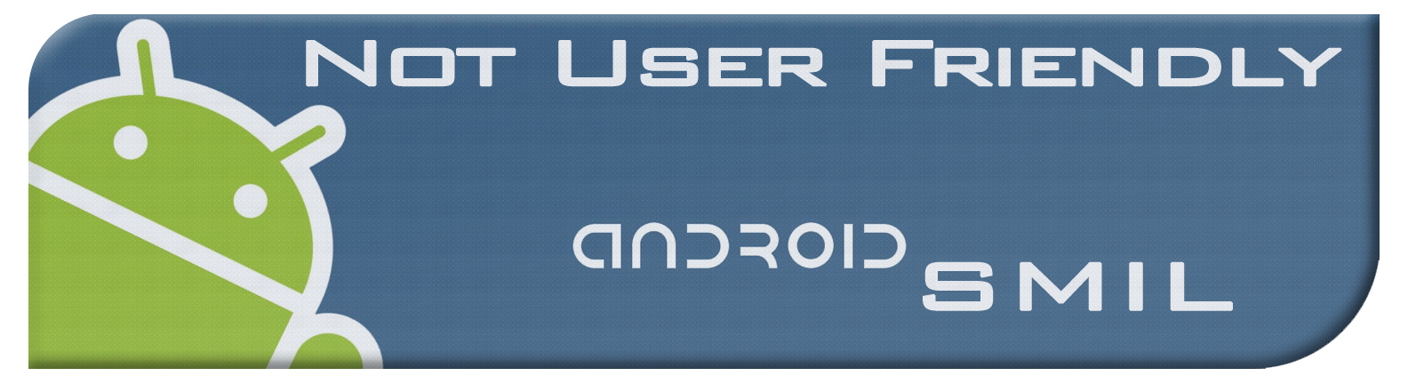**Agenda**

Week 11

03/15/2012

**Overall Objective:**

We have a new App Engine Connected Android project, everyone needs to try to import that and work out any bugs. We need to also begin revising documents for the second delivery and address any items that have yet to be completed.

**Individual Tasks:**

**Alex:**

|  |
| --- |
| **Task 1:** Import new project |
|  |
| **Task 2: Revise Test Plan** |
|  |
| **Task 3:** |
|  |

**Brad:**

|  |
| --- |
| **Task 1: Working on the cloud** |
|  |
| **Task 2: Revise Use Cases** |
|  |
| **Task 3:** |
|  |

**Jacob:**

|  |
| --- |
| **Task 1: Work on the composer** |
|  |
| **Task 2: Work on phase 2 delivery documents** |
|  |
| **Task 3:** |
|  |