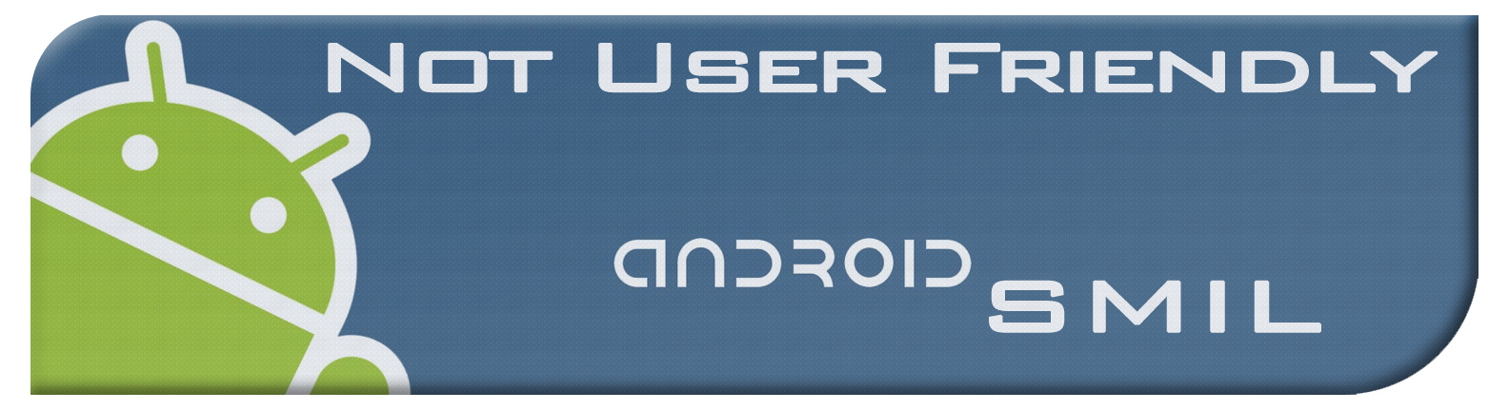**Agenda**

Week 7

02/16/2012

**Overall Objective:**

We now have a workable demo but we still cannot connect to the cloud in any way what so ever. Alex and Chris this task has to make some tangible progress this week, if you’re unable to get it working then I’ll take the task and give you my tasks for week 8. On the UI side we need to get the player to open a real smil file and play it instead of a pseudo one. Because the cloud is finished we’ll create a work around and call the parser directly.

**Individual Tasks:**

**Alex:**

|  |
| --- |
| **Task 1:** Work on the cloud |
|  |
| **Task 2:** |
|  |
| **Task 3:** |
|  |

**Brad:**

|  |
| --- |
| **Task 1: Work on refining the timing interface, finish the smil writer** |
|  |
| **Task 2:** |
|  |
| **Task 3:** |
|  |

**Chris:**

|  |
| --- |
| **Task 1: Work on the cloud** |
|  |
| **Task 2:** |
|  |
| **Task 3:** |
|  |

**Jacob:**

|  |
| --- |
| **Task 1: Open a smil file with the reader.** |
|  |
| **Task 2: Begin working on the composer extension to handle editing the canvas** |
|  |
| **Task 3:** |
|  |