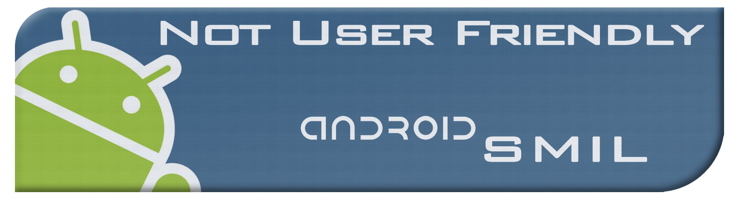**Agenda**

Week 8

02/23/2012

**Overall Objective:**

Continue working on tasks from before the delivery. Begin transition to an App Engine connected project. Refine the UI and continue adding functionality.

**Individual Tasks:**

**Alex:**

|  |
| --- |
| **Task 1:** Testing |
|  |
| **Task 2:** |
|  |
| **Task 3:** |
|  |

**Brad:**

|  |
| --- |
| **Task 1: Working on the cloud** |
|  |
| **Task 2:** |
|  |
| **Task 3:** |
|  |

**Chris:**

|  |
| --- |
| **Task 1: ?** |
|  |
| **Task 2:** |
|  |
| **Task 3:** |
|  |

**Jacob:**

|  |
| --- |
| **Task 1: Work on the composer** |
|  |
| **Task 2:** |
|  |
| **Task 3:** |
|  |