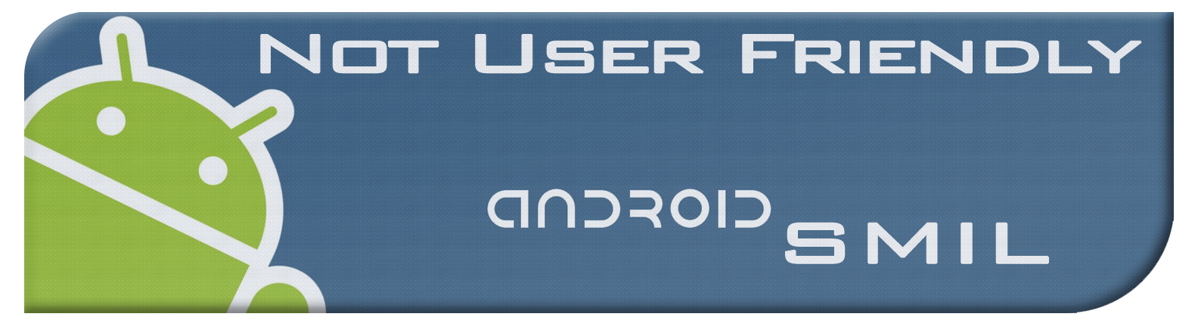**Weekly Status Update**

**Alex**

**Date: 01/28/2012**

|  |  |
| --- | --- |
| **Task: Research Google Cloud API** | **Time Spent: 5 hours** |
|  | |
| **Status: Ongoing** | |
| **Issues: Find out what classes that need to be invoked** | |
| **Notes: Google cloud db connector class @** | |
| <http://code.google.com/appengine/docs/python/datastore/modelclass.html#Introduction> | |
|  | |
| **Task: Set up google api environment** | **Time Spent: 1 hour** |
|  | |
| **Status: Complete** | |
| **Issues: What type of project to use** | |
| **Notes: We are using Android and Google App Engine, but we choose not to use the project** | |
| **with both, and just create an Android project and import google app engine** | |
|  | |
| **Task:** | **Time Spent:** |
|  | |
| **Status:** | |
|  | |
| **Issues:** | |