**Weekly Status Update**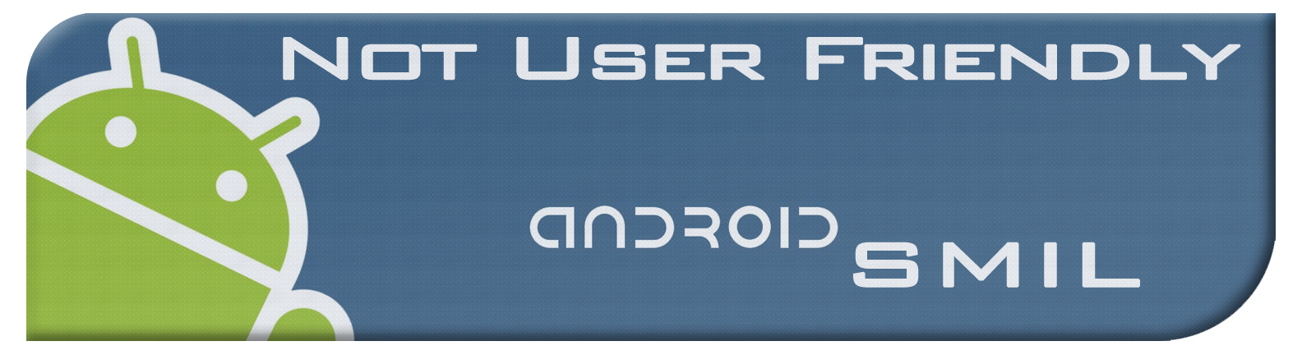

**Chris Bond**

**Date: 02/09/2012**

|  |  |
| --- | --- |
| **Task: Cloud Connector** | **Time Spent: 4 hrs** |
|  | |
| **Status: This week I really tried to get a local communication between my AVD and the GAE sdk that is run through eclipse. My opinion is to use an interface with the datastore known as objectify. It is the simplest way to create entities**  **in the datastore and requires only one jar file. These entities can have**  **properties(fields with accessors/mutators) to blobstore keys that reference the**  **image/video/text/ect... blobs in the blobstore, which google recommends for**  **files over 1MB in size. Note that blobstore blobs are immutable**  **after creation. This will require a servlet on the cloud side that handles**  **incoming requests from users and sends back a one time use url that sends them to the blobstore blob for download to upload or download. I am having trouble with how that connection is established on the android side. There are some examples on the web that use http post using appache packages that android can import. Another way to go about it would be to use the cloud connected android app wizard in google which sets up most of the files we need. This way might require Cloud 2 Device Messaging (C2DM), and I don't know if we should use this or not(we would have to sign up for the service). Either way, I don't know if I should commit anything or not to the current project because the way eclipse sets up cloud based projects has tons of configuration files and I think we should consider how the project structure should look before we continue. I don't know if I am over-thinking my side of things but I could use some help. I feel like I haven't produced much in the way of the project and don't want this to be a setback. I think I should also mention that I don't have much experience with servlets but it doesn't look to difficult to pick up. If anyone has some suggestion or resources please email me. Here are some web pages I think most pertain to this status update.**  **Entities and other google datastore terminology**  **http://code.google.com/appengine/docs/java/datastore/entities.html**  **Info regarding the Servlet Environment**  **http://code.google.com/appengine/docs/java/runtime.html**  **Authenticating users via google accounts**  **http://code.google.com/appengine/docs/java/users/overview.html**  **Blobstore overview**  **http://code.google.com/appengine/docs/java/blobstore/overview.html**  **Objectify-appengine(may also be helpful for caching down the road)**  **http://code.google.com/p/objectify-appengine/** | |
|  | |
| **Issues: I'm probably over-thinking this portion of the project but I think we should spend some time talking about whether or not to use eclipse's built in wizard for the cloud connected android app w/ C2DM. I really think this should be decided before more I make major changes to the repo. I need some help android side with connecting to the cloud servlet. The creation of entity classes is pretty easy and if we decide to use objectify I have an entity model for our smil presentations.** | |
|  | |
|  | |
| **Task:** | **Time Spent:** |
|  | |
| **Status:** | |
|  | |
| **Issues:** | |
|  | |
|  | |
| **Task:** | **Time Spent:** |
|  | |
| **Status:** | |
|  | |
| **Issues:** | |