CSC443 Assignment 1 Part2 Report

Fangzhou Yu

Yu Xie

2.1:

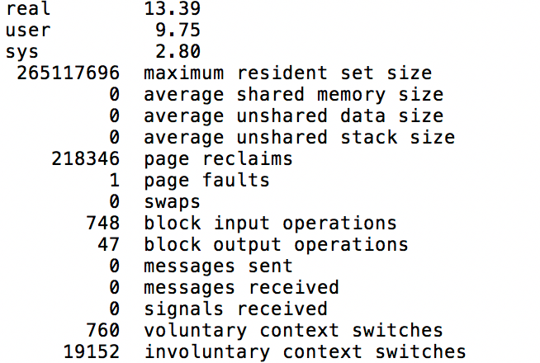

2.2:

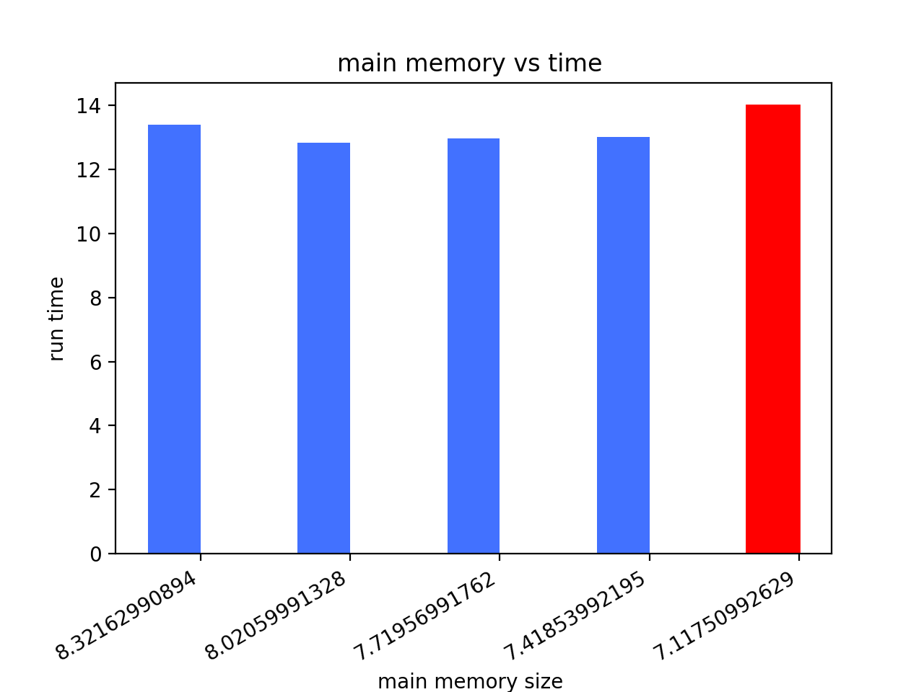

Q: Is there any difference in performance in your experiments? Explain why there is a difference or why there is no difference.

A: There is no difference in performance. All the run time we got are very similar.

2.3