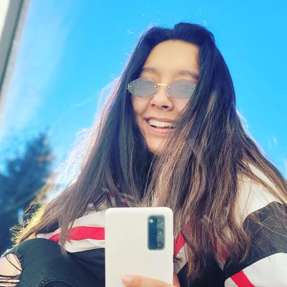Hello, my name is Jocelyn Perez, and my pronouns are She/Her. I am a junior at Aurora. I am currently double majoring in Computer Science and Cybersecurity. My career plan as of right now is undecided, definitely something to do with web design but I’m still not completely sure. I’m taking CSC 4500 as part of my major requirements for Computer Science. Some of my non-career goals would be traveling the world, I want to take a year and just travel anywhere and everyone.

Other things about me:

I was born and raised in Elgin, IL, and I still live there with my parents and siblings. My family consists of my mom and dad, my sister Juliana, my brother Andrew, and me. I am the oldest of the other two while my brother is 15 and my sister 9 years old. We currently have one dog; she is a Pomeranian/chihuahua mix and she just turned 4 years old. Her name is Lulu and she is spoiled by everyone in the family but she really only loves me the most, obviously. I’m also in the process of getting another dog, but I still haven’t gotten to pick her up since she is still a puppy.

Some of my interests are maintaining my business where I resell items for a profit. A hobby of mine is watching movies especially marvel movies which I got obsessed with during quarantine, so I’m currently in the process of watching all of the older marvel movies. My go to streaming services are Netflix/Hulu and Disney plus but Netflix still has the top for all of my movie needs. My favorite music is mostly pop and rap, but I will listen to a lot of different artists and genres. Favorite artist at the moment has to be Billie Eilish and favorite song is any of her songs.

My favorite place that I have traveled to so far is California and Florida. California because it was the first place I went to without my parents, it was only me and my cousin which took some convincing from our parents but they let us at the end of the day. Florida because it was the first place we went as a family to not visit other family is more to just travel and we ended up going to Disney World which was fun. My favorite food has to be Mole or Pozole which are Mexican dishes that are made usually by a grandma and they are amazing. My favorite snack is Takis or anything salty and crunchy.