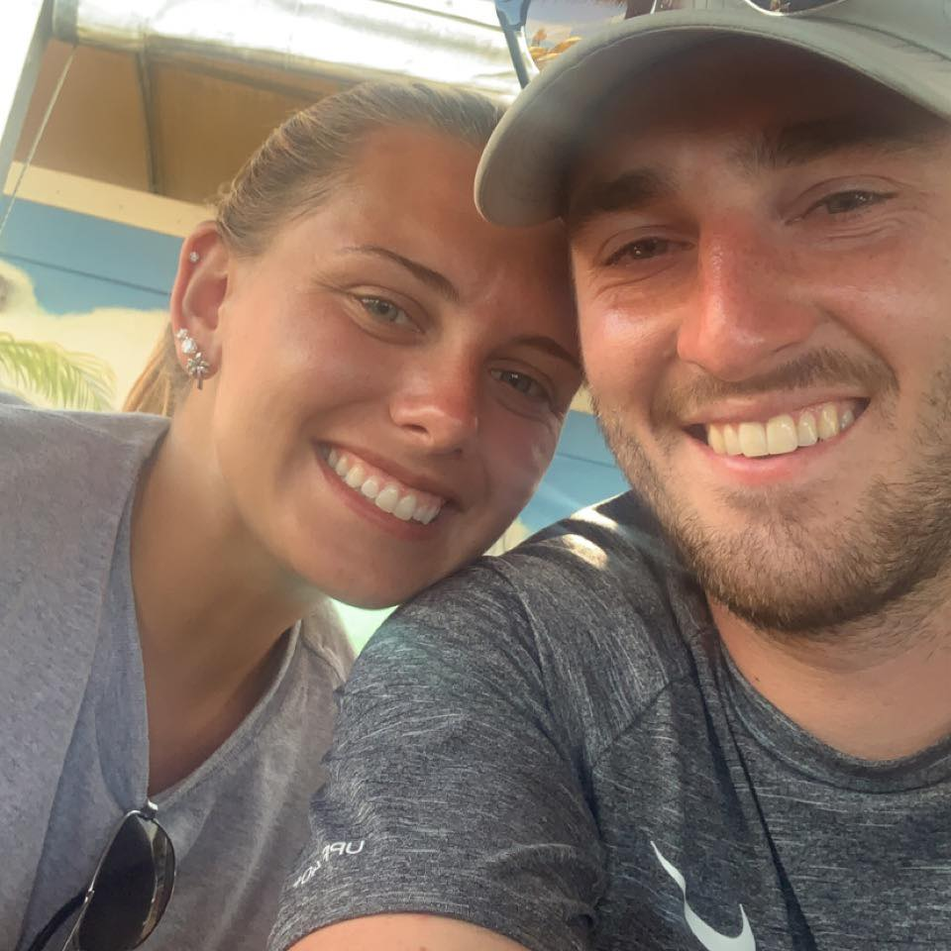Hello, my name is Mason Conroy, and I am a senior (5th year, last semester). My pronouns are He/Him/His. I am a Computer Science major, and I am going for a minor in Mathematics as well. To be totally honest, I have a lot of different interests in the computer science field so my plan for right now is to get a job and then figure out what I want to do from there. I do know that I want to develop something that will make someone’s life easier so wherever I can end up that will put me into that role. I am in CSC 4500 because of major requirements but I really want to know how to properly use and set up databases. I think that managing and storing data is very interesting as well as important. Properly maintained data makes everything a lot easier. In the future I am hoping to have a family and I would like to be able to retire earlier in life.

So, I have moved around a lot in my life. I went to two different elementary schools, two middle schools, and two high schools. I have lived anywhere between Dekalb, Illinois and Milwaukee, Wisconsin. I really enjoy playing basketball and now that I am done as a player, I have been coaching for the last 5 years. I am very close to my family. My dad coached me when I played in high school and now, I will be coaching along side of him at Kishwaukee College as an assistant coach. I have been coaching in his AAU program since I was a senior in High School as well.

While I wish I did, I do not have any pets, but I used to get fish a lot as a kid just to give me something to do. Allergies is what keeps pets out of our house unfortunately as I have always wanted a dog. I watch movies and shows on Netflix, Disney plus, Apple TV, HBO Max and Hulu. I have a lot of different options so it does not really feel like I will ever run out of things to watch (even though I tend to watch a lot of the same stuff). I really like the shows New Girl, Schitt’s Creek, Ted Lasso and the newer marvel movies. I listen to a wide variety of music, but I mainly listen to country and rap. My favorite artists consist of Eminem, Thomas Rhett, Luke Combs, and really the list can go on and on.

My favorite season is probably summer. I really enjoy going to the pool and beach and just being about to be outside. I also really enjoy the daylight that we get later during the day as well. It feels like you can get more out of the day in the summer. I also enjoy how you can basically do any activity in the summer as well. I really enjoy basketball and try to play whenever I can, but I mainly coach right now. I am not too big into watching sports though, I would much rather play. When I do watch sports. My favorite team for basketball is the Chicago Bulls (go figure) and for football is the Green Bay Packers (my dad is a fan to rebel against his mom who is a Bears fan).

My favorite is blue. My favorite ice-cream is the Ben & Jerry’s Topped and the core kind. I really like when the ice-cream it has fudge in it or peanut butter cups. I like lemonade and my favorite alcoholic drink is just Blue Moon. I am not too big into drinking, but Blue Moon is a go to. When I was a kid, I always thought I was going to be a teacher. I started at an education major my first two years but wanted to give myself a challenge before settling down to teach. I am getting a mathematics minor for that reason so I can go back and become a teacher in the future. I pick AU because it was close to home, and I wanted a smaller school to go to because I was not ready to get out on my own and be at a big university. So that is a little bit about me, and I am excited for this semester!