Mason Conroy

Database Project Assignment 7: Web Connectivity

Connect your database to a web application. You can use ROR, PHP, Flask, NodeJS, .NET, Django, Struts, or whatever else you’d like to use to exhibit your skills.

Explain the process of connecting your database to the web by creating documentation. Include detailed explanations and screenshots!

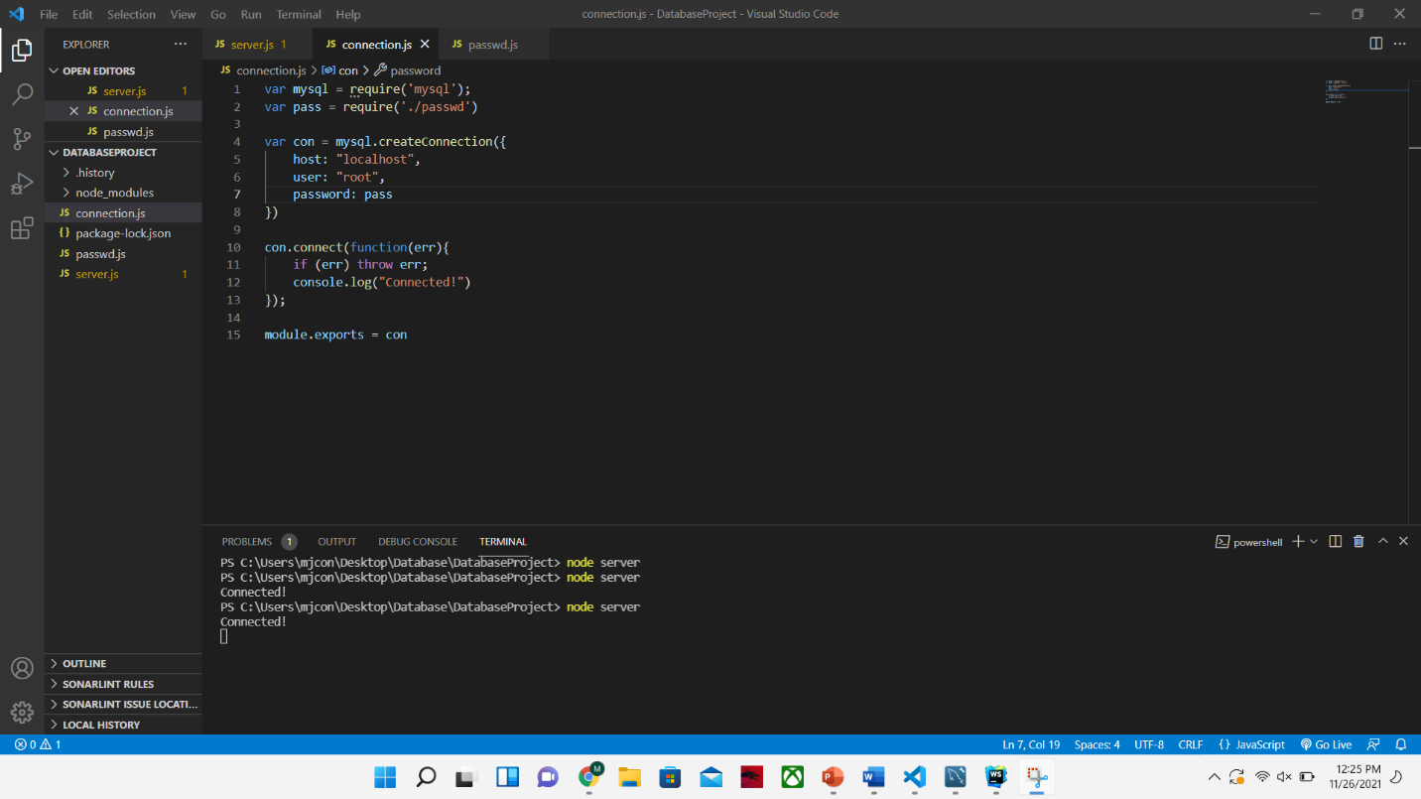To fully submit this assignment for grading, demo your work on Flipgrid.

The above figure is the code that allows for the connection from the database to the node.js server I created. As you can see, I am passing a variable “pass” into the javascript to hide the password. This code will create the connection to the database so we can get outputs.

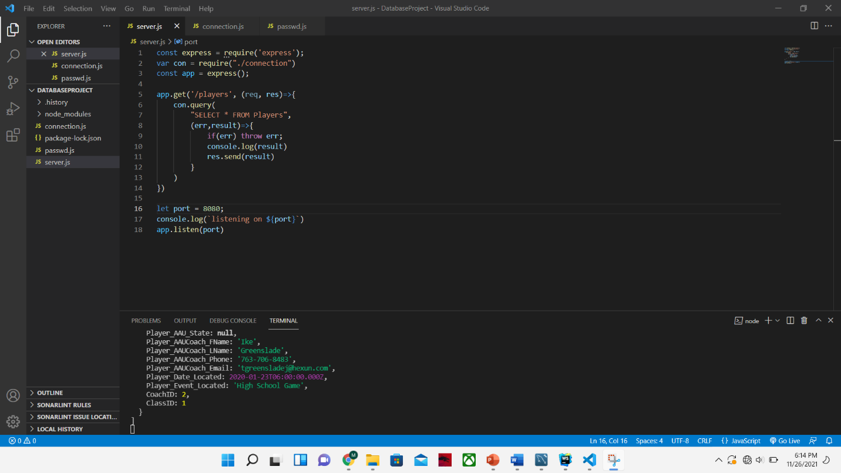

In the picture above, you can see the query that will show us that we are able to get the data that is within our database. I used a simple query that will allow for the most output to make sure that the data is all there. In the terminal in this picture as well as the next picture, is showing the output.

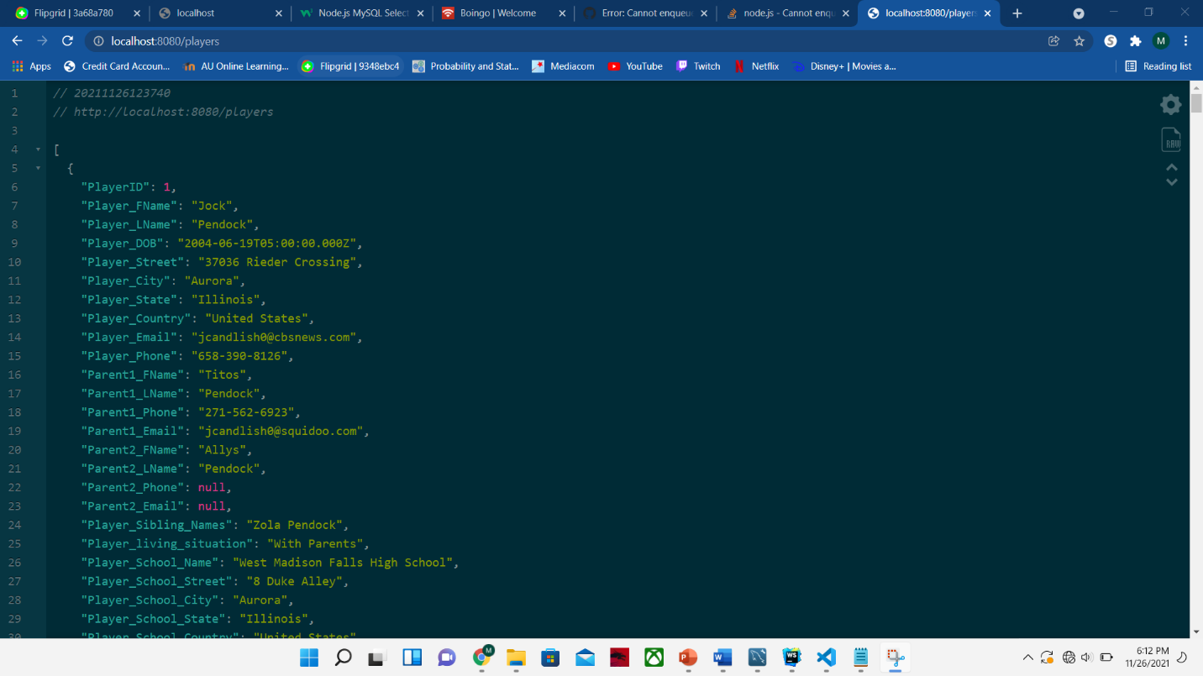

The screenshot above is showing the players found within the database and is routing to the localhost:8080/players. This output is very basic and is in raw JSON, which can be easily manipulated to use in either HTML or PUG.