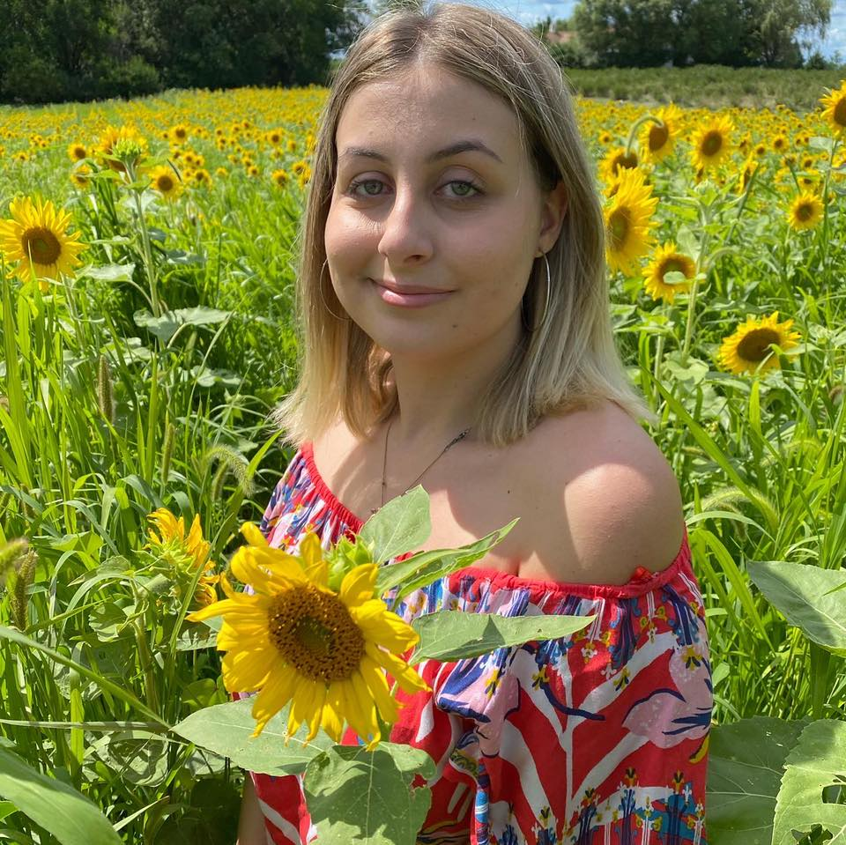My name is Savanna Mussa, my pronouns are she/her/hers, and my major is computer science with a minor in psychology. This class is required to graduate so I am taking it for that reason but also I think it’ll be interesting to build our own databases. Career plans are a bit unclear, I’m not really sure what to do with my future but I’m definitely thinking about getting a master’s degree. Some things I would like to do in the future is to travel with my friends, go to a bunch of concerts, and try new things.

Other things about me:

I’m from Plano, Illinois, as for my family, I live with my parents and younger brother Dagan, he’s the only sibling I have. He’s 12 years old and just entered middle school, he loves to play Minecraft and Roblox all of the time.

I like to read, hang out with friends, and shop whether it’s online or in person. My favorite season is summer because we got a break from school, it finally gets warm out, and I was born in the summer, so my birthday comes around. My favorite flavor of ice cream would have to be mocha almond fudge, but I can't really find it anymore in stores, so I haven't had it for a long time. My dream job as a kid was definitely to become a famous fashion designer or become a doctor.

My favorite things to watch on Netflix, Disney+, and HBO Max is Vampire Diaries, Demon Slayer, anything Marvel related, Boys Over Flowers. If I want to just have something play in the background, I will almost always play Friends or Spongebob.

My favorite music would have to be pop or alternative genre, but I listen to a lot of different things. My favorite artists are Taylor Swift, BTS, Pierce The Veil, Rina Sawayama, and Harry Styles. So far, the only artists that I’ve seen live from this list is BTS and Harry Styles (back when he was in One Direction), but I am going to see Harry styles again on his upcoming tour.

I chose to go to Aurora university because it was close to home, it was less expensive than most places, and I would save money by living at home with my parents. I can speak another language not necessarily fluent, but I can speak some Albanian because my parents are from Albania. If my life was a movie, I would be the main character because I'm a leo and leo's are always the main character.

Places I would like to travel to the most would be Tokyo, Seoul, London, Paris, and Mexico. The coolest place I've been would have to be either Albania or Macedonia, they both have breathtaking views and a lot of mountains. My favorite color is red, pink, and yellow. Unfortunately, I do not have any pets but I want a cat or a dog, honestly anything at this point.