Comparing student earnings summaries
Student earnings methods | October 20, 2026
I worked with Yahir to compare three ways to combine program median earnings into academic buckets. My proposed choice for describing a typical program is the median of program medians, with the other methods shown for comparison. None of the three gives the exact median earnings of all individual graduates in a bucket.

Method comparison
Method | What it does | Advantage | Limitation
Mean of program medians | Adds the available program medians and divides by their number. | Simple comparison; includes every available program value. | Small and large programs get equal weight. Extreme program medians can pull it up or down.
Median of program medians | Finds the middle of the available program medians. | Less affected by extreme program medians; describes a typical program. | Ignores program size. It is not the median individual graduate’s salary.
Count weighted mean of program medians | Weights each program median by its corresponding earnings cohort count. | Gives larger reported cohorts more influence. | Needs matching cohort counts. It still does not recover the pooled student median or mean.

Recommendation
Use the label “median of program median earnings” if the goal is to describe a typical program. Keep the weighted average as a comparison when program size matters. I would not call one method the most accurate estimate of student earnings because the underlying individual salaries are unavailable. A method that is less affected by outliers can still answer a different question from the one the report is asking.
For the four year comparison, use the four year earnings counts as weights, keep suppressed salaries missing, and apply the same degree and record filters to all three methods. Report the number of usable program records with each bucket result.

Results comparison
I included Yahir’s chart comparing bachelor’s programs at four years after graduation across UC and CSU schools. This is the screenshot he shared; I still need his code and results table to check the filters and calculations.
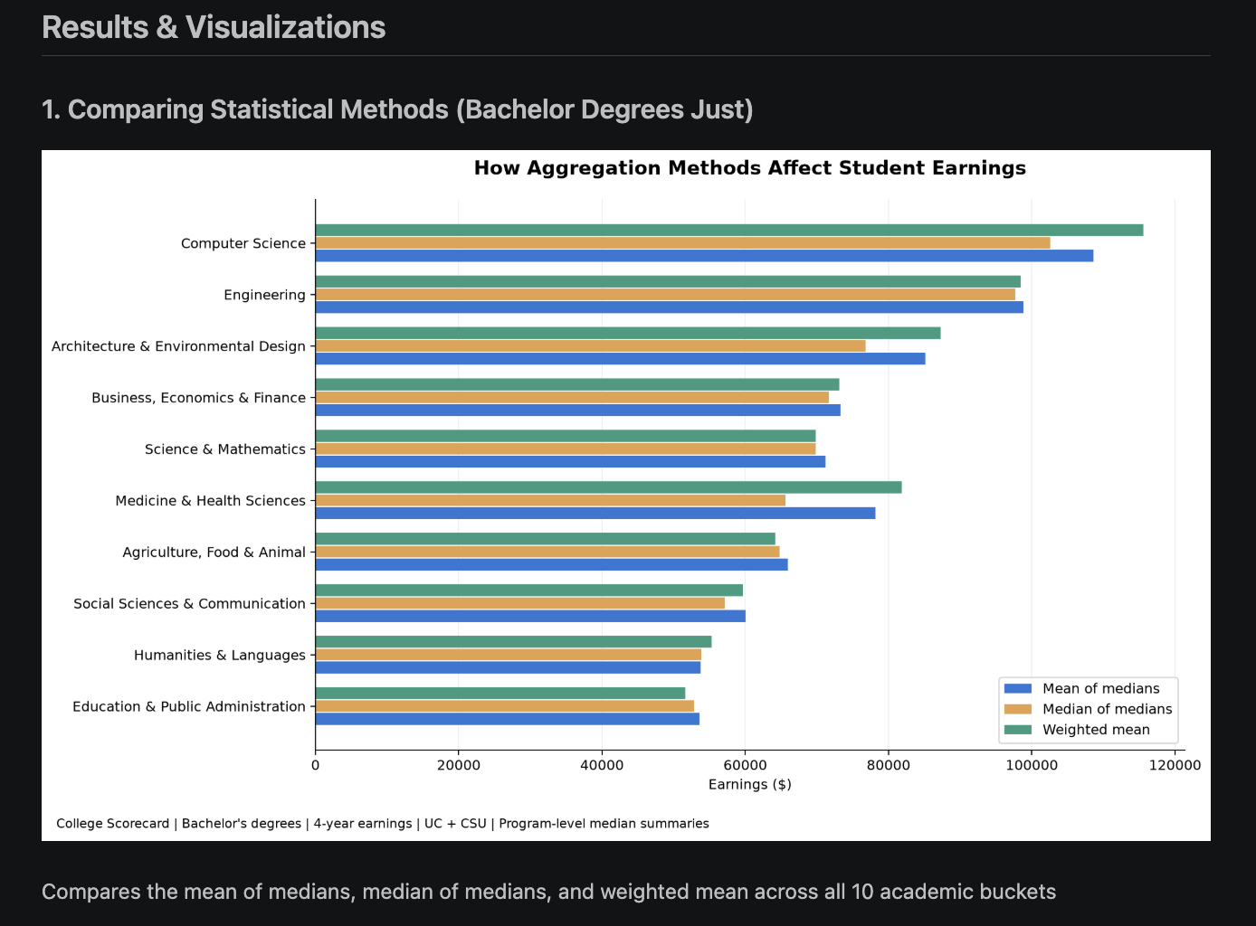
The chart shows that the choice of summary changes some buckets more than others. Computer Science, Medicine and Health Sciences, and Architecture and Environmental Design show visible differences between the methods. These differences show sensitivity to the method, not error against a known true student median.

Limits and documentation
Confirm the exact input version, how bachelor’s records were selected, which duplicates were removed, and which earnings counts were used. The current student pipeline drops the credential level column during its final cleanup, so degree filtering needs an earlier stage with that identifier retained. The existing project time series uses a count weighted average of program medians; changing it should be a class decision.

Sources
Statistics Canada. Median definition. https://www150.statcan.gc.ca/n1/pub/81-004-x/def/4068724-eng.htm
McGrath et al. One-sample aggregate data meta-analysis of medians. Statistics in Medicine, 2019. https://pubmed.ncbi.nlm.nih.gov/30460713/ (abstract reviewed)
Project student pipeline and Student Data Wiki. https://github.com/CSC4693-Fall-2026/CSC4693/wiki/Student-Data
I used ChatGPT to help with the comparison code. Yahir made the chart.

