Daydream Manual

Requirements:

* Microsoft Kinect V2
* Android device with Virtual Reality capability
* Windows OS
* Cardboard headset
* Unity Beta 5.6
* Android Studio/SDK
* Microsoft Kinect SDK
* Java JRE
* KinectVR Unity Project
* Micro USB sync cable

Building App on Android

* Make sure you are not connected to the school’s WiFi. (Creating a WiFi hotspot with your phone is an option; Cannot use the phone you are building this project onto.)
* Find and record your local IP address of your computer by opening the Command Prompt and calling the *ipconfig* command.
* Once all the requirements have been met, open the KinectVR Unity Project in Unity as a project by opening unity and clicking open.
* Find the project and click “Select Folder”.
* Once the project is loaded in Unity, click the “Project” tab and navigate to the “Scenes” folder under “Assets” folder.
* Double click the “MainMenu” scene.
* Once scene is loaded, click the arrow next to the GameOject “KinectVR” in the “Hierchy” tab on the left.
* Next, click the “AliceManager” GameObject under KinectVR.
* On the left, in the “Inspector” tab, edit the “Host” field to local IP address you found earlier.
* Hit Ctrl + S to save the scene, then open the “SelectionMenu” scene from the “Scenes” folder in the “Project” tab..
* Once scene is loaded, click the arrow next to the GameOject “KinectVR” in the “Hierchy” tab on the left.
* Next, click the “AliceManager” GameObject under KinectVR.
* On the left, in the “Inspector” tab, edit the “Host” field to local IP address you found earlier.
* Hit Ctrl + S to save the scene, then open the “gym” scene from the “Scenes” folder in the “Project” tab.
* Once scene is loaded, click the arrow next to the GameOject “KinectVR” in the “Hierchy” tab on the left.
* Next, click the “AliceManager” GameObject under KinectVR.
* On the left, in the “Inspector” tab, edit the “Host” field to local IP address you found earlier.
* Now, in the “Inspector” tab, click the gear to the right of the Alice Manager (Script) title.
* In the dropdown menu, click “Edit Script” and wait for either MonoDeveloper or Visual Studio to open.
* Once open, edit line 12 using the local IP address recorded earlier from “public string host = ‘172.20.10.3’;” to “public string host = ‘*your local IP address*’;”
* Click save or Ctrl + S.
* Open Unity and go to File->Build Settings.
* Make sure Android is selected as the Platform and your android device is connected.
* Click Build and Run.
* Your Android device will run the app once it is done, but you will need to exit out of it.

Starting the App

* Make sure Kinect in properly connected to PC in the USB 3.0 slot.
* Open the ***KinectVR-Broadcaster.exe*** file in the ***KinectVr-Client*** *folder*.
* Two windows will open: one is the Broadcaster and the other is a node.js terminal winding logging the activity of the server.
* Make sure your local WiFi IP is entered in the host field in the broadcaster
* 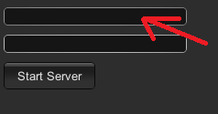
* 5000 will be entered in the second field
* When Broadcaster is ready, hit the ***Start Server***button*.* (In the terminal window, it should say that there is 1 device connected.
* Connect your phone to the WiFi network that your laptop/ computer is on.
* Now open the Unity app that was built onto your phone.
* Place your Android phone into your cardboard device.
* The app will load into the ***Main Menu***. If the local IP address is correct and you are not on the school’s WiFi, your “character” will drop from the spawning point. This confirms node.js has properly sent the kinect data.
* You will have a small reticle on the middle of the screen, this is used to select menu items.
* When hovering over an option you want to select, press the selection button down that is on the cardboard device just above your right eye. 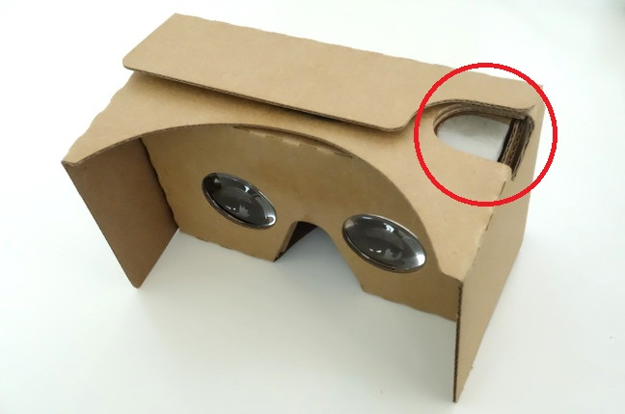
* Selecting “Start” will take you to the ***Selection Menu***. Select a workout in the same manner.
* You will then be loaded into the proper workout scene. Follow the directions for the workout and enjoy.
* There will be a back button and menu button. The former takes you back to the workout selection, while the latter takes you to the main menu.