Purpose of System
The main purpose of this system is to provide the newly added branch of the College of Liberal Arts, the Department of Film and Media, with an application with which they can manage, and query data taken from the Internet Movie Database. The users will be able to query the names of film cast members in order to generate the answers to trivia questions from various class assignments and quizzes.
With this application, the users will be able to access the IMDB database without the unnecessary additional information, and without the need for internet access. However, if they users have internet access, they will be able to fetch updated information. As a student, I want more information about an actor’s movies to help me with an assignment on their filmography. As a professor, I want information on a director’s career work in order to verify details for student assignments. As a grader, I want information on cast and crew members quickly to expedite the grading process.

High-Level Entity Design
GUI: This is the interface that the users interact with. All interactions with the database and other aspects will go through here. This is how the user will call database info, and modify, add, or delete data in the database. This is needed, so the users have an easier time interacting with the database.
Parser: This is a program to scan user text and send them to the command executor to run. Using the language provided, we will parse through the text a user enters, display any syntax errors, and then send the commands in a command executor friendly format if there are no syntax errors. This needs to be a separate process because reading and checking for all errors is an intensive task on the developers’ side of the application.
Command Executor: The section that connects the database to all of the other components, and it will also store any necessary variables. This is the heart of the backend of the application. This needs to be a separate entity because it is a central component that allows this application to work.
Fetcher: A program that will automatically retrieve and refresh the database with the newest version of the IMDb. This is a feature we wanted to add to automate the process of refreshing the database with new information. This needs to be separate because we want the user to have the power of when to update the database.
Database: The thing that holds the all the movie information, and any other data the user inserts. The user can parse through and retrieve data or add data to it. This needs to be a separate component because we want the database to be isolated and only accessed through the command Executor.

Low-Level Entity Design

GUI

Relationships
The GUI interacts only with the parser and command execution systems. With the parser the GUI sends scripts to be evaluated and run while also being able to display syntax errors brought up by the parser. The GUI interacts with the command executor by sending direct commands the user issues to it as well as being able to show output form the SHOW command originating from the parser or the GUI itself.

Thought Process
The GUI is meant to be the front end of the whole system and handles all interaction with the user. The GUI should have multiple windows. The initial window serves as the main control board with the fetch button and opening buttons for all other control windows. The Script window contains a text editor as well as open, save, parse, and execute buttons to allow the user to interact with written scripts that contain many commands to be executed sequentially. The command window is a window which allows the user to execute every command with the click of a button. This window will have a button for all commands as well as a list of all currently loaded variables and their values. This window allows the user to execute arbitrary commands.

Benefits
The GUI encapsulates all human interaction in a single system allowing for consistency across the system and for all possible actions in the same location. It also allows for more depth in script development and more features can be implemented within the internal IDE.

Risks
The GUI could very easily become cluttered and unfriendly to the user if care is not taken to ensure that the main purpose of easy human interaction is followed. The GUI could also become a limiting factor for the rest of the system as it handles all human interaction.

Parser

Relationships
The parser interacts with the GUI and the Command executor. With the GUI the parser receives scripts to be parsed and sends back results of any syntax errors found within the scripts received. With the command executor the parser sends lists of commands parsed from scripts to be run.

Thought Process
The parser is meant to handle all script verification and translation. Its job is to take a script, check for errors, then convert it into a executable list of commands. To accomplish this, it will use a file that contains the grammar allowing for easy updating to this grammar by just updating the file.

Benefits
This system makes it easy for command execution to be separated away from parsing of an arbitrary script where many errors can occur before command execution even occurs. This also allows for scripts to be parsed without blocking other command execution. A grammar file also allows for easy updating of grammar.

Risks
The Parser will be using a grammar file meaning that errors could result from uncarefully added items to this file. The parser could also be easily written in a way that disallows for parallel execution which could result in less than preferable run times.

Command Executor

Relationships
The command executor relates to all other systems. It relates to the GUI in that it executes commands given to it by the GUI and displays the SHOW command on the GUI. It relates to the parser in that it takes in a command list to be executed. It relates to the Fetcher in that it sends and receives information in order to execute the fetch command. It relates to the database in that it executes database commands.

Thought Process
The Command executor is the system that takes commands and handles their execution. It stores all created local variables and handles all commands related to them. All database commands are relayed to the database system and fetch commands to the fetch system.

Benefits
Having a separate command executor allows for encapsulation of local variables and for functions that can be called in any context. This also helps with performance as this system can be isolated in its own thread.

Risks
This system is the backbone of the whole product as it connects every other system together, and therefore it is relied on the most. Any error in this system could easily delay all other systems progress and care must be taken to limit breaking changes.

Fetcher

Relationships
The Fetcher only relates to the command executor as that is where the command is called from and where the fetcher sends its own commands.

Thought Process
The Fetcher is meant to facilitate auto updating of the database. This can be done with a single fetch command and the fetcher will access the IMDB database from the internet, download it, and then issue the necessary command list to the Command Executor. This should also be reconfigurable to add more databases to the list to be updated.

Benefits
This allows for easy updating of the database by the end user without thorough knowledge of the database structure.

Risks
This system could be rendered inoperable if IMDB were to go down or be inaccessible. Care must also be taken to handle all the possible error states that could arise with networking.

Database

Relationships
The database relates exclusively to the command executor system in that it receives all command from that system and returns all data to it.

Thought Process
The database system is designed as a wrapper around the SQL database to add easy functions for all supported SQL commands.

Benefits
This system allows us to encapsulate all SQL interaction and allows us to control message data types between systems.

Risks
This system can be vulnerable to many types of problems that all SQL databases face such as SQL injection. In addition, this system must deal with networking to the database and as such must be able to handle all the problems that come with that.

UML Diagram
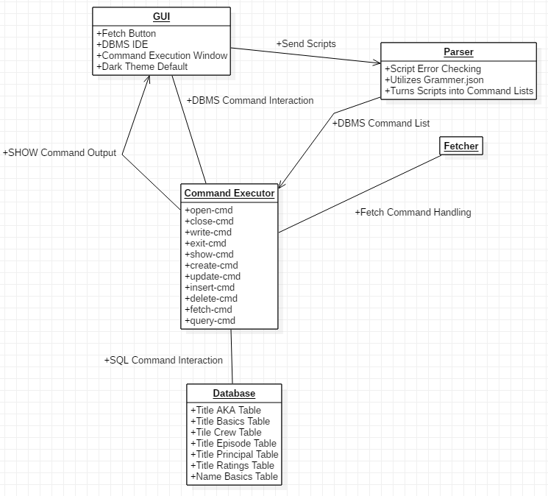This diagram shows the relationships between all the systems and what kind of messages go between them.

Interaction Diagram
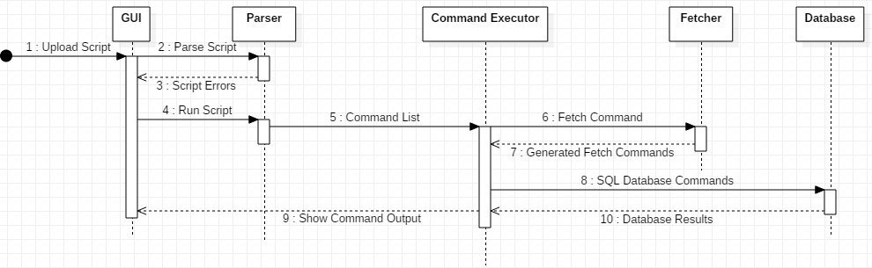
This diagram shows how the system interact when a script is uploaded to the program.

Expectations
This system will provide the students and educators in the department of cinematic arts persistently collect information that will aid them in the courses they take, or teach. For students, it will be a useful tool that will help them in their coursework. For teachers, it will be a useful tool that will help them in developing and grading coursework.
One of the assumptions we make is that the user will update the information in the database before retrieving any information, as the system would be most useful to the user when they have the most recent information. Having the users update information manually presents the potential risk of them not updating the database over a long period of time. This may seem like a trivial issue, however if the user were a teacher and they needed to utilize the system in order to fact check a students work they would not have the pertinent information available in our database. The same could be said for a student who need the information provided by the database for their coursework.
Another assumption that we are making is that the parser will work perfectly in order to find the relevant query from the user’s entered script, without compromising the user experience with long wait times. If the parser doesn’t work perfectly, then the user experience with our system will take a large hit. They could potentially not get the information they desire in a timely manner, or not get information that is relevant to their query. However, we will work hard to make sure that user’s experience is a positive as can be.

Credits
Brett Etter, Johnathan Labrum, and Abeer Hasan Zaidi

