Sprint 1 Materials

Team 53

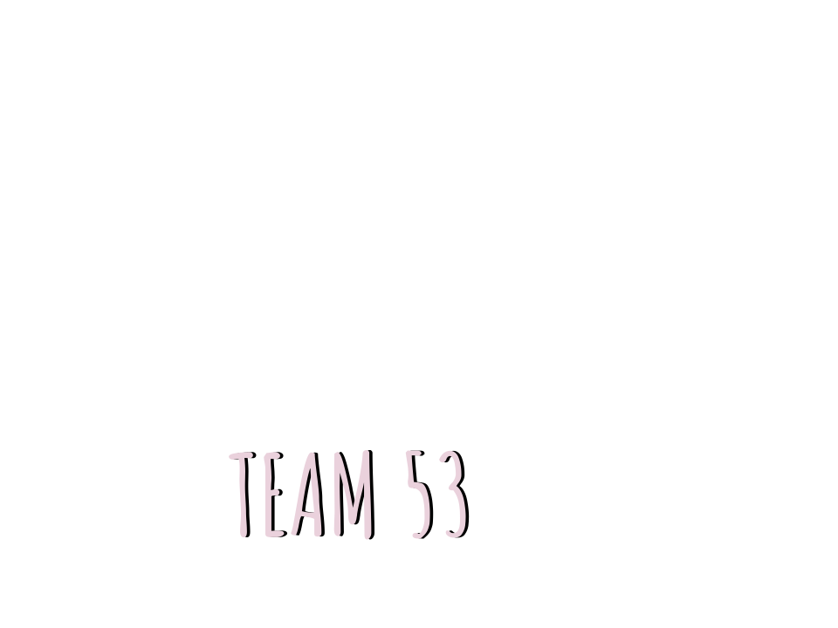

Preksha Vaghela

Victoria Pham

Annie Ren

Hexin Hu

# Retrospective Summary

In our retrospective we discussed what we accomplished, what could have gone better, and what we plan to do moving forward. In the first couple days of the sprint, we realized that the amount of work we initially committed to was unrealistic. After scaling down our sprint goal to just the login and customer facing pages, we were able to produce a working product. Our program is now capable of pulling data from the database to create a menu. It then uses that data to create an ordering page where customers can submit their own orders. In this sprint, the backend/middle-end team unintentionally took on a lot more work than the frontend team. This happened because the backend team was dependent on the frontend to be completely finished before integrating. What ended up happening was that the backend team took on more work to help finish the frontend quickly, in addition to their own work. In our meeting, we discussed how to avoid this from happening moving forward. We decided that at the beginning of the sprint, we will set a deadline for the frontend team to meet, so the backend team has sufficient time to integrate and test everything. We will also communicate any delays to the timeline as soon as we are aware of them. Our backlog goals were met after readjusting the scope of our sprint plans. We discussed how many story points we should take on based on how we felt about this sprint. We also discussed the issues with our current estimations of the sprint story points. We decided that now that we have more familiarity with the code base, we should go in and re-estimate the story points to be more accurate of the time commitment.

# GitHub Release Link

<https://github.com/CSCE315-F22-Taele/Team-53-Project_3/releases/tag/v.1.0.0>

This includes an ordering and checkout page. Anyone, a customer or cashier, can take an order and pay for it. It will add the order info and checkout info to the database.

# Product Backlog

All items in the backlog are not started. They will come in scope in future sprints.

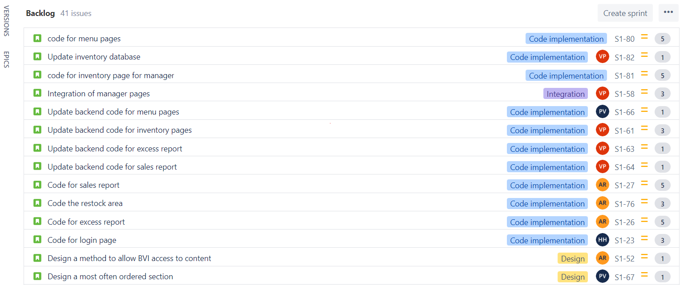

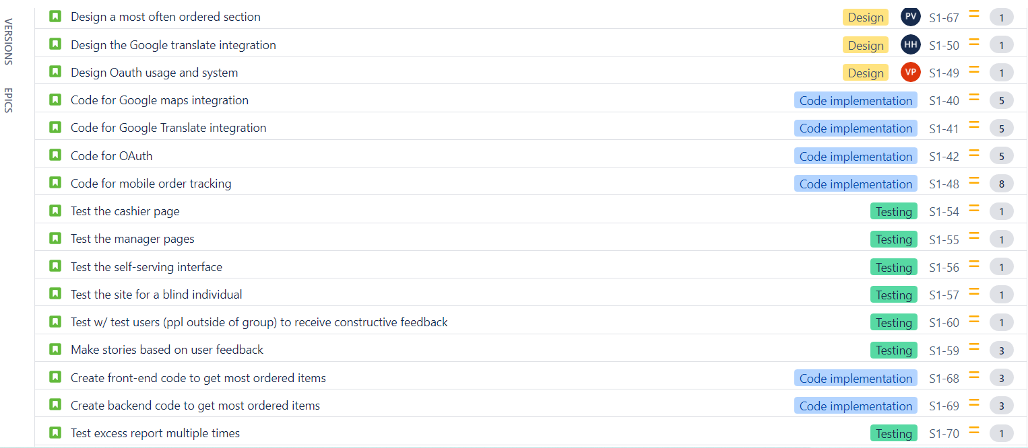

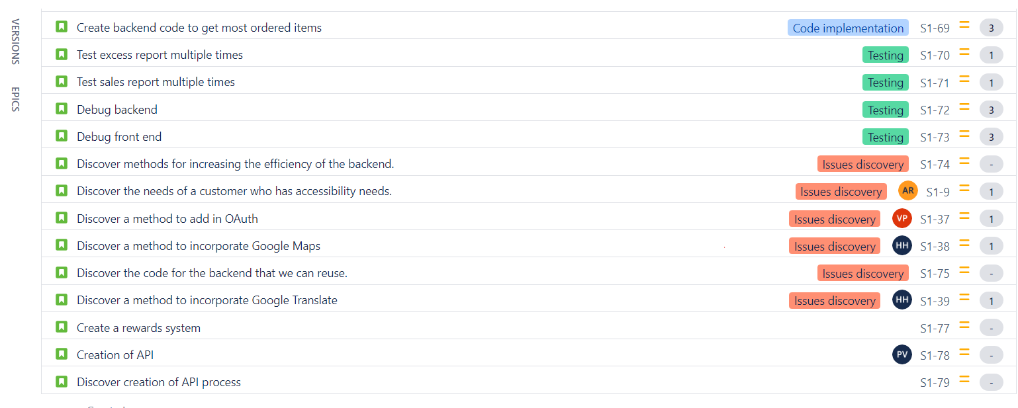

Sprint Backlog

All items in the spring backlog have been completed.

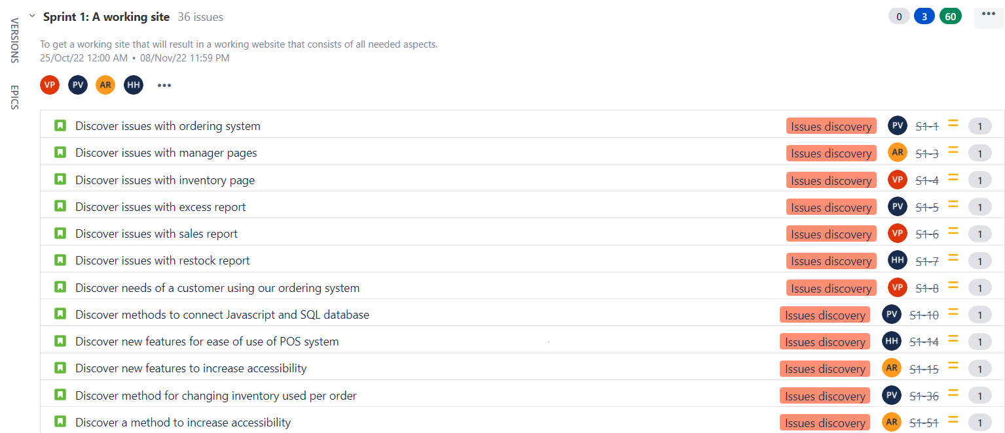

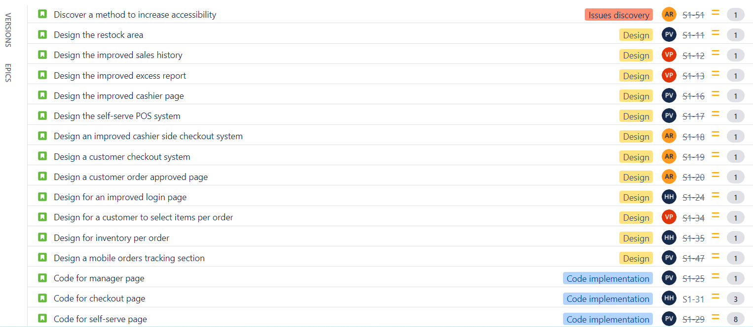

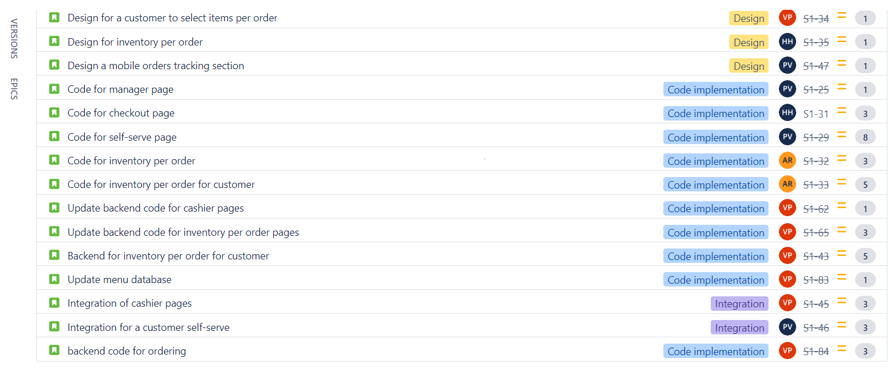

**Story Point Summary**

|  | Sprint 1 | Sprint 2 | Sprint 3 |
| --- | --- | --- | --- |
| Preksha | 20 pts | N/A | N/A |
| Victoria | 22 pts | N/A | N/A |
| Annie | 14 pts | N/A | N/A |
| Hexin | 7 pts | N/A | N/A |

# Burn-down Charts

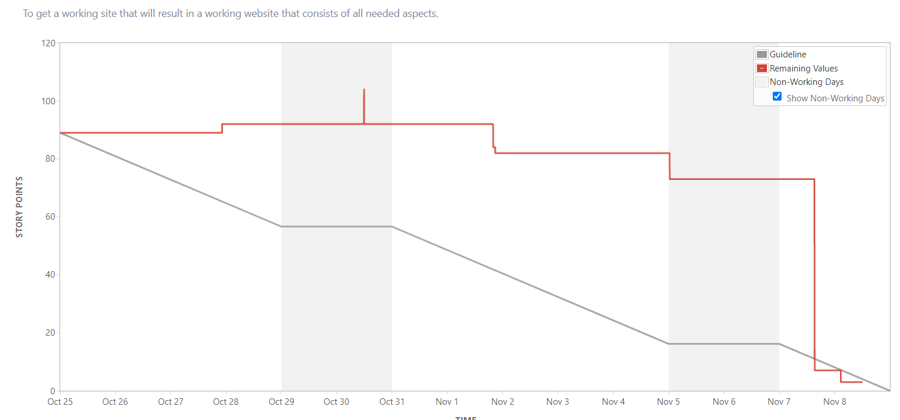

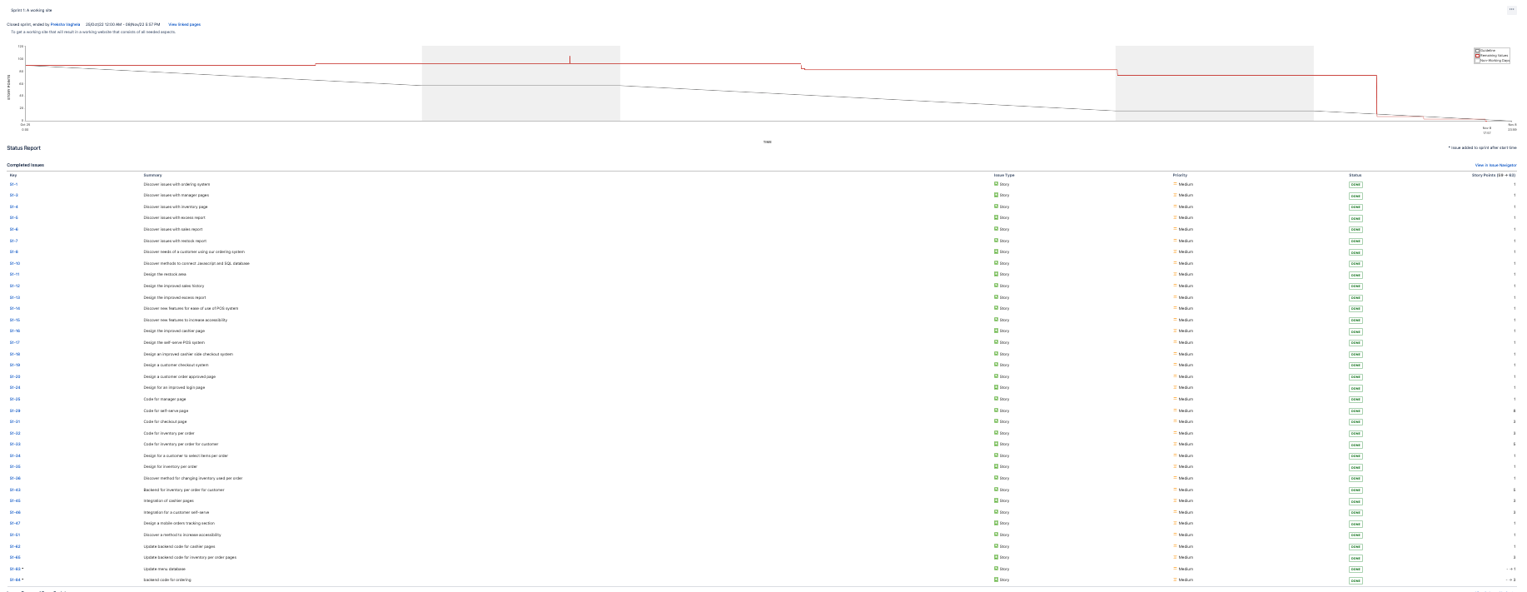

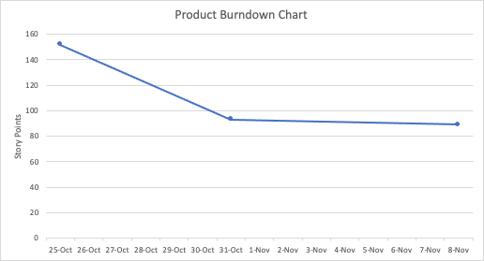

# Next Sprint’s SCRUM Meeting Schedule

11/9/2022: 3 pm

11/11/2022: 9:30 am

11/13/2022: 10 am

Appendix 1: SCRUM Meeting Agendas and Minutes

SCRUM Meeting 1 for Pom and Honey Complete POS System

Prepared by: Preksha Vaghela

Meeting Date: 11/01/2022

## Meeting Attendees

1. Preksha Vaghela
2. Victoria Pham
3. Annie Ren
4. Hexin Hu

## Meeting Agenda Items

* Discuss the design of all items for this sprint.
* Discuss the division of items in the sprint backlog.
* Discuss the expectations for team members.

## Status Update Since Last Meeting

Accomplishments:

* Created a plan on the deliverables for this sprint and our Sprint 1 MVP
* Divided out the work evenly based on group members skills and preferences

Tasks Completed:

| **Task Description** | **Assigned to** | **Completed? (yes/no)** |
| --- | --- | --- |
| Created and estimated the backlog for project | Preksha | Yes |
| Created low level design | Preksha  Victoria  Annie  Hexin | Yes |
| Divided out the work and set deadlines | Preksha | Yes |

## Before The Next Meeting

Plans:

* Setup React on everyone’s local devices
* Create a standard format for the pages to create a more professional look.
* Everyone should have started working on their tasks and made progress.

Task Assignments:

| **Task Description** | **Assigned to** |
| --- | --- |
| Standard React page format | Preksha |
| Setting up a database connection with React | Victoria |
| Understand ways to increase accessibility | Annie |
| Setup react on local machines and start working on assigned front-end pages. | Preksha  Annie  Hexin |

## Minutes from Previous Meeting

Last meeting we discussed the shortcomings of our previous design. We discussed what we will do to ensure that these problems do not occur again. Our discussion showcased that we need to focus on our design and ensure that all group members understand the design needed. We made plans to have a design meeting and discussed our personal and team goals for Project 3. We also made plans on having progress checks to have more accountability so that the division of work was more evenly distributed.

We discussed that we want to use React for our front-end since it would be the easiest to use due to great documentation. We also discussed that we need to figure out the accessibility features we want to add. Finally, we discussed what features would be the most important to add that were not included in Project 2.

SCRUM Meeting 2 for Pom and Honey Complete POS System

Prepared by: Preksha Vaghela

Meeting Date: 11/3/2022

## Meeting Attendees

1. Preksha Vaghela
2. Victoria Pham
3. Annie Ren
4. Hexin Hu

## Meeting Agenda Items

* Discuss progress on the assigned pages
* Discuss issues encountered
* Understand the timeline for completion.
* Set a soft deadline for all front-end pages.
* Set a soft deadline for all back-end pages.

## Status Update Since Last Meeting

Accomplishments:

* Victoria got the db connected and can query properly using XXXXX. She is planning on making backend functions for the other group member’s front-end pages. She mentioned its been working pretty well, but there will probably be issues when the real integrations start
* Preksha is setting up the customer pages. She set up an example page that is the routing page for manager tools. All the pages everyone else does should use this as a standard format. She is right now trying to figure out ways to get buttons and navbars to route to different pages so we have all the pages integrated for a seamless user experience.

Tasks Completed:

| **Task Description** | **Assigned to** | **Completed? (yes/no)** |
| --- | --- | --- |
| Standard React page format | Preksha | yes |
| Setting up a database connection with React | Victoria | yes |
| Understand ways to increase accessibility | Annie | yes |
| Setup react on local machines and start working on assigned front-end pages. | Preksha  Hexin | yes |

## Before The Next Meeting

Plans:

* Create basic customer and checkout pages
* Update the backend code for inventory per order and customer

Task Assignments:

| **Task Description** | **Assigned to** |
| --- | --- |
| Code for checkout page | Hexin |
| Code for inventory per order | Annie |
| Code for customer page | Preksha |
| Update backend code for inventory per order | Victoria |

## Minutes from Previous Meeting

Everyone got to look at the Jira board and see what they were assigned. They got to understand the reasoning behind working with React. We also decided to additionally use Material UI to make our React pages. We discussed the problems we’ve encountered while working with React. We all encountered the same issue of being able to launch a React app, but not being able to change it from the default app. We made setting up our React app the first priority for everyone, and then we revisited the proposed timeline. After, we decided on the branches everyone would create and work on in github in order to minimize merge conflicts.

SCRUM Meeting 3 for Pom and Honey Complete POS System

Prepared by: Preksha Vaghela

Meeting Date: 11/6/2022

## Meeting Attendees

1. Preksha Vaghela
2. Victoria Pham
3. Annie Ren
4. Hexin Hu

## Meeting Agenda Items

* Discuss the status of everyone’s assignments
* Discuss any roadblocks that people are facing
* Confirm a timeline for each person’s work

## Status Update Since Last Meeting

Accomplishments:

* Preksha created an initial page for customer ordering
* Hexin created a page for checkout
* Victoria updated all the backend code we are using

Tasks Completed:

| **Task Description** | **Assigned to** | **Completed? (yes/no)** |
| --- | --- | --- |
| Code for checkout page | Hexin | No. in progress |
| Code for inventory per order | Annie | No. in progress |
| Code for customer page | Preksha | No. in progress |
| Update backend code for inventory per order | Victoria | No. in progress |

## Before The Next Meeting

Plans:

* Push a working customer and checkout page to github
* Integrate ordering pages
* Setup render

Task Assignments:

| **Task Description** | **Assigned to** |
| --- | --- |
| Code for checkout page front-end | Hexin |
| Code for inventory per order front-end | Annie |
| Code for cashier page front-end | Preksha |
| Create all backend APIs to call in front-end | Victoria |
| Integrate cashier/customer data with database using API calls | Preksha |

## Minutes from Previous Meeting

Last meeting, we looked at everyone’s progress and challenges they were facing. We have a customer ordering page layout and checkout layout complete. Both front end pages have buttons they can interact with. Both pages are dealing with the challenge of getting the receipt area to have the intended functionalities and display properly. We decided that one person should focus on the receipt area, and reuse the code on both pages. This allows others to work on other fixes and bugs. The backend was mainly done and being roadblocked by the progress of the frontend. We moved up the timeline to complete the frontend to allow for enough time for integration.