How to share a document the good and right way in OneDrive
- Visit office.com/apps,
or if Microsoft changed this URL again to try to trick you into using Copilot, just log into your Outlook email on the web and find OneDrive in the app tray at the top left. If you find Microsoft’s web interfaces infuriating, welcome to the club.
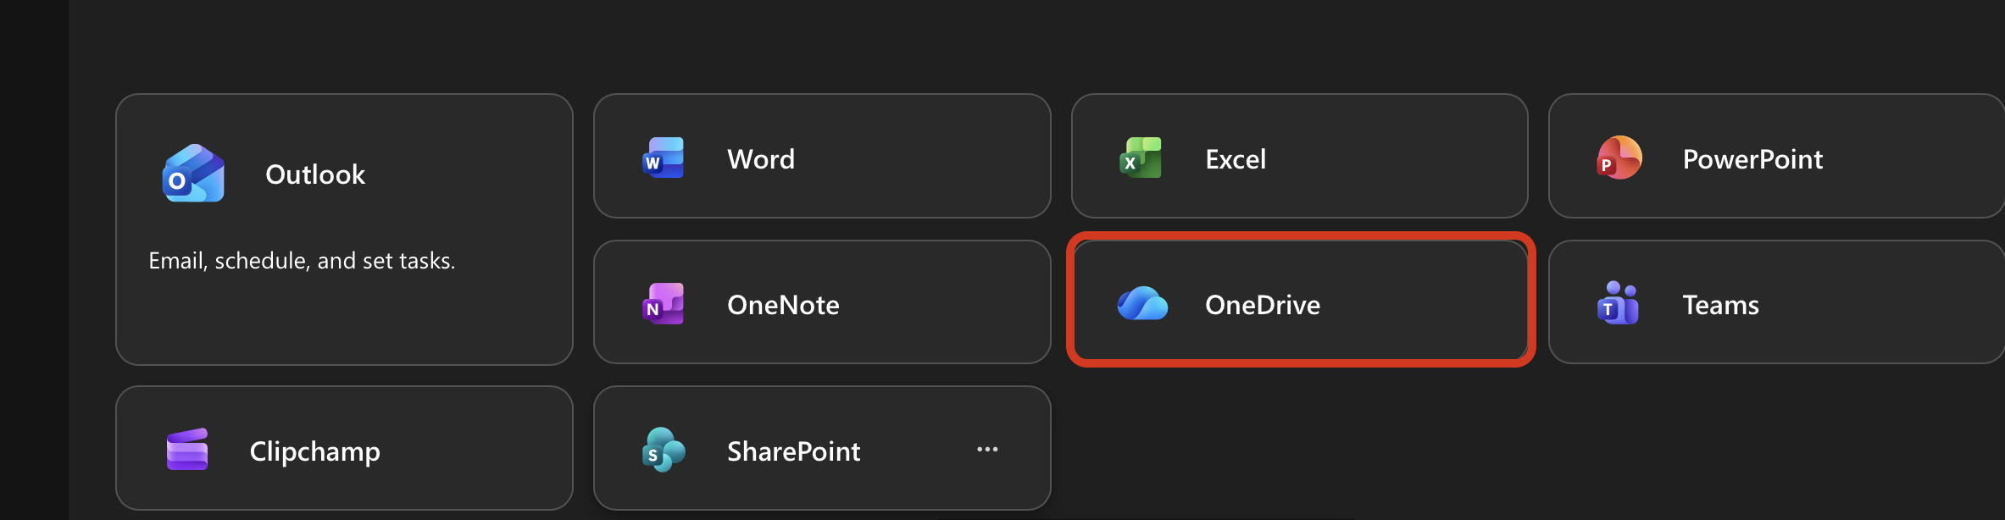
It is possible that since the time I have written this, all the icons have changed yet again to an even worse, even less distinct visual design, and all the icons look the same, much like Google apps in 2025: A continual reminder of the tech industry’s decline and the tragic brain injuries that visual designers at large tech companies must be sustaining in order to make choices like these.

- Find the file you want to share and click the little share button thing – it says “Share this item with other people” when you hover your cursor over it.
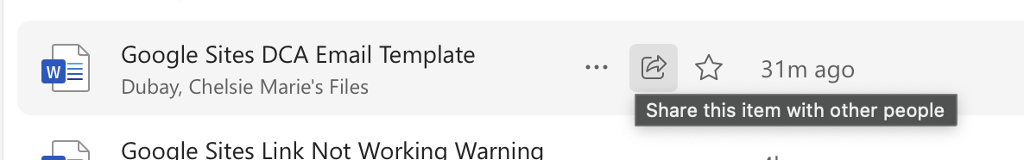
Nope, this ain’t over yet, pal. Scroll to the next page.

- Now click the share settings (gear icon next to the copy link button, unless Microsoft needlessly redesigned it, to make it harder to figure out):

Now you have gotten to the good stuff. Click Anyone and click Apply. APPPPLLLY!
Always just click anyone. Don’t share it over email. It’s annoying, things don’t work as expected, I have to request access. You don’t see the request for 3 days. Then you are like huh? And I’m like can you make the link public? So just select Anyone!
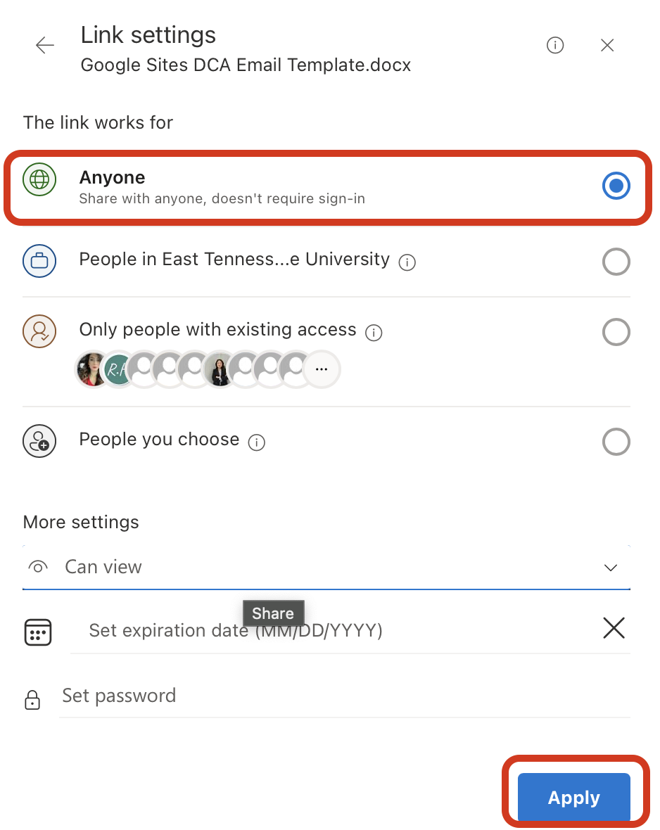
Note: The default permission is “Can edit” – how annoying! You can change this to “Can view” if you don’t want randos editing your work. But if you do, then enjoy, I guess.
Scroll down. One more page!

- Alright, buckle up. This one’s really advanced: Click the back button on the top left of the sharing settings dialog window.
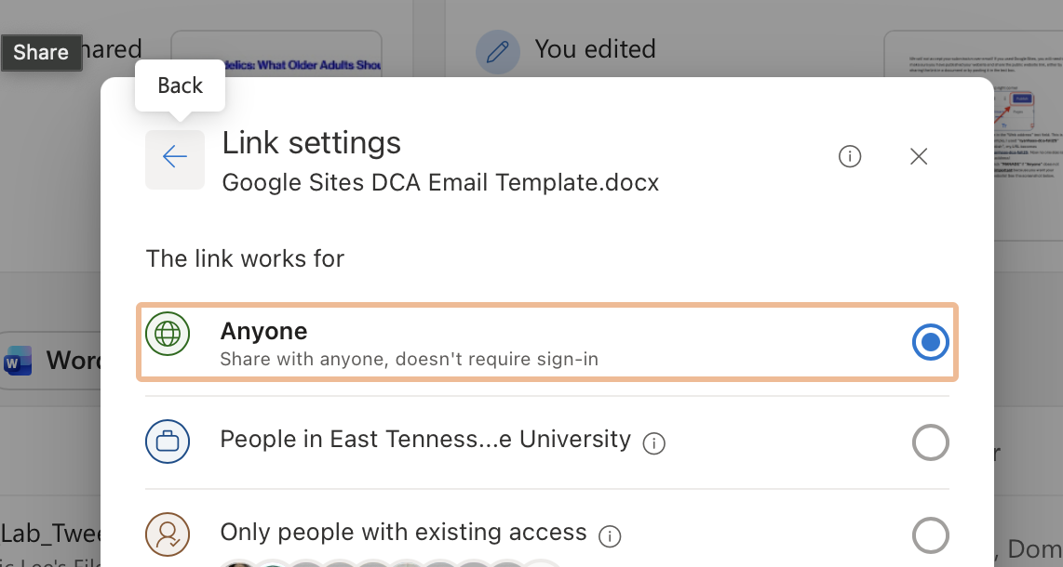

- Finally, click Copy link. If you float your cursor over the copy button and it doesn’t tell you that Anyone can view, take a deep breath, splash some water on your face, say a positive affirmation, and start back over at the beginning.
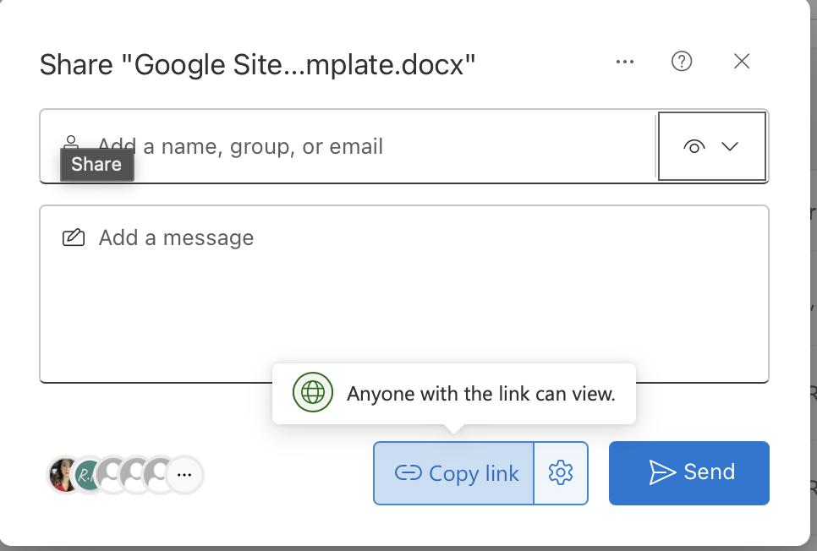
- Congratulations. You’ve done it now. Now take that link and link it, or share it, or submit it to Dropbox, or whatever you’re trying to do with it!

