# Introduction

Decisions are a constant occurence in daily life. For instance consider an instructor teaching CSCI 1301. At the beginning of class the instructor may

* Ask if there are questions. If a student has a question, then the instructor will answer it, and ask again (“Anything else?”).
* When there are no more questions, the instructor will move on to the next step.
* If there is a quiz scheduled, the next step will be distributing the quiz.
* If there is no quiz scheduled or the quiz is complete (and collected), the instructor may introduce the lecture topic (“Today, we will be discussing Decisions and Decision Structures”) and start the class.
* etc.

This type of “branching” between multiple choices can be represented with an [activity diagram](https://www.wikiwand.com/en/Activity_diagram):

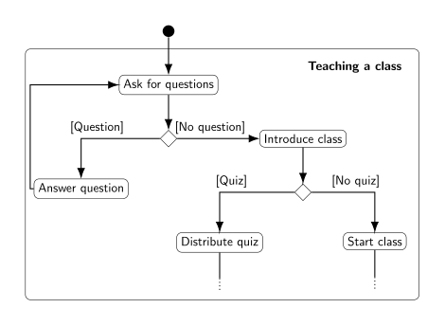

“An Activity Diagram on Teaching a Class”

In C#, we will express

* repetitions (or “loops”) (“As long as there are questions…”) with the while, do…while and for keywords,
* branchings (“If there is a quiz…”) with the if, if…else and switch keywords.

Both structures need a datatype to express the result of a decision (“Is it *true* that there are questions.”, or “Is it *false* that there is a quiz.”) called booleans. Boolean values can be set with conditions, that can be composed in different ways using three operators (“and”, “or” and “not”). For example, “If today is a Monday or Wednesday, and it is not past 10:10 am, the class will also include a brief reminder about the upcoming exam.”