# if

## if Statements

### Introduction

* Recall from a previous lecture (Booleans and Comparisons) that decision structures change the flow of code execution based on conditions
* Now that we know how to write conditions in C#, we can write decision structures
* Our first decision structure is the **if statement**, which executes a block of code *only if a condition is true*

### Example code with an if statement

Console.WriteLine("Enter your age");  
int age = int.Parse(Console.ReadLine());  
if (age >= 18)  
{  
 Console.WriteLine("You can vote!");  
}  
Console.WriteLine("Goodbye");

* After the keyword if is a condition, in parentheses: age >= 18
* On the next line after the if statement, the curly brace begins a code block. The code in this block is “controlled” by the if statement.
* If the condition age >= 18 is true, the code in the block (the WriteLine statement with the text “You can vote!”) gets executed, then execution proceeds to the next line (the WriteLine statement that prints “Goodbye”)
* If the condition age >= 18 is false, the code in the block gets *skipped*, and execution proceeds directly to the line that prints “Goodbye”
* The behavior of this program can be represented by this flowchart:
* 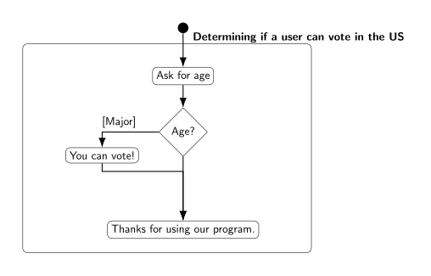
* “A flowchart representation of an if statement”
* Example interaction 1:
* Enter your age  
  20  
  You can vote!  
  Goodbye
* When the user enters “20”, the value 20 is assigned to the age variable, so the condition age >= 18 is true. This means the code inside the if statement’s block gets executed.
* Example interaction 2:
* Enter your age  
  17  
  Goodbye
* When the user enters “17”, the value 17 is assigned to the age variable, so the condition age >= 18 is false, and the if statement’s code block gets skipped.

### Syntax and rules for if statements

* Formally, the syntax for an if statement is this:
* if (<condition>)  
  {  
   <statements>  
  }
* The “condition” in parentheses can be any expression that produces a bool value, including all of the combinations of conditions we saw in the previous lecture (Booleans and Comparisons). It can even be a bool variable, since a bool variable “contains” a bool value.
* Note that there is no semicolon after the if (<condition>). It’s a kind of “header” for the following block of code, like a method header.
* The statements in the code block will be executed if the condition evaluates to true, or skipped if it evaluates to false
* If the code block contains only *one* statement, the curly braces can be omitted, producing the following syntax:
* if(<condition>)  
   <statement>
* For example, the if statement in our previous example could be written like this, since there was only one statement in the code block:
* if(age >= 18)  
   Console.WriteLine("You can vote!");  
  Console.WriteLine("Goodbye");
* Omitting the curly braces is slightly dangerous, though, because it makes it less obvious which line of code is controlled by the if statement. It is up to you, the programmer, to remember to indent the line after the if statement, and then de-indent the line after that; indentation is just a convention. Curly braces make it easier to see where the if statement starts and ends.

## if-else Statements

Example:

if(age >= 18)  
{  
 Console.WriteLine("You can vote!");  
}  
else  
{  
 Console.WriteLine("You are too young to vote");  
}  
Console.WriteLine("Goodbye");

* The **if-else statement** is a decision structure that chooses *which* block of code to execute, based on whether a condition is true or false
* In this example, the condition is age >= 18 again
* The first block of code (underneath the if) will be executed if the statement is true – the console will display “You can vote!”
* The *second* block of code, which comes after the keyword else, will be executed if the statement is *false* – so if the user’s age is less than 18, the console will display “You are too young to vote”
* Only one of these blocks of code will be executed; the other will be skipped
* After executing one of the two code blocks, execution continues at the next line after the else block, so in either case the console will next display “Goodbye”
* The behavior of this program can be represented by this flowchart:
* 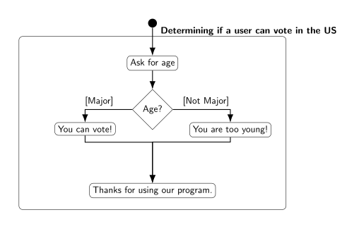
* “A flowchart representation of an if-else statement”

### Syntax and comparison

* Formally, the syntax for an if-else statement is this:
* if (<condition>)  
  {  
   <statement block 1>  
  }  
  else  
  {  
   <statement block 2>  
  }
* As with the if statement, the condition can be anything that produces a bool value
* Note that there is no semicolon after the else keyword
* If the condition is true, the code in statement block 1 is executed (this is sometimes called the “if block”), and statement block 2 is skipped
* If the condition is false, the code in statement block 2 is executed (this is sometimes called the “else block”), and statement block 1 is skipped
* This is very similar to an if statement; the difference is what happens if the condition is false
  + With an if statement, the “if block” is executed if the condition is true, but *nothing happens* if the condition is false.
  + With an if-else statement, the code in the “else block” is executed if the condition is false, so something always happens - one of the two code blocks will get executed

## Nested if-else Statements

* If-else statements are used to change program flow based on a condition; they represent making a decision
* Sometimes decisions are more complex than a single yes/no question: once you know whether a certain condition is true or false, you then need to ask another question (check another condition) based on the outcome
* For example, we could improve our voting program to ask the user whether he/she is a US citizen, as well as his/her age. This means there are two conditions to evaluate, as shown in this flowchart:
* 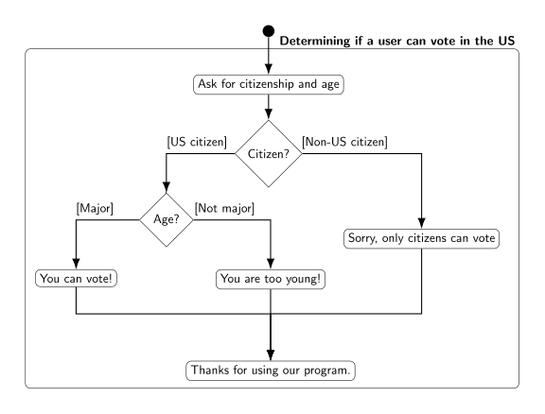
* “A flowchart representation of the nested if-else statement”
  + First, the program should test whether the user is a citizen. If not, there is no need to check the user’s age, since he/she cannot vote anyway
  + If the user is a citizen, the program should then test whether the user is over 18 to determine if he/she is old enough to vote.

### Using nested if statements

* An if statement’s code block can contain any kind of statements, including another if statement
* Putting an if statement inside an if block represents making a sequence of decisions - once execution has reached the inside of an if block, your program “knows” that the if condition is true, so it can proceed to make the next decision
* For the voting example, we can implement the decision structure from the flowchart above with this code, assuming age is an int and usCitizen is a bool:
* if(usCitizen == true)  
  {  
   if(age >= 18)  
   {  
   Console.WriteLine("You can vote!");  
   }  
   else  
   {  
   Console.WriteLine("You are too young to vote");  
   }  
  }  
  else  
  {  
   Console.WriteLine("Sorry, only citizens can vote");  
  }  
  Console.WriteLine("Goodbye");
  + First, the program tests the condition usCitizen == true, and if it is true, the code in the first “if block” is executed
  + Within this if block is another if statement that tests the condition age >= 18. This represents checking the user’s age after determining that he/she is a US citizen - execution only reaches this second if statement if the first one evaluated to true. So “You can vote” is printed if both usCitizen == true and age >= 18
  + If the condition usCitizen == true is false, the if block is skipped and the else block is executed instead, so the entire inner if statement is never executed – the user’s age does not matter if he/she isn’t a citizen
  + Note that the condition usCitizen == true could also be expressed by just writing the name of the variable usCitizen (i.e. the if statement would be if(usCitizen)), because usCitizen is a bool variable. We do not need the equality comparison operator to test if it is true, because an if statement already tests whether its condition is true (and a bool variable by itself is a valid condition)
  + Note that indentation helps you match up an else block to its corresponding if block. The meaning of else depends on which if statement it goes with: the “outer” else will be executed if the condition usCitizen == true is false, while the “inner” else will be executed if the condition age >= 18 is false.
* Nested if statements do not need to be the *only* code in the if block; you can still write other statements before or after the nested if
* For example, we could change our voting program so that it only asks for the user’s age if he/she is a citizen:
* if(usCitizen == true)  
  {  
   Console.WriteLine("Enter your age");  
   int age = int.Parse(Console.ReadLine());  
   if(age >= 18)  
   {  
   Console.WriteLine("You can vote!");  
   }  
   else  
   {  
   Console.WriteLine("You are too young to vote");  
   }  
  }  
  else  
  {  
   Console.WriteLine("Sorry, only citizens can vote");  
  }  
  Console.WriteLine("Goodbye");

## if-else-if Statements

* Sometimes your program needs to test multiple conditions at once, and take different actions depending on which one is true
* Example: We want to write a program that tells the user which floor a ClassRoom object is on, based on its room number
  + If the room number is between 100 and 200 it is on the first floor; if it is between 200 and 300 it is on the second floor; if it is greater than 300 it is on the third floor
* There are 3 ranges of numbers to test, and 3 possible results, so we cannot do it with a single if-else statement

### If-else-if syntax

* An if-else-if statement looks like this:
* if(<condition 1>)  
  {  
   <statement block 1>  
  }  
  else if(<condition 2>)  
  {  
   <statement block 2>  
  }  
  else if(<condition 3>)  
  {  
   <statement block 3>  
  }  
  else  
  {  
   <statement block 4>  
  }
* Unlike an if statement, there are multiple conditions
* They are evaluated *in order*, top to bottom
* Just like with if-else, exactly one block of code will get executed
* If condition 1 is true, statement block 1 is executed, and everything else is skipped
* If condition 1 is false, statement block 1 is skipped, and execution proceeds to the first else if line; condition 2 is then evaluated
* If condition 2 is true, statement block 2 is executed, and everything else is skipped
  + Thus, statement block 2 is only executed if condition 1 is false *and* condition 2 is true
* Same process repeats for condition 3: If condition 2 is false, condition 3 is evaluated, and statement block 3 is either executed or skipped
* If *all* the conditions are false, the final else block (statement block 4) is executed

### Using if-else-if to solve the “floors problem”

* Assuming myRoom is a ClassRoom object, this code will display which floor it is on:
* if(myRoom.GetNumber() >= 300)  
  {  
   Console.WriteLine("Third floor");  
  }  
  else if(myRoom.GetNumber() >= 200)  
  {  
   Console.WriteLine("Second floor");  
  }  
  else if(myRoom.GetNumber() >= 100)  
  {  
   Console.WriteLine("First floor");  
  }  
  else  
  {  
   Console.WriteLine("Invalid room number");  
  }
* If the room number 300 or greater (e.g. 365), the first “if” block is executed, and the rest are skipped. The program prints “Third floor”
* If the room number is less than 300, the program continues to the line else if(myRoom.GetNumber() >= 200) and evaluates the condition
* If myRoom.GetNumber() >= 200 is true, it means the room number is between 200 and 299, and the program will print “Second floor.” Even though the condition only tests whether the room number is >= 200, this condition is only evaluated if the first one was false, so we know the room number must be < 300.
* If the second condition is false, the program continues to the line else if(myRoom.GetNumber() >= 100), evaluates the condition, and prints “First floor” if it is true.
* Again, the condition myRoom.GetNumber() >= 100 is only evaluated if the first two conditions have already been tested and turned out false, so we know the room number is less than 300 and less than 200.
* In the final else block, the program prints “Invalid room number” because this block is only executed if the room number is less than 100 (all three conditions were false).

### if-else-if with different conditions

* We often use if-else-if statements to test the same variable multiple times, but there is no requirement for the conditions to use the same variable
* An if-else-if statement can use several different variables, and its conditions can be completely unrelated, like this:
* int x;  
  if(myIntVar > 12)  
  {  
   x = 10;  
  }  
  else if(myStringVar == "Yes")  
  {  
   x = 20;  
  }  
  else if(myBoolVar)  
  {  
   x = 30;  
  }  
  else  
  {  
   x = 40;  
  }
* Note that the order of the else-if statements still matters, because they are evaluated top-to-bottom. If myIntVar is 15, it does not matter what values myStringVar or myBoolVar have, because the first if block (setting x to 10) will get executed.
* Example outcomes of executing this code (which value x is assigned) based on the values of myIntVar, myStringVar, and myBoolVar:
* | myIntVar | myStringVar | myBoolVar | x | | - | - | - | | | 12 | “Yes” | true | 20 | | 15 | “Yes” | false | 10 | | -15 | “yes” | true | 30 | | 10 | “yes” | false | 40 |

### if-else-if vs. nested if

* Sometimes a nested if statement can be rewritten as an if-else-if statement
* This reduces the amount of indentation in your code, which makes it easier to read
* To convert a nested if statement to if-else-if, you’ll need to combine the conditions of the “outer” and “inner” if statements, using the logical operators
* A nested if statement inside an if block is testing whether the outer if’s condition is true *and* its own condition is true, so combine them with the && operator
* The else block of the inner if statement can be rewritten as an else if by combining the outer if’s condition with the *opposite* of the inner if’s condition, since “else” means “the condition is false.” We need to explicitly write down the “false condition” that is normally implied by else.
* For example, we can rewrite this nested if statement:
* if(usCitizen == true)  
  {  
   if(age >= 18)  
   {  
   Console.WriteLine("You can vote!");  
   }  
   else  
   {  
   Console.WriteLine("You are too young to vote");  
   }  
  }  
  else  
  {  
   Console.WriteLine("Sorry, only citizens can vote");  
  }
* as this if-else-if statement:
* if(usCitizen == true && age >= 18)  
  {  
   Console.WriteLine("You can vote!");  
  }  
  else if(usCitizen == true && age < 18)  
  {  
   Console.WriteLine("You are too young to vote");  
  }  
  else  
  {  
   Console.WriteLine("Sorry, only citizens can vote");  
  }
* Note that the else from the inner if statement becomes else if(usCitizen == true && age < 18) because we combined the outer if condition (usCitizen == true) with the opposite of the inner if condition (age >= 18).
* Not all nested if statements can be rewritten this way. If there is additional code in a block, other than the nested if statement, it is harder to convert it to an if-else-if
* For example, in this nested if statement:
* if(usCitizen == true)  
  {  
   Console.WriteLine("Enter your age");  
   int age = int.Parse(Console.ReadLine());  
   if(age >= 18)  
   {  
   Console.WriteLine("You can vote!");  
   }  
   else  
   {  
   Console.WriteLine("You are too young to vote");  
   }  
  }  
  else  
  {  
   Console.WriteLine("Sorry, only citizens can vote");  
  }  
  Console.WriteLine("Goodbye");
* the code that asks for the user’s age executes after the outer if condition is determined to be true, but before the inner if condition is tested. There would be nowhere to put this code if we tried to convert it to an if-else-if statement, since both conditions must be tested at the same time (in if(usCitizen == true && age >= 18)).
* On the other hand, any if-else-if statement can be rewritten as a nested if statement
* To convert an if-else-if statement to a nested if statement, rewrite each else if as an else block with a nested if statement inside it – like you’re splitting the “if” from the “else”
* This results in a lot of indenting if there are many else if lines, since each one becomes another nested if inside an else block
* For example, the “floors problem” could be rewritten like this:
* if(myRoom.GetNumber() >= 300)  
  {  
   Console.WriteLine("Third floor");  
  }  
  else  
  {  
   if(myRoom.GetNumber() >= 200)  
   {  
   Console.WriteLine("Second floor");  
   }  
   else  
   {  
   if(myRoom.GetNumber() >= 100)  
   {  
   Console.WriteLine("First floor");  
   }  
   else  
   {  
   Console.WriteLine("Invalid room number");  
   }  
   }  
  }